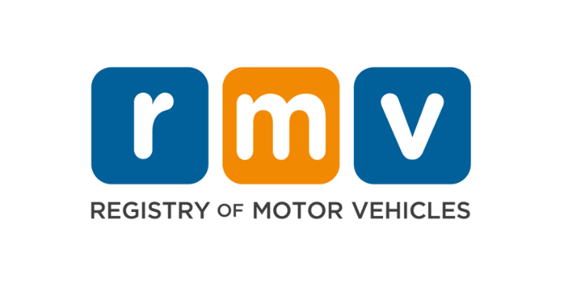

Professional Driving School Remote Instructions

Effective 7/1/23 all online remote classes to be reduced to maximum of 25 students per one live instructor.

To ensure consistent and quality education, all professional driving schools must adhere to the following guidelines when conducting remote classroom instruction:

- Utilize an online training solution that will be interactive (Zoom, GoToMeeting, Microsoft Teams etc.)

- Participation for remote instruction is limited to 25 students per class.

- Instruction will be required from your Driving School location, either main or instructional. Prior accommodations were granted to align with Covid Restrictions which have now been lifted. All remote classes must be delivered from the Driving School.

- Remote and In-Person classes are not to be combined. Classes are either remote or in person.

- Ensure each enrolled student fully participates and completes each module. Webcam visual confirmation during the class is required.

- Individual who is conducting the class must hold a valid Driving Instructor Certificate, be visible and available to all students for the duration of the class. Driving Instructor should not leave the students in the class unattended at any time.

- Attendance must be confirmed for all students at the beginning and end of each class. Students will not receive credit for the module if they are not present for any portion of the class. The RMV requires student signatures for every completed module. These can either be ink or electronic signatures and must be available upon request from an RMV staff member or during an audit.

- The final exam shall consist of a minimum of 50 questions. At least 30 percent of the questions must pertain to the rules of the road. The remaining questions are at the discretion of the driving school, however, should be based on the Driver’s Education Curriculum.

- The requirements for attendance and participation also apply to the Parent/Guardian Class. Webcam visual confirmation is required.

- All modules / classes should be entered within 7 days of completion.

- Non-compliance with the RMV requirements will be considered a violation of the RMV process. Driving schools will be subject to disciplinary action.
Updated 04-07-2023

