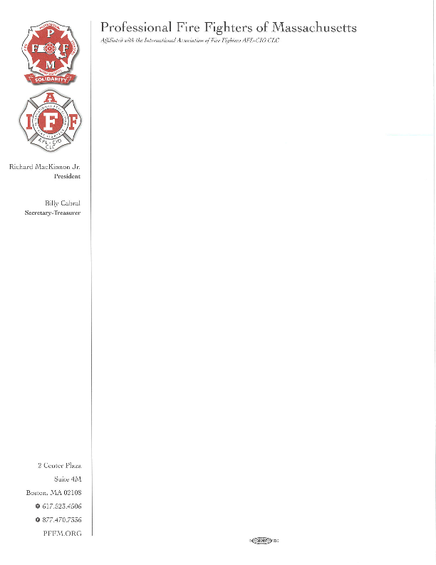

June 29, 2018

To: Department of Public Health

250 Washington Street

Boston, MA 02108

To the Department of Public Health

This letter is in response to the recent draft for the proposed amendment to establish new fees is section 105 CMR Department of Public Health. The Professional Firefighters of Massachusetts (PFFM) would like to thank the Department of Public Health in advance for allowing our comments to be part of the record.

The Professional Fire Fighters of Massachusetts represent 12,000 members from 222 locals across the Commonwealth of Massachusetts. Of those 222 locals, over 160 fire departments operate fire-based EMS. The PFFM oppose this new rate structure as it will impose an undo financial burden to communities that would potentially participate in mobile integrated health and ED avoidance programs. Municipalities that would need to meet this proposed rate structure must raise an appropriate within their respective community budgets, budgets that at times are strained by various community needs. Mobile Integrated Health programs and ED avoidance programs require administrative functions, equipment, training and a workforce, which all come with a cost. Adding these high fees will delay any new programs or possibly not allow them to operate at all. We hope that the department will reevaluate the fee structure to lessen the impact to communities across Massachusetts. Mobile integrated health and ED avoidance programs are a great and proactive initiative. Communities and EMS services need to have a proactive fee structure to promote MIH and ED avoidance programs.

Another significant challenge, is there is no delineated funding stream by health insurance companies, Medicaid or Medicare. Communities or EMS services looking to develop a MIH or ED avoidance programs must be creative and innovative to identify ample funding for a new and proactive program. The proposed rates will impose additional financial hurdles to most MIH and ED avoidance programs.

We would be happy to assist the department in designing a rate structure that is more feasible. Thank you for the opportunity to submit written and verbal testimony

Sincerely;

***Thomas J Henderson***

Thomas J. Henderson

Director of EMS

Professional Fire Fighters of Massachusetts

***Richard MacKinnon, Jr***

Richard MacKinnon, Jr.

President

Professional Fire Fighters of Massachusetts