School and District Profiles https://profiles.doe.mass.edu/

For information about Massachusetts districts or schools, a great place to start is the School and District Profiles website. Profiles contains detailed data and reports that cover a wide range of information on the Commonwealth’s public districts and schools, including: student enrollment, state assessment results, graduation rates, district expenditures, and accountability reports.
Access
All of the data in School and District Profiles is available to the public. In most cases, you will be able to obtain information at the state, district, or school level. You can also use the data filters to view information for special populations, such as English Language Learners and Special Education students.
For questions about School and District Profiles, you can contact the Department of Elementary and Secondary Education at data@doe.mass.edu.

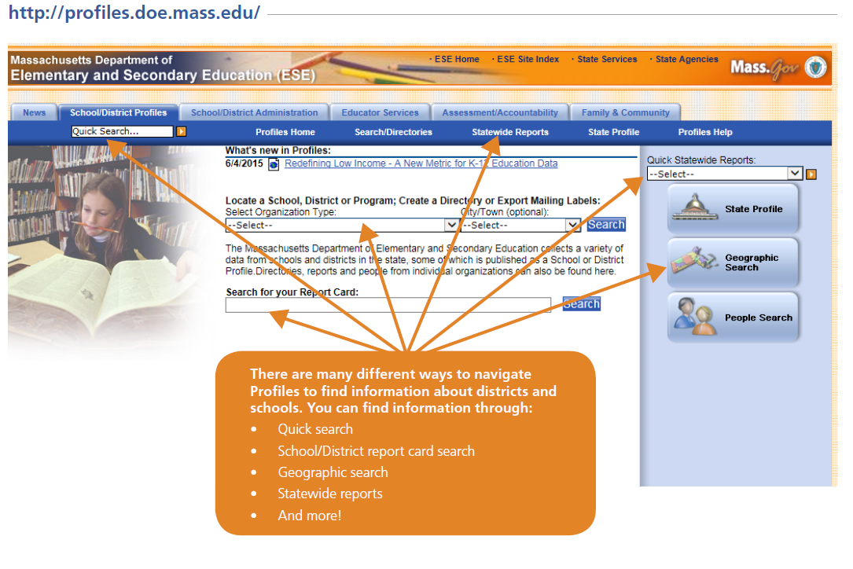

Instructional Resources
Look for the “Learn More” icon to access tutorials providing additional support on using the data

