
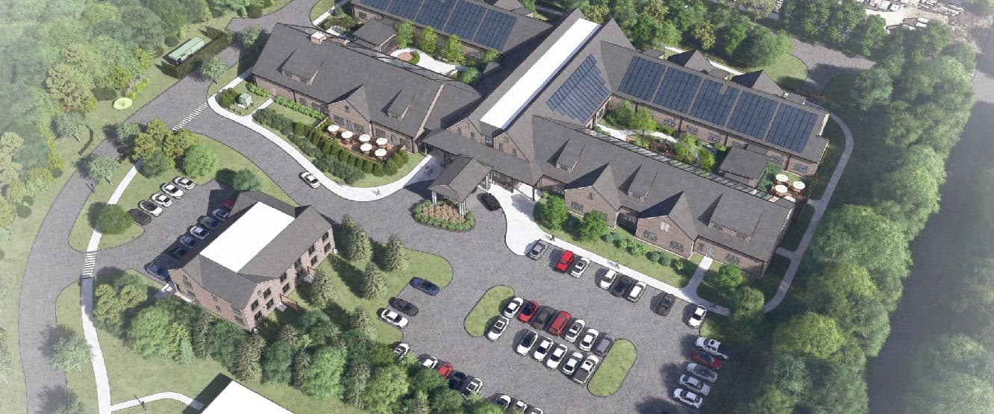

Town of Nantucket – New Our Island Home Skilled Nursing Facility
Project Story
January 21, 2025

1

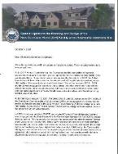
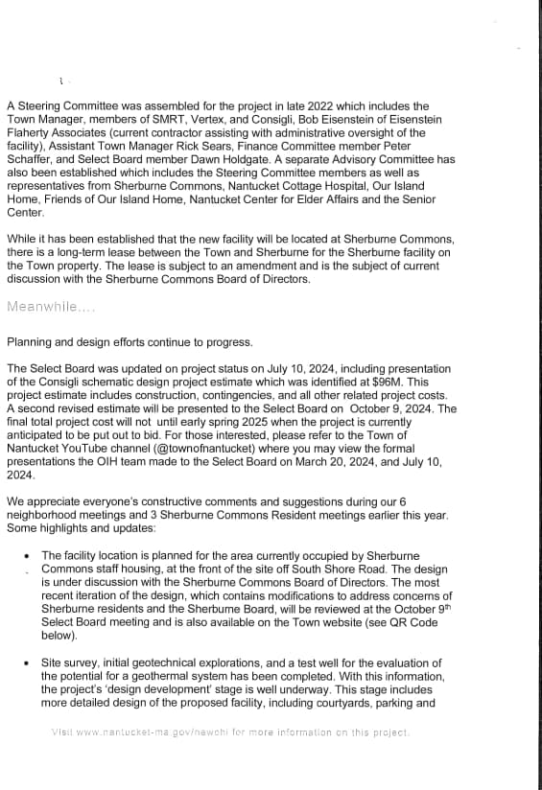
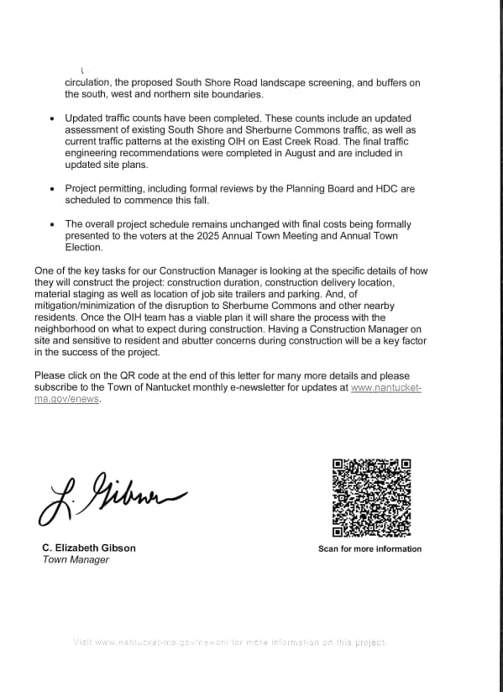

Communications Plan

Why New OIH at Sherburne Commons?

ATM 2022

ATM 2025

Select Board – August 2021
ATM 2021

Article 15 – Adopted Operating Override
($5,000,000)
- Several different feasibility options evaluated the ability to expand and rebuild at the existing OIH site and all were impractical.
- The select board decided to rebuild a new OIH on Town owned land at Sherburne Commons.
- The select board agreed to put Article 11 of ATM 2022 to the voters.

Article 11: Design and OPM Services - Adopted
- Yes – 757
- No – 130

- No indication of size or number of beds
- Site: Sherburne Commons

TBD: Total Anticipated Project Cost including:
- Construction Cost and Design Team Construction Oversight, Project Closeout

ATM 2022 Approval: Project Charter – Article 11

- Locate New Our Island Home on Town owned land at Sherburne Commons Campus
- Existing OIH is outdated and does not meet best practices for patient care, or current Department of Public Health regulations for nursing support and mechanical systems.
- Voters approved having an on-island nursing facility it needs to be replaced.
- Select Board and Finance Committee have voted unanimously to support this Article and OIH project

New Our Island Home will benefit all Islanders by:
  - Allowing for flexibility and more space, providing improved quality of life:
    - Privacy
    - Dignity
    - Independence
    - Meaningful activities for residents
  - Continuing the operation of a local Skilled Nursing Facility, saving Nantucketer’s the time, inconvenience and expenses of off-Island travel
  - Creating a more home-like facility that can focus on person- centric care
  - Replacing a failing building with code compliant facility that will meet the standards of care of Skilled Nursing Facilities for years to come
  - Allowing the existing site at 9 East Creek to be repurposed for a new Senior Center

Our Island Home Guiding Principles

Care for the Residents & Families

Operationally Sound

Safety

Future Ready & Sustainably Designed

Care for the Caregivers

- Abundant natural light, access & views to nature.
- Good neighbor. Community focused.
- Choice/encouragement around social & activity spaces.
- Glare and noise reduction.
- Non-institutional look/feel. Welcoming to all – EDI focused.
- Easy wayfinding and navigation.
- Patient access and parking.
- Clear main entrance.
- Space for special occasions & visiting presentations.
- Budget / project viability
- Balance between resident privacy & staff observation.
- Thoughtful storage solutions. Right stuff, right place, right time.
- Durable materials that are easy to maintain & stand the test of time.
- Standardization for workflow and maintenance.
- Plug & play technology ready
  - Single patient rooms.
  - Environmental: Air quality and temperature.
  - Balance of both physical and mental well-
being/memory care.
  - Facility ready for future pandemics.
  - Clear paths of travel that minimize travel distances.
  - Covered drop-off zone.
  - Outdoor resident space with controlled access.
  - Maximize use of sustainable materials.
  - Reduce operational cost/lower energy use/or zero energy use.
  - Easy to maintain systems.
  - Red List Free, PFAS free.
  - Low carbon materials where possible.
  - Aligns with Passive House, LEED, and WELL building design principles.
  - Space for expansion.
  - Reliable redundant solutions
  - Offset electricity consumption with on-site renewable energy. Solar? Geothermal?
- Safe & supportive environment in which to provide quality care.
- Staff respite space.
- Maximize natural light.
- Efficient design for collaboration & communication
- Clear zoning between resident and staff areas
- Recruitment and retention.
- Design that supports staffing challenges and optimizes workflow.

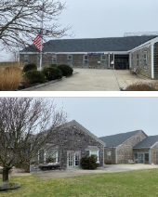

Project Highlights

What is the need for change – new needs for nursing care?

When comparing the existing OIH facility to the future OIH facility, there are some major improvements that will dovetail with improving health outcomes for residents as well as enhancing their quality of life. Some deficiencies to highlight in the existing OIH building are.

  - Most of the rooms are double occupancy, which creates privacy issues for residents, staff and families on a daily basis.
  - The resident room bathrooms are undersized and predominately not ADA compliant.
  - The sightlines from the nurse station to each resident wing is compromised and, in some cases, non-existent.
  - There is no ADL component in the existing OIH, making some rehabilitation services a challenge.
  - There is one modestly sized room that is used for both the Living Room and Activity functions. The space is severely undersized for 45 residents and creates challenges when residents prefer to do varying activities.

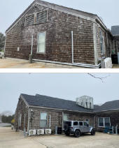

Project Highlights

What is the need for change – new needs for nursing care? (cont.)

  - Generally, the facility compromises the concept of choice for the residents.
  - Resident rooms do not have any ceiling lifts, therefore creating challenges around safety for both resident and staff.
  - There are very limited areas for residents to go if they are experiencing sensory overload.
  - Clinical space functions are compromised due to space constraints.
  - General storage throughout is lacking.
  - Interior finishes are dated and tired. Many areas do not align with healthcare /FGI design guidelines / best practice for skilled nursing facilities.

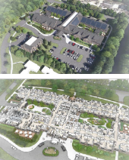

Project Highlights

Improving health outcomes / safety

    - The new OIH is planned for 45 private resident rooms. Single Resident Rooms are associated with many benefits to the resident, staff and families including:
      - Enhanced environment for resident’s home, privacy and control.
      - Improved sleep patterns, reduced aggression / agitation (especially for residents with dementia), improved infection prevention, potential for reduction in medications and fewer medication errors.
      - In addition, single rooms provide the opportunity for improved HIPPA compliance, patient dignity, pandemic- safety, equity around natural light and views to outside, opportunity for privacy with family, opportunity for tele- health and personal phone and video calls.
      - Allows for greater flexibility management for new admissions (male/female)

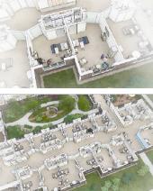

Project Highlights

Improving health outcomes / safety (cont.)

      - The headwall of each resident room will have a grab bar that leads to the bathroom for improved resident safety.
      - Each room is planned to have a ceiling lift. These will improve safety for both residents and staff. Private rooms will also allow for in-room rehabilitation services to occur.
      - Improved hygiene with private European style bathrooms in each resident room. All are ADA compliant, have grab bars throughout, a shower seat, and storage. The ceiling lift track will have the capability to transfer the resident directly into the bathroom shower as well as the toilet area.
      - In addition to the typical resident room, we have planned for a Person of Size room, two connected rooms, and a Hospice suite that includes a dedicated area for families.

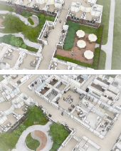

Project Highlights

Improving health outcomes / safety (cont.)

    - Handrails and seating nooks throughout the building to help residents move throughout as well as offer areas to rest along their journey.
    - Placement of Nurse stations and CNA stations: The new OIH has been designed for optimal viewing from the center nursing core area toward each of the resident wings. There are CNA stations designed at the end of each corridor for additional observation as well as charting.
    - Rehabilitation / PT is planned to have an ADL component, a ceiling lift with walk-assist, and an outdoor area specific to rehabilitation, all aiding in both short- and long-term patient’s and resident’s recovery.
    - Materials and finishes selected are non-institutional and comply with both healthcare-grade as well as FGI guidelines. Selected materials are and are low maintenance, environmentally friendly, and selected for their longevity.

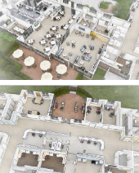

Project Highlights

Improving health outcomes / safety (cont.)

    - Wayfinding approach throughout the building will be both intuitive and purposeful, aiding those with navigational and visual challenges to find their destination.
    - Thoughtful and standardized processes and storage solutions for staff aimed to help with efficiency and reduce frustration.
    - Equipment alcoves throughout the resident corridors to declutter and provide clear and safe circulation for all.
    - Clear zoning between staff and resident spaces.

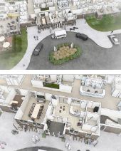

Project Highlights

Enhancing quality of care / quality of life

The new OIH is planned to have many features, as outlined below, incorporated into the facility to enhance the quality of care and quality of life for residents, staff, and families.

- Community-focused. Choice and encouragement around social and activity spaces.
- Areas for families to gather for regular visits as well as special occasions.
- Accessible and safe outdoor space.
  - Two courtyards, passive and active approach.
  - Three exterior patio areas with security fencing.
  - Seating, walking paths, rehabilitation functions (in active courtyard).
- Maximize natural light throughout the building.
- Integrated Loop Technology in Living Room, Private Dining, and the Conference Room to assist those with hearing challenges.
- Places for families to meet with OIH staff including the ability for video capability.

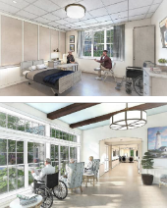

Project Highlights

Enhancing quality of care / quality of life

- Areas for staff to do training – both resident-focused and clinical focused.
- Plug & play technology ready.
- Improved acoustics throughout the building.
- Resident rooms have a dedicated parking spot and power outlet for residents with electric wheelchairs.
- Non-denominational spiritual space and flexible sensory room are both included in the design.
- Flexible furnishings are planned throughout that will accommodate the variety of needs of this population.
- Community spaces: many different locations and sizes throughout the building to offer choice for the residents and their families
- Staff respite space and break space with natural light and access to outdoor space.
- Covered drop off zone at main entrance.
- The building is planned to be Passive House certified which will result in comfortable indoor temperatures as well as improved acoustics from outdoor noise.

Why is the new OIH the size it is?
Project Breakdown: Gross Square Footage: 59,267 gsf
− 47,382 gsf (First Floor)
- Including: 1,500 gsf (Future expansion)
− 14, 572 gsf (Basement)
- Including 2,687 gsf (Future Shell Space)

39%
Staff/Building Support Spaces Sized to support
resident's requirements

41%: Resident Spaces – BEDROOMS – THREE 15 BED NEIGHBORHOODS
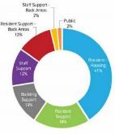
− 24,300 gsf 45 Single Rooms with individual toilet/shower room:
- 12 of these are sized to be converted from singles to doubles in future, for 12 additional Beds if census requires: needed
- Allowing for flexibility and more space
- Improve quality of life: Privacy, dignity, independence and meaningful activity
20%: Resident Spaces – REQUIRED COMMON AREAS
− 11,853 gsf
- Improve quality of life: Privacy, dignity, independence and meaningful activity
39%: Staff / Building Support Spaces – REQUIRED BACK OF HOUSE SPACES
− 23,114 gsf
- Improve quality of care and working conditions for staff
61% Resident Spaces – CODE REQUIRED DIMENSIONS
14


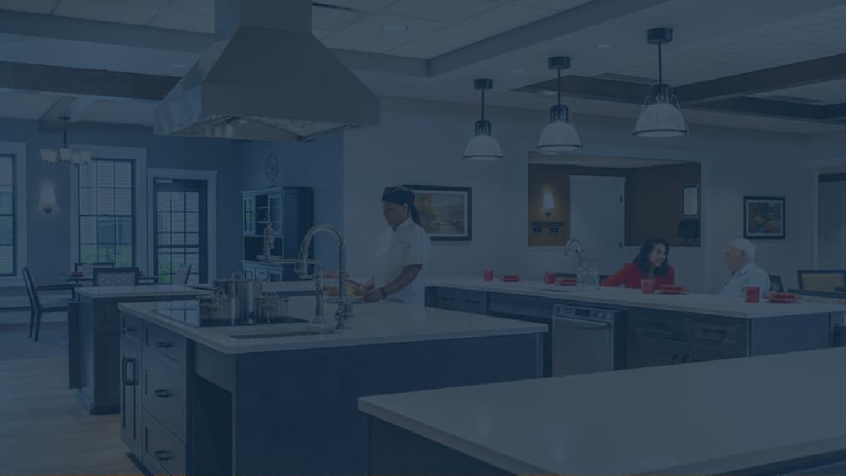
Project Renderings

15

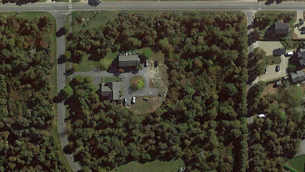

Existing
Site Plan ₁₆

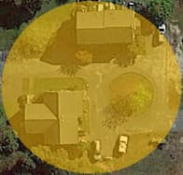
Existing Sherburne Staff Housing

Existing
Site Plan ₁₇

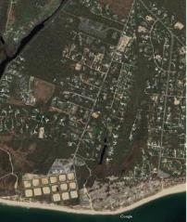


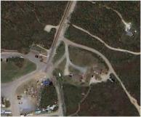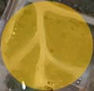
`
Relocated / Moved Sherburne Staff Housing
18

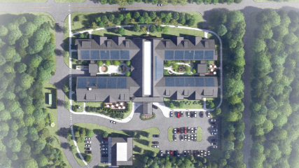

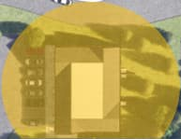

New Sherburne Staff
Housing
19

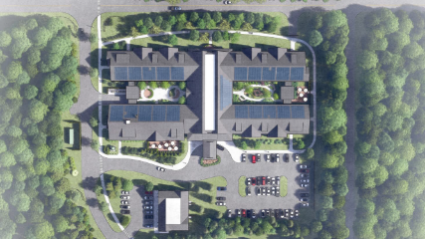
Site Plan

20

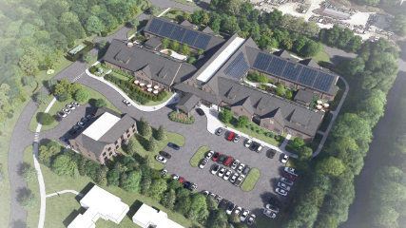

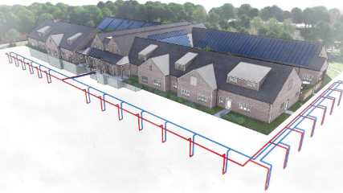
Geothermal System

22

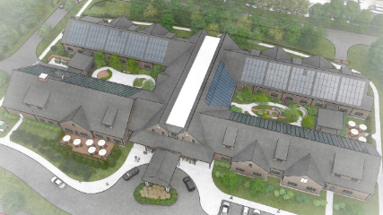

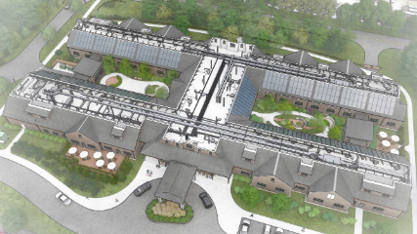

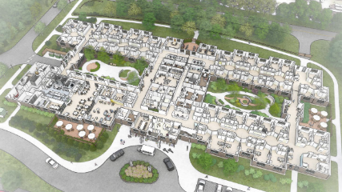

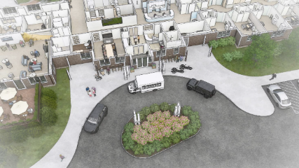
Resident / Family Covered Drop Off Area

26

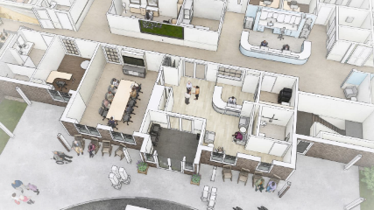

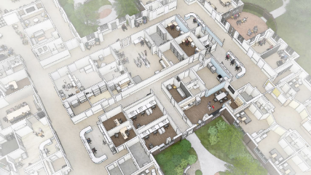

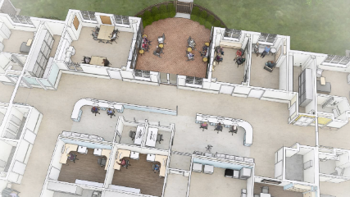
Nurse Area, Resident Activities, Sensory, Meditation

29

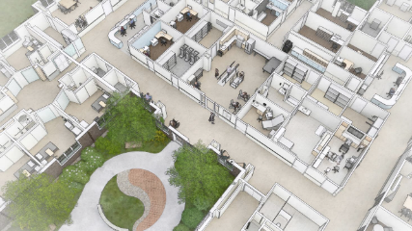

Physical Therapy Corridor

Active Main Street
- Access to courtyard
- Physical Therapy
- Connections to resident neighborhoods
- Large windows allow for natural light and views to courtyard
- Interior spaces have transom lights to extend natural dayout far into the interior of the building.

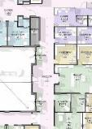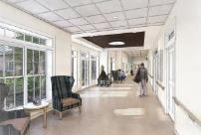

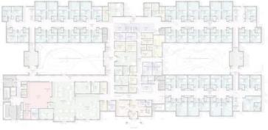
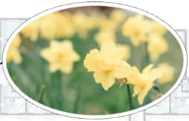
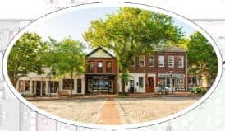

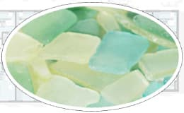
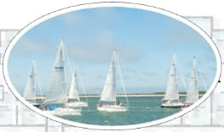

Narrative – The Project Design Concept – Use as Resident Therapy

Sail

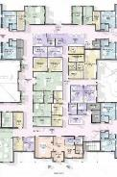
Resident Wing Entrance

Daffodil

Distinct Neighborhoods –
- Homelike and recognizable with clear wayfinding
- Good for residents

Floors:
- Rubber Flooring, natural product, easily cleanable, durable and long lasting
- Minimize patterns and shinning which is disorienting for some

Wall Protection:
- Simple look but reduces need to patch repair walls from equipment impacts.

Neighborhood
Neighborhood

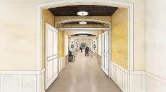
Sea glass Neighborhood

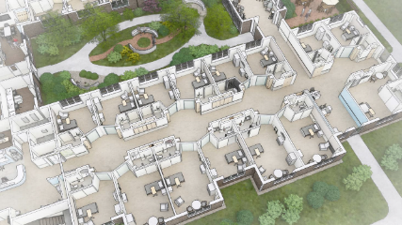

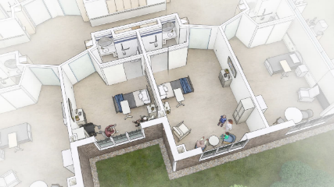
Resident Room (Private and Large Private)

35

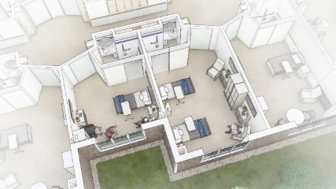
Resident Room (Private and Future Double)

36

Resident Room

Single Occupancy Private Bedrooms
- Space for wheelchairs
- Space for recliner
- Space for visitors to visit and welcome to stay
- Views to nature

Ceilings:
- Cost effective – Acoustical Ceiling Tiles

Ceiling Lifts:
- Resident transfer if needed to/from bed and assistance to bathroom.

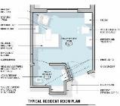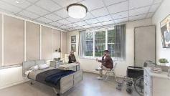

Resident Room Restroom

Handrails
- All rooms are handicap accessible
- Continuous from resident bed to the toilet, reduces resident falls.

Ceramic Tiles:
- Provides excellent slip resistance (grout lines)
- Long lasting and timeless

Mirrors/Lighting:
- Clean and modern

Shower:
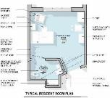
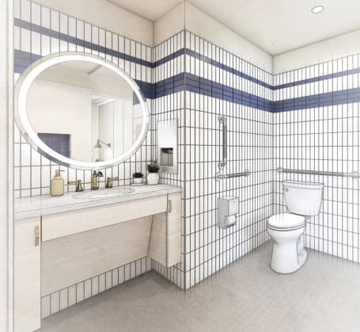
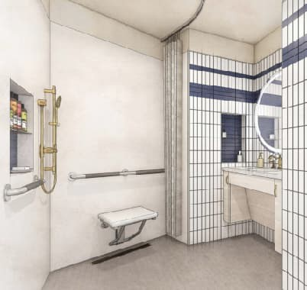
- Flexible and sized for staff assistance if required, seat and handrails.

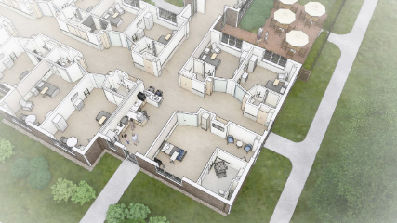
Resident Room (Person of Size Room)

39

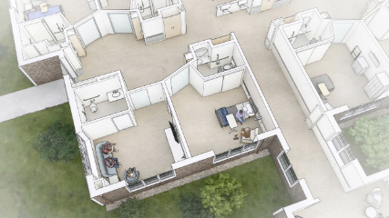
Resident Room (Hospice Suite)

40

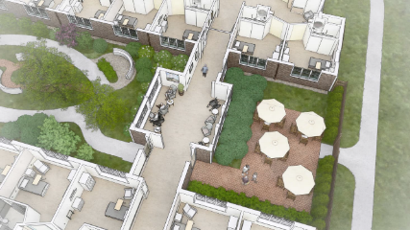

Porches

Active Neighborhood Street / Porch Meeting Areas
- Access to courtyard
- Gathering space outside of resident room for loved ones to meet with resident
- Connections to resident neighborhoods allows for residents to
pace walk and avoid dead ends
- Convenient access for staff/supplies between neighborhoods

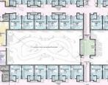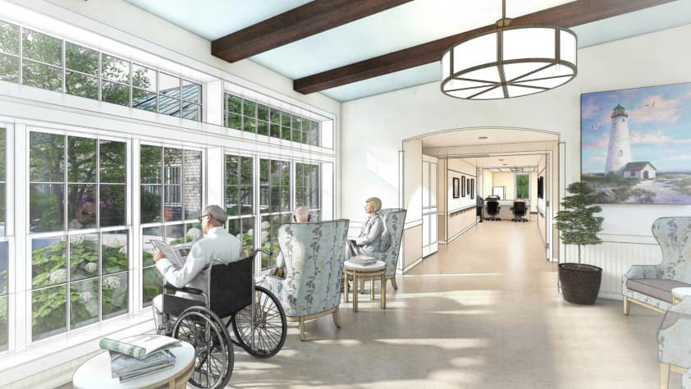

42

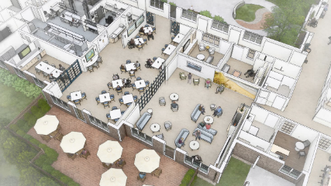

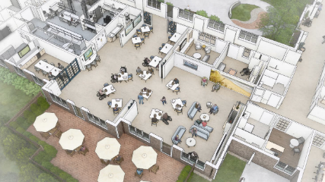
Dining and Living Rooms – Large Event

44

Living Room

Hearth
- Timeless gathering area

Graphics / Images / TV:
- Variety of therapy for residents and activities
- Aquarium (similar to what is today at OIH)
- Simply ceiling feature (lights and details reinforces active space)
- Large graphic image to evoke memories and discussion with staff (art therapy)

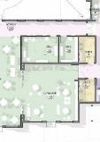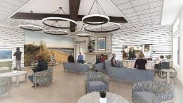

Dining Room

Private Dining Room
- Options for resident celebrations with family / friends
- Quieter dining option for residents who prefer less activity
- Reinforcing resident choice.

Choice:
- Variety of dining table options.

Flexibility:
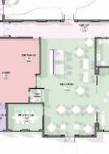
- Living Room and Dining Room can be opened up to one large space. This space can be used for larger gatherings with staff, family and community events

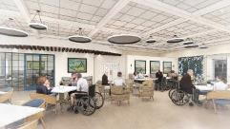

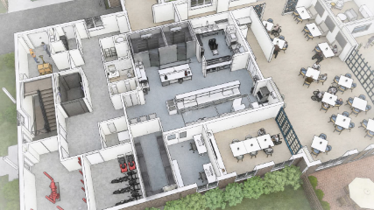
Service Entrance / Kitchen / Dining Room

47

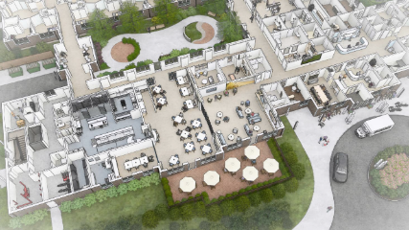
First Floor – Service / Dining / Living Activities Wing

48

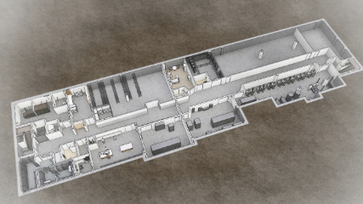
Basement – Service / Staff Only Area

49

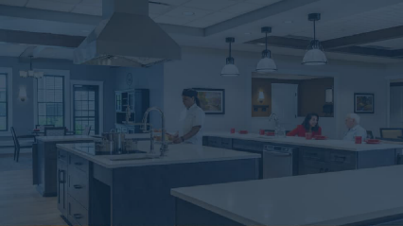
Site Development and Renderings

50

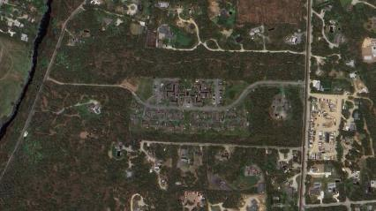

Existing
Site Plan ₅₁

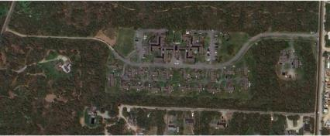
Existing
Site Plan ₅₂

Existing
Site Plan ₅₃

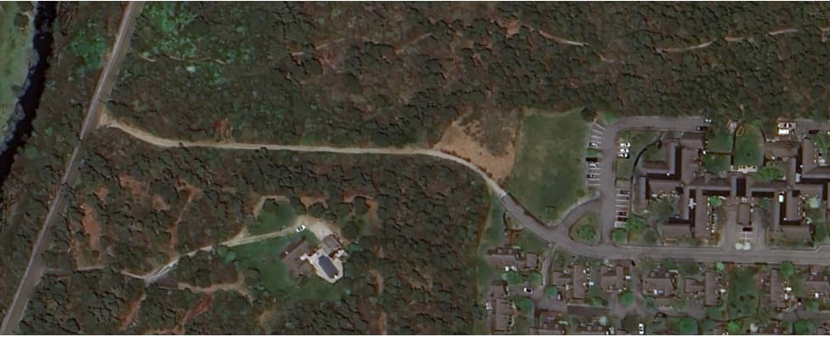

Existing Emergency Access to Miacomet Road
54

Existing Sherburne Staff Housing

Existing
Site Plan ₅₅

`
Relocated / Moved Sherburne Staff Housing
56

ar

New Sherburne Staff
Housing
57

Site Plan

58

Geothermal System

60

First Floor – Service / Dining / Living Activities Wing

64

Basement – Service / Staff Only Area

65

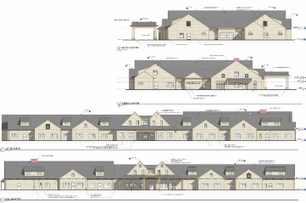

Building Elevations OIH

Building Elevations – Replaced Sherburne Staff Housing
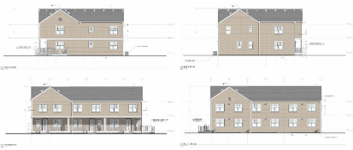

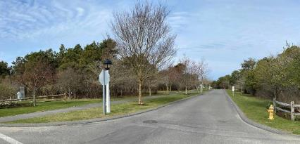

Existing Sherburne Entry View from South Shore Road

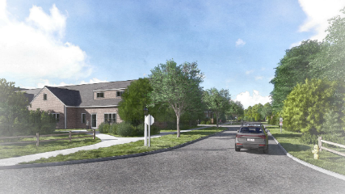
Proposed Entry View from South Shore Road

69

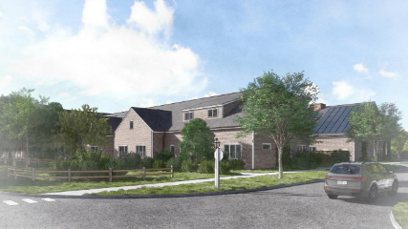
Proposed Entry View from South Shore Road

70

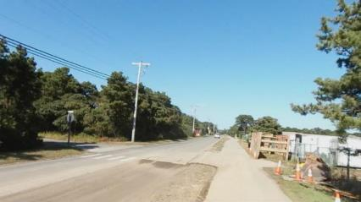
View from South Shore Road (Looking Northwest, just past South Pasture)

71

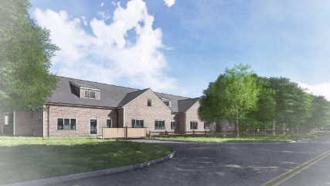

Proposed view from South Shore Road (Looking Northwest)

72

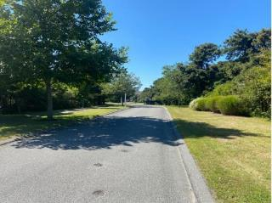

Entry View from driveway to Sherburne Staff Housing
73

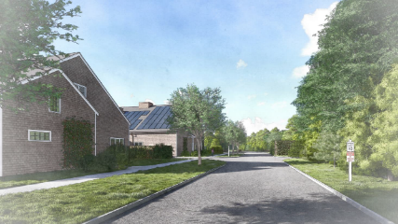

Proposed Sherburne Commons Road
74

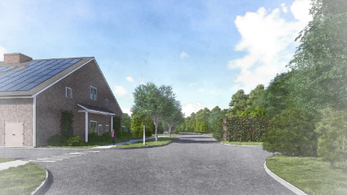

Proposed Sherburne Commons Road
75

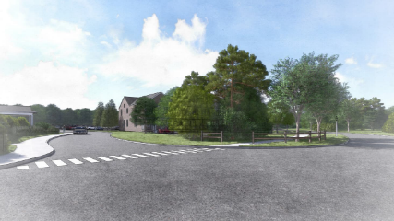

Proposed View of New OIH / Staff Housing from Sherburne Commons Road
76

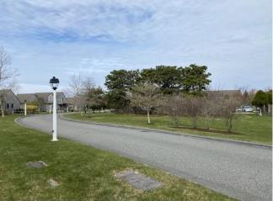

Existing Sherburne Commons looking West
77

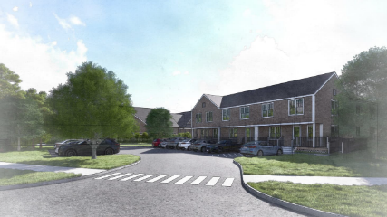

Proposed View of New OIH / Sherburne Commons Housing from
Sherburne Commons Road from Sherburne Commons looking East 78

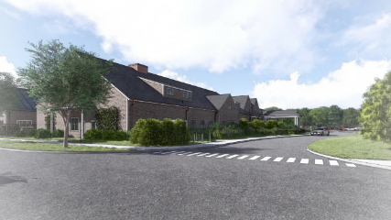

Proposed View of New OIH Entrance from Sherburne Commons Road
79

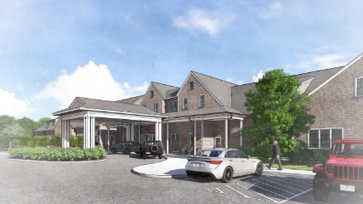
Proposed Building Entry view

80

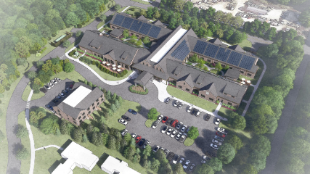


Bird’s-Eye
Perspective ₈₁

Project Schedule / Next Steps

82

Milestone Budget Updates
Construction Documents (CD): 1/10/25:
Consigli – Bidding / Guaranteed Maximum Price (GMP) Schedule
− Trade Bids Due: March 4, 2025
− Remaining Bids Due: March 11, 2025
− Initial GMP: March 7, 2025
− Final GMP: April 2, 2025
− Select Board Update: April 9, 2025
ATM 2025: Saturday May 3, 2025
Pending all permitting and ATM25 Approval / Election:
− Construction Phase/Procurement: September 2025 to September 2027

Permitting Milestone Updates

Planning Board: COMPLETE: Received Approval with conditions on 12/9/24 HDC Submission: IN PROCESS: 12/2/24, Hearing on 1/21/25 Massachusetts Department of Public Health:
- Determination of Need
- Plan Review Process

Sustainability / Reslilience Update

85

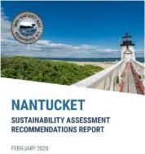
Sustainability Update
The path forward
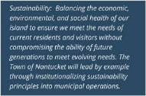


OIH Sustainability Update

The path forward

Energy Reduction Measures
- New OIH is predicted to use 78% less energy per square footage than the existing OIH
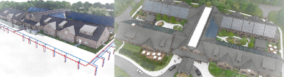
- The new facility will be an all-electric building, with on-site energy generation from geothermal and PV array system. This approach with provide stability on utility costs in a volatile energy market.

OIH Sustainability Update

The path forward

Energy Reduction Measures
On-Site Renewable Energy: Photovoltaic (PV)
- Based on the possibility area for roof mounted PV, an array could support approximately 72% of the building energy demand.
- The roof mounted PV array would reduce the energy demand from utility services by 93% when compared to the existing facility. Reducing annual energy grid consumption to 611,000 kBtu, equating to a predicted annual energy cost from the utility grid of $0.57/sf.
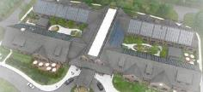

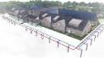
OIH Sustainability Update

The path forward

Energy Reduction Measures
HVAC/Geothermal
- The building will utilize energy recovery ventilators (ERV) for ventilating occupant spaces and common areas. The ERVs will be highly efficient at recovering the energy from the exhaust air taken from the building to condition the incoming fresh air. The fresh air supplied through the ERVs will all come from outdoors and all of the exhaust air taken from the building will be discharged outdoors (i.e. there is no recirculation of ventilation air in the building).
- The building will utilize highly efficient, variable-refrigerant-flow (VRF) heat pump systems for space heating and cooling and for tempering ventilation air. The VRF systems will be connected to the geothermal well field which allow the systems to operate at a higher efficiency than VRF systems that utilize outdoor equipment.
- The building will utilize a geothermal well-field for providing energy to the space heating and cooling systems and tempering ventilation air. The geothermal well-field will also be used to provide energy for the domestic hot water system and refrigeration systems serving the commercial kitchen.
- The geothermal well-field allows for outdoor equipment to be eliminated and for all major pieces of equipment to be located indoors within mechanical spaces.
  - Locating equipment indoors allows for easier access for service and maintenance and results in longer lifespans for equipment as they will not be exposed to coastal conditions.
  - Locating equipment indoors reduces exterior noise generated by HVAC equipment which benefits both building occupants and
neighbors.

How Geothermal Closed Loop System Works

Absorbing heat from the earth during winter to heat OIH and then releasing heat back into the ground during summer for cooling purposes

By circulating a mixture of water and antifreeze through a connected network of buried pipes warmed by the ground which is 50 degrees year-round

450 feet deep wells

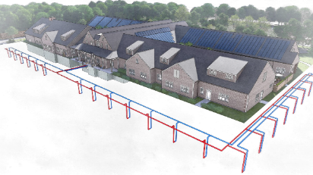





- Heating in winter: The fluid in the underground loop absorbs heat from the surrounding soil. Reverse in summer.
- Heat pump transfer: The fluid is pumped to the heat pump where it transfers its heat to the refrigerant inside the unit. Reverse in winter.
- Air distribution: The heated refrigerant is then used to warm the air in the building via an air handler 90

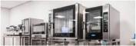

OIH Sustainability Update

The path forward

Energy Reduction Measures
Fully electric Kitchen
- Environmental impact: Switching to electric appliances eliminates direct greenhouse gas emissions from gas combustion, contributing to a more sustainable kitchen operation.
- Indoor air quality: Electric cooking produces significantly less fumes and pollutants compared to gas, improving air quality for
kitchen staff.
- Induction technology: Many modern electric appliances use induction cooking, which provides precise temperature control and heats cookware directly, potentially leading to faster cooking times and improved efficiency.
- Electrical infrastructure needs: Upgrading the electrical system in the building may be necessary to accommodate the increased power demand from electric appliances.
- Cost considerations: While electric appliances might have a higher upfront cost, potential energy savings and reduced ventilation
needs could offset the initial expense over time.
- Electrified kitchen promoted a healthy environment for kitchen staff and residents by eliminating greenhouse gas emissions associated with the burning of propane. The existing facility’s kitchen produced roughly 21,500 kg CO2e annually, this is equivalent to carbon sequestered by 21.6 acres of U.S. forests each year.
- Electrified kitchen removes the dependency on utility gas delivery and can be operated from renewable energy systems.

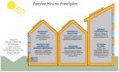
OIH Sustainability Update

The path forward

Passive House
A third-party building certification program that prioritizes energy efficiency and occupant wellness and thermal comfort through high thermal resistance and airtight building envelope construction.
Passive House certification provides third-party verification which ensures the building construction meets the design intent of a quality exterior envelope through enhanced inspections and testing.
Passive houses are built with high-quality materials and strict construction methods/monitoring, which makes them durable. Passive House aligns with the goals of improving the lives of the residents in a senior care environment. Focusing on the thermal comfort for the residents through the following:
- System, free from outside drafts, colds spots and overheating
- Improved air quality
- Quiet: tight envelope and insulation reduces noises from exterior

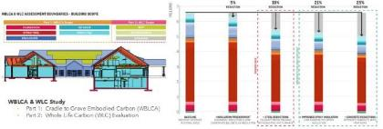

OIH Sustainability Update

The path forward

WBLCA & WLC Study
- Part 1: Cradle to Grave Embodied Carbon (WBLCA)
- Part 2: Whole Life Carbon (WLC) Evaluation

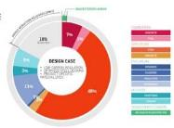
OIH Sustainability Update

The path forward

Greenhouse Gas Emissions
  - Through comparative modeling, which evaluates the building as designed against the same building with a baseline mechanical system and code minimum thermal envelope, the proposed design is predicted to produce nearly 45% less greenhouse gas emissions, before consideration of the additional offsets associated with PV.
  - The PV array offers an additional 28% reduction of greenhouse gas emissions, totaling approximately 73% in GHG reductions.
  - All electric building is able to become “carbon neutral” with both on and offsite renewable energy sources are implemented on the site and the electrical grid becomes decarbonized. Building using fossil fuels will always produce greenhouse gas emissions until those system are replaced with electrified systems.


OIH Sustainability Update

The path forward
Potential Incentives | $4,494,149
Mass Save - PV | $304,606
Mass Save – Construction Incentive | $120,600
Mass Save – Passive House Certification | $3,000
Mass Save – Post Occupancy Incentive | $90,500
Mass Save – Appointed Technical Advisor Fee | ($7,500)
Mass Save – Ground Source Heat Pump | $859,100
IRA Federal 30% Tax Credit – PV | $345,843
IRA Federal Tax Credit – Geothermal | $2,778,000

Rebates/Incentives
  - Through Mass Saves, the project is able to recoup a percentage of the project costs associated with the proposed rooftop PV array, the geothermal ground source heat pump system, as well as additional rebates for Passive House Certification and Post Occupancy Incentives. Anticipated Rebate $500,000.

  - The Federal Inflation Reduction Act (IRA) offers additional incentives that are targeted for both the rooftop PV array as well as the geothermal ground source heat pump system. Anticipated Rebate:
$4,000,000.

