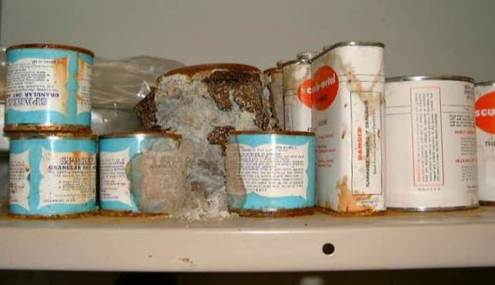

Massachusetts Department of Public Health
Bureau of CLIMATE AND Environmental Health | Indoor Air Quality Program

Guidance Concerning Proper Use and Storage of Chemicals in Schools to Protect Public Health
The safety of students, faculty, and school staff, as well as emergency responders can be adversely affected by the use and storage of chemicals. Improper use and storage of chemicals in schools can lead to irritant symptoms and degrade indoor air quality, particularly in buildings with poor exhaust ventilation. More serious incidents can occur when chemicals are mixed or spilled. Due to the inherent dangers presented by chemicals used in science classes and cleaning/maintenance materials used by custodial staff, appropriate measures for proper use and storage of these materials are needed to minimize exposure.
Municipal fire departments have exclusive authority to regulate storage of flammable materials (527 CMR 14.00). The fire safety office at the municipal fire department should be consulted for assistance in compliance with these regulations.
The following guidelines are intended to serve as recommendations for the proper use and storage of these hazardous materials.

Chemical Identification

Container Labeling
Each container must be labeled with the chemical name of the material stored within, not just the chemical formula. Chemical names must be consistent with M.G.L. c. 111F (Hazardous Substances Disclosure by Employers, also known as the Massachusetts Right-To-Know Law) to facilitate identification of the chemical(s) in case of a spill.

Safety Data Sheet (SDS)
An SDS (formerly Material Safety Data Sheet, or MSDS) contains important information about a product, including its chemical components, safe use and handling, hazards, and spill protocols. The most recent SDS for custodial supplies and chemicals used in science, art, photography, or other programs should be obtained from the chemical supplier/ manufacturer and kept in an area that is accessible to all individuals during periods of building operations in conformance with M.G.L. c. 111F. If an SDS is not available for a product because 1) the manufacturer no longer exists; 2) the manufacturer cannot be identified from the label, or 3) the chemical was obtained prior to the promulgation of M.G.L. c. 111F, that material should be considered hazardous waste and disposed of in a manner consistent with Massachusetts hazardous waste regulations.

Chemical Storage and Handling

Flammables Storage Cabinet
All cabinets for storage of flammable materials must comply with Massachusetts statutes and regulations, as well as local ordinances promulgated, pursuant to M.G.L. c. 148, § 13. In addition, all flameproof cabinets must meet the design and installation criteria set forth in the National Fire Prevention Association’s (NFPA) latest edition of NFPA 30: Flammable and Combustible Liquids Code.

Acids Storage Cabinet
Acids should be stored in a cabinet constructed from corrosion-resistant materials. Each acid cabinet should be properly vented to reduce acid vapor build up.

Chemical Storeroom Ventilation
Rooms that are designated for use as chemical storage areas must have a functioning dedicated exhaust ventilation system that operates continuously to remove fugitive chemical vapors. The local exhaust system should be independent of the general ventilation system and ducted to the outdoors. Each room must also have an appropriate source of transfer (or make-up) air allowing for exhaust vents to operate efficiently. Such chemical storage ventilation systems must be in conformance with the applicable fire and building codes. Chemical storeroom exhaust vents must be inspected annually by appropriately trained individuals to ensure proper function.

Shelving
If chemicals are stored on shelving:
- Shelving must be constructed of materials that will resist corrosion resulting from leaking containers stored on or around the shelves. For example, chemicals that are oxidizers should not be stored on wood and acids should not be stored on or near steel.
- The shelving must be able to support the weight of stored materials.
- Guardrails should be installed along the edge of shelving to prevent accidental slippage.

Chemical Hoods
Chemical hoods used in science experiments must be maintained in accordance with manufacturers’ recommendations. Chemical hoods must be inspected/recalibrated annually by appropriately trained individuals to ensure proper function. Documentation of annual recalibration should be accessible to all building occupants. If an area is designed so the chemical hood is the sole exhaust vent for an area, the chemical hood must operate continuously during occupied hours. Chemical hoods should not be used to store unattended chemicals.

Prohibited Activities
The following chemical storage/handling practices should be prohibited to provide for the health and safety of school occupants:
- Shock sensitive materials should NOT be present in the school and should only be removed after consultation with the local fire safety office.
- Flammable materials should NOT be stored outside flameproof cabinets.
- Non-flammable materials should NOT be stored inside flameproof cabinets.
- Chemically incompatible materials must be separated and stored according to the manufacturer’s recommendations.
- No flameproof cabinet should be vented to allow for backflow of air into the cabinet.
- No cabinet should share venting with the chemical hood.
- Acids should not be stored in cabinets on shelves made of steel.
- Carpeting should not be used in laboratories.
- Schools should not store more flammables or liquid chemicals than are necessary to meet curriculum needs, and in no event more than a two-year supply.
- No water-reactive materials should be stored within 10 feet of a water source.
- Chemicals must not be stored in recycled food storage containers.

Chemical Spill Response Plan
Schools should have a chemical inventory and emergency response plan. The elements of an emergency response plan should include the following:
- Procedures for evacuation away from the spill location and out of the building, in the case of a spill that may result in exposure to building occupants.
- Contact information (e.g., 911) for emergency response to a chemical spill.
- Emergency procedures to contain the material in the spill location, including door closures and deactivation of the ventilation system.
- Contact information for remediation services.
- Procedures for proper disposal of hazardous material in compliance with Massachusetts hazardous waste disposal laws.
reviewed July 2023

For more information, contact:

Indoor Air Quality Program
Bureau of Climate and Environmental Health
Massachusetts Department of Public Health
250 Washington Street, 7th Floor
Boston, MA 02108
Phone: 617-624-5757 | Fax: 617-624-5183 | TTY: 617-624-5286
www.mass.gov/dph/iaq

For information about the Right-To-Know Law and label standards, please refer to the following Massachusetts Department of Labor and Standards document: https://www.mass.gov/doc/right-to-know-workplace-poster/download

