INCIDENT HIGHLIGHTS
DATE:
July 2, 2018
TIME:
10:45 a.m.
VICTIM:
57-year-old property maintenance worker
INDUSTRY/NAICS CODE:
Residential property manager/531311
EMPLOYER:
Property management company
SAFETY & TRAINING:
Employer provided PPE and on-the-job training
SCENE:
Parking garage
LOCATION:
Massachusetts
EVENT TYPE:
Crushing

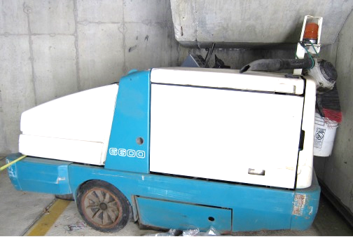

REPORT#: 18MA035 REPORT DATE: 8/13/2021
Property Maintenance Worker Caught between Industrial Sweeper and Low Ceiling—Massachusetts

SUMMARY
On July 2, 2018, a 57-year-old property maintenance worker was killed while operating a ride-on industrial sweeper. He was using the sweeper to clean a parking garage. While backing the sweeper, it went into an area with a low ceiling and he was caught between the sweeper and the ceiling.
READ THE FULL REPORT> (p.3)

CONTRIBUTING FACTORS
Key contributing factors identified in this investigation include:
- Accessible areas with low height clearance;
- Absence of a protective cab on the sweeper; and
- Lack of a comprehensive safety and health program.
LEARN MORE> (p. 8)
______________________________________________________
RECOMMENDATIONS
The Massachusetts FACE Program concluded that, to help prevent similar occurrences, employers should:
- Ensure that ride-on equipment without a protective cab are not operated in the vicinity of overhead obstructions.
- Ensure that a job hazard analysis is performed for each task assigned to employees.
- Develop and implement a comprehensive safety and health program that addresses hazard recognition, avoidance of unsafe conditions, and proper use of equipment.
In addition, equipment manufacturers should:
- Adopt and implement the concept of Prevention through Design (PtD) to identify potential hazards associated with equipment and then eliminate these hazards through design changes. LEARN MORE> (p.8)
Fatality Assessment and Control Evaluation (FACE) Program

The Massachusetts Department of Public Health, in cooperation with the National Institute for Occupational Safety and Health (NIOSH), conducts investigations on the causes of work-related fatalities. The goal of this program, known as Massachusetts Fatality Assessment and Control Evaluation (Massachusetts FACE) is to prevent future fatal workplace injuries. Massachusetts FACE aims to achieve this goal by identifying and studying the risk factors that contribute to workplace fatalities, by recommending intervention strategies, and by disseminating prevention information to employers and employees.

NIOSH funded state-based FACE Programs currently include: California, Kentucky, Massachusetts, Michigan, New York, Oregon, and Washington.

SUMMARY
On July 2, 2018, a 57-year-old property maintenance worker was killed while operating a ride-on industrial sweeper. He was using the sweeper to clean a parking garage. While backing the sweeper in an area with a low ceiling, he became caught between the sweeper and the ceiling. The victim was eventually discovered unresponsive by a resident of the apartment building who placed a call for emergency medical services (EMS). The man had suffered blunt trauma to his head and neck and was pronounced dead at a local trauma center.

INTRODUCTION
On July 2, 2018, a property maintenance worker for a property management company that operated a condominium complex was fatally injured while using an industrial sweeper to clean the complex’s parking garage. The Massachusetts FACE Program was notified by OSHA on July 3, 2018. On August 30, 2018, representatives from the Massachusetts FACE Program traveled to the complex to discuss the incident with the property management company and to view the garage and sweeper. The police report, death certificate, workers’ compensation records, OSHA records, sweeper operator manual, and other information were reviewed during the course of the investigation.

EMPLOYER
The employer is a property management company that was formed to manage a multiple building condominium property where the incident occurred. The company was overseen by the board of the condominium association. The board directed the property management company on maintenance tasks that needed to be performed. The company had a head property manager, an administrative assistant, a site manager, and the victim as full-time staff. The regular work schedule for these staff members was 7:00 a.m. to 3:30 p.m., Monday through Friday. The property manager and site manager were on-call for overnights and weekends. There were two part-time workers who only worked on the weekends, whom together with the site manager and the victim made up the maintenance crew. Seasonal lifeguards were also hired to be posted at the property’s pool. Most maintenance tasks such as landscaping, utility work including electrical and plumbing, and the opening and closing of a swimming pool was contracted out to other firms. The company had workers’ compensation insurance that covered its employees, as required by Massachusetts law. Employees did not have union representation.

WRITTEN SAFETY PROGRAMS and TRAINING
At the time of the incident, the company did not have a comprehensive safety and health program. Workers were provided some basic training and on-the-job equipment training, including review of the operator’s manual for the sweeper involved in the incident, and supervised operation of the sweeper in an open area. The victim was the most experienced sweeper operator and was reportedly responsible for training new users of the sweeper. The condo association also owned a scissor lift and had a harness to use with the lift, as well as some ladders. There was no training on proper use of the lift, ladders, and cleaning chemicals provided to the maintenance workers. It was reported that the lifeguards were trained in cardio-pulmonary resuscitation (CPR) in order to supervise use of the swimming pool. Workers were provided with some personal protective equipment (PPE), including hearing protection.

WORKER INFORMATION
The victim was a 57-year-old male who had been employed as a property maintenance worker by the company for approximately four years. He had a background in asphalt sealcoating and line painting and had experience snowplowing. He was responsible for the maintenance of the private road that serviced the complex, the garage, and walkways. This maintenance involved sweeping, snow removal and treating the surfaces in the winter. He also cleaned windows and vacuumed. His regular work schedule was Monday through Friday, 7:00 a.m. to 3:30 p.m.

INCIDENT SCENE
The incident occurred in a parking garage at a high-rise condominium complex (Figures 1 and 2). The three apartment buildings in the complex ranged in height from 10 to 16 stories and combined contained 38 floors and 276 housing units. The garage was under the apartment buildings and had 420 parking spaces and storage areas on two levels, a basement level and a level that was above ground. The basement level had ceiling heights of 18 feet while the second level had a general ceiling height clearance of 6’4” because of concrete beams spanning the garage. The incident occurred on the second level of the garage in a corner where there was a stairwell. The incident occurred shortly after 10:00 a.m. and the area was well-lit from sunlight entering the half-wall sides of the garage and from overhead light fixtures.

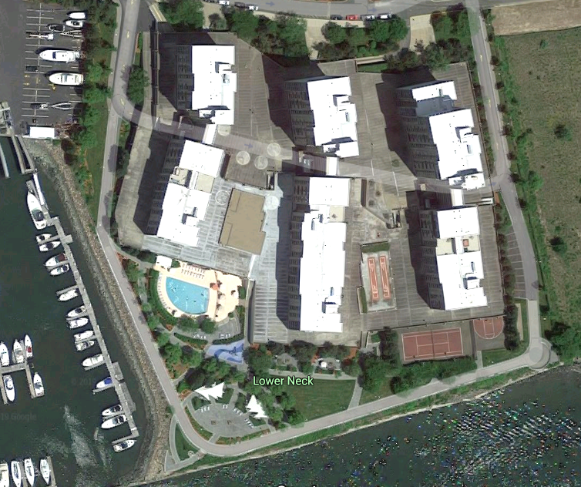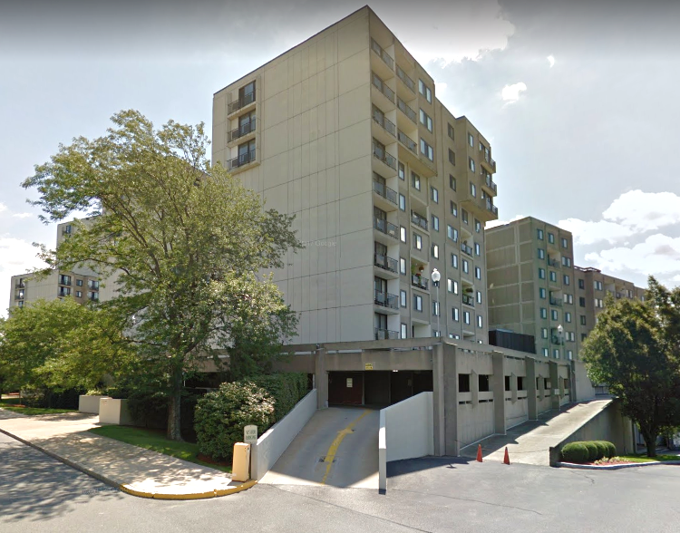
Figure 1 – Overhead view of condominium complex. Figure 2- Outside view of residential structure with parking garage below.

WEATHER
The weather at the time of the incident was approximately 74 degrees Fahrenheit, with fair skies.¹ The weather is not believed to have been a factor in this incident.

EQUIPMENT
The equipment being used at the time of the incident was a 55-horsepower gasoline-powered ride-on industrial sweeper (Figures 3 and 4). The unit had rotating brushes and a vacuum system with two stages of filters in order to collect dust. According to the manufacturer’s specifications, the sweeper was 93 inches long, 62.5 inches wide, and 58 inches tall. The 58 inch height dimension was the tallest point of the body of the sweeper located at the rear of the machine, and was approximately the height of the tallest operator control lever (Figures 3 and 4). The actual height of the tallest part of the machine involved in the incident was measured to be 64 inches. This is the height of the protective cage over the rotating strobe light that had been installed at the rear of the machine. The height of the sweeper’s floorboard was measured to be 21 inches and the height of the seat pan was 39 inches. The manufacturer offered an overhead guard for the operator’s area as an accessory for this model. Installing the overhead guard on the sweeper would have brought the sweeper’s total height to 82 inches. This would have made the sweeper too tall to operate on the second floor of the garage.
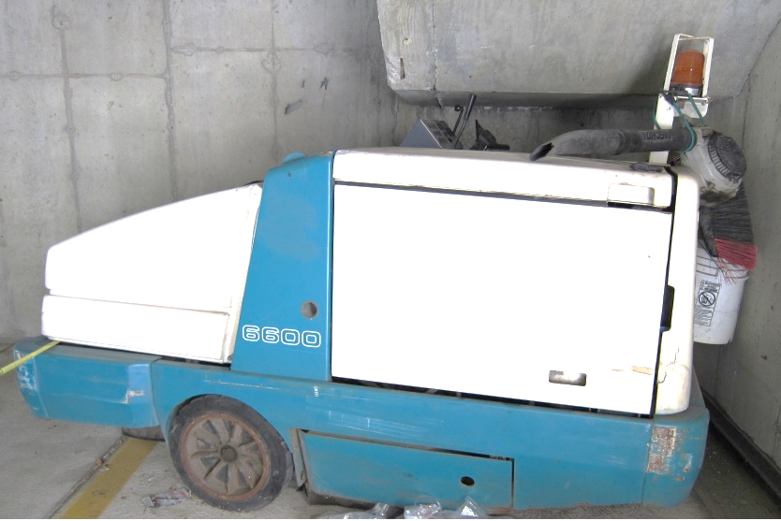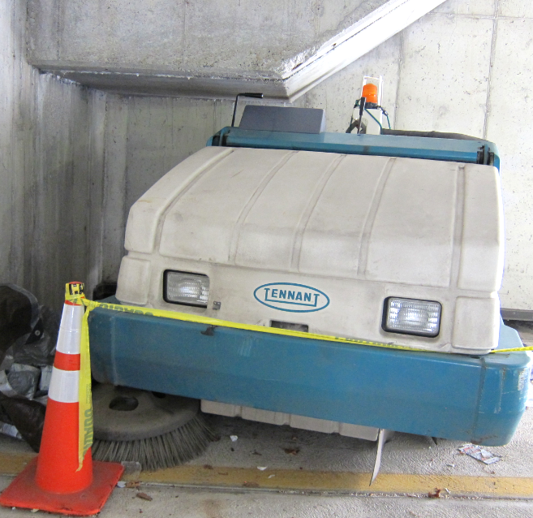
Figure 3 - Industrial sweeper, left side view. Arrow indicates height of Figure 4 – Industrial sweeper, front view.
housing and controls in relation to the height of the yellow light.
The machine weighed 3,520 pounds and had a hopper capacity of 14 cubic feet and up to 1,200 pounds. The sweeper had a main brush that was cylindrical and was 45 inches wide. The front right corner brush had a diameter of 26 inches. The sweeper brushes were linked to a hydraulic system and the brushes were lowered or raised using control levers located in the operator’s area. The hopper was raised and dumped using control levers also located in the operator’s area. The discharge height of the sweeper was up to 60 inches and the collected debris was discharged into a dumpster at the site.
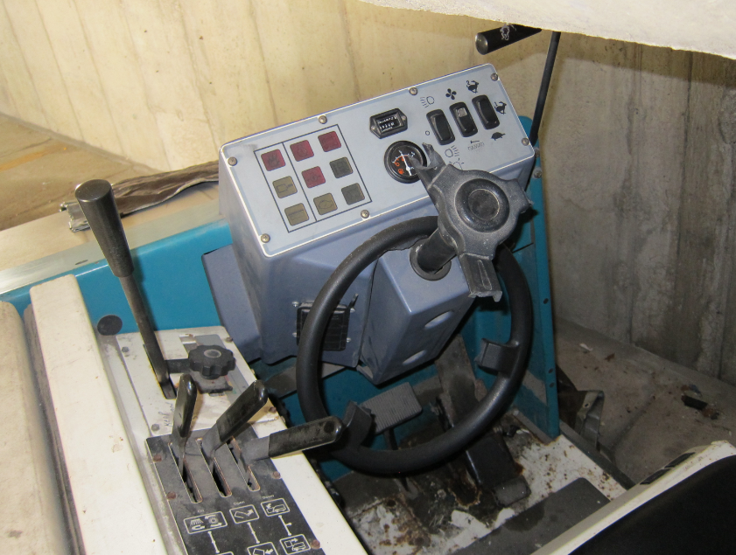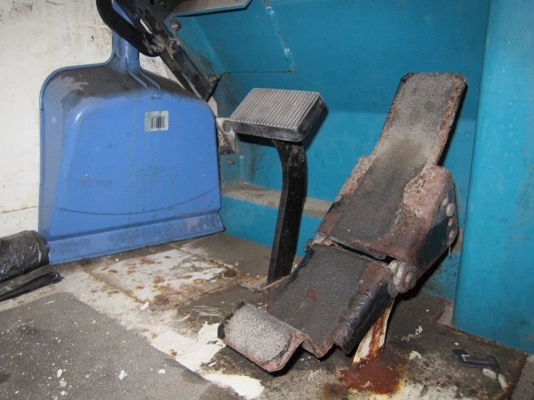
Figure 5 - Operator controls. Figure 6 – Brake pedal (left pedal) and directional pedal (right pedal).
The sweeper had a maximum ground speed of 10 mph in forward and 2.5 mph in reverse. Steering was provided by the single rear-wheel that located in the center at the rear of the machine. The sweeper had a central brake pedal and a directional pedal that controlled forward and reverse motion. The pedal was pressed with the toe to accelerate forward or pressed with the heel to move in reverse. It had an integrated heel rest to help the operator position their foot. Removing pressure on the pedal would allow it to return to neutral. This was one way to stop the machine’s motion. The brake pedal could also be used to stop the machine. A parking brake lever was located to the left of the brake pedal.
The sweeper had two external warning decals in the operator’s area that included simple messaging about reading the manual before operation and describing the toxic gas emissions and the need for ventilation. The manufacturer-developed operator’s manual detailed these hazards as well as pinch points, moving fans and belts, and hot surfaces. The manual was made available to operators and was used in training.
The unit was purchased used in 2004 from the manufacturer and was estimated to be 17 years old at the time of the incident. The operation clock was up to 650 hours at the time of the incident. The sweeper was serviced by the dealer twice each year and had been serviced the week prior to the incident and was tested and found to be operating normally.
The sweeper was used approximately every four to six weeks to clean the parking garage. The sweeper was used in conjunction with a separate gasoline-powered blower to clean both levels of the parking garage. The hand-held blower can be seen where it was stored, strapped to the top of the sweeper unit, in Figure 3. The hand blower was used to move debris out of the corners of the garage, such as the area of the garage under the stairway where the incident occurred.

INVESTIGATION
The victim arrived at the worksite to start his normal shift at around 7:00 a.m. He made rounds of the property to check for any issues and checked on the boiler room. He and the site manager were then planning to clean the garage and touch up the painted markings before an expected arrival of visitors for an Independence Day firework display the following day. The victim had the maintenance division cellular phone with him and started to clean the garage at around 10 a.m. The plan was to start the sweeping task on the second floor of the garage, in the corner where the incident occurred, while the site manager went to a supply closet on the first level to retrieve paint.
While the event was not witnessed, it appears that immediately prior to the incident the victim was operating the sweeper in reverse near the corner of the garage where the incident occurred, when the sweeper backed under the stairwell. Evidence suggests the protective housing of the strobe light scrapped along the section of the ceiling that was slanted due to the stairwell (Figure 7). The scrape line indicates the sweeper was traveling close to directly backwards, or parallel with the side wall. The operator’s seat, where the victim was located, was under the lowest part of the stairwell, which had a height of 58 inches (Figure 7).
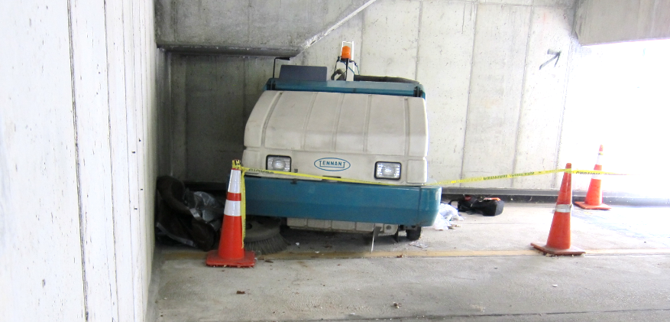
Figure 7 – Sweeper position after the victim was removed.
The sweeper continued travelling backwards and the victim became caught between the steering wheel and controls and the bottom of the stairwell. Part of the steering wheel was broken by the force of the impact and fell down near the victim’s feet. The victim’s back and then head were pressed against the underside of the stairwell.
A resident of the building entered the garage and heard the sweeper running and then noticed the brushes were still running but the sweeper was not moving and stuck in the corner. The resident approached the sweeper and discovered the worker pinned and unresponsive. The resident checked for a pulse and called 911. The time was 10:42 a.m.
Additional bystanders, police, and then rescue personnel from the fire department and nearby hospital arrived at the scene. Responders turned off the sweeper and were ultimately able to move the machine to free the victim and begin CPR. The victim was transported to the nearest hospital where he was pronounced dead approximately one hour after being found
A small gas can was found on the floor by the victim’s feet. This was the gas can for the hand-held blower. It is not believed to have interfered with the operation of the foot pedals. It is unclear how the design of the directional pedal may have contributed to the incident. It is possible the victim’s posture after becoming pinned may have prevented him from releasing downward pressure on the heel of the pedal.

CAUSE OF DEATH
The medical examiner listed the cause of death as multiple blunt traumatic injuries.

CONTRIBUTING FACTORS
Occupational injuries and fatalities are often the result of one or more contributing factors or key events in a larger sequence of events that ultimately result in the injury or fatality. The Massachusetts FACE Program identified the following contributing factors in this incident:
- Accessible areas with low height clearance;
- Absence of a protective cab on the sweeper; and
- Lack of a comprehensive safety and health program.

RECOMMENDATIONS/DISCUSSION
Recommendation #1: Employers should ensure that ride-on equipment without a protective cab is not operated in the vicinity of overhead obstructions.
Discussion: The style of sweeper used in this incident is still available for sale in used and new condition and many of the newest sweepers and smaller ride-on floor cleaners still have a cab-less design. The absence of a protective cab and operating this piece of equipment in proximity to an overhead obstruction are factors that contributed to this incident. Employers should ensure that ride-on equipment that does not have overhead protection is not operated in areas with low ceiling clearance or other overhead obstructions. Those areas should be identified through a specific job hazard analysis (Recommendation 2). Such areas could still be cleaned using the hand blower, but steps should be taken to ensure the sweeper is not operated in those areas. A physical barrier, such as a bollard/post, railing, or curbing, could be installed to prevent the equipment from entering the space. Additionally, the knowledge of this type of hazard could be made more prominent in the warning decals and training materials for the equipment.

Recommendation #2: Employers should ensure that a job hazard analysis is performed for each task assigned to employees.
Discussion: A job hazard analysis (JHA) is a technique to systematically evaluate job tasks to ensure they are performed safely. It involves identifying potential hazards and hazardous situations that could occur when performing tasks by focusing on the relationship between the worker, the task, the tools, and the work environment.² Each analysis should periodically be reviewed to help ensure that the analysis remains current and to identify any uncontrolled or potential hazards that were not previously identified. The JHA should begin by breaking down the tasks to be performed into steps, including the selection and operation of any equipment and the use of tools to complete the task. Each step should be evaluated to identify the hazards or potential hazards and the best equipment and tools to be used to safely complete the task. Information in the manufacturer operator’s manual and on the equipment’s warning labels should be reviewed. It is important to have the employees that perform the tasks participate in the JHA process. Once hazards are identified, employers should take steps to eliminate or control these hazards, such as selecting different equipment and tools or the proper personal protective equipment.
In this case, performing an initial JHA of the sweeping task would have identified potential hazards and unsafe conditions involved with operating the sweeper in proximity to areas of low clearance in the garage. The JHA would have led to removing or controlling the identified hazards, such as selecting a different sweeper or incorporating engineering controls to prevent the sweeper from entering the low clearance areas. In addition, information about the hazard would have been added to the training provided to employees on operating the sweeper.
Recommendation #3: Employers should develop and implement a comprehensive safety and health program that addresses hazard recognition, avoidance of unsafe conditions, and proper use of equipment.
Discussion: Having a safety and health program is an important part of keeping employees safe. A safety and health program should include the systematic identification, evaluation, and prevention or control of both general workplace hazards and the hazards of specific jobs and tasks. The core elements of an effective safety and health program are management leadership, worker participation, hazard identification and assessment, hazard prevention and control, education and training, and program evaluation and improvement.³ The program should outline safe work practices workers are expected to adhere to, specific safety protections for all tasks workers perform, how workers can identify and avoid hazards, and who workers should contact when safety and health issues or questions arise. The program should also include an explanation of the workers’ rights to protection in the workplace.
When developing a safety and health program, employers could start by performing a general hazard analysis (recommendation #2) of tasks routinely performed by employees. This would identify potential hazards and controls and that information would be incorporated into the comprehensive program.³ Employers should also use their employees’ expertise throughout the program development process, and eventually during the updating process, by seeking employee input. Once the program is developed, employers should ensure that they have fully and effectively implemented their safety and health program by routinely performing assessments of tasks and immediately addressing any observed unsafe conditions. The program should also be updated when safety concerns arise and when new equipment, tasks and chemicals are introduced into the workplace.
Routine training should be provided to all employees on the program’s topics and procedures and should also include hazard recognition and the avoidance of unsafe conditions. All training provided to employees should be documented. Training ensures that workers know how to safely perform required job tasks. Trainings should be performed by a competent person, which is defined by OSHA as “one who is capable of identifying existing and predictable hazards in the surroundings or working conditions which are unsanitary, hazardous, or dangerous to employees, and who has authorization to take prompt corrective measures to eliminate them.” Any training needs to be provided in the employee’s preferred language. This means the training must be provided in the language(s) and at the literacy level(s) of the employees.
The Massachusetts Department of Labor Standards (DLS) offers free consultation services to help small employers improve their safety and health programs, identify hazards, and train employees. DLS can be contacted at 508-616-0461. More information about DLS can be found on their website at www.mass.gov/dos/consult.
The Massachusetts Department of Industrial Accidents (DIA) has grants available for providing workplace health and safety training to employers and employees. Any company covered by the Massachusetts Workers’ Compensation Insurance Law is eligible to apply for these grants. More information about these DIA grants can be found on their website at www.mass.gov/dia/safety.
Recommendation #4: Equipment manufacturers should adopt and implement the concept of Prevention through Design (PtD) to identify potential hazards associated with equipment and then eliminate these hazards through design changes.
Discussion: The concept of Prevention through Design (PtD), as it would relate to equipment manufacturers, is addressing safety and health needs during the design process to prevent or minimize hazards that could result in injuries, illnesses and fatalities to equipment operators and others.⁴ Applying PtD during the design phase would initiate the process of thinking about how the machine functions in relation to the individuals who would operate, maintain, come in contact with, or interact with the machine. The goal is to identify potential hazards during these interactions. Once hazards are identified, the machine design can be altered to eliminate or control these hazards.
In this case, the manufacturer designed the base model of the sweeper involved in the incident without a protective cab and offered a cab as an additional accessory. The manufacturer offered additional sweeper models with and without protective cabs. Other manufacturers of similarly sized sweepers as well as ride-on floor cleaners also sell base models without cabs.
This base model sweeper, which is still being manufactured without an included cab, serves as an example of the potential for eliminating or minimizing injury risks through a comprehensive PtD review of the equipment. If PtD was applied to this equipment, the potential for the worker, equipment, and built environment interaction that led to the incident might have been identified and highlighted the need to redesign and/or incorporate additional engineering controls to the operator area. While the available cab accessory from the manufacturer would not have fit in this garage, a different design that still provided protection could have been designed and installed. For example, vertical posts that extended at least as high as the height of a seated operator could be installed on the front and rear or on the corners of the sweeper. If such a protective device had been installed on this machine the victim might not have been compressed. PtD could also have led to a more advanced sensing system that would detect when the sweeper comes up against a stationary object while its controls are still engaged and sound an alarm or halt the machine. This system could also incorporate additional features that detect if the equipment is stuck in a position while the controls are continuously activated for a period of time. Any alterations to equipment should be approved by the manufacturer or a registered engineer.

ADDITIONAL RESOURCES
Massachusetts FACE. Landscape Construction Laborer Compressed between Compact Excavator and Steel Beam at Residential Site—Massachusetts. https://www.mass.gov/info-details/landscape-construction-laborer-compressed-between-compact-excavator-and-steel-beam-at

DISCLAIMER
Mention of any company or product does not constitute endorsement by the National Institute for Occupational Safety and Health (NIOSH). In addition, citations to websites external to NIOSH do not constitute NIOSH endorsement of the sponsoring organizations or their programs or products. Furthermore, NIOSH is not responsible for the content of these websites. All web addresses referenced in this document were accessible as of the publication date.

REFERENCES
1. Weather Underground. Weather History. Massachusetts: TWC Product and Technology LLC.

2. OSHA. Job Hazard Analysis. Publication Number: 3071. www.osha.gov/Publications/osha3071.pdf.

3. OSHA. Recommended Practices for Safety and Health Programs. OSHA 3885. 2016. www.osha.gov/shpguidelines/

4. NIOSH. Workplace Safety & Health Topics. Prevention Through Design. www.cdc.gov/niosh/topics/ptd

