# BACKGROUND

**INDOOR AIR QUALITY**

**PRE-OCCUPANCY ASSESSMENT**

**Proposed Leicester Vocational Educational Program Building**

**70 Winslow Avenue**

**Leicester, MA**

Proposed Leicester Vocational Educational Program Building
70 Winslow Avenue
Leicester, MA


Prepared by:

Massachusetts Department of Public Health

Bureau of Climate and Environmental Health

Indoor Air Quality Program

October 2023

|  |  |
| --- | --- |
| Building: | Proposed Leicester Vocational Education Program building, former Leicester Middle School (LMS) |
| Address: | 70 Winslow Avenue, Leicester, MA |
| Assessment Requested by: | Dr. Brett Kustigian, Superintendent, Leicester Public Schools |
| Date of Pre-Occupancy Assessment: | August 25, 2023 |
| Massachusetts Department of Public Health/Bureau of Climate and Environmental Health (MDPH/BCEH) Staff Conducting Assessment: | Michael Feeney, Director, Indoor Air Quality (IAQ) Program |

# Introduction/Building Description

The LMS was originally constructed in 1962 as Leicester High School. An addition for the original structure was added to the uphill, north section of the original building. This wing contains classrooms that were designed for vocational education programs including a garage. This wing also contains a gymnasium, cafeteria/kitchen, and other classrooms. This assessment was limited to classrooms and areas that are intended for use for the newly established vocational technical (VocTech) educational program, which includes the garage, classrooms 16 to 18, as well as hallways.

# Previous Relevant Environmental History

No current/active Massachusetts Contingency Plan projects for this building or property were found in the Massachusetts Department of Environmental Protection database.

# The IAQ Program assessed the entire LMS complex in 2021, at which time recommendations were made regarding the entire building. The report from that assessment can be found at: <https://www.mass.gov/info-details/indoor-air-quality-reports-cities-and-towns-l#leicester->.

# METHODS

Please refer to the IAQ Manual for methods, sampling procedures, and interpretation of results (MDPH, 2015). The following table is a summary of indoor air testing results. BCEH/IAQ staff also performed visual inspection of building materials for water damage and/or microbial growth and examined the space for the presence of odors or other environmental concerns.

# RESULTS AND DISCUSSION

| **Media sampled** | | **MDPH Guideline/**  **Comparison Value** | | **Measured Range** | | | **Comments** | |
| --- | --- | --- | --- | --- | --- | --- | --- | --- |
| **Outdoors/**  **Background** | | **Indoors** |
| Carbon Dioxide (CO2) | | < 800 parts per million (ppm) is preferred | | 353 | | 363-406 | HVAC operating, unoccupied | |
| Total Volatile Organic Compounds (TVOCs) | | Equal to or below background level measured | | ND | | ND | New carpeting and painting, no odors detected | |
| Carbon Monoxide (CO) | | Non-detectable (ND) or equal to or below background level measured | | ND | | ND |  | |
| Particulate Matter 2.5 (PM2.5) | | US EPA National Ambient Air Quality Standards (NAAQS) 35 μg/m3 or less | | 5 | | 5-6 | Areas were clean and free of dust and debris | |
| Temperature | | 70 to 78ºF | | 65 | | 71-81 | Garage had high temperature | |
| Relative Humidity (RH) | | 40% to 60% | | 93 | | 70-81 | Garage had highest relative humidity standing water on floor.  no temperature controls | |
| ppm = parts per million | µg/m3 = microgram per cubic meter | | ND = non-detectable | |  | | |

The northwest portion of the LMS contained former shop classrooms and a garage currently used by the Town of Leicester. These classrooms and garage were added to ground that is uphill from the original building (Picture 1). The heating, ventilation, and air-conditioning (HVAC) system is configured in a different manner than the original building since air intakes are located above ground level except in one location (Picture 2). In addition, unlike classrooms in the original building, water-damaged wood covering heating pipes is not present in these areas.

Walls are constructed from painted cement block (Picture 3). The wall construction and HVAC system intakes are configured in a manner to limit water vapor intake from pooling water, unlike many locations (e.g., the garage doors).

At the time of assessment, interior renovations were in progress. New flooring was being installed. The MDPH typically recommends wet-wiping surfaces and high-efficiency particulate arrestance (HEPA) vacuuming multiple times prior to occupancy. Additional cleaning once files, materials, and furniture have been transported into the building will help remove any dust, debris and moisture brought in from outside during the move.

No water-damaged or moist materials were observed in any proposed classrooms during the assessment. However, the garage contains walls that are constructed from gypsum wallboard, which had visible mold (Picture 4). The use of gypsum wallboard in an unconditioned space is not recommended, particularly in a location that appears to experience standing water.

Standing water was also noted along some areas along the exterior walls of the proposed VocTech classrooms. Standing water may cause damage to cement slab/foundation over time.

# RECOMMENDATIONS

Based on the observations made during this assessment, use of the areas examined would be appropriate for the proposed VocTech Program. Management of buildings that do not have the means to provide air conditioning during hot, humid weather can be challenging. The following documents can provide guidance that can be used to reduce the impact of hot, humid weather in buildings.

* Preventing mold growth in Massachusetts schools during hot, humid weather: <https://www.mass.gov/service-details/preventing-mold-growth-in-massachusetts-schools-during-hot-humid-weather>
* Remediation and prevention of mold growth and water damage in public schools and buildings to maintain air quality: <https://www.mass.gov/service-details/remediation-and-prevention-of-mold-growth-and-water-damage-in-public-schools-and-buildings-to-maintain-air-quality>.
* Methods for increasing comfort in non-air-conditioned schools: <https://www.mass.gov/doc/methods-for-increasing-comfort-in-non-air-conditioned-schools/download>.

In view of the findings at the time of the visit, the following recommendations are provided:

1. Remove water-damaged gypsum wallboard in the garage in a manner consistent with the US EPA guidelines, Mold Remediation in Schools and Commercial Buildings. Available at: <http://www.epa.gov/mold/mold-remediation-schools-and-commercial-buildings-guide>
2. For any activity that may produce dust, fumes, vapor or gas, ensure there is an appropriate exhaust ventilation system installed and maintained.
3. Improve drainage on the garage to prevent standing water.
4. Improve water drainage around exterior walls of the proposed VocTech classrooms. Prevention of standing water near the fresh air intake in Picture 2 is highly recommended. Consider reconfiguring the air intake to draw air at least one foot above the ground.
5. Change filters for HVAC equipment prior to occupancy, and additionally 2-4 times a year using the highest Minimum Efficiency Reporting Value (MERV) rating the building’s ventilation system can accommodate to improve air filtration as much as possible without significantly reducing airflow.
6. If the HVAC system has not been balanced prior to this assessment, consider balancing the system after move-in and every five years (SMACNA, 1994).
7. Upon completion of renovations and moving, perform a final, thorough cleaning of the space including wet wiping of all surfaces and use of a HEPA vacuum of all carpeting prior to staff moving into the space.
8. Consistent with previously established protocol, once the space has been occupied for a minimum of three weeks, contact the BEH/IAQ Program to conduct a follow-up assessment of the space.

# REFERENCES

SMACNA. 1994. HVAC Systems Commissioning Manual. 1st ed. Sheet Metal and Air Conditioning Contractors’ National Association, Inc., Chantilly, VA.

MDPH. 2015. Massachusetts Department of Public Health. “Indoor Air Quality Manual: Chapters I-III”. Available at: [Indoor air quality - manual and appendices | Mass.gov](https://www.mass.gov/lists/indoor-air-quality-manual-and-appendices)

**Picture 1**

LMS section reported to contain proposed vocational education programs
(northwest portion of LMS complex)


**LMS section reported to contain proposed vocational education programs**

**(northwest portion of LMS complex)**

**Picture 2**

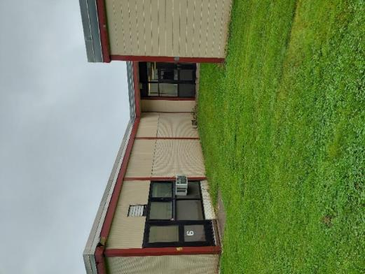

**Ground level fresh air intake (arrow)**

**Picture 3**

Exterior walls are painted cement block
Note standing water


**Exterior walls are painted cement block, note standing water**

**Picture 4**

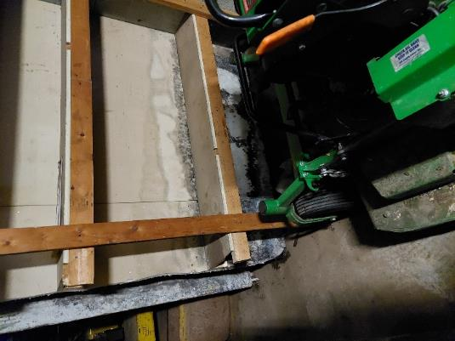

**Mold-colonized gypsum wallboard in garage**