INDOOR AIR QUALITY ASSESSMENT
OF
PROPOSED OFFICE SITE FOR

ESSEX COUNTY REGISTRY OF DEEDS

45 Congress Street
Shetland Park
Salem, Massachusetts 01970

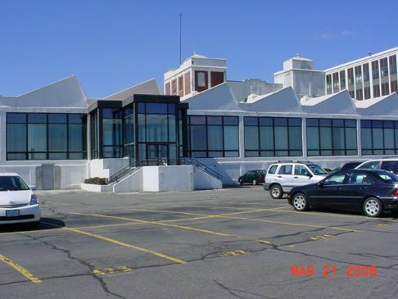

Prepared by:
Massachusetts Department of Public Health
Bureau of Environmental Health
Indoor Air Quality Program
April 2008

Background/Introduction
At the request of Bruce Tebo, Division of Capital Asset Management, the Massachusetts Department of Public Health (MDPH), Bureau of Environmental Health (BEH) provided assistance and consultation regarding indoor air quality concerns at 45 Congress Street, Shetland Park, Salem, Massachusetts. On March 21, 2008, a visit was made to this building by Mike Feeney, Director, and Susan Koszalka, Inspector, in BEH’s Indoor Air Quality (IAQ) Program.
The office space has undergone a complete renovation and is currently unoccupied. The Essex County Registry of Deeds is scheduled to move into this space in Spring 2008. The office space exists on a single floor that faces Salem Harbor. Windows in the office space are openable.

Methods
The evaluation consisted primarily of a site/visual inspection. Air tests for carbon monoxide, temperature and relative humidity were conducted with the TSI, Q-TRAK™ IAQ Monitor, Model 8551. BEH staff also performed a visual inspection of building materials for water damage and/or microbial growth.

Discussion
As mentioned previously, the office space was renovated and currently unoccupied. The Essex County Registry of Deeds is scheduled to move into this office space in Spring 2008. The following is a discussion of the conditions observed at this building at the time of the assessment.

Ventilation
Air-handling units (AHUs) provide fresh air to the office space. AHUs are electrically powered and located within the ceiling plenum of the building (Pictures 1 and 2). These units appear to be operating normally; however, water-stained ceiling tiles were observed beneath the AHUs.

Microbial/Moisture Concerns
Several areas had water-damaged ceiling tiles which can indicate sources of water penetration (Table 1). Water-damaged ceiling tiles were observed under the AHUs and within the loading dock area adjacent to the office space. Water-damaged ceiling tiles were also noted in a hallway and a restroom. Water-damaged ceiling tiles can provide a source of mold and should be replaced after a water leak is discovered and repaired.
The US Environmental Protection Agency (US EPA) and the American Conference of Governmental Industrial Hygienists (ACGIH) recommend that porous materials be dried with fans and heating within 24 to 48 hours of becoming wet (US EPA, 2001; ACGIH, 1989). If not dried within this time frame, mold growth may occur. Once mold has colonized porous materials, they are difficult to clean and should be removed/discarded.
The front of the building contains a newly installed exterior door providing access to the building for the disabled (Picture 3). The threshold of this door (Picture 4) should be configured to prevent water penetration through the door frame during periods of wind-driven rains. Install weather stripping around exterior doors to prevent drafts, water penetration and pest entry.
The floor of the office space is massive slabs with concrete-filled gaps (Picture 5). BEH staff could not identify any locations in the floor that would serve as a migration route for odors and/or moisture to travel into the occupied space from below floor locations.

Other Concerns
Indoor air quality can be negatively influenced by the presence of respiratory irritants, such as products of combustion. Carbon monoxide is a by-product of incomplete combustion of organic matter (e.g., gasoline, wood and tobacco). Exposure to carbon monoxide can produce immediate and acute health affects. Several air quality standards have been established to address carbon monoxide and prevent symptoms from exposure to these substances. The MDPH established a corrective action level concerning carbon monoxide in ice skating rinks that use fossil-fueled ice resurfacing equipment. An operator of an indoor ice must take actions to reduce carbon monoxide levels, if those levels exceed 30 ppm, 20 minutes after resurfacing within a rink (MDPH, 1997).
The American Society of Heating Refrigeration and Air-Conditioning Engineers (ASHRAE) has adopted the National Ambient Air Quality Standards (NAAQS) as one set of criteria for assessing indoor air quality and monitoring of fresh air introduced by HVAC systems (ASHRAE, 1989). The NAAQS are standards established by the US EPA to protect the public health from six criteria pollutants, including carbon monoxide and particulate matter (US EPA, 2006). As recommended by ASHRAE, pollutant levels of fresh air introduced to a building should not exceed the NAAQS levels (ASHRAE, 1989). The NAAQS were adopted by reference in the Building Officials & Code Administrators (BOCA) National Mechanical Code of 1993 (BOCA, 1993), which is now an HVAC standard included in the Massachusetts State Building Code (SBBRS, 1997). According to the NAAQS, carbon monoxide levels in outdoor air should not exceed 9 ppm in an eight-hour average (US EPA, 2006).
Carbon monoxide should not be present in a typical, indoor environment. If it is present, indoor carbon monoxide levels should be less than or equal to outdoor levels. Outdoor carbon monoxide concentrations were non-detect (ND) (Table 1). Carbon monoxide levels measured in the building were also ND (Table 1). While CO was ND, potential for vehicle exhaust entering the building exists due to the parking area located beneath office windows (Picture 6). Office windows should be kept closed to prevent this contingency.
Renovations can result in an accumulation of odors from new installed building furnishings (e.g., carpet, lacquered counters, etc.). “Because carpet systems off-gas when new, carpet is a potential source of indoor air pollution. Typically, most volatile organic compounds (VOCs) are emitted from the backing, adhesive, and seam sealer rather than from the wear layer” (CHPS, 2002). New carpet odor and construction debris can be irritating to the eyes, nose and respiratory system. It is recommended that carpeting be allowed to off gas prior to occupancy and a vacuum cleaner equipped with a high efficiency particle arrestance (HEPA) filter be used to remove accumulated debris (SMACNA, 1995).
The CHPS provides the following recommendations for reducing the amount of odors associated with newly installed carpet:
- “Air out space(s) where carpet has been installed for a minimum of 72 hours. With a central HVAC system, the ventilation supply should be on, the return grille(s) sealed, and windows open.
- Extra ventilation should continue for a minimum of 72 hours after installation” (CHPS, 2002).
Since the office is not planned for occupancy until late May, each of these recommendations can be readily accomplished prior to the move.

Recommendations
- Remediate the water damage noted and replace ceiling tiles.
- Clean the space with a HEPA filter vacuum prior to occupancy.
- Provide adequate amount of time to ventilate the office to remove residual renovation odors.
- Refrain from opening windows to prevent vehicle exhaust entrainment.
- Examine options to prevent water penetration through the access door.
References
ACGIH. 1989. Guidelines for the Assessment of Bioaerosols in the Indoor Environment. American Conference of Governmental Industrial Hygienists, Cincinnati, OH.
ASHRAE. 1989. Ventilation for Acceptable Indoor Air Quality. American Society of Heating, Refrigeration and Air Conditioning Engineers. ANSI/ASHRAE 62-1989

BOCA. 1993. The BOCA National Mechanical Code-1993. 8th ed. Building Officials & Code Administrators International, Inc., Country Club Hills, IL. M-308.1

CHPS. 2002. CHPS Best Practices Manual 2002 Interior Surfaces. Collaborative for High Performance Schools, San Francisco, CA. www.chps.net/manual/documents/2002_updates/IntSurf.pdf

SBBRS. 1997. Mechanical Ventilation. State Board of Building Regulations and Standards. Code of Massachusetts Regulations. 780 CMR 1209.0

SMACNA. 1995. IAQ Guidelines for Occupied Buildings Under Construction. 1st ed. Sheet Metal and Air Conditioning Contractors’ National Association, Inc., Chantilly, VA.

US EPA. 2001. Mold Remediation in Schools and Commercial Buildings. US Environmental Protection Agency, Office of Air and Radiation, Indoor Environments Division, Washington, D.C. EPA 402-K-01-001. March 2001.

US EPA. 2006. National Ambient Air Quality Standards (NAAQS). US Environmental Protection Agency, Office of Air Quality Planning and Standards, Washington, DC. http://www.epa.gov/air/criteria.html.

Picture 1

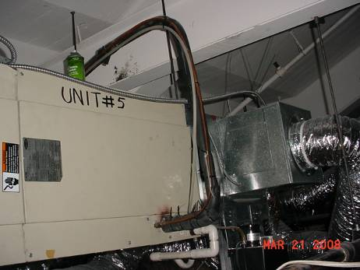

AHU in Ceiling Plenum

Picture 2

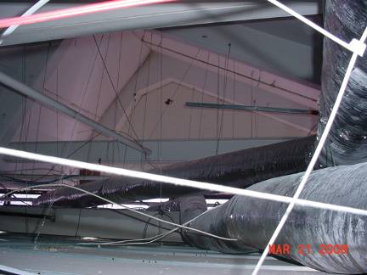

Ductwork above Ceiling

Picture 3

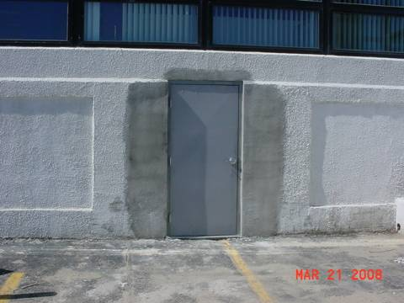

Newly Installed Door to Provide Access to the Building for the Disabled

Picture 4

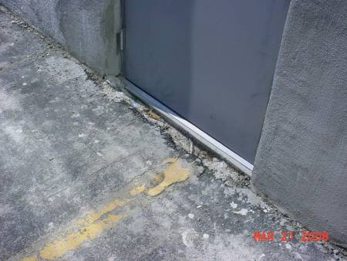

Threshold of Door in Picture 3
Picture 5

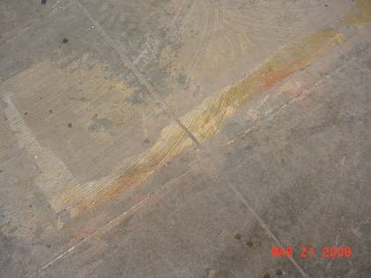

Cement Floor beneath Carpeting

Picture 6

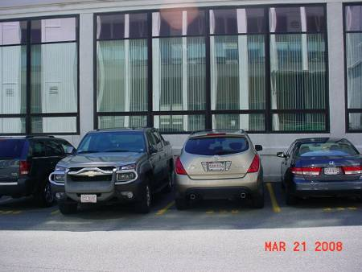

Parking beneath Office Windows
Location | Temp  (°F) | Relative  Humidity  (%) | Carbon Monoxide  (ppm) | Windows  Openable | Ventilation |  | Remarks
 |  |  |  |  | Supply | Exhaust | Remarks
GIS Office 1 | 64 | 25 | ND | Y | Y | Y
GIS 1 | 64 | 27 | ND | Y | Y | Y
Scanning 1 | 64 | 27 | ND | Y | Y | Y
IT Office | 64 | 27 | ND | N | Y | Y
Microfilm Lab | 63 | 29 | ND | N | Y | Y
Janitor | 64 | 29 | ND | N | Y | Y | Electric water heater
NDP (Computer) | 65 | 33 | ND | N | Y | Y
Sheriff’s Office | 64 | 30 | ND | N | Y | Y
Office/Conference (Sheriff) | 64 | 31 | ND | N | Y | Y
Office 2-6 | 64 | 30 | ND | N | Y | Y
Office 01-8 | 64 | 30 | ND | N | Y | Y
Reception | 64 | 30 | ND | N | Y | Y
Files | 64 | 30 | ND | N | Y | Y

Location | Temp  (°F) | Relative  Humidity  (%) | Carbon Monoxide  (ppm) | Windows  Openable | Ventilation |  | Remarks
 |  |  |  |  | Supply | Exhaust | Remarks
Common Area Restroom | 64 | 28 | ND | N | Y | Y | Restroom exhaust
Common Area | 65 | 29 | ND | Y | Y | Y
Storage | 65 | 28 | ND | N | Y | N
Engineering | 65 | 26 | ND | N | Y | Y
Staff Room | 65 | 25 | ND | N | Y | Y
Café | 66 | 23 | ND | Y | Y | Y | Tile floor
Recorded Land Recording | 66 | 25 | ND | Y | Y | Y
Land Court Recording | 66 | 25 | ND | N | Y | N
Land Court Documents | 66 | 25 | ND | N | Y | Y
Land Court Public Books | 66 | 25 | ND | N | Y | Y
Plan Room | 66 | 25 | ND | N | Y | Y | Uncovered floor/cement slab
Men’s Room | 65 | 27 | ND | N | Y | N | 2 water damaged ceiling tiles
Women’s Room | 65 | 27 | ND | N | Y | N
3rd Assistant | 65 | 27 | ND | N | Y | Y
Office | 65 | 27 | ND | N | Y | Y
Copy/Fax | 65 | 27 | ND | N | Y | Y
Tech Assistance 2 | 65 | 27 | ND | N | Y | Y

Please note these actions should be done prior to occupancy and during a period of time of favorable weather

