DATA REPORT
Prostate Cancer in Massachusetts: 2014-2018
Released: November 2023

Purpose
This report presents descriptive data on prostate cancer incidence and mortality among Massachusetts residents. Incidence refers to the number of people newly diagnosed with prostate cancer, while mortality refers to the number of people who have died from the disease. This report summarizes prostate cancer incidence and mortality in Massachusetts by race/ethnicity, age, stage, and county and compares rates to the rest of the United States. Many of the analyses reported here focus on the most recently available data from the Massachusetts Cancer Registry, covering the period 2014-2018. However, the report also presents incidence and mortality rates over the past two decades.
Prostate cancer is the most common type of cancer for men in both Massachusetts and the United States. The US Preventive Services Task Force (USPSTF) recommends that “for men aged 55 to 69 years the decision to undergo periodic prostate-specific antigen (PSA) -based screening for prostate cancer should be an individual one and should include discussion of the potential benefits and harms of screening with their clinician” for prostate cancer. However, screening should only be conducted following a discussion by men and their providers of the pros and cons of prostate cancer screening using the PSA (shared decision-making). Therefore, this report also presents Massachusetts prostate cancer screening shared decision-making data from the Behavioral Risk Factors Surveillance System (BRFSS) and includes some lifestyle and screening recommendations.
The report begins by highlighting some key findings from this data review and then presents a detailed summary of prostate cancer incidence and mortality in Massachusetts. Technical details and definitions of terms (e.g., age-adjusted rates, age-specific rates) are included at the end of the report, along with a summary of data sources.

Key points
- Prostate cancer was the most commonly diagnosed cancer among men in Massachusetts during 2014-2018 (Table 1). It was also the second leading cause of cancer death for Massachusetts men (Table 2).
- During this time, age-adjusted incidence and mortality rates in Massachusetts were slightly higher than in the U.S., but the difference was not statistically significant (Table 3).
- Over the past two decades, prostate cancer incidence and mortality rates in Massachusetts have steadily declined (Figures 1 and 2).
- From 2014-2018, the prostate cancer incidence rate was highest among Black non-Hispanic men (over one and half times higher than among White non-Hispanic men), followed by White non-Hispanic men, Asian non-Hispanic men, and Hispanic men (Figure 5).
- The prostate cancer mortality rate among Black non-Hispanic men was two times higher than among White non-Hispanic men between 2014 and 2018 (Figure 6).
- Prostate cancer incidence and mortality rates increase with age (Figure 7). Most men diagnosed with prostate cancer have a long survival rate, with the highest prostate cancer mortality rate occurring in the 80-84 years and 85-plus age groups.
- In 2018, over four in ten (45.0%) Massachusetts men 40 years and older reported that they talked to their provider about the advantages of prostate cancer screening using the PSA test.
- Over one in four (27.2%) of Massachusetts men 40 years and older reported that they talked to their provider about the disadvantages of prostate cancer screening using the PSA test.

Prostate cancer compared with other cancers
Table 2. Total deaths and percentage of all deaths for
the five most common causes of cancer deaths, Massachusetts, 2014-2018
Cancer Site | Deaths | Percent
Lung and Bronchus | 7,809 | 24.0
Prostate | 3,135 | 9.6
Colon and Rectum | 2,480 | 7.6
Pancreas | 2,406 | 7.4
Liver & intrahepatic Bile Duct | 1,924 | 5.9
Data Source: Massachusetts Registry of Vital Record and Statistics

Table 1. Total incident cases and percentage of all incident cases for the five most commonly diagnosed cancers, Massachusetts, 2014-2018
Cancer Site | Cases | Percent
Prostate | 22,432 | 24.1
Lung and Bronchus | 12,198 | 13.1
Colon and Rectum | 7,311 | 7.8
Urinary Bladder | 6,932 | 7.4
Melanoma | 4,934 | 5.3
Data Source: Massachusetts Cancer Registry

New cases

- Prostate cancer was the most common cancer diagnosis in Massachusetts men overall between 2014 and 2018, accounting for almost a quarter (24.1%, n=22,432) of all men (93,246) in Massachusetts who were diagnosed with cancer (an average of 4,486 total prostate cancer cases per year).
- Prostate cancer was also the leading cause of cancer in Black non-Hispanic, White non-Hispanic, Asian non-Hispanic, and Hispanic men.
- Other leading cancers in Massachusetts men included lung and bronchus (13.1%), colon and rectum (7.8%), urinary bladder (7.4%), and melanoma of the skin (5.3%).

Deaths
- Prostate cancer was the second leading cause of cancer death in Massachusetts men overall between 2014 and 2018, accounting for one in ten (9.6%, n=3,135) of all cancer deaths in Massachusetts men (an average of about 627 total prostate cancer deaths per year).
- Prostate cancer was also the leading cause of cancer deaths in Black non-Hispanic men, the second leading cause of cancer deaths in White non-Hispanic and Hispanic men, and sixth among Asian non-Hispanic men.
- Other leading causes of cancer deaths in Massachusetts men included colon and rectum (7.6%), pancreas (7.4%), and liver and intrahepatic bile duct (5.9%).

Prostate cancer in Massachusetts compared to the U.S.
Table 3: Prostate Cancer Incidence and Mortality Rates. Massachusetts and US, 2014-2018
 | Incidence Rate* | Mortality Rate*
Massachusetts | 108.4 | 18.5
United States | 106.2 | 18.9
Data Source: Massachusetts Cancer Registry, CDC Cancer Profiles
*Age-adjusted Rate Per 100,000

- The age-adjusted incidence rate of prostate cancer in Massachusetts men was 108.4 per 100,000 between 2014 and 2018.
- During the same period, the age-adjusted incidence rate of prostate cancer in U.S. men was 106.2 per 100,000.
- Between 2014 and 2018, the age-adjusted mortality rate of prostate cancer was 18.5 per 100,000 and 18.9 per 100,000 in Massachusetts and U.S. men, respectively.
- There was no significant difference in prostate cancer incidence and mortality rates between Massachusetts and the United States during this period.

Prostate cancer incidence trends

Data Source: Massachusetts Cancer Registry, SEER*Stat
- Between 2000 and 2018, the overall annual prostate cancer incidence rates significantly decreased by an average of 3.6% per year.
- The annual prostate cancer incidence rates significantly decreased for all racial/ethnic groups in Massachusetts men between 2000 and 2018.
- Prostate cancer incidence rates were significantly higher in Black non-Hispanic men than in other racial/ethnic groups during this period.
- Although there was a significant decrease in prostate cancer incidence rates per year from 2000-2018, the gap in incidence rates between Black non-Hispanic and White non-Hispanic men remained wide.
- In 2000, the age-adjusted prostate cancer incidence rates were 293.6 per 100,000 and 186.4 per 100,000 among Black non-Hispanic and White non-Hispanic men, respectively, or 1.6 times higher among Black non-Hispanic men.
- Although incidence rates were significantly lower in both Black non-Hispanic (185.0 per 100,000) and White non-Hispanic men (107.1 per 100,000) in 2018 compared to 2000, the prostate cancer incidence rate among Black non-Hispanic men was 1.7 times higher than in White non-Hispanic men.
- Incidence rates for White non-Hispanic men were similar to Massachusetts' overall rate.
- Asian non-Hispanic men had the lowest prostate cancer incidence rates between 2000 and 2018.

Prostate cancer mortality trends

Data Source: Massachusetts Registry of Vital Records and Statistics, SEER*Stat
Note: Mortality trends for Asian non-Hispanic and Hispanic men could not be calculated due to small numbers.
- As with incidence, the overall prostate cancer mortality rate in Massachusetts significantly decreased by an average of 3.1% per year between 2000 and 2018.
- Prostate cancer mortality rates in Massachusetts significantly decreased annually for White non-Hispanic (an average of 3.2% per year) and Black non-Hispanic (an average of 3.0% per year) men in 2000 and 2018.

Figure 3. Age-adjusted prostate cancer incidence in the United States, 2014-2018
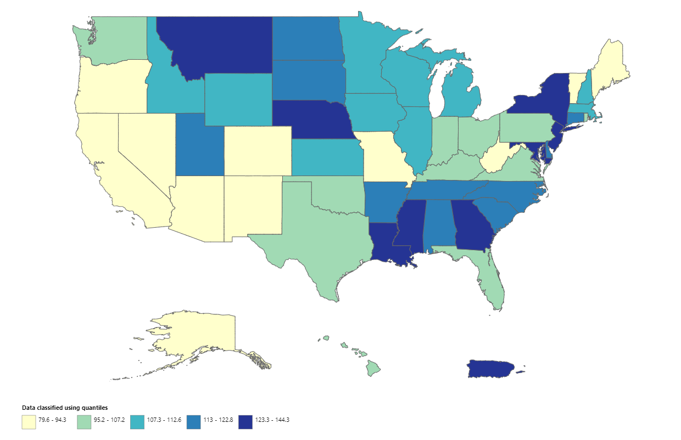
Data Source: United States Cancer Statistics - Incidence: 1999 - 2018, WONDER Online Database. United States Department of Health and Human Services, Centers for Disease Control and Prevention and National Cancer Institute; 2021.
Accessed at: http://wonder.cdc.gov/cancer-v2018.html.
- Between 2014 and 2018, the overall prostate cancer incidence rate in Massachusetts men was 108.4 per 100,000, compared to 106.2 per 100,000 for the U.S. as a whole.
- During this period, Massachusetts had the twenty-fourth lowest incidence rate for prostate cancer in the United States.

Figure 4. Age-adjusted prostate cancer mortality in the United States, 2014–2018
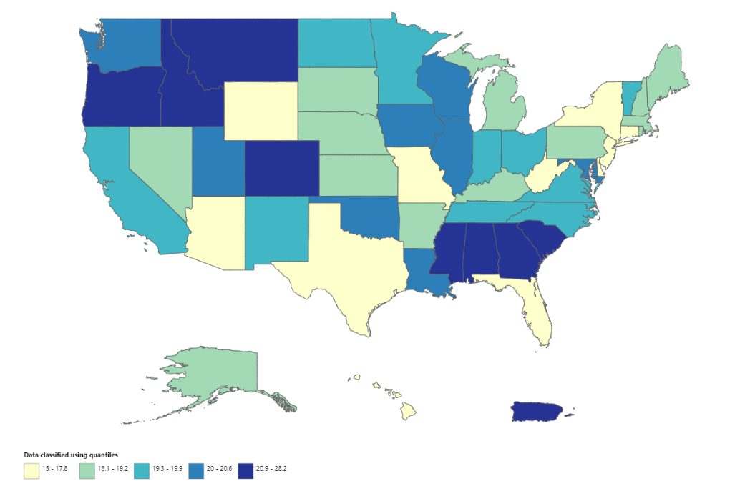
Data Source: United States Cancer Statistics - Mortality: 1999 - 2018, WONDER Online Database. United States Department of Health and Human Services, Centers for Disease Control and Prevention; 2021.
Accessed at: http://wonder.cdc.gov/CancerMort-v2018.html.
- Between 2014 and 2018, the overall prostate cancer mortality rate in Massachusetts men was 18.5 per 100,000, compared to 18.9 for the U.S. as a whole.
- During this period, the prostate cancer mortality rate in Massachusetts men was the fourteenth lowest in the United States.

Patterns in prostate cancer by race/ethnicity

Data Source: Massachusetts Cancer Registry
- The age-adjusted prostate cancer incidence rate in Massachusetts between 2014 and 2018 was 108.4 per 100,000.
- The highest prostate cancer incidence rate was observed among Black non-Hispanic men's, followed by White non-Hispanic men, Hispanic men, and Asian non-Hispanic men.
- Black non-Hispanic men were almost 2 times more likely to be diagnosed with prostate cancer than White non-Hispanic men.
- Asian non-Hispanic men had the lowest prostate cancer incidence rate (55.6 per 100,000).

Data Source: Massachusetts Registry of Vital Records and Statistics
- The overall age-adjusted prostate cancer mortality rate in Massachusetts between 2014 and 2018 was 18.5 per 100,000.
- The highest prostate cancer mortality rates among Massachusetts men were observed among Black non-Hispanic men's, followed by White non-Hispanic men, Hispanic men, and Asian non-Hispanic men.
- The prostate cancer mortality rate among Black non-Hispanic men was more than double that of White non-Hispanic men (37.8 per 100,000 vs. 18.1 per 100,000, respectively).
- Asian non-Hispanic men had the lowest prostate cancer mortality rate (6.8 per 100,000) compared to other racial/ethnic groups.
Patterns in prostate cancer incidence by age

Data source: Massachusetts Cancer Registry

- Prostate cancer age-specific incidence rates begin to greatly increase after the 45-49 years age group (28.7 per 100,000), continue to increase until they reach the highest rates among those aged 60-64 years (607.4 per 100,000) and 70-74 years (639.6 per 100,000), and then begin to decrease after the age of 75 years.

Patterns of prostate cancer by stage at diagnosis
Table 4. Percentage of new prostate cancer cases by stage at diagnosis, Massachusetts, 2014-2018
Stage at diagnosis | Percent | N
Local (confined to the organ where it began) | 72.6 | 16,281
Regional (spread to some nearby areas) | 15.8 | 3,539
Distant (spread into other parts of the body) | 7.1 | 1,593
Unknown (a stage is not assigned) | 4.5 | 1,019
Data source: Massachusetts Cancer Registry

- The majority of prostate cancer cases in Massachusetts were diagnosed at either a local or regional stage from 2014-2018.
- According to the American Cancer Society, prostate cancer is >99% survivable when found early (when diagnosed at a local or regional stage).

Data source: Massachusetts Cancer Registry

- In all racial/ethnic groups, the majority of prostate cancer cases (over seven in ten) in Massachusetts were diagnosed at a local stage between 2014 and 2018.

- Black non-Hispanic and Hispanic men had a higher percentage of cases (8.1%) and (8.2%) diagnosed at the distant stage, compared to White non-Hispanic and Asian non-Hispanic men. However, the differences were not statistically significant.

Patterns of prostate cancer by county
Figure 9. Age-Adjusted Prostate Cancer Incidence Rates in Massachusetts, 2014-2018
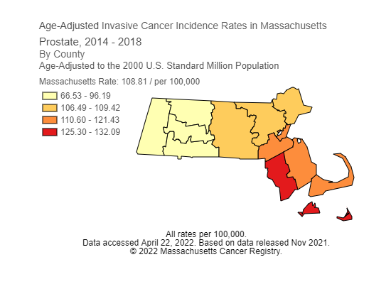
Data source: Massachusetts Cancer Registry
- Prostate cancer incidence in Massachusetts varied by county, with the highest age-adjusted incidence rates between 2014-2018 in Bristol, Dukes (Martha’s Vineyard), and Nantucket counties.
- The lowest prostate cancer incidence rates were in Franklin, Hampshire, Hampden, and Berkshires counties.
- It is not clear why prostate cancer incidence and mortality rates vary by county. Possible reasons for differences in incidence and mortality rates for prostate and other cancers include patterns of risk behaviors, demographics, healthcare access, and social determinants of health.

Figure 10. Age-Adjusted Prostate Cancer Mortality Rates in Massachusetts, 2015-2019
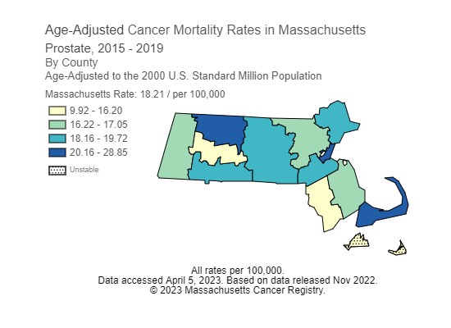
Data source: Massachusetts Registry of Vital Records and Statistics
- Prostate cancer mortality in Massachusetts varied by county, with the highest age-adjusted incidence rates between 2015-2019 in Barnstable, Suffolk, and Franklin counties.
- The lowest prostate cancer mortality rates were in Hampshire and Bristol counties.

Prostate cancer screening shared decision-making

Data source: Massachusetts BRFSS

Data source: Massachusetts BRFS

Data source: Massachusetts BRFSS
- In 2018, over four in ten (45.0%) of Massachusetts men 40 years and older reported that they talked to their provider about the advantages of the prostate cancer screening using the prostate-specific antigen (PSA) test. In contrast, only 27.2% reported that they talked to their provider about the disadvantages of prostate cancer screening using the PSA test from 2016-2018, and 22.3% talked to their provider about both the advantages and disadvantages of prostate cancer screening using the PSA.
- White non-Hispanic men were more likely to report talking to their provider about the advantages (48.4%) and disadvantages (28.4%) of prostate cancer screening than other racial/ethnic groups.
- Black non-Hispanic and Hispanic men were less likely to report talking to their provider about the advantages and disadvantages of prostate cancer screening than White non-Hispanic men.
Discussion and implications for prevention
- As detailed in this report, prostate cancer is the most common cancer diagnosed in Massachusetts men and the second leading cause of cancer deaths in Massachusetts men. Prostate cancer incidence rates have declined steadily in Massachusetts over the past 20 years, and the rates for 2014-2018 are similar between Massachusetts and the rest of the nation.
- Prostate cancer becomes more common as men age, with a considerable increase starting between the ages of 60 and 64, and the highest incidence rates occurring in the 70-74 years age group.
- Prostate cancer is highly curable if it is found and treated early. Most men in Massachusetts with prostate cancer were diagnosed at either a local or regional stage.
- Although prostate cancer affects men from all racial/ethnic groups in Massachusetts, the disease is most common among Black non-Hispanic men compared to White non-Hispanic, Hispanic, or Asian non-Hispanic men.
- Many risk factors for prostate cancer, including age, race, and family history, cannot be controlled. As a result, there is no sure way to prevent prostate cancer, but some measures to reduce the risk of prostate cancer are listed below.

Lifestyle recommendations

- There are no proven ways to prevent prostate cancer. However, a few healthy lifestyle choices might reduce the risk of prostate cancer. According to the American Cancer Society, the best advice about diet and physical activity to possibly reduce the risk of prostate cancer is to:

  - Get to and stay at a healthy weight.
  - Keep physically active.
  - Follow a healthy eating pattern, which includes a variety of colorful fruits and vegetables and whole grains, and avoid or limit red and processed meats, sugar-sweetened beverages, and highly processed foods.

Prostate cancer screening and shared decision-making recommendations

- The 5-year relative survival rate for localized prostate cancer is >99% (when prostate cancer is caught early).

- The U.S. Preventive Services Task Force (USPSTF) makes evidence-based recommendations about clinical preventive services. The USPSTF recommends that for men aged 55 to 69 years, the decision to undergo periodic prostate-specific antigen (PSA)-based screening for prostate cancer should be an individual one, following discussion with their provider.
- The USPSTF recommends against PSA-based screening for prostate cancer in men 70 years and older.
- The use of digital rectal examination (DRE) is not recommended for prostate cancer screening due to the lack of evidence on its benefits.
- Before deciding whether to be screened, men should have an opportunity to discuss the potential benefits and harms of screening with their clinician and to incorporate their values and preferences in the decision.
- Patients and clinicians should consider the balance of benefits and harms based on family history, race/ethnicity, comorbid medical conditions, patient values about the benefits and harms of screening and treatment-specific outcomes, and other health needs.
- Clinicians should not screen men who do not express a preference for screening.
- Additional efforts are needed to ensure that populations at higher risk, including Black non-Hispanic men, participate in shared decision-making with their providers to reduce persistent disparities in prostate cancer outcomes. Individuals need to understand the benefits and harms of prostate cancer screening using the PSA before being screened.

Health and racial equity in prostate cancer
Significant inequities in prostate cancer exist in Massachusetts. Black non-Hispanic men are one and half times more likely to be diagnosed with prostate cancer and two times more likely to die from the disease than White non-Hispanic men. Black non-Hispanic men with prostate cancer are also less likely to receive appropriate treatment and have access to high-quality care. Racial and ethnic disparities in the cancer burden in general and prostate cancer in Black and Hispanic men in particular generally reflect long-standing inequities in socio-economic status (SES) and access to high-quality health care. These long-standing inequities are partly due to historical and persistent structural racism in the United States. To achieve health equity in prostate cancer, we must work towards dismantling structural racism and address the root causes driving inequities in prostate cancer incidence, mortality, diagnosis, treatment, and survivorship.,
Engaging in healthy behaviors, such as healthy eating, physical activity, avoiding tobacco, and limiting alcohol use, can help reduce a person’s cancer risk. However, not everyone who wants to make healthy choices can do so. Root causes largely influence a person’s ability to engage in healthy behaviors in the environments where people are born, live, learn, work, play, worship, and age — these are also referred to as social determinants of health (SDoH). These conditions affect a wide range of health, functioning, and quality-of-life outcomes including cancer and the modifiable risk factors associated with developing cancer. Examples of SDoH that may be linked to prostate cancer risk, stage at diagnosis, and survival include socioeconomic status, educational attainment, neighborhood disadvantage, and the social environment (e.g., low levels of social cohesion and social support). The SDoH are the biggest drivers of inequities, disproportionately affecting communities of color, such as Black communities. Structural racism - defined as a system in which public policies, institutional practices, and social norms reinforce racial hierarchies — is one of the root causes influencing the SDoH. Current and historically racist policies and institutional practices, such as redlining, mass incarceration, discriminatory policing practices, and unfair hiring practices have created unjust barriers to health for people of color. Racism influences all systems, from education to housing to healthcare, and continues to drive disparities in cancer, leading to poor communication between providers and cancer patients, delays in treatment after an abnormal finding, unequal access to high quality treatment, and more. Racism also intersects with other “isms” like ableism, classism, and heterosexism, which can amplify inequities in cancer, especially among groups disproportionally affected by cancer, such as people with disabilities, LGBTQ+ people, and people with low socioeconomic status. Each of these systems of oppression have a direct impact on cancer outcomes and an influence on the SDoH.
The Massachusetts Department of Public Health (DPH) seeks to reduce disparities in cancer outcomes and achieve health equity. Health equity for cancer will be achieved when there are no longer differences in cancer incidence, mortality, or outcomes based on social position (e.g., socioeconomic status) or other factors such as race, gender identity/gender expression, ethnicity, disability status, sexual orientation, geography, etc.. Achieving health equity in cancer outcomes will require upstream approaches (e.g., policy, system, and environmental changes) that improve community conditions and address the institutional and social inequities that drive poor cancer outcomes.

Prostate cancer specific initiatives at DPH

MA Prostate Cancer Workgroup:
The Prostate Cancer Workgroup consists of individuals and experts interested in prostate cancer prevention and control activities in Massachusetts. The workgroup meets several times a year to collaborate and work on prostate cancer projects. Past projects have included developing a prostate cancer shared decision-making decision aid and research projects to assess disparities in prostate cancer treatment in Massachusetts. Current projects include the prostate cancer awareness and education campaign and the development of the 2024-2029 state cancer plan.

Prostate Cancer Awareness and Education Campaign:
The Cancer Initiatives Unit at DPH is collaborating with the Prostate Cancer Workgroup (described below) to conduct formative research related to prostate cancer. This project seeks to engage those at risk for prostate cancer, medical providers, and subject matter experts across Massachusetts to better understand attitudes, beliefs, and behaviors around prostate health and screening. Information gathered through this research will be used to design and implement a media campaign, which will be conducted in 2024, to encourage patients to have conversations with their health care providers about prostate health and the risks and benefits of screening. Priority populations for this campaign will include high-risk persons, such as those identifying as Black/African American or Hispanic, and those with a family history of prostate cancer.

Massachusetts 2024-2029 State Cancer Plan:
The Massachusetts Comprehensive Cancer Control Program at DPH is collaborating with the Prostate Cancer Workgroup and the Massachusetts Comprehensive Cancer Coalition’s Secondary Prevention Health Equity Committee to develop prostate cancer goals and objectives to address prostate cancer disparities in Massachusetts for the next Statewide Cancer Plan. The 2024-2029 state cancer plan will be launched in the spring of 2024. It will include health equity as one of its cross-cutting themes to address root causes of cancer disparities and will focus on increasing access to healthcare, quality services (e.g., services that address the social, mental and emotional health, cultural, spiritual, financial, and physical needs of people impacted by cancer), and providing resources (e.g., cancer information, educational programs) in a timely manner, creating environments for people to achieve their highest health potential.

Prostate Cancer Resources:
In addition to the above initiatives, several prostate cancer resources are available for Massachusetts residents and health and social services providers via the Massachusetts Health Promotion Clearinghouse, including a prostate cancer screening decision aid and fact sheet. An online interactive decision aid is also available to help people make informed choices about their prostate health.

Technical notes and definitions
Age-adjusted rate: a rate that accounts for the age structure of a geographic area, allowing for the comparison of areas with different age distributions. In this report, age-adjusted rates were calculated by weighting the age-specific rates for a given year by the age distribution of the U.S. standard population in 2000. The weighted age-specific rates were then added to produce the adjusted rate for all ages combined. Rates should only be compared if they have been adjusted to the same standard population.
Age-specific rate: a rate among people of a particular age range in a given time period. In this report, age-specific rates were calculated by dividing the number of people in an age group who were newly diagnosed with cancer (incidence) or died of cancer (mortality) by the number of people in that same age group overall.
Incidence: the number of people who are newly diagnosed with a disease, condition, or illness during a particular time period. The incidence data presented in this report were coded using the International Classification of Disease for Oncology (ICD-O) coding system.
Mortality: the number of people who died of a disease, condition, or illness during a particular time period. The mortality data presented in this report were coded using the International Classification of Diseases (ICD).
Race/ethnicity: categories presented in this report are mutually exclusive. Cases and deaths are only included in one race/ethnicity category.
Statistical significance: an estimate of the probability that the trend or difference between groups is due to chance alone. In this report, the trend or difference between groups was considered statistically significant when the p value was less than or equal to 0.05.

Data sources
Behavioral Risk Factor Surveillance System (BRFSS): The data on prostate cancer screening shared decision making were collected by the Health Survey Program as part of Massachusetts BRFSS. The BRFSS is a random-digit-dial telephone survey conducted among residents of Massachusetts 18 years of age and older. The data collected by the BRFSS include health characteristics, risk factors, and preventive behaviors. The shared decision-making data presented in this report were weighted and represent estimates for adults in Massachusetts. More information is available at
cdc.gov/brfss/index.html.
Massachusetts Cancer Registry (MCR): All Massachusetts incidence data are provided by the MCR, which is part of the Massachusetts Department of Public Health (DPH). The MCR is a population-based cancer registry that began collecting reports of newly diagnosed cancer cases in 1982. More information is available at mass.gov/guides/massachusetts-cancer-registry-mcr-data.

Massachusetts Registry of Vital Records and Statistics (RVRS): RVRS provides statistics on births, deaths, fetal deaths, divorces, and marriages. These data are used by local and state public health programs and medical researchers to help understand our population, promote wellness, and ensure health equity within the Commonwealth. The RVRS gathered the mortality data in this report. More information is available at
mass.gov/orgs/registry-of-vital-records-and-statistics.

North American Association of Central Cancer Registries (NAACCR): Established in 1987, NAACCR, Inc. is a collaborative umbrella organization for cancer registries, governmental agencies, professional associations, and private groups in North America interested in enhancing the quality and use of cancer registry data. All central cancer registries in the United States and Canada are members. U.S. cancer Incidence data were gathered by the NAACCR. More information is available at mass.gov/orgs/registry-of-vital-records-and-statistic.

National Center for Health Statistics (NCHS): National mortality data were obtained from the Centers for Disease Control and Prevention’s NCHS, which collects national death data from individual state vital statistics registries. More information is available at cdc.gov/nchs/index.htm.

U.S. Cancer Statistics Public Information Data: Cancer Incidence rates data for each state were obtained from the United States Cancer Statistics - Incidence: 1999-2018, WONDER Online Database. United States Department of Health and Human Services, Centers for Disease Control and Prevention and National Cancer Institute; 2021. More information is available at wonder.cdc.gov/cancer-v2018.html.
Cancer mortality rates data were obtained from the United States Cancer Statistics - Mortality: 1999-2018, WONDER Online Database. United States Department of Health and Human Services, Centers for Disease Control and Prevention; 2021. More information is available at wonder.cdc.gov/CancerMort-v2018.html.

Acknowledgements
This report was prepared by Joshua Nyambose. Thanks are extended to Richard Knowlton and Annie MacMillan for their work in providing the data and reviewing the report. We also thank Shioban Torres and the DPH Cancer Initiative Unit for including the racial equity framing language and DPH Prostate Specific Initiatives in the report. And a final thanks to Susan Gershman, Sai Cherala, and Abbie Averbach for their report review. We acknowledge the Centers for Disease Control and Prevention for its support of the staff under cooperative agreement NU58DP007092-02-00 and the National Cancer Institute under contract HHSN261201800008I awarded to the Massachusetts Department of Public Health. Its contents are solely the responsibility of the authors and do not necessarily represent the official views of the Centers for Disease Control and Prevention nor the National Cancer Institute.

References

U.S. Preventive Services Task Force. Screening for prostate cancer: U.S. Preventive Services Task Force recommendation statement. JAMA. 2018;319(18):1901-1913. doi:10.1001/jama.2018.3710. Available at: https://www.uspreventiveservicestaskforce.org/uspstf/recommendation/prostate-cancer-screening
American Cancer Society. Cancer Facts and Figures 2023. Available at: https://www.cancer.org/content/dam/cancer-org/research/cancer-facts-and-statistics/annual-cancer-facts-and-figures/2023/2023-cancer-facts-and-figures.pdf
Moss JL, Pinto CN, Srinivasan S, Cronin KA, Croyle RT. Persistent Poverty and Cancer Mortality Rates: An Analysis of County-Level Poverty Designations. Cancer Epidemiol Biomarkers Prev. 2020 Oct;29(10):1949-1954. doi: 10.1158/1055-9965.EPI-20-0007. PMID: 32998949; PMCID: PMC7534551
American Cancer Society. Prostate Cancer Causes, Risk Factors, and Prevention. Available at: https://www.cancer.org/cancer/types/prostate-cancer/causes-risks-prevention/prevention.html
American Cancer Society. Survival Rates for Prostate Cancer. Available at: https://www.cancer.org/cancer/types/prostate-cancer/detection-diagnosis-staging/survival-rates.html
U.S. Preventive Services Task Force. Screening for prostate cancer: U.S. Preventive Services Task Force recommendation statement. JAMA. 2018;319(18):1901-1913. doi:10.1001/jama.2018.3710. Available at: https://www.uspreventiveservicestaskforce.org/uspstf/recommendation/prostate-cancer-screening
Cole, A., Herzon, P., Iyer, H., Marchese, M. et al. Racial differences in the treatment and outcomes for prostate cancer in Massachusetts. Cancer 2021 Aug 1;127(15):2714-2723.
Centers for Disease Control and Prevention. Social Determinants of Health (SDOH) and Places Data. Available at: https://www.cdc.gov/places/social-determinants-of-health-and-places-data/index.html
Coughlin, S. A review of social determinants of prostate cancer risk, stage, and survival. Prostate Int. 2020 Jun; 8(2): 49–54. Published online 2019 Aug 27. doi: 10.1016/j.prnil.2019.08.001
Adapted from Achieving Health Equity in Ohio’s Comprehensive Cancer Control Plan: A CCCP Equity Checklist. Available at: https://ohiocancerpartners.org/wp-content/uploads/2020/03/Equity_checklist_Program_Plan_Partnership_FINAL.pdf

