
Model Policy for Covered Care Providers
Related to Interacting with Civil Law Enforcement
September 4, 2026
On August 5, 2026, Governor Maura Healey signed the PROTECT Act. It is now the law in Massachusetts that, except as required by state or federal law or as required for the Commonwealth or its subdivisions to administer a state or federally supported or funded program, civil arrests, including for federal immigration enforcement, are not allowed in areas designated as “nonpublic” by covered care providers, without a Judicial Warrant or Judicial Order.
Consistent with the Act, this model policy provides for: (1) the designation of a contact person or persons to be notified of the presence of, or information requests from law enforcement officers engaged in civil law enforcement; (2) the designation of nonpublic areas (where civil arrests would be prohibited, without a Judicial Warrant or Judicial Order) in covered care service sites; (3) procedures for informing staff and volunteers on how to respond to requests relating to civil law enforcement, and (4) other information DPH, DMH, and DDS deem relevant to covered care providers.
This model policy is intended to serve as a template only. Covered care providers are encouraged to modify this model policy, or revise existing policies, as required, and in accordance with applicable law, to meet the specific characteristics and needs of their service sites. Portions of the model policy below (*) are required under the PROTECT Act and shall be included in any policy adopted by the Covered Care Provider.

Definitions
This model policy uses the following words and phrases consistent with the PROTECT Act.
“Civil arrest” means an arrest that is not for the purpose of preparing the person subject to such arrest for criminal prosecution for an alleged violation of a state or federal criminal law. Civil arrests may be authorized by, among other things: (1) a parole warrant issued under G.L. c. 127, § 149A, or a probation warrant issued under G.L. c. 279, § 3; (2) state law permitting protective custody for incapacitated and intoxicated persons, G.L. c. 111B § 8, or (3) an administrative warrant issued by a federal agency like the United States Immigration and Customs Enforcement (ICE) agency for violations of the federal Immigration and Nationality Act, or related civil immigration enforcement efforts.
“Civil law enforcement” means efforts to investigate, enforce or assist in the investigation or enforcement of state or federal civil law, including, but not limited to, any federal civil immigration law. For added context, civil law enforcement often relates to preventative detention for an individual’s safety or security, enforcement of civil actions in court, or immigration law enforcement. In contrast, criminal law enforcement involves the investigation and enforcement of state or federal criminal laws (like those outlawing theft and assault). Note that law enforcement officers (defined below) can engage in civil law enforcement and/or criminal law enforcement.
“Covered care provider” includes any of the following:
- A DPH- or DMH-licensed hospital, community health center, clinic, mobile clinic, free medical group, convalescent or nursing home, rest home, charitable home for the aged, emergency medical service, adult day health center or substance use disorder treatment program;
- A DPH- or DMH-operated public hospital;
- A health care practice operated by physicians licensed to practice medicine by Board of Registration in Medicine (“BORIM”) (as set forth in c. 111, section 251);
- A health care practice of an independently practicing, Board of Registration in Nursing (“BORIN”)-licensed nurse practitioner, psychiatric nurse mental health clinical specialist or nurse anesthetist;
- Any DDS-licensed provider of services or treatment to persons with intellectual or developmental disabilities;
- Any provider that DDS pays to provide services or treatment to persons with intellectual or development disabilities, even if DDS does not license that provider; and
- A MassHealth-enrolled day habilitation services provider.
“Covered care service site” means the building(s) or parts thereof owned, leased, or otherwise controlled by a covered care provider and in which services are provided, including any connected walkways, parking lots, courtyards, and other property owned, leased or controlled by the covered care provider.
“Front-line staff” means employees, volunteers, or contractors who greet, register, or interact with visitors or recipients in public areas of the covered care provider and who may be the first individuals to encounter a law enforcement officer entering the service site or requesting information about a patient or other person affiliated with the covered care provider. Front-line staff include but are not limited to: people working at reception, an information desk, or outpatient check-in desk; security officers stationed at entrances or public desks; greeters; and switchboard operations.
“Judicial Warrant” or “Judicial Order” refers to an arrest warrant or other judicial order, signed by a judge or magistrate sitting in the judicial branch of a local or state government or of the federal government, authorizing an arrest. See Appendix A for Sample Judicial Warrants and Administrative Warrants.
“Law enforcement officer” or “officer” means any agent or officer of a federal, state, county, municipal, or district law enforcement agency, including but not limited to local police departments, sheriffs, constables, the Massachusetts State Police, the United States Immigration and Customs Enforcement (ICE) agency, the United States Customs and Border Protection (CBP) agency, and the United States Department of Homeland Security (DHS).
“Recipient” means any person seeking or receiving care or services from a covered care provider, including, but not limited to, a patient, client, or resident.

Areas Designated as Nonpublic*
The following areas are designated as nonpublic:
Covered care providers should use this section to identify the areas they have designated nonpublic and public, consistent with the accompanying Guidance for Covered Care Providers Related to Interacting with Civil Law Enforcement Providers. This section should include enough specificity for staff to understand and implement these designations. Staff should be instructed to mark nonpublic areas with signage.
Providers with multiple service sites may consider listing each site and, within each site, the nonpublic areas.
Civil arrests are not allowed in the designated nonpublic spaces of our service sites, without a Judicial Warrant or Judicial Order.

Interacting with Law Enforcement Officers Engaged in Civil Law Enforcement
- Guiding Principles
Employees, volunteers, contractors, and administrators must apply this policy equally to all forms of law enforcement and with the following guiding principles in mind:
- Care first: Recipient health and safety are the top priorities. Providers must provide competent care and treatment, respect the rights of patients, and regard their responsibility to the recipient as paramount.
- Supportive environment: Staff are not expected to make legal judgments, confront law enforcement, or place their own immigration status, mental health, or well-being at risk.
- Consistency: Responses to civil law enforcement should follow a clear, delineated process. We include a recommended “escalation protocol” below.
- Privacy: Recipient information is protected by law and by ethical obligations. Information should not be released to law enforcement officers engaged in civil law enforcement, except as outlined below.
- Physical safety: Staff should never physically interfere with law enforcement or place themselves in physical danger.

Designated Contact Person(s)*
Under the PROTECT Act, covered care providers must designate a contact person to be notified if law enforcement officers engaged in civil law enforcement arrive on site or request information. Our designated contact person(s) and their back up are listed below. In the event you cannot reach either of these people, please contact [emergency]. Covered care providers should include contact information for other people listed in the escalation protocol below—like the Administrator on Call, if not the designated contact person, and legal counsel—in this section as well.
Primary Designated Contact Person
Name:
Position:
Title:
Contact Number:

Back Up Designated Contact Person:
Name:
Position:
Title:
Contact Number:

Escalation Protocol for Law Enforcement Officers Engaged in Civil Law Enforcement*
- Front-line staff: When a law enforcement officer engaged in civil law enforcement arrives on site, follow our existing visitor policy, ask the officer to wait in a public area, and inform the officer that the staff person will contact an administrator to assist them. Immediately contact the designated contact person.
- When first encountering officers, you may use the following language:
  - “I am not authorized to allow you to enter the service site.”
  - “Please wait here while I contact a supervisor.”
  - “I am not authorized to discuss specific individuals or to speak with you about the patient/recipient of care. I am going to contact an administrator who will discuss this further with you.”
  - “I am not permitted to discuss/disclose nonpublic information to you.”
- Front-line staff are not expected to interpret legal documents or make decisions about access.
- If the officer does not answer questions or comply with directions, refrain from further engagement and await the arrival of the designated contact person. Document, in writing, an officer’s refusal to provide requested information or comply with applicable site procedure and communicate the same to the designated contact person.
- Front-line staff must not physically interfere with law enforcement.

- Designated contact person: Immediately notify [covered care provider should advise whether to notify legal counsel, Risk Management Officer, or a similar body, and provide contact information here. If the designated contact person is someone other than the Administrator on Call (AOC), they may be instructed to contact the AOC at this time, too.] Go to the location where the law enforcement officers are waiting.
    - If the officer is not already there, ask the officer to continue to wait in a public area pending approval of the entry.
    - Ask to see the officer’s credentials (name, badge number, or other identifying information).
    - Ask for a copy of any warrant or other documentation. Review those materials—with assistance, as feasible, from an attorney, Risk Management officer, and/or high-level administrator—to determine whether the document is a valid Judicial Warrant or Judicial Order. See Section III(D) (Review of Warrants) for tips on reviewing a warrant.
    - If the officers do not appear to have a valid Judicial Warrant or Judicial Order, or they have only an administrative warrant (see Appendix A for an example), inform them that they are not authorized to conduct the arrest and ask them to leave.
    - If a valid Judicial Warrant or Judicial Order is presented, comply with the terms of the warrant or order. The designated contact person should request that, where feasible, law enforcement officers avoid any nonpublic areas where patients are receiving treatment.
    - Note: If the documents cannot be verified, their meaning or scope is unclear, or staff are uncertain as to their validity or the appropriate response, the designated contact should promptly contact the covered care provider’s legal counsel for guidance, if legal counsel has not yet been contacted.
- If at any point in the interaction, the officer disregards staff instructions, no one should attempt to physically interfere with the officer. Rather, the designated contact person should immediately notify the covered care provider’s legal counsel, if they have not yet been notified; and staff should follow the guidance below about documenting an interaction. See Section III(E)Documenting Interactions).

- If there is an imminent threat to the safety of any individual/person, staff should not hesitate to call 9-1-1 for assistance.

Review of Warrants
Front-line staff are not expected to and should not attempt to review the validity of a warrant or other documentation provided by law enforcement officers.
The designated contact person, AOC, and any other administrators/supervisors likely to interact with law enforcement officers engaging in civil law enforcement (including all back ups) at each covered care service site will be generally familiar with the concept of a judicial warrant and judicial order based on the information in the accompanying Guidance for Covered Care Providers Related to Interacting with Civil Law Enforcement. A sample judicial warrant is included in the appendix of this model policy.
Judicial Warrants and Judicial Orders are documents issued by a judge or magistrate sitting in the judicial branch of state or federal government. These documents authorize a search of a specific place or an arrest of a specific person based on sufficient information to support that a crime has been committed (“probable cause”).
A Judicial Warrant is: (1) signed by a judge, magistrate, or assistant clerk magistrate and dated; (2) issued by a court; and (3) includes the location to be searched or the persons or items to be seized/arrested.
A Judicial Order may take many forms but should include: (1) the caption of a court case; (2) the name of the court; and (3) a judge, clerk magistrate, or assistant clerk magistrate’s signature, with a date.

Documenting Interactions
All employees, volunteers, contractors and administrators who encounter law enforcement officers engaged in civil law enforcement are expected to document the interaction, in writing and with as much detail as possible, as soon as it is safe to do so, and without interfering with the officer’s movements.
Staff should use [identify the reporting mechanism] to document these interactions and submit those reports to [identify name, title, and contact information for the person collecting and maintaining these reports].
When documenting interactions with law enforcement officers engaged in civil law enforcement, staff should include the following, to the best of their recollection:
- Date and time when law enforcement officers arrived at the covered care service site or made the information request;
- The names and badge numbers of the officers, and the agency they represented;
- The number of vehicles and license plate numbers, if visible;
- The names of other individuals involved in, impacted by or witnessing the event. Recipients or other individuals whose identity is protected by privacy or confidentiality requirements should be identified only when the individual has provided the authorization or consent required for such disclosure;
- Steps taken to notify the designated contact person, AOC, and/or legal counsel, as the case may be, about the presence of civil law enforcement;
- The actions of the law enforcement officers, including whether the officers complied with instructions;
- Whether the law enforcement officers had a valid Judicial Warrant or Judicial Order, or some other documentation;
- Whether a civil arrest was made in a nonpublic area; and
- Impact on any individuals receiving care, staff or bystanders (after any immediate issues have been addressed) and any follow-up actions needed to support them.

Requests for Information/Confidential or Personally Identifying Information
Law enforcement officers engaged in civil law enforcement may request information about recipients, employees, and other persons affiliated with a covered care provider.
Covered care providers should use this space to direct staff to existing privacy, health information management, and/or human resources policies governing how to handle these requests. If you do not have any such policy, consider adopting the following:
- Staff should promptly refer any requests for protected information made by law enforcement officers engaged in civil law enforcement to a designated contact person. This may be the same designated contact person identified for purposes of the escalation protocol above.
- The designated contact person should immediately notify the covered care provider’s legal counsel, health information management office (or similar body), or human resources department at the covered care provider’s discretion. If the designated contact person is someone other than the AOC, they may be instructed to contact the AOC at this time, too.
- Applicable privacy laws or regulations must be considered and followed when responding to requests for information. For instance, personal information may be confidential or otherwise protected from disclosure under the Health Insurance Portability and Accountability Act of 1996 (HIPAA), the Massachusetts Fair Information Practices Act (FIPA), and other applicable federal or state privacy and confidentiality laws and regulations. Such information should not be disclosed unless disclosure is authorized or required by applicable law or supported by appropriate legal authority.

Care for Recipients in Custody
Recipients may seek care from a covered care provider while in custody of law enforcement officers engaged in civil law enforcement. Under applicable law, covered care providers have the exclusive authority to recommend treatment options to such recipients and to provide such treatment to them.
Covered care providers likely to provide care for recipients in custody should include information, like the following, in any policy issued under the PROTECT Act.
- In the intake process, the covered care provider’s clinicians should establish clear expectations with law enforcement officers engaged in civil law enforcement.
- This discussion is to coordinate clinical and security roles to allow all recipient needs to be safely met. Topics may include:
- Clarify the clinical plan and anticipated care needs;
- Clarify the security plan and use of restraints;
- Identify any additional security concerns officers may have;
- Establish shared expectations for how officers will be present during the provision of clinical care;
- Establish communication protocols to prevent misunderstandings that could disrupt treatment or compromise safety;
- Reinforce covered care provider expectations of respectful treatment of recipients and staff by all other providers;
- Notwithstanding this focus on collaboration at the bedside, clinical decisions are made exclusively by the care team. These include but are not limited to:
- Determining the recipient’s triage level;
- Deciding what tests, procedures, or treatments are needed;
- Deciding who may be present during examinations, including whether family members or other visitors need to be present for clinical medical reasons;
- Determining when restraints are clinically appropriate;
- Maintaining the clinically appropriate dietary, sanitary, accessibility, and communications standards required by accreditation;
- Deciding when a recipient is medically stable for discharge (if applicable);
- Protecting recipient privacy during care

- Law enforcement officers engaged in civil law enforcement may not:
- Direct or influence medical treatment;
- Delay or prevent necessary care;
- Access PHI without proper legal authority;
- Remain in the room during sensitive exams unless the recipient consents or the clinician determines it is clinically necessary for safety;
- Impose new restrictions on access, either in person or by phone, to an attorney, family member, or other representative beyond what would apply in the detention facility.
- If an officer attempts to influence clinical decisions, staff should calmly remind the officer that treatment decisions are made by the clinical team and promptly notify the highest-ranking on-site Supervisor. Sample language to this effect:
“Treatment decisions are made by the clinical team. We will keep you informed of the recipient’s discharge status.”
- Law enforcement officers engaged in civil law enforcement retain authority over:
- Maintaining custody of the recipient;
- Applying or removing security restraints (unless clinically contraindicated);
- Determining officer positioning for safety;
- Transporting the recipient once medically cleared
- Provider staff on the care team are responsible for maintaining the clinical integrity of the care they provide and coordinating with law enforcement officers engaged in civil law enforcement, as needed. All staff should interact with the officers professionally and notify supervisors if officers interfere with care.
- For recipients in custody, the care team should document the names or badge numbers of accompanying officers, any efforts to establish collaboration, any significant interactions affecting care, and any conflicts between clinical and security decisions.

Minor and Adult Recipients with Legal Representatives/Guardians
Covered care providers should consider including in their written policy a section dedicated to requests for information or access to recipients who are (1) minors or (2) adults with a legal representative or guardian. At a minimum:
Covered care provider staff will immediately notify a minor recipient’s parent or guardian, or legal representative/guardian of an adult recipient under guardianship, when a law enforcement officer requests access to the recipient for civil law enforcement purposes, unless the request was made pursuant to a Judicial Warrant or Judicial Order (including a subpoena) that prohibits or restricts such notification.
A minor recipient’s parent or guardian or the guardian of an adult with legal guardianship may provide consent or authorization for access by or disclosure of information to law enforcement, as permitted by applicable law. If this consent is provided, staff should notify the designated contact person of the consent and nature of the interaction with law enforcement. Any such consent or authorization shall be documented, including the scope of consent or authorization and the date, time and identity of the individual providing it.

Existing Obligations
Nothing in this model policy alters the covered care provider's obligations to comply with state and federal laws or existing policies or procedures. Nothing in this model policy prohibits appropriate cooperation with authorities, including police, fire departments, emergency medical services, child protective authorities, or other public safety officials responding to an emergency, protecting a child from abuse or neglect, or otherwise exercising lawful authority unrelated to civil law enforcement.
If there is an imminent threat to the safety of a recipient of care, resident, patient, staff member, family member, or other person, the covered care provider staff should not hesitate to call 9-1-1 for assistance.

Staff Training and Support
Under the PROTECT Act, personnel, including administrative staff and volunteers, shall not be subject to discipline, retaliation, or adverse action by the covered care provider or any licensing authority for acting in good faith compliance with M.G.L. c. 111, § 251 or a policy adopted thereunder. Such personnel shall not be subject to retaliation or adverse action for making a complaint under M.G.L. c. 111, § 251 or a policy adopted thereunder.
The PROTECT Act also provides that personnel of a covered care provider, including administrative staff and volunteers, are immune from civil, criminal or administrative liability for actions or omissions taken in good faith and within the scope of their duties in compliance with M.G.L. c. 111, § 251 or a policy adopted thereunder.
APPENDIX A
Sample Judicial Warrants and Administrative Warrants
Figure 1: State Court Judicial Warrant
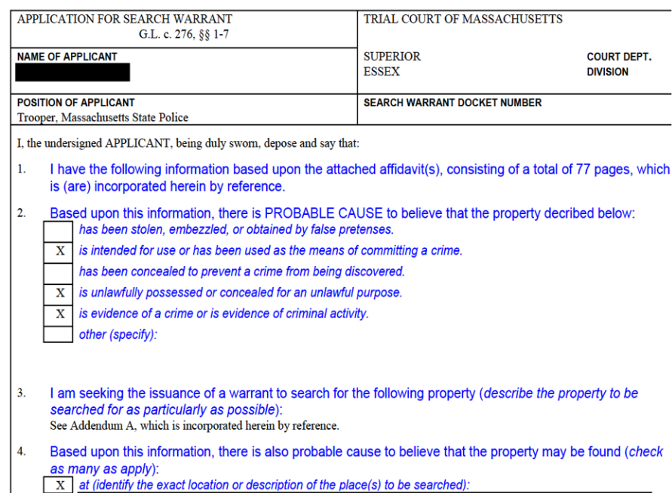
Figure 2: Federal Court Judicial “search warrant” (left) & Administrative “ICE Warrant” (right)
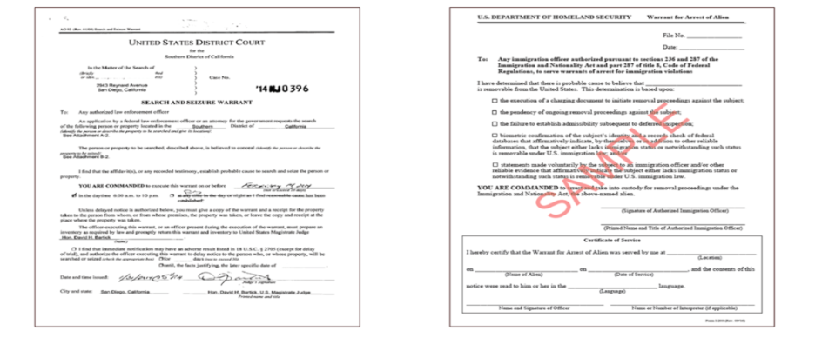

In rare circumstances, law enforcement officers may identify an immediate health or safety threat that qualifies as an exception to the warrant requirement.
In the drafting of specific policies, covered care providers should be mindful of their applicable state and federal laws and regulations. For example, substance use disorder (SUD) treatment programs subject to 42 C.F.R. Part 2 should consult their legal counsel to confirm court orders/warrants meet the specific requirements under that federal regulation.
42 U.S.C. § 290dd-2 protects “[r]ecords of the identity, diagnosis, prognosis, or treatment of any patient which are maintained in connection with the performance of any program or activity relating to substance use disorder education, prevention, training, treatment, rehabilitation, or research, which is conducted, regulated, or directly or indirectly assisted by any department or agency of the United States.” See also 42 C.F.R. Part 2.

