Children are usually hurt by lead from lead paint and dust in their homes.

MASSACHUSETTS DEPARTMENT OF PUBLIC HEALTH | BUREAU OF ENVIRONMENTAL HEALTH

Protect Children from Leaded Paint Chips and Soil in Yards and Play Areas

Children can also be harmed by lead paint chips and lead in soil in their yards and play areas. Loose paint chips and soil with high lead levels may be found near old homes or buildings with chipping paint, busy roads, or near bridges painted with lead paint. Unsafe renovation or scraping of old paint that has lead can also cause high levels of lead in soil.

HOW DOES LEAD IN PAINT CHIPS AND SOIL GET INTO CHILDREN’S BODIES?

Children can be hurt by lead paint chips and lead in soil if they:

- Swallow soil, dust, or paint chips,
- Put their hands in their mouths after touching soil, dust, or paint chips,
- Eat fruits and vegetables grown in soil with high levels of lead.
- Breath in lead dust from unsafe renovation work.

HOW DOES LEAD MAKE CHILDREN SICK?

Lead harms the developing brains of young children.

Toddlers have the highest chance of being hurt by lead because they are naturally curious and
often put their hands, toys, and sometimes soil and
paint chips in their mouths.

Most children with high levels of lead in their blood do not look or act sick.

A blood lead test is the only way to measure the level of lead in a child’s body.

There is no safe level of lead in children.

PICKING UP PAINT CHIPS NEAR TOBIN BRIDGE
MassDOT's workers are picking up the paint chips near the Tobin Bridge.

You Can Help Too:
- Let the workers into your yard to pick up paint chips.
- Do not let children play near or touch paint chips.
- Show the MassDOT workers where the chips are so that they can pick them up.
- Get your young child tested for lead at their next well-child visit or sooner if you are concerned about lead exposure.
- Call MassDOT at if you have questions about picking up the paint chips.
- Call CLPPP at 1-800-532-9571 if you have questions
about your child's health.
LEAD FACTS

- Infants, young children under 6, and pregnant women are most likely to be harmed by lead.

- Toddlers have the highest chance of being hurt by lead because they are naturally curious and often put their hands in their mouths.

- Children are most commonly harmed by lead from lead-based paint dust and chips in their home.

- Soil is more likely to have high lead levels near:
  - Old homes or buildings,
  - Busy roads and bridges, or
  - Properties contaminated by historic dumping.

- There is no safe level of lead in children.

- Talk to your child’s doctor if you are concerned that your child may be harmed by lead.

Do NOT let children touch or play with paint chips or
DON’T:
bare soil that may have high levels of lead.
Do NOT let children eat on or near bare soil or paint chips.

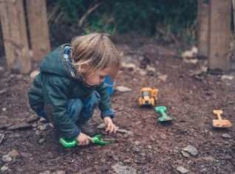

Talk to your child’s doctor about a blood lead test. In MA, children must be tested at ages 1, 2, and 3, and sometimes at 4, depending on where they live.
DO:
Wash hands after touching soil and especially before eating.

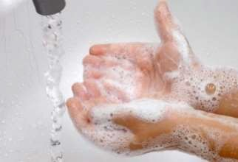Use a doormat and remove shoes before entering a home.
Keep your pets clean. Dogs and cats can bring dirt inside on their paws or fur.

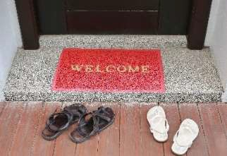

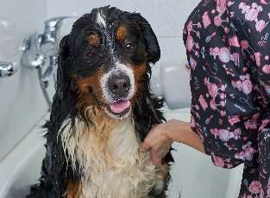Use raised beds with a water permeable liner and clean soil for vegetable gardens.
Wash all vegetables and fruits. Peel root vegetables.

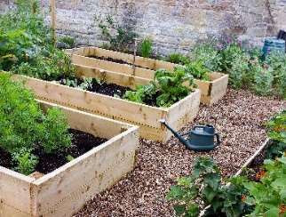

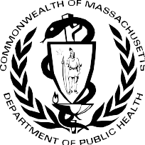Cover soil with grass, wood chips, mulch, mats or other ground cover. Use sand boxes for children.

Massachusetts Department of Public Health Bureau of Environmental Health
250 Washington Street
Boston, MA 02108
Phone: 617-624-5757 |
www.mass.gov/dph/environmental_health
April 2023
Maintain the exterior paint on your home.

