**Massachusetts Department of Public Health | Bureau of Environmental Health**

# Protecting Children from High Levels of Lead in Soil

Children are most commonly harmed by lead from lead-based paint and lead dust.

Children can also be harmed by lead in soil. Soil is more likely to have high lead levels near old homes or buildings with chipping paint, busy roads, or properties contaminated by historic dumping. Unsafe renovation or scraping of old paint that has lead can also cause high levels of lead in soil.

HOW DOES LEAD IN SOIL GET INTO CHILDREN’S BODIES?

Children can be hurt by lead in soil if they:

* Swallow soil, dust, or paint chips,
* Put their hands in their mouths after touching soil, dust, or paint chips,
* Breathe in lead dust, or
* Eat fruits and vegetables grown in soil with high levels of lead.

HOW DOES LEAD MAKE CHILDREN SICK?

Lead harms the developing brains of young children. Toddlers have the highest chance of being harmed by lead because they are naturally curious and often put their hands in their mouths. Most children with high levels of lead in their blood do not look or act sick. A blood lead test is the only way to measure the level of lead in a child’s body. There is no safe level of lead in children.

Lead can also pass from a pregnant woman to her developing baby. Women who are pregnant, or plan to become pregnant, should talk to their doctor about their chance of being hurt by lead and if they should have a blood lead test.

Common Sources of Lead in Soil

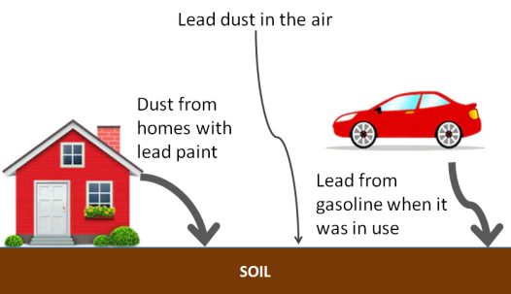

**LEAD FACTS**

* Infants, young children under 6, and pregnant women are most likely to be harmed by lead.
* Toddlers have the highest chance of being hurt by lead because they are naturally curious and often put their hands in their mouths.
* Children are most commonly harmed by lead from lead-based paint dust and chips in their home.
* Soil is more likely to have high lead levels near:
* Old homes or buildings,
* Busy roads, or
* Properties contaminated by historic dumping.
* There is no safe level of lead in children.
* Talk to your child’s doctor if you are concerned that your child may be harmed by lead.

Do **NOT** let children play with bare soil that has high levels of lead.

**DO:**

**DON’T:**

|  |  |  |  |
| --- | --- | --- | --- |
|  |  |  | |
| **Talk to your child’s doctor** about a blood lead test. In MA, children must be tested at ages 1, 2, and 3, and sometimes at 4, depending on where they live. | | | | |  | |
| **Use a doormat and remove shoes** before entering a home. | | | | |  | |
| **Use raised beds** with a water permeable liner and clean soil for vegetable gardens. | | | | |  | |
| **Cover soil** with grass, wood chips, mulch, mats or other ground cover. **Use sand boxes** for children. | | | | |  | |
| Do **NOT** let children eat on or near bare soil. | | |  | | |
| **Wash hands** after touching soil and especially before eating. | | |  | | |
| **Keep your pets clean.** Dogs and cats can bring dirt inside on their paws or fur. | | |  | | |
| **Wash** all vegetables and fruits. **Peel** root vegetables. | | |  | | |
| **Maintain the exterior paint** on your home. | | |  | | |

Massachusetts Department of Public Health

Bureau of Environmental Health

250 Washington Street

Boston, MA 02108

Phone: 617-624-5757 |

[www.mass.gov/dph/environmental_health](http://www.mass.gov/dph/environmental_health)

May 2020

