طﻔل ﺻﻐﯾر ﯾﺿﻊ اﻟﻛﺣل ﺣول ﻋﯾﻧﯾﮫ

ﻛﯿﻒ ﻟﻲ أن أﻋﺮف إذا ﻛﺎن طﻔﻠﻲ ﻣﺼﺎﺑًﺎ ﺑﺎﻟﺘﺴﻤﻢ
ﺑﺎﻟﺮﺻﺎص؟

• ﻏﺎﻟﺑﯾﺔ اﻷطﻔﺎل اﻟذﯾن ﯾﻌﺎﻧون ﻣن ﻣﺳﺗوﯾﺎت ﻋﺎﻟﯾﺔ ﻣن
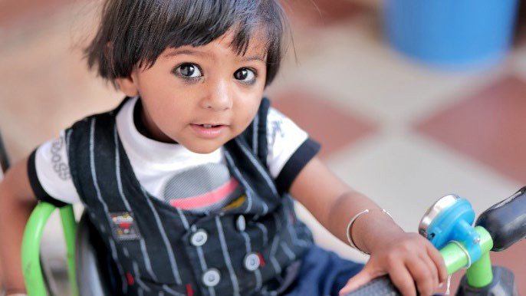

اﻟرﺻﺎص ﻓﻲ اﻟدم ﻻ ﯾﺑدو ﻋﻠﯾﮭم اﻹﺻﺎﺑﺔ ﺑﻣرض أو
ﯾﺗﺻرﻓون ﻋﻠﻰ أﻧﮭم ﻛذﻟك

Shutterstock :اﻟﻤﺼﺪر
وﯾﻌﺪ ﻗﯿﺎس ﻧﺴﺒﺔ اﻟﺮﺻﺎص ﻓﻲ اﻟﺪم ﺑﻤﺜﺎﺑﺔ اﻟﻄﺮﯾﻘﺔ اﻟﻮﺣﯿﺪة ﻟﻤﻌﺮﻓﺔ ﻣﺎ إذا ﻛﺎن اﻟﻄﻔﻞ ﯾﻌﺎﻧﻲ ﻣﻦ اﻟﺮﺻﺎص ﻓﻲ ﺟﺴﻤﮫ. ﯾﻤﻜﻨﻚ أن ﺗﻄﻠﺐ ﻣﻦ اﻟﻄﺒﯿﺐ اﻟﻤﻌﺎﻟﺞ
ﻟﻄﻔﻠﻚ إﺟﺮاء اﺧﺘﺒﺎر ﻟﻨﺴﺒﺔ اﻟﺮﺻﺎص.
ﻛﯿﻒ ﻟﻲ أن أﺣﻤﻲ ﻋﺎﺋﻠﺘﻲ؟

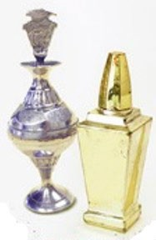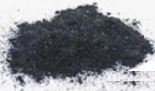اﻟﺮﺻﺎص ﺳ ﱞﻢ ﻗﺎﺗﻞ. اﻷطﻔﺎل اﻟﺼﻐﺎر ھﻢ اﻷﻛﺜﺮ ﻋﺮﺿﺔ
ﻻ ﺗﺴﺘﻌﻤﻠﻲ ﻣﻨﺘﺠﺎت اﻟﻜﺤﻞ ﻣﺜﻞ ھﺬه. ﻓﮭﻲ ﻗﺪ ﺗﺤﺘﻮي ﻋﻠﻰ
ﻛﻤﯿﺎت ﻛﺒﯿﺮة ﻣﻦ اﻟﺮﺻﺎص ﺑﺪاﺧﻠﮭﺎ.
ﻻ ﺗﺴﺘﻌﻤﻠﻲ
ﻷﺿﺮار اﻟﺮﺻﺎص.

• ﯾﺣﺗوي ﻣﻌظم اﻟﻛﺣل اﻟذي ﯾﺄﺗﻲ ﻣن آﺳﯾﺎ وأﻓرﯾﻘﯾﺎ واﻟﺷرق اﻷوﺳط
ﻋﻠﻰ ﻣﻌدن اﻟرﺻﺎص.

• أﺟﺮﯾﺖ اﺧﺘﺒﺎرات ﻋﻠﻰ اﻟﻌﺪﯾﺪ ﻣﻦ اﻷطﻔﺎل ﻓﻲ ﺟﻤﯿﻊ أﻧﺤﺎء اﻟﻮﻻﯾﺎت
اﻟﻤﺘﺤﺪة ﻻﻛﺘﺸﺎف ﻧﺴﺒﺔ اﻟﺮﺻﺎص اﻟﻌﺎﻟﯿﺔ ﻟﺪﯾﮭﻢ ﻧﺘﯿﺠﺔ ﻣﻦ اﺳﺘﺨﺪام
اﻟﻜﺤﻞ. ُوﯾﻄﻠﻖ ﻋﻠﻰ اﻟﻜﺤﻞ أﯾﻀﺎ اﺳﻢ "راﻧﺠﺎ" أو "ﺳﻮرﻣﺎ" أو
"ﻛﺎﺟﺎل" أو "ﺟﺎﺟﺎل" أو "ﻛﺤﺎل" أو "طﻮزاﻟﻲ" أو "اﻟﻜﺤﺎل."
• ﯾﻤﻜﻦ أن ﯾﺴﺒﺐ اﻟﺮﺻﺎص أذى ﻟﻠﺪﻣﺎغ وﯾﺠﻌﻞ ﻣﻦ اﻟﺼﻌﺐ ﻋﻠﻰ
اﺳﺘﻌﻤﻠﻲ اﻟﻤﻨﺘﺠﺎت اﻟﻤﺼﻨﻮﻋﺔ ﻓﻲ اﻟﻮﻻﯾﺎت اﻟﻤﺘﺤﺪة أو أوروﺑﺎ.
اﺳﺘﻌﻤﻠﻲ ﻣﻨﺘﺠﺎت أﻛﺜﺮ أﻣﺎﻧًﺎ
اﻷطﻔﺎل اﻟﺘﻌﻠﻢ واﻻﻧﺘﺒﺎه وﻣﻤﺎرﺳﺔ اﻟﺤﯿﺎة.
• ﻻ ﯾﻮﺟﺪ ﻣﺴﺘﻮى آﻣﻦ ﻟﻠﺮﺻﺎص ﻟﺪى اﻷطﻔﺎل.

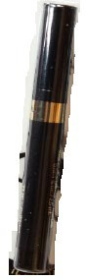ھﻞ ﯾﻤﻜﻦ أن ﯾﺆذي اﻟﺮﺻﺎص اﻷﺷﺨﺎص اﻟﺒﺎﻟﻐﯿﻦ؟

ﻋﺎ ﻓﻲ ﺿﻐﻂ اﻟﺪم وﺗﻠﻒ اﻟﺪﻣﺎغ
• ﻧﻌﻢ، ﯾﻤﻜﻦ أن ﯾﺴﺒﺐ اﻟﺮﺻﺎص ارﺗﻔﺎ

واﻟﻜﻠﻰ وﺣﺪوث ﻣﺸﻜﻼت ﻓﻲ اﻟﺨﺼﻮﺑﺔ.

ﻀﺎ ﻣﻦ اﻟﻤﺮأة اﻟﺤﺎﻣﻞ
• ﯾﻤﻜﻦ أن ﯾﻨﺘﻘﻞ اﻟﺮﺻﺎص أﯾ
إﻟﻰ ﺟﻨﯿﻨﮭﺎ اﻟﺬي ﻟﻢ ﯾُﻮﻟﺪ ﺑﻌﺪ.

ﺻﺤﯿﻔﺔ وﻗﺎﺋﻊ ﻣﻘﺘﺒﺴﺔ ﺑﺈذن ﻣﻦ اﻟﻮﺣﺪات اﻟﻤﺘﺨﺼﺼﺔ ﻓﻲ
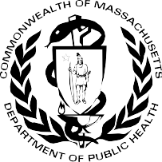

اﻟﺼﺤﺔ اﻟﺒﯿﺌﯿﺔ ﻟﻸطﻔﺎل ﻓﻲ اﻟﻮﻻﯾﺎت اﻟﻐﺮﺑﯿﺔ.
إدارة اﻟﺼﺤﺔ اﻟﻌﺎﻣﺔ ﻓﻲ وﻻﯾﺔ ﻣﺎﺳﺎﺗﺸﻮﺳﺘﺲ
ﻣﻜﺘﺐ اﻟﺼﺤﺔ اﻟﺒﯿﺌﯿﺔ ﺑﺮﻧﺎﻣﺞ اﻟﻮﻗﺎﯾﺔ ﻣﻦ اﻟﺘﺴﻤﻢ ﺑﺎﻟﺮﺻﺎص ﻓﻲ ﻣﺮﺣﻠﺔ اﻟﻄﻔﻮﻟﺔ
Washington Street 250
02108 Boston, MA
617-624-5757 :ھﺎﺗﻒ

ﯾﻮﻧﯿﻮ 2022
https://www.mass.gov/orgs/childhood-lead-poisoning-prevention-program

Arabic
إدارة اﻟﺼﺤﺔ اﻟﻌﺎﻣﺔ ﻓﻲ وﻻﯾﺔ ﻣﺎﺳﺎﺗﺸﻮﺳﺘﺲ | ﻣﻜﺘﺐ اﻟﺼﺤﺔ اﻟﺒﯿﺌﯿﺔ
ﺑﺮﻧﺎﻣﺞ اﻟﻮﻗﺎﯾﺔ ﻣﻦ اﻟﺘﺴﻤﻢ ﺑﺎﻟﺮﺻﺎص ﻓﻲ ﻣﺮﺣﻠﺔ اﻟﻄﻔﻮﻟﺔ

ﺣﻤﺎﯾﺔ اﻷطﻔﺎل ﻣﻦ اﻟﺮﺻﺎص اﻟﻤﻮﺟﻮد ﻓﻲ اﻟﻜﺤﻞ

Young child with kohl around eyes

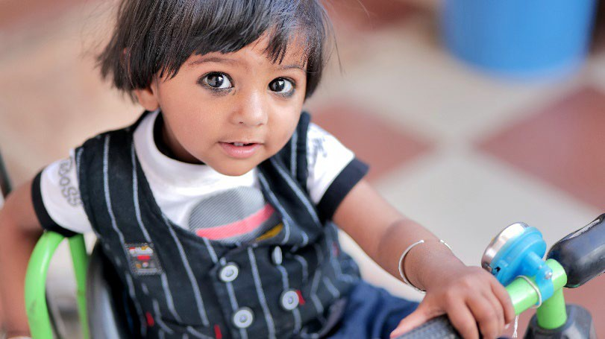
Source: Shutterstock

Lead is a poison. Young children are most likely to be harmed by lead.

- Most kohl that is from Asia, Africa, and the Middle East has lead.

- Many children across the United States have tested high for lead from using kohl. Kohl is also called “ranja,” “surma,” “kajal,” “gajal,” “kahal,” “tozali,” or “al-kahal.”
- Lead can harm the brain and make it hard for children to learn, pay attention, and behave.
Use products made in the USA or Europe.
Use Safer Products
- There is no safe level of lead in children.

Can lead harm adults?
- Yes, lead can cause high blood pressure, brain, kidney, and fertility issues.

- Lead can also pass from a pregnant woman to her unborn baby.

How do I know if my child has lead poisoning?

- Most children with high levels of lead do not look or act sick.

A blood lead test is the only way to know if a child has lead in their body. You can ask your child’s doctor for a lead test.

How can I protect my family?
Do not use kohl products like these. They may have high amounts of lead in them.
Do Not Use

Massachusetts Department of Public Health Bureau of Environmental Health
Childhood Lead Poisoning Prevention Program 250 Washington Street
Boston, MA 02108
Phone: 617-624-5757

Factsheet adapted with permission from the Western States Pediatric Environmental Health Specialty Units.

June 2022
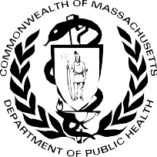

https://www.mass.gov/orgs/childhood-lead-poisoning-prevention-program

MASSACHUSETTS DEPARTMENT OF PUBLIC HEALTH | BUREAU OF ENVIRONMENTAL HEALTH CHILDHOOD LEAD POISONING PREVENTION PROGRAM

Protecting Children from Lead in Kohl

