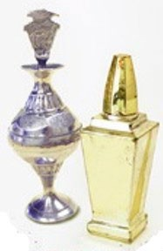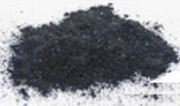Shutterstock :ﻣﻨﺒﻊ
از اﯾن ﻗﺑﯾل ﻣﺣﺻوﻻت ﺳرﻣﮫ را اﺳﺗﻔﺎده ﻧﮑﻧﯾد. ﻣﻣﮑن اﺳت ﻣﻘﺎدﯾر زﯾﺎدی ﺳرب در آن ھﺎ وﺟود داﺷﺗﮫ ﺑﺎﺷد
اﺳﺗﻔﺎده ﻧﮑﻧﯾد

ﺳﺮب ﯾﮏ زھﺮ اﺳﺖ. اطﻔﺎل ﺧﺮدﺳﺎل ﺑﯿﺸﺘﺮ در ﻣﻌﺮض
آﺳﯿﺐ ﺳﺮب ھﺴﺘﻨﺪ.
• ﺑﯿﺸﺘﺮ ﺳﺮﻣﮫ ھﺎی ﮐﮫ از آﺳﯿﺎ، اﻓﺮﯾﻘﺎ و ﺷﺮق ﻣﯿﺎﻧﮫ اﺳﺖ ﺳﺮب
دارﻧﺪ.
• ﺑﺴﯿﺎری از اطﻔﺎل در ﺳﺮاﺳﺮ اﯾﺎﻻت ﻣﺘﺤﺪه ﺑﺮای ﺳﺮب ﺑﺎﻻی
اﺳﺘﻔﺎده از ﺳﺮﻣﮫ ﺗﺴﺖ ﺷﺪه اﻧﺪ. ﺳﺮﻣﮫ را "رﻧﺠﮫ"، "ﮐﻮھﻞ"،
"ﮐﺠﻞ"، "ﮔﺠﻞ"، "ﮐﮭﺎل"، "ﺗﻮزاﻟﯽ" ﯾﺎ "اﻟﮑﮭﺎل"ﻧﯿﺰ ﻣﯽ ﻧﺎﻣﻨﺪ.
• ﺳﺮب ﻣﯽ ﺗﻮاﻧﺪ ﺑﮫ ﻣﻐﺰ آﺳﯿﺐ ﺑﺮﺳﺎﻧﺪ و ﯾﺎدﮔﯿﺮی، ﺗﻮﺟﮫ و رﻓﺘﺎر را
از ﻣﺤﺼﻮﻻت ﺳﺎﺧﺖ اﻣﺮﯾﮑﺎ ﯾﺎ اروﭘﺎ اﺳﺘﻔﺎده ﮐﻨﯿﺪ.
از ﻣﺣﺻوﻻت ﻣﺻؤن ﺗر اﺳﺗﻔﺎده ﮐﯾﻧد
ﺑﺮای اطﻔﺎل ﺳﺨﺖ ﮐﻨﺪ.
• ﺳﻄﺢ ﻣﺼﺆن ﺳﺮب در اطﻔﺎل وﺟﻮد ﻧﺪارد.

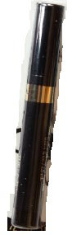آﯾﺎ ﺳﺮب ﻣﯽ ﺗﻮاﻧﺪ ﺑﮫ ﮐﻼن ﺳﺎﻻن ﺿﺮر ﺑﺮﺳﺎﻧﺪ؟

• ﺑﻠﯽ، ﺳﺮب ﻣﯽ ﺗﻮاﻧﺪ ﺑﺎﻋﺚ ﻣﺸﮑﻼن ﭼﻮن ﻓﺸﺎر ﺧﻮن ﺑﺎﻻ،
ﻣﺸﮑﻼت ﻣﻐﺰ، ﮔﺮده و ﺑﺎروری ﺷﻮد.
• ﺳﺮب ھﻤﭽﻨﯿﻦ ﻣﯽ ﺗﻮاﻧﺪ از ﯾﮏ زن ﺣﺎﻣﻠﮫ ﺑﮫ ﺟﻨﯿﻦ او اﻧﺘﻘﺎل ﮐﻨﺪ.

دﯾﭙﺎرﺗﻤﻨﺖ ﺻﺤﺖ ﻋﺎﻣﮫ ﻣﺎﺳﺎﭼﻮﺳﺖ دﻓﺘﺮ ﺻﺤﺖ ﻣﺤﯿﻂ
ﺑﺮﻧﺎﻣﮫ ﭘﯿﺸﮕﯿﺮی از ﻣﺴﻤﻮﻣﯿﺖ ﺑﺎ ﺳﺮب در دوران طﻔﻮﻟﯿﺖ
250 Washington Street
Boston, MA 02108
ﺗﯿﻠﻔﻮن: 617-624-5757
ورق ﻣﻌﻠﻮﻣﺎﺗﯽ اﻗﺘﺒﺎس ﺷﺪه ﺑﺎ ﻣﺠﻮز واﺣﺪھﺎی
ﺗﺨﺼﺼﯽ ﺻﺤﯽ ﻣﺤﯿﻂ اطﻔﺎل اﯾﺎﻻت ﻏﺮﺑﯽ.
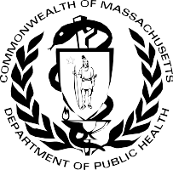

2022 ﺟﻮن

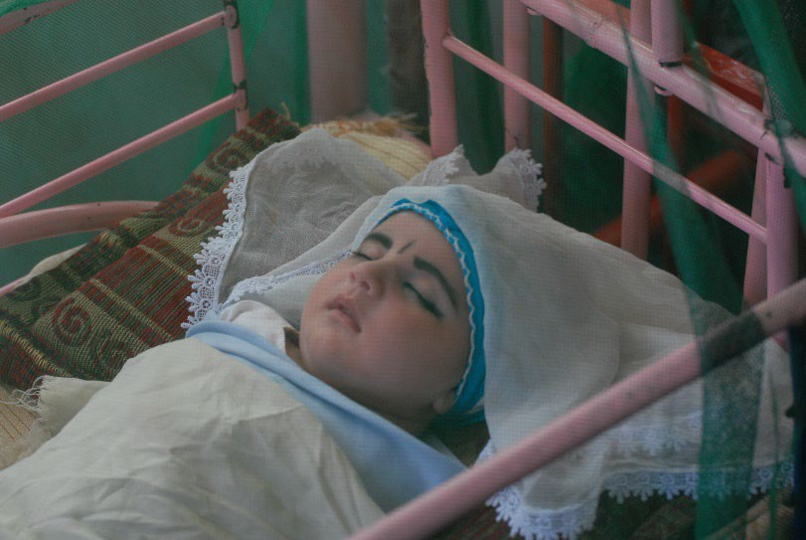
دﯾﭙﺎرﺗﻤﻨﺖ ﺻﺤﺖ ﻋﺎﻣﮫ ﻣﺎﺳﺎﭼﻮﺳﯿﺖ | دﻓﺘﺮ ﺻﺤﺖ ﻣﺤﯿﻂ ﺑﺮﻧﺎﻣﮫ ﭘﯿﺸﮕﯿﺮی از ﻣﺴﻤﻮﻣﯿﺖ ﺑ ﺎ ﺳﺮب در دوران طﻔﻮﻟﯿﺖ
Dari
ﻣﺣﺎﻓظت از اطﻔﺎل در ﺑراﺑر ﺳرب در ﺳرﻣﮫ
طﻔﻠﯽ ﺑﺎ ﺳﺮﻣﮫ در اطﺮاف ﭼﺸﻤﺎن اش
ﭼﮕﻮﻧﮫ ﺑﺪاﻧﻢ ﮐﮫ طﻔﻞ ام ﻣﺴﻤﻮﻣﯿﺖ ﺑﺎ ﺳﺮب دارد؟

• اﮐﺜﺮ اطﻔﺎﻟﯽ ﮐﮫ ﺳﻄﺢ ﺳﺮب ﺑﺎﻻﯾﯽ دارﻧﺪ، ظﺎھﺮاً ﻣﺮﯾﺾ
ﻧﯿﺴﺘﻨﺪ.

ﺗﺴﺖ ﺳﺮب ﺧﻮن ﺗﻨﮭﺎ راھﯽ ﺑﺮای ﺗﺸﺨﯿﺺ وﺟﻮد ﺳﺮب در ﺑﺪن
طﻔﻞ اﺳﺖ. ﻣﯽﺗﻮاﻧﯿﺪ از داﮐﺘﺮ طﻔﻞ ﺗﺎن ﺗﺴﺖ ﺳﺮب ﺑﺨﻮاھﯿﺪ.
ﭼﮕوﻧﮫ ﻣﯽ ﺗواﻧم از ﺧﺎﻧواده ﺧود ﻣﺣﺎﻓظت ﮐﻧم؟
https://www.mass.gov/orgs/childhood-lead-poisoning-prevention-program

MASSACHUSETTS DEPARTMENT OF PUBLIC HEALTH | BUREAU OF ENVIRONMENTAL HEALTH CHILDHOOD LEAD POISONING PREVENTION PROGRAM

Protecting Children from Lead in Surma

Baby with surma around eyes

Source: Shutterstock

Lead is a poison. Young children are most likely to be harmed by lead.

- Most surma that is from Asia, Africa, and the Middle East has lead.

- Many children across the United States have tested high for lead from using surma. Surma is also called “ranja,” “kohl,” “kajal,” “gajal,” “kahal,” “tozali,” or “al-kahal.”
- Lead can harm the brain and make it hard for children to learn, pay attention, and behave.
Use products made in the USA or Europe.
Use Safer Products
- There is no safe level of lead in children.

Can lead harm adults?
- Yes, lead can cause high blood pressure, brain, kidney, and fertility issues.

- Lead can also pass from a pregnant woman to her unborn baby.

How do I know if my child has lead poisoning?

- Most children with high levels of lead do not look or act sick.

A blood lead test is the only way to know if a child has lead in their body. You can ask your child’s doctor for a lead test.

How can I protect my family?
Do not use surma products like these. They may have high amounts of lead in them.
Do Not Use

Massachusetts Department of Public Health Bureau of Environmental Health
Childhood Lead Poisoning Prevention Program 250 Washington Street
Boston, MA 02108
Phone: 617-624-5757

Factsheet adapted with permission from the Western States Pediatric Environmental Health Specialty Units.

June 2022
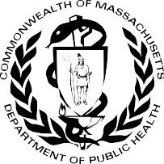

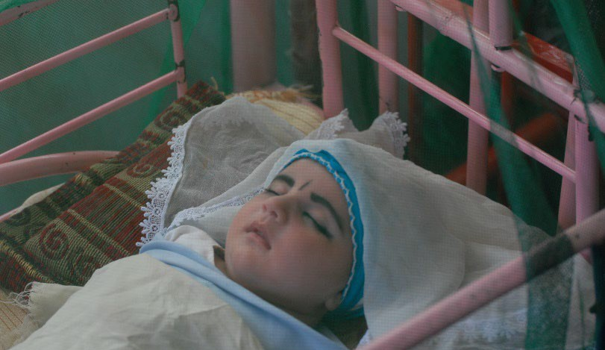https://www.mass.gov/orgs/childhood-lead-poisoning-prevention-program

