د ﭼﺎﭘﯧﺮﯾﺎﻟﻲ روﻏﺘﯿ ﺎ دﻓﺘﺮ
د ﻣﺎﺳﻮﭼﯧﺴﺖ د ﻋﺎﻣﯥ روﻏﺘﯿ ﺎ رﯾﺎﺳﺖ |
Pashto

ﭘﮫ ﻣﺎﺷﻮﻣﺘﻮب ﮐﯥ ﭘ ﮫ ﺳﺮﭘﻮ د ﻣﺴﻤﻮﻣﯿﺖ د ﻣﺨﻨﯿﻮي ﭘﺮوګﺮام

د رﻧﺟو ﻟﮫ ﺳرﭘو څﺧﮫ د ﻣﺎﺷوﻣﺎﻧو ﺧوﻧدي ﮐول

ﻣﺎﺷﻮم ﭼﯥ ﺳﺘﺮګﯥ ﯾﯥ ﭘﮫ رﻧﺠﻮ ﺗﻮرې دي

څﻨګﮫ ﭘﻮه ﺷﻢ ﭼﯥ ﻣﺎﺷﻮم ﻣﯥ ﺳﺮﭘﻮ ﻣﺴﻤﻮم ﮐړی؟

• ډﭔری ﻣﺎﺷوﻣﺎن ﭼﯥ ﭘﮫ ﻟوړه ﮐﭼﮫ ﭘﮫ ﺳرﭘو ﻣﺳﻣوم وي، د
•
ﻧﺎروغ ﭘﺷﺎن ﻧﮫ ښﮑﺎري او ﻧﮫ ھﻐﺳﯥ ﻋﻣل ﮐوي.

• د دې ﻟﭘﺎره ﭼﯥ ﭘوه ﺷو ﭼﯥ د ﻣﺎﺷوم ﭘﮫ ﺑدن ﮐﯥ ﺳرپ دي،
ﯾوازﯾﻧۍ ﻻر دا ده ﭼﯥ ﭘﮫ وﯾﻧﮫ ﮐﯥ ﯾﯥ د ﺳرﭘو ﻣﻌﺎﯾﻧﮫ وﺷﻲ. د ﺧﭘل ﻣﺎﺷوم ﻟﮫ ډاﮐټر څﺧﮫ د ﺳرﭘو د ﻣﻌﺎﯾﻧﯥ ﻏوښﺗﻧﮫ ﮐوﻟﯽ
ﺷﺊ.

• څﻧګﮫ ﻣﯥ ﺧﭘﻠﮫ ﮐورﻧۍ ﺧوﻧدي ﺳﺎﺗﻠﯽ ﺷم؟

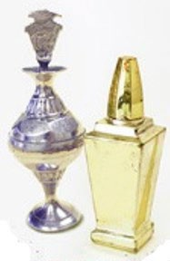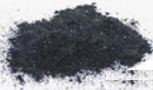Shutterstock :ﺳﺮﭼﯿﻨﮫ
دا ډول د رﻧﺠﻮ ﻣﺤﺼﻮﻻت ﻣﮫ ﮐﺎروئ. ﭘﮫ دې ﮐﯥ ښﺎﯾﻲ ﭘﮫ ﻟﻮړه
ﮐﭽﮫ ﺳﺮپ وي.
دا ﻣﻪ کﺎروئ!

ﺳﺮپ زھﺮي ﻣﺎده ده. د ﺳﺮﭘﻮ د زﯾﺎن رﺳﻮﻟﻮ اﺣﺘﻤﺎل ﭘﮫ
ﻣﺎﺷﻮﻣﺎﻧﻮ ﮐﯥ زﯾﺎت دی.

• ډﭔری راﻧﺟﮫ ﭼﯥ ﭘﮫ آﺳﯾﺎ، اﻓرﯾﻘﺎ او ﻣﻧځﻧﻲ ﺧﺗﯾځ ﮐﯥ دي، ﺳرپ
ﻟري.

• ﭘﮫ اﻣﺮﯾﮑﺎ ﮐﯥ ﭼﯥ د ډﭔﺮی ﻣﺎﺷﻮﻣﺎﻧﻮ ﻣﻌﺎﯾﻨﮫ ﺷﻮې، د رﻧﺠﻮ ﺳﺮپ
ﯾﯥ ډﭔﺮ ﻟﺮل. رﻧﺠﻮ ﺗﮫ ھﻤﺪارازﺳﺮﻣﮫ، ﮐﻮھﻞ، ﮐﺎﺟﻞ، ګﺎﺟﻞ،
ﮐﺎھﺎل، ﺗﺎزاﻟﻲ ﯾﺎ اﻟﮑﮭﺎل واﯾﻲ.

• ﺳﺮپ ذھﻦ ﺗﮫ زﯾﺎن رﺳﻮﻟﯽ ﺷﻲ او ﻣﺎﺷﻮﻣﺎﻧﻮ ﺗﮫ زدهﮐړه او ﭘﺎﻣﻠﺮﻧﮫ
ھﻐﮫ ﻣﺤﺼﻮﻻت وﮐﺎروئ ﭼﯥ ﭘﮫ اﻣﺮﯾﮑﺎ او اروﭘﺎ ﮐﯥ ﺟﻮړ
ﺷﻮي.
ﺧﻮﻧﺪي ﻣﺤﺼﻮﻻتوکﺎروئ!
ﺳﺨﺘﻮي او ﭘﺮ ﭼﻠﻨﺪ ﯾﯥ اﻏﯧﺰ ﮐﻮي.

• ﭘﮫ ﻣﺎﺷﻮﻣﺎﻧﻮ ﮐﯥ د ﺳﺮﭘﻮ ﺧﻮﻧﺪي ﮐﭽﮫ ﻧﺸﺘﮫ.

ﺳﺮپ ﻟﻮﯾﺎﻧﻮ ﺗﮫ زﯾﺎن رﺳﻮﻟﯽ ﺷﻲ؟
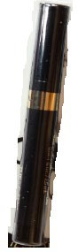

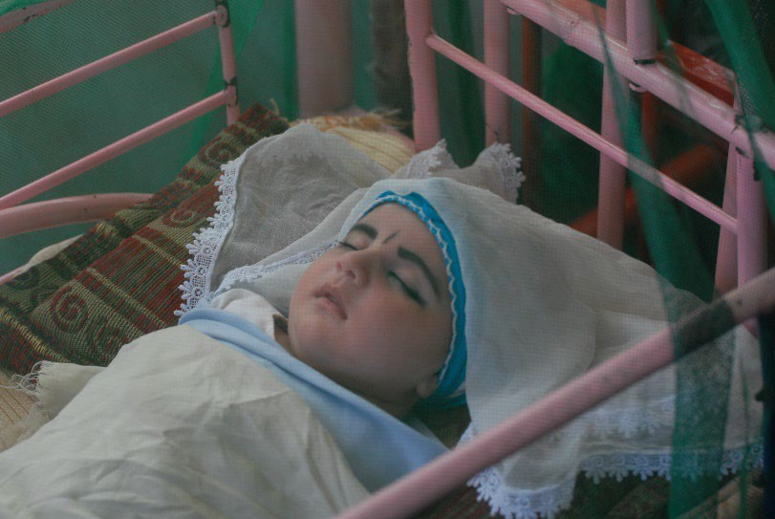• ھﻮ، ﺳﺮپ د وﯾﻨﯥ د ﻟﻮړ ﻓﺸﺎر او د ﻣﻐﺰو، ﺑډوډو او اﻣﯧﻨﺪوارۍ ﭘﮫ
ﺑﺮﺧﻮ ﮐﯥ د ﺳﺘﻮﻧﺰو ﻻﻣﻞ ﮐﯧږي.

• ﺳﺮپ ھﻤﺪاراز ﮐﻮﻟﯽ ﺷﻲ ﻟﮫ ﯾﻮې اﻣﯧﻨﺪوارې ښځﯥ ﺗﯧﺮ ﺷﻲ او
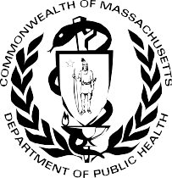ﻧﺎزﯾږﭔﺪﻟﻲ ﻣﺎﺷﻮم ﺗﮫ ﯾﯥ ورﺳﯧږي.

ﻓﮑټ ﺷﯿټ د ﻟﻮﭔﺪﯾځﻮ اﯾﺎﻟﺘﻮﻧﻮ د ﻣﺎﺷﻮﻣﺎﻧﻮ د ﭼﺎﭘﯧﺮﯾﺎﻟﻲ
روﻏﺘﯿﺎ د ﻣﺘﺨﺼﺼﻮ واﺣﺪوﻧﻮ ﭘﮫ اﺟﺎزه ﻣﻨﻞ ﺷﻮی.

ﺟﻮن 2022

د ﻣﺎﺳﻮﭼﯧﺴﺖ د ﻋﺎﻣﯥ روﻏﺘﯿﺎ رﯾﺎﺳﺖ
د ﭼﺎﭘﯧﺮﯾﺎﻟﻲ روﻏﺘﯿﺎ دﻓﺘﺮ ﭘﮫ ﻣﺎﺷﻮﻣﺘﻮب ﮐﯥ ﭘﮫ ﺳﺮﭘﻮ د ﻣﺴﻤﻮﻣﯿﺖ د ﻣﺨﻨﯿﻮي ﭘﺮوګﺮام
250 Washington Street
Boston, MA 02108
617-624-5757 :ﺗﻠﯿﻔﻮن https://www.mass.gov/orgs/childhood-lead-poisoning- prevention-program

MASSACHUSETTS DEPARTMENT OF PUBLIC HEALTH | BUREAU OF ENVIRONMENTAL HEALTH CHILDHOOD LEAD POISONING PREVENTION PROGRAM

Protecting Children from Lead in Surma

Baby with surma around eyes

Source: Shutterstock

Lead is a poison. Young children are most likely to be harmed by lead.

- Most surma that is from Asia, Africa, and the Middle East has lead.

- Many children across the United States have tested high for lead from using surma. Surma is also called “ranja,” “kohl,” “kajal,” “gajal,” “kahal,” “tozali,” or “al-kahal.”
- Lead can harm the brain and make it hard for children to learn, pay attention, and behave.
- There is no safe level of lead in children.

Can lead harm adults?
- Yes, lead can cause high blood pressure, brain, kidney, and fertility issues.

- Lead can also pass from a pregnant woman to her unborn baby.

How do I know if my child has lead poisoning?

- Most children with high levels of lead do not look or act sick.

A blood lead test is the only way to know if a child has lead in their body. You can ask your child’s doctor for a lead test.

How can I protect my family?
Do not use surma products like these. They may have high amounts of lead in them.
Do Not Use

Massachusetts Department of Public Health Bureau of Environmental Health
Use products made in the USA or Europe.
Use Safer Products
Childhood Lead Poisoning Prevention Program 250 Washington Street
Boston, MA 02108
Phone: 617-624-5757

Factsheet adapted with permission from the Western States Pediatric Environmental Health Specialty Units.

June 2022
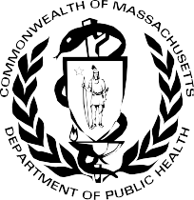

https://www.mass.gov/orgs/childhood-lead-poisoning-prevention-program

