ﺳﺮﻣﺎ ﻟﮕﺎﺋﮯ ﮨﻮﺋﮯ اﯾﮏ ﺑﭽہ
آﻧﮑﮭﻮں ﻣﯿﮟ

ﻣﺠﮭﮯ ﮐﯿﺴﮯ ﭘﺘہ ﭼﻠﮯ ﮔﺎ ﮐہ ﻣﯿﺮے ﺑﭽﮯ ﮐﻮ ﻟﯿﮉ
ﭘﻮاﺋﺰﻧﻨﮓ ﮨﻮﺋﯽ ﮨﮯ؟

• ﺳﯾﺳہ ﮐﯽ زﯾﺎده ﻣﻘدار ﮐﯽ ﺳطﺣوں واﻟﮯ ﺑﯾﺷﺗر ﺑﭼﮯ ﺑﯾﻣﺎر
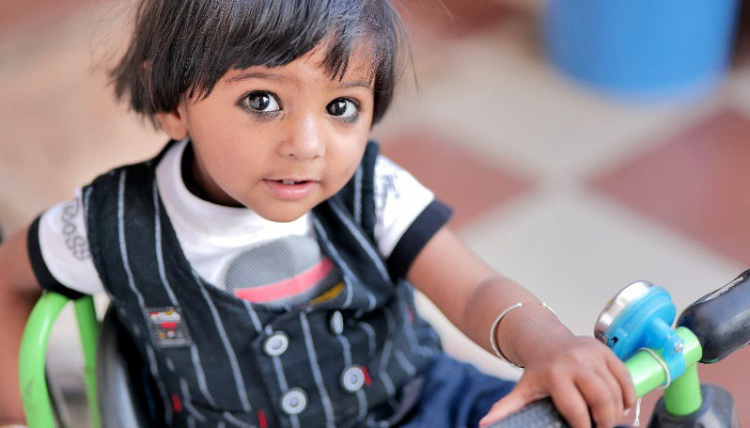

دﮐﮭﺎﺋﯽ ﻧﮩﯾں دﯾﺗﮯ اور ﻧہ ﺑﯾﻣﺎر ﺷﺧص ﮐﯽ طرح ﺑرﺗﺎؤ
ﮐرﺗﮯ ﮨﯾں۔

ﻣﺎﺧﺬ: ﺷﮣﺮ اﺳﮣﺎک

ﺳﯿﺴہ اﯾﮏ زﮨﺮ ﮨﮯ۔ ﭼﮭﻮﮢﮯ ﺑﭽﻮں ﮐﻮ ﺳﯿﺴہ ﺳﮯ زﯾﺎده
ﻧﻘﺼﺎن ﭘﮩﻨﭽﻨﮯ ﮐﺎ اﻣﮑﺎن ﮨﻮﺗﺎ ﮨﮯ۔
ﺧون ﮐﺎ ﺳﯾﺳہ ﮢﯾﺳٹ ﮨﯽ ﯾہ ﺟﺎﻧﻧﮯ ﮐﺎ واﺣد طرﯾﻘہ ﮨﮯ ﮐہ آﯾﺎ ﮐﺳﯽ ﺑﭼﮯ ﮐﮯ ﺟﺳم ﻣﯾں ﺳﯾﺳہ ﮨﮯ ﯾﺎ ﻧﮩﯾں۔ آپ اﭘﻧﮯ ﺑﭼﮯ
ﮐﮯ ڈاﮐﮢر ﮐو ﺳﯾﺳہ ﮢﯾﺳٹ ﮐرﻧﮯ ﮐﺎ ﮐﮩہ ﺳﮑﺗﮯ ﮨﯾں۔

ﻣﯾں اﭘﻧﮯ ﺧﺎﻧدان ﮐو ﮐﯾﺳﮯ ﻣﺣﻔوظ رﮐﮭ ﺳﮑﺗﺎ ﮨوں؟

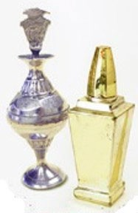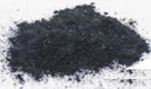• اﯾﺷﯾﺎ، اﻓرﯾﻘہ اور ﻣﺷرق وﺳط ٰﯽ ﺳﮯ ﺣﺎﺻل ﮨوﻧﮯ واﻟﮯ زﯾﺎده
اس طﺮح ﮐﯽ ُﺳﺮﻣﺎ ﻣﺼﻨﻮﻋﺎت اﺳﺘﻌﻤﺎل ﻣﺖ ﮐﺮﯾﮟ۔ ان ﻣﯿﮟ
ﺳﯿﺴہ ﮐﯽ ﺑﮩﺖ زﯾﺎده ﻣﻘﺪار ﮨﻮ ﺳﮑﺘﯽ ﮨﮯ۔
اﺳﺘﻌﻤﺎل ﻣﺖ ﮐﺮﯾﮟ
ﺗر ﺳرﻣﺎ ﻣﯾں ﺳﯾﺳہ ﮨوﺗﺎ ﮨﮯ۔

ﺳﺮﻣﺎ اﺳﺘﻌﻤﺎل ﮐﺮﻧﮯ ﮐﮯ ﺳﺒﺐ ﺑﮩﺖ ﺳﮯ
• رﯾﺎﺳﺘﮩﺎﺋﮯ ﻣﺘﺤﺪه ﻣﯿﮟ

ﺑﭽﻮں ﮐﮯ ﮢﯿﺴﭧ ﻣﯿﮟ ﺑﮩﺖ زﯾﺎده ﻣﻘﺪار ﻣﯿﮟ ﺳﯿﺴہ ﭘﺎﯾﺎ ﮔﯿﺎ ﮨﮯ۔ ُﺳﺮﻣﺎ ﮐﻮ "راﻧﺠﺎ،" "ﮐﻮﮨﻞ،" "ﮐﺎﺟﻞ،" "ﮔﺠﻞ،" "ﮐﮩﻞ،"
"ﺗﻮزاﻟﯽ،" ﯾﺎ "اﻟﮑﺎﮨﻞ" ﺑﮭﯽ ﮐﮩﺎ ﺟﺎﺗﺎ ﮨﮯ۔
• ﺳﯿﺴہ دﻣﺎغ ﮐﻮ ﻧﻘﺼﺎن ﭘﮩﻨﭽﺎ ﺳﮑﺘﺎ ﮨﮯ اور ﺑﭽﻮں ﮐﮯ ﻟﯿﮯ
اﻣﺮﯾﮑہ ﯾﺎ ﯾﻮرپ ﻣﯿﮟ ﺗﯿﺎر ﮐﺮده ﻣﺼﻨﻮﻋﺎت اﺳﺘﻌﻤﺎل ﮐﺮﯾﮟ۔
ﻣﺤﻔﻮظ ﻣﺼﻨﻮﻋﺎت اﺳﺘﻌﻤﺎل ﮐﺮﯾﮟ
ﺳﯿﮑﮭﻨﺎ، ﺗﻮﺟہ دﯾﻨﺎ اور ﺑﺮﺗﺎؤ ﮐﺮﻧﺎ ﻣﺸﮑﻞ ﺑﻨﺎ ﺳﮑﺘﺎ ﮨﮯ۔
• ﺑﭽﻮں ﻣﯿﮟ ﺳﯿﺴہ ﮐﯽ ﮐﻮﺋﯽ ﻣﺤﻔﻮظ ﺳﻄﺢ ﻧﮩﯿﮟ ﮨﮯ۔

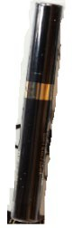ﮐﯿﺎ ﺳﯿﺴہ ﺑﺎﻟﻎ اﻓﺮاد ﮐﻮ ﻧﻘﺼﺎن ﭘﮩﻨﭽﺎ ﺳﮑﺘﺎ ﮨﮯ؟

• ﮨﺎں، ﺳﯿﺴہ ﮨﺎﺋﯽ ﺑﻠﮉ ﭘﺮﯾﺸﺮ، دﻣﺎغ، ﮔﺮدے، اور ﻓﺮﮢﯿﻠﯿﮣﯽ ﮐﮯ
ﻣﺴﺎﺋﻞ ﮐﺎ ﺳﺒﺐ ﺑﻦ ﺳﮑﺘﺎ ﮨﮯ۔
• ﺳﯿﺴہ ﺣﺎﻣﻠہ ﻋﻮرت ﺳﮯ اس ﮐﮯ ﻧﺎﻣﻮﻟﻮد ﺑﭽﮯ ﻣﯿﮟ ﺑﮭﯽ ﻣﻨﺘﻘﻞ ﮨﻮ
ﺳﮑﺘﺎ ﮨﮯ۔

ﺣﻘﺎﺋﻖ ﻧﺎﻣہ ﮐﻮ ﻣﻐﺮﺑﯽ رﯾﺎﺳﺘﯿﮟ ﭘﯿﮉﯾﺎﮢﺮک اﻧﻮاﺋﺮﻧﻤﻨﮣﻞ ﮨﯿﻠﺘﮭ اﺳﭙﯿﺸﻠﮣﯽ ﯾﻮﻧﮣﺲ ﮐﯽ اﺟﺎزت ﺳﮯ اﺧﺘﯿﺎر/ﺗﯿﺎر ﮐﯿﺎ
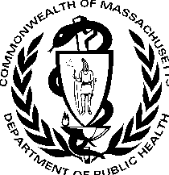

ﮔﯿﺎ۔

ﻣﯿﺴﺎﭼﻮﺳﮣﺲ ڈﯾﭙﺎرﮢﻤﻨﭧ آف ﭘﺒﻠﮏ ﮨﯿﻠﺘﮭ
ﺑﯿﻮرو آف اﻧﻮاﺋﺮﻧﻤﻨﮣﻞ ﮨﯿﻠﺘﮭ ﺑﭽﭙﻦ ﻣﯿﮟ ﺳﯿﺴہ ﮐﮯ زﮨﺮﯾﻠﮯ ﭘﻦ ﺳﮯ ﺑﭽﺎؤ ﮐﺎ ﭘﺮوﮔﺮام
250 Washington Street
Boston, MA 02108

ﻣﯿﺴﺎﭼﻮﺳﮣﺲ ڈﯾﭙﺎرﮢﻤﻨﭧ آف ﭘﺒﻠﮏ ﮨﯿﻠﺘﮭ | ﺑﯿﻮرو آف اﻧﻮاﺋﺮﻧﻤﻨﮣﻞ ﮨﯿﻠﺘﮭ ﺑﭽﭙﻦ ﻣﯿﮟ ﺳﯿﺴہ ﮐﮯ زﮨﺮﯾﻠﮯ ﭘﻦ ﺳﮯ ﺑﭽﺎؤ ﮐﺎ ﭘﺮوﮔﺮا م
Urdu
ﺑﭽﻮں ﮐﻮ ﺳُﺮﻣﺎ ﻣﯿﮟ ﻣﻮﺟﻮد ﺳﯿﺴہ ﺳﮯ ﻣﺤﻔﻮظ رﮐﮭﻨﺎ
2022 ﺟﻮن
617-624-5757

https://www.mass.gov/orgs/childhood-lead-poisoning-prevention-program
ﻓﻮن:

MASSACHUSETTS DEPARTMENT OF PUBLIC HEALTH | BUREAU OF ENVIRONMENTAL HEALTH CHILDHOOD LEAD POISONING PREVENTION PROGRAM

Protecting Children from Lead in Surma

Young child with surma around eyes

How do I know if my child has lead poisoning?

- Most children with high levels of lead do not look or act sick.

A blood lead test is the only way to know if a child has lead in their body. You can ask your child’s doctor for a lead test.

How can I protect my family?

Source: Shutterstock
Do not use surma products like these. They may have high amounts of lead in them.
Do Not Use

Lead is a poison. Young children are most likely to be harmed by lead.

- Most surma that is from Asia, Africa, and the Middle East has lead.

- Many children across the United States have tested high for lead from using surma. Surma is also called “ranja,” “kohl,” “kajal,” “gajal,” “kahal,” “tozali,” or “al-kahal.”
- Lead can harm the brain and make it hard for children to learn, pay attention, and behave.
Use products made in the USA or Europe.
Use Safer Products
- There is no safe level of lead in children.

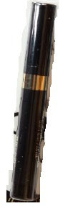Can lead harm adults?
- Yes, lead can cause high blood pressure, brain, kidney, and fertility issues.

- Lead can also pass from a pregnant woman to her unborn baby.

Massachusetts Department of Public Health Bureau of Environmental Health
Childhood Lead Poisoning Prevention Program 250 Washington Street
Boston, MA 02108
Phone: 617-624-5757

Factsheet adapted with permission from the Western States Pediatric Environmental Health Specialty Units.

June 2022
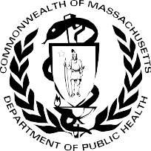

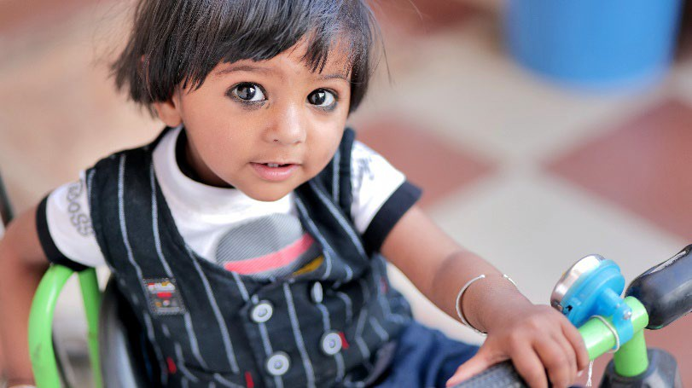https://www.mass.gov/orgs/childhood-lead-poisoning-prevention-program

