Technical Assistance Reference Document

Provider Application Request

National Provider Identifier (NPI)
Before a school district can enroll as a School-Based Medicaid Program (SBMP) provider with MassHealth, the district must first obtain a National Provider Identifier (NPI).
The NPI is a unique 10-digit identification number issued to health car providers by the Centers for Medicare & Medicaid Services (CMS). This number is required for provider enrollment, claims submission and ongoing participation in the Medicaid program.
If your district does not already have an organizational NPI for School-Based Medicaid services, this must be completed before moving forward with the MassHealth provider application.
Please refer to the (insert link for NPI Technical Assistance doc.) for step-by-step instructions on how to apply for and obtain an NPI.
Once the NPI has been obtained, the district can move forward with the MassHealth provider enrollment application.

Provider Application Request
Access the provider application

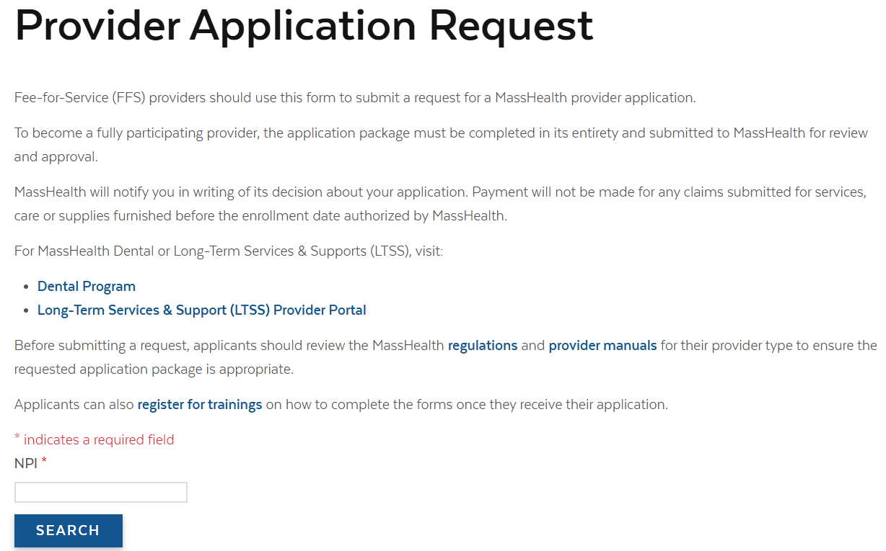
Enter the school district NPI number at the bottom of the screen, then select search.
Confirm your Provider Information is accurate
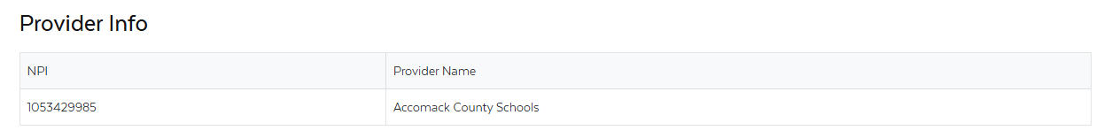
0123456789
ABC School District
Select the Provider Type
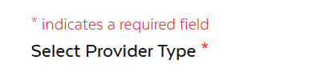
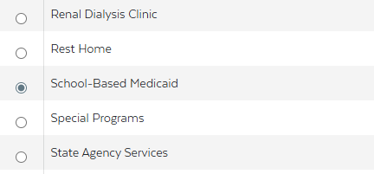

Select Next
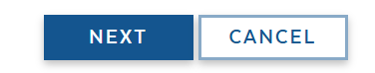
Provide your contact information
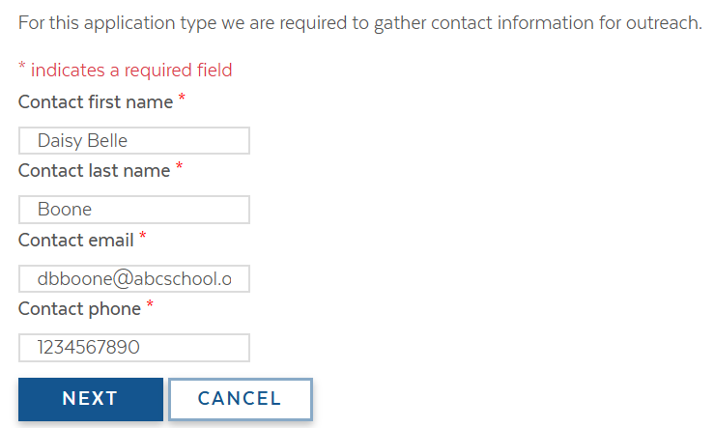
Select Next
Once the application is complete, you will get a notification that your application has been accepted.
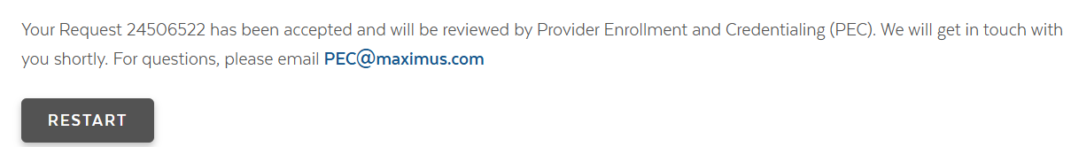

You will receive an email from MAHealthPublications@maximus.com with further instructions.
Below is a sample of the email.
