PROVIDER DATA MANAGEMENT USER GUIDE
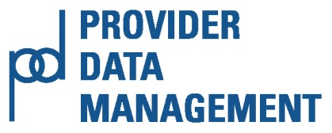
RELEASE 5.0
December 18, 2015
COMMONWEALTH OF MASSACHUSETTS
The Executive Office of Health and Human Services
INFORMATION TECHNOLOGY (IT) VIRTUAL GATEWAY (VG)

This page is intentionally left blank

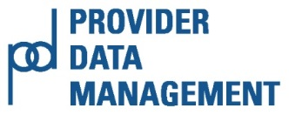
Table of Contents
Chapter 1: Virtual Gateway’s Provider Data Management (PDM) System 5
OVERVIEW 5
SYSTEM REQUIREMENTS 7
Enable JAVA scripting on IE 7.0, IE 8.0 7
Enable JAVA scripting on Firefox 7
Chapter 2: Getting Started 9
ACCESSING PDM ON THE VIRTUAL GATEWAY (VG) 9
Virtual Gateway Customer Service 11
Questions about the PDM Program 11
Chapter 3: Principal Purchasing Agency (PPA) and Agency Observer Roles 13
OVERVIEW 13
PROVIDER SEARCH 14
Search By Provider 14
PDM Information Page 17
PDM Qualification Page 18
PDM Qualification – Financial Ratios 22
PDM Qualification – Corrective Measures 23
PDM CONTRACT DETAILS 25
PDM SURPLUS REVENUE 26
Chapter 4: POS Program Operations Role 28
OVERVIEW 28
PROVIDER SEARCH 29
Search By Provider 29
PDM INFORMATION 32
PDM Qualification 35
PDM Qualification – Financial Ratios 40
PDM Qualification – Corrective Measures 41
PDM CONTRACT DETAILS 43
PDM SURPLUS REVENUE 44
Chapter 5: DDS Program Operations and DDS Operations Observer Roles 47
OVERVIEW 47
PROVIDER SEARCH 48
SERVICE DIRECTORY 50
UPDATE SERVICE DIRECTORY 52
Provider's Details 52
Other Contact Information 52
Service Information 53
ADD SERVICE 54
MODIFY SERVICE 54
DELETE SERVICE 55
Chapter 6: PDM Contracted Providers Operations and Observer Provider Roles 57
OVERVIEW 57
PDM INFORMATION 58
SERVICE DIRECTORY 61
PDM QUALIFICATION 63
PDM Qualification - Financial Ratios 65
PDM Qualification - Corrective Measures 67
PDM CONTRACT DETAILS 69
PDM SURPLUS REVENUE 70
Appendix A: PDM Security Matrix 71
Appendix B: JAWS COMMANDS 73
Appendix C: Listing of Figures 77
This page is intentionally left blank

Chapter 1: Virtual Gateway’s Provider Data Management (PDM) System

OVERVIEW
The Virtual Gateway is an Internet portal designed by the Executive Office of Health and Human Services (EOHHS) to provide the general public, medical providers, community-based organizations, and EOHHS staff with online access to health and human services. By consolidating information and online services in a single location on the Internet, the Virtual Gateway simplifies the process of connecting people to critical health and human services programs and information.
Provider Data Management is a web-based service that gives Purchase of Service (POS) providers and EOHHS agencies a single place to view and edit information commonly requested by Health and Human Services agencies. The Provider Data Management System is a web based EOHHS application that supports:
- State agencies within the Executive Office of Health and Human Services through a centralized location to view provider information required for contracting monitoring.
- Provider organizations with whom EOHHS agencies contract by hosting a central repository of all Purchase of Service (POS) contracts, service data, forms and reports, and organizational profiles.
- Annual Provider Qualification review process aimed at minimizing financial and administrative risk to the Commonwealth and the people served through the Purchase of Service system.
- Creation of specialized reports and service directories designed to meet federal funding requirements and assist general public in identifying service providers.
- Special initiatives undertaken by the EHS to meet legislative directives.
The PDM Business Service is intended to serve as a well-organized, easily navigated ‘filing system’ of provider data. It is important to note that the application requires both web-based data entry and population of the PDM data from external source systems.
PDM is an application built to manage providers servicing the Purchase of Service (POS) provider population. This enhanced functionality will support enrolling provider agencies and individual providers to provide different waiver program services.
Provider Management allows individual providers and provider agencies access to update their demographic information; and manage their services and qualifications in the system. Certain business rules apply in order to modify service related information especially when they are part of an existing plan and are currently providing services to consumers. Provider initiated service modifications and additions go through a review and approval process by the reviewers.
The Provider Data Management system has four primary pages.
- Information: The Information page stores information about a Provider such as Corporate Contact Information, Provider’s PDM Contact, Executive Contact, and general corporate information (Mission Statement and Corporate Description).
  - Service Directory: Service Directory (SD) is a tool developed by the Massachusetts Department of Developmental Services (DDS) to assist individuals, families, support brokers, and clinical staff to locate services and service providers in the Commonwealth of Massachusetts. The SD helps clients to locate particular service providers, search for services and supports provided in their community and provide information about specific services funded by the Department of Developmental Services (DDS) under the Home and Community - Based Services Waivers.
  - Service Directory will appear as a link on the Information page to Providers who have contracts/services with the Department of Developmental Services (DDS).
  - Visit the Service Directory page to find services and supports for clients and/or their family member. (https://service.hhs.state.ma.us/pdm4public/ssdHome.jsp)
- Qualification: The Qualification page stores information about the POS Provider’s qualifications such as Principle Purchasing Agency (PPA), Qualification Status, UFR Filing Period reviewed, Date UFR Received by OSD, Date Qualification Status Last Updated, Concerns/Issues, and Comments. The Qualification Page has two links:
  - Financial Ratios: The Financial Ratios page assists agencies in assessing the financial stability of a provider. The EOHHS Purchase of Service (POS) Integrity Unit established the standard Financial Assessment Measures and benchmarks. The Financial Ratios page is pre-populated when the Operational Services Division (OSD) receives a provider’s annual Uniform Financial Report (UFR) and parses the information into the OSD database.
  - Corrective Measures: The Corrective Measures page displays, by PQ Fiscal Year, the UFR Audit Findings, the Corrective Action Plan, and Audit Records (OSA Audit).
- Contract Detail: The Contract Detail page stores information about the POS Provider’s contracts for the current fiscal year such as Activity Code, Activity Name, Doc ID, Object Code, Maximum Contract Obligation, Expended to Date, and Unexpended Amount. For Release 5.0 PDM will only display contracts with Object Codes MM3 and M03.
Note: The information found under the Contract Details tab is sourced from the Commonwealth’s Information Warehouse. Information about services offered, but not contracted through EOHHS is entered by the provider.
- Surplus Revenue: The Surplus Revenue page is primarily used by the Principal Purchasing Agency (PPA) to record and retain an account of the surplus revenue liability based on the Annual SSR of 5% limit.
Security roles determine what a user can view and edit in PDM. Refer to Appendix B: PDM Security Matrix for a listing of security roles.
More information about PDM can be found via the EOHHS Virtual Gateway: www.mass.gov/vg/pdm.

SYSTEM REQUIREMENTS
All computers used to access the Virtual Gateway require Internet Explorer 6.0 or higher. For the PDM application, the minimum system requirements are the following.
- Windows (2000 or XP Professional)
- Internet Explorer 7.0 or 8.0
- 1280x960 screen resolution
- 300MHz CPU and 128MB RAM
Additionally, the preferred system features to enhance the performance of PDM are the following.
- Windows XP Professional
- 1440x900 screen resolution
- 500MHz CPU and 256MB RAM
Acceptable Alternatives:
- Browsers: Firefox
- Compatible with Dragon and JAWS
Note: Java Script is required and must be enabled to use the PDM application. To enable JAVA Script, follow the steps below.

Enable JAVA scripting on IE 7.0, IE 8.0
    - From the Tools menu, or the Tools drop-down in the upper right, choose Internet options.
    - Click the Security tab, and then click Custom Level.
    - Scroll to the “Scripting” section of the list. For “Active Scripting,” click Enable.
    - Click OK, and confirm if prompted.
    - Close and restart your browser.

Enable JAVA scripting on Firefox
    - From the Tools menu, select Options.
    - Click Content.
    - Check or uncheck Enable Java Script and Enable Java.
Note: If a lower screen resolution is selected, then the user needs to select the “Smaller” text size.
- Select the View menu from the Internet Explorer browser.
- Select Text Size>>Smaller.

This page is intentionally left blank

Chapter 2: Getting Started

ACCESSING PDM ON THE VIRTUAL GATEWAY (VG)
Select the link: Virtual Gateway Login Assistance Page for more information on accessing the Virtual Gateway.
- To use the Virtual Gateway's PDM system, users must log on to the Virtual Gateway at https://gateway.hhs.state.ma.us/authn/login.do.
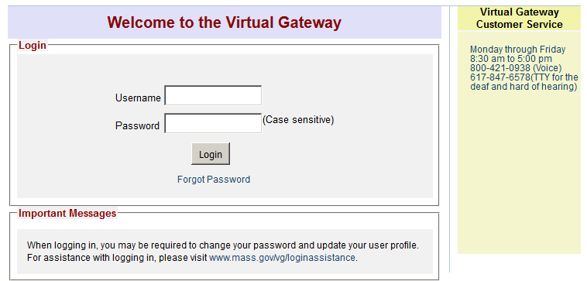
Figure 1: Welcome to the Virtual Gateway page.
From the Welcome to the Virtual Gateway page:
- Enter your VG Username and Password.
From the VG Business Service page:
- Select the Provider Data Management link.
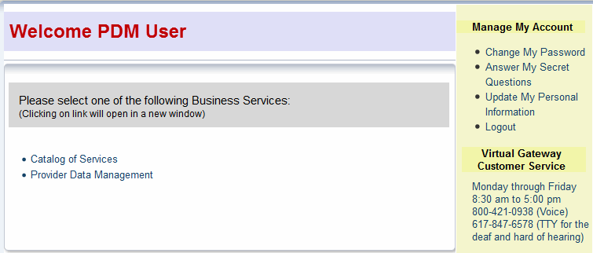
Figure 2: Virtual Gateway Business Service page.
Notes:
- If logging on for the first time, refer to your New User Email for Username and temporary password.
- Refer to the Virtual Gateway Login Assistance (http://www.mass.gov/eohhs/provider/training-and-edu/vg/login-help-for-providers-and-state-agency-staff.html) page for additional guidance on logging on to the Virtual Gateway and account maintenance.
PDM Welcome Page
The Welcome to the Provider Data Management Information System page appears.
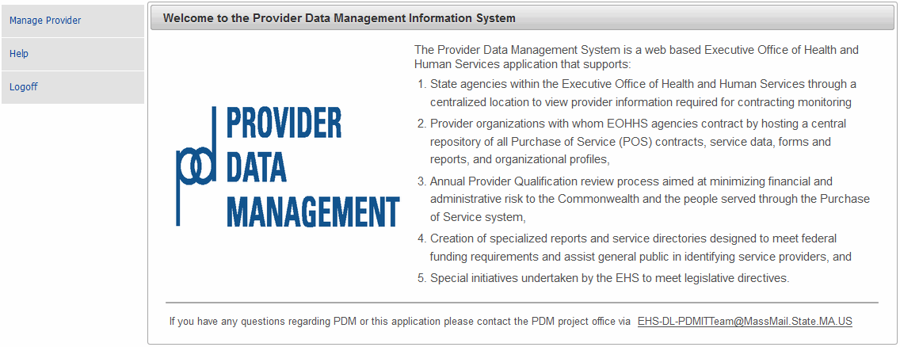
Figure 3: Welcome to the Provider Data Management Information System page.

The options available from the PDM Home Page are briefly described in the table below:
Menu Option | Description
Manage Provider | This option will redirect the user to the applicable page based on the assigned security role of the user and allow user to view qualified provider information about the current services that are being provided.
Help | This option will redirect the user to the PDM User Guide documentation. This documentation is available in Word and PDF format.
Logoff | Exits PDM and redirects the user to the Virtual Gateway Home Page.

Virtual Gateway Customer Service
The Virtual Gateway Customer Service provides login and technical assistance to providers and state Agency staff.
If you have questions on accessing PDM on the Virtual Gateway, contact Virtual Gateway Customer Service for assistance.
- 800-421-0938 (Voice)
- 617-847-6578 (TTY for people who are deaf, hard of hearing, or speech disabled)
- Monday through Friday (8:30 a.m. to 5:00 p.m.)

Questions about the PDM Program
If you have any questions regarding PDM or this application please contact the PDM project office via EHS-DL-PDMITTeam@MassMail.State.MA.US.
This page is intentionally left blank

Chapter 3: Principal Purchasing Agency (PPA) and Agency Observer Roles

OVERVIEW
Principal Purchasing Agency (PPA): The Principal Purchasing Agency (PPA) role allows agency staff to edit and view provider information. This role can also enter information that supports the POS provider evaluation and annual prequalification process; and access predefined agency reports.
Agency Observer: This role allows designated agency staff to view only Provider information and access predefined reports.
PDM Role | Information | Qualifications  (Including Financial Ratio and Corrective Measures) | Contract Detail | Surplus Revenue
Principal Purchasing Agency (PPA) | View | View/Edit | View | View/Edit
Agency Observer | View | View | View | View
Reminders When Using PDM:
- All fields denoted with an asterisk (*) are required fields and must be completed in order to save the record.
- Do not save a record until all sections are completed. If the user tries to save before completing all required fields within each section, the user will receive error messages at the top of the page listing the missing data.
- If you attempt to navigate to another page while in Edit mode without first saving you will receive a warning message (different text depending on the web browser you are working in) such as:
  - Firefox: “This page is asking you to confirm that you want to leave – data you have entered may not be saved.”
  - Internet Explorer: “Are you sure you want to navigate away from this page? This page is asking you to confirm that you want to leave – data you have entered may not be saved. Press OK to continue, or Cancel to stay on the current page.”
For guidance on using JAWS with PDM, refer to Appendix B: JAWS Commands.

PROVIDER SEARCH
The Principal Purchasing Agency (PPA) and Agency Observer both have the ability to search for providers. It is important to know how to search for providers within the database. The search page allows the user to search for an existing Provider in order to manage or view (dependent on role) an existing provider who is active for the current PQ year and who has had a contract with the Commonwealth in the past five years.
Using a name, FEIN or an alphabetical listing the search engine conducts a search of the database to display a provider’s profile.
The Search page is accessed by selecting Manage Provider from the Navigation menu.
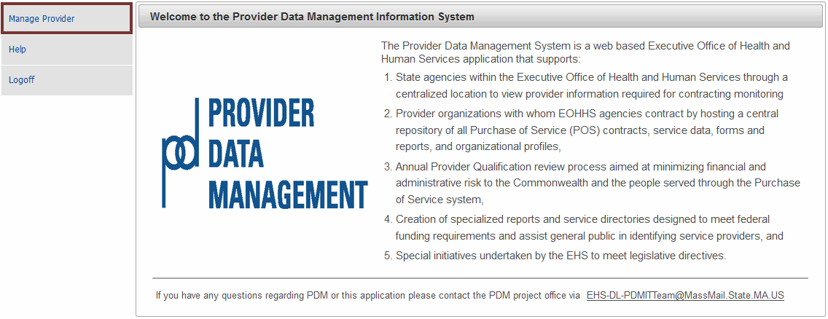
Figure 4: Welcome to the Provider Data Management System page.
The Provider Search page allows users to search for entries in two ways:
- Search By Provider
- Search Alphabetically
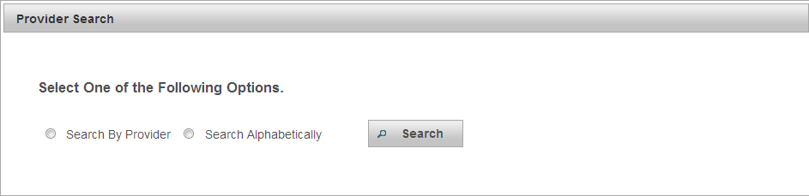
Figure 5: Provider Search page.

Search By Provider
- Select the Search By Provider radio button.
- Select the Search button.
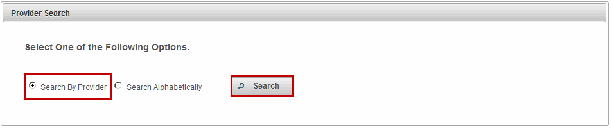
Figure 6: Searching by Provider option.
Note: The Provider Search page allows users to search for records in three ways. Users can search by using one option or a combination of options.
- FEIN (Federal Employment Identification Number)
- Name (Provider Name)
- PPA (Principal Purchasing Agency)
- Type the Name. (Full or Partial name).
There are three buttons under the Provider Search section:
- Search: To conduct a search per entered criteria.
- Clear: To clear criteria from fields.
- Return: To return to the Search option page.
- Select the Search button
The Provider Search page returns with results based off of entered criteria.
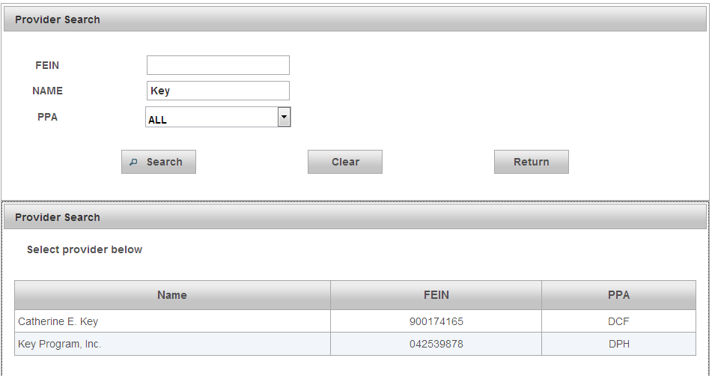
Figure 7: Provider Search page returns with results based off of entered criteria.
Note: Wildcard Search, the * (asterisk) can be used as a wildcard in the name field to search for a provider. If you are unsure of the full name of the provider, or want to see all the options using a portion of a name , use the wild card to search. (i.e. *key will produce Catherine Key, Berkshire* will produce Berkshire Community Center etc., *education* will produce any provider who has the word education in their organization name.)
- Select record to view. The user will be redirected to the PDM Information page.
Search Alphabetically
- Select Search Alphabetically radio button.
- Select the Search button.
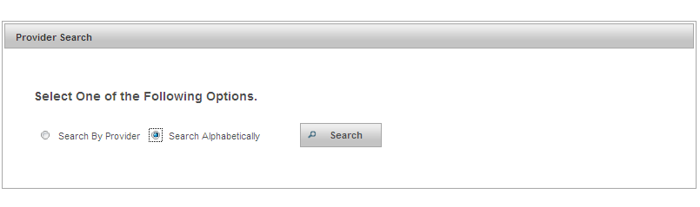
Figure 8: Provider Search - Search Alphabetically.
- Select the Select drop down menu to select the corresponding letter for the Provider Name.
- Select the Search button.
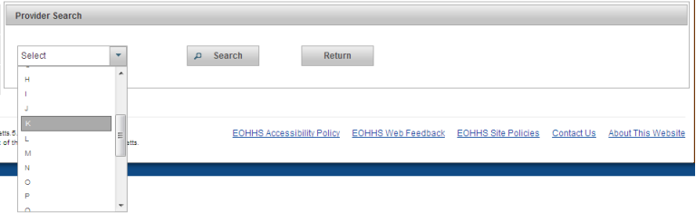
Figure 9: Provider Search - Search Alphabetically by Provider Name.
The Provider Search page returns with results based off of entered criteria.
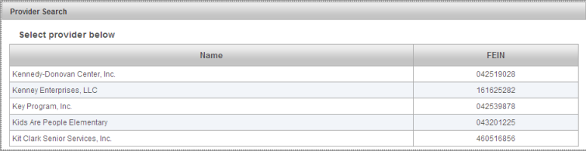
Figure 10: Search Alphabetically - The Provider Search page returns with results based off of entered criteria.
- Select record to view. The user will be redirected to the PDM Information page.

PDM Information Page
The PDM Information page contains demographic information about the selected provider and displays the following information:
- Corporate Contact Information
- Provider’s PDM Contact
- Executive Contacts
- General Corporate Information
Users assigned the Principal Purchasing Agency (PPA) and Agency Observer roles have View only rights on the Information page.
The Information page has the following button located at the bottom of the page:
- Return to Search: Returns user to the Provider Search page.
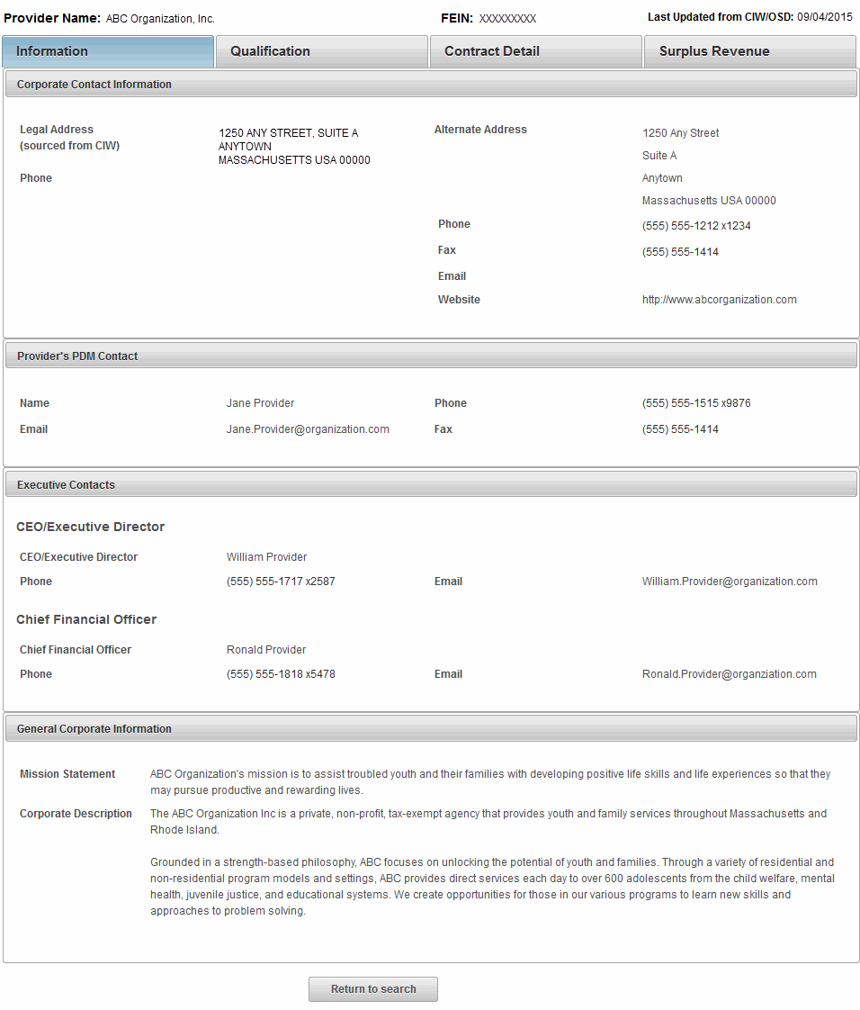
Figure 11: PDM Information page.

PDM Qualification Page
The PDM Qualification page is populated when the EOHHS Principal Purchasing Agency (PPA) Provider Qualification Officer (PQO) completes the review process. The PDM system calculates these fields using data from Provider’s UFR filing from OSD data feed and cannot be edited.
A user assigned the Principal Purchasing Agency (PPA) role can edit specific data fields on this page.
A user assigned the Agency Observer role has View only rights.
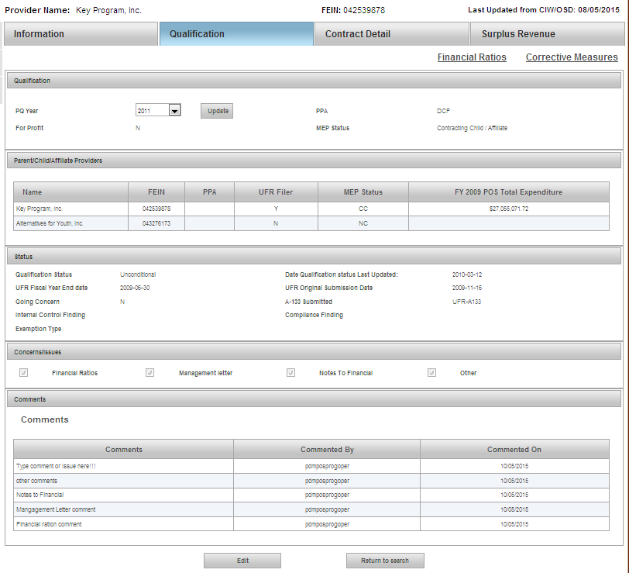
Figure 12: PDM Qualification page.
Qualification – Viewing PQ Year
PDM maintains the current PQ year along with previous years. The Qualifications page defaults to the current PQ Year. To view a prior year,
- Select the PQ Year drop down arrow and select the Year to be viewed.
- Select the Update button.
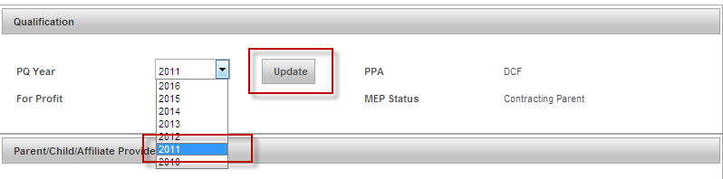
Figure 13: Under the Qualifications page, changing the PQ Year to 2011 and selecting the Update button.
Note: Each time the PQ Year is selected it must be followed by selecting the update button to ensure all data is up to date per the selection.
A user with the Principal Purchasing Agency (PPA) role can edit the following sections on the Qualifications page:
- Qualification Status
- Concerns / Issues
- Comments
- Select the Edit button at the bottom of the page.
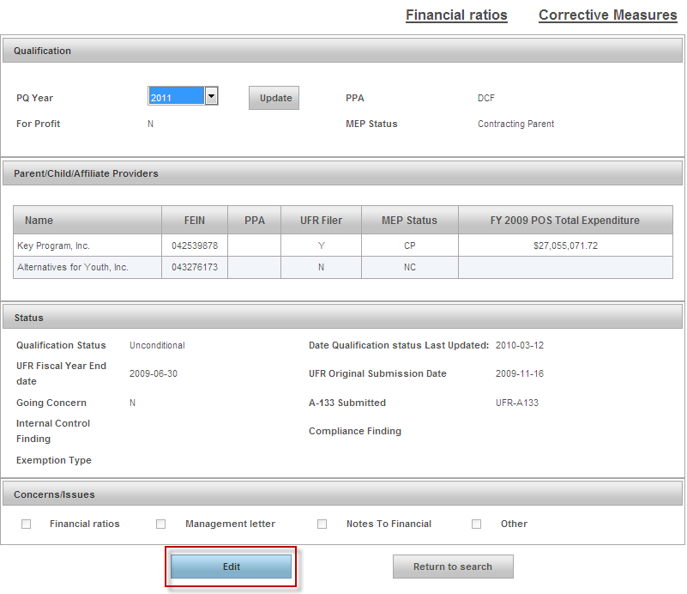
Figure 14: Selecting the Edit button on the Qualification page.
Parent/Child/Affiliate Providers
The Parent/Child/Affiliate Providers section allows the Principal Purchasing Agency (PPA) and Agency Observer to view the other providers associated to this provider.
Note: Parent/Child/Affiliate Providers information will only be visible if the Provider has Child or Affiliate Providers.
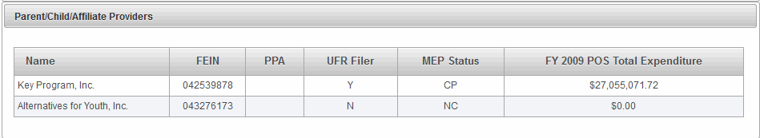
Figure 15: Parent/Child/Affiliate Providers section under the Qualification page.
- Select record to view. The user will be redirected to the PDM Information page for that provider organization.
Status
The Status section allows the PPA to update the Qualification Status.
To update the Qualification Status field,
- Select the Qualification Status drop down arrow and select one of the following options:
  - Conditional
  - Limited
  - No POS Business
  - Pending
  - Provisional
  - Public Entity
  - Qualification with CAP
  - Rejected
  - Unconditional
- Select the Save button.
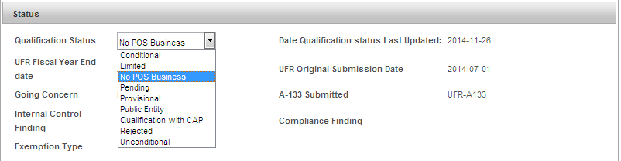
Figure 16: Status section under the Qualification page.

Concerns/Issues
A user with the Principal Purchasing Agency (PPA) role can edit the Concerns/Issues section. If a checkmark is placed in any one of the checkboxes, the user will need to add an explanation one the Corrective Measures page. Refer to the Corrective Measures in this chapter for more information.
Figure 17: Concerns/Issues section on the Qualification page.
Comments
A user with the Principal Purchasing Agency (PPA) role can add /delete comments in this section.
To Add a Comment:
- Type the Comments you desire in the Comment field.
- Select the Save button.
The comment will display in the comments dialog box.
To Delete a Comment:
- Select the Delete link.
- Select the Save button.
Note: Only the author can edit and/or delete his or her own comments.
The graphic below represents comments added along with highlighting the Delete option.
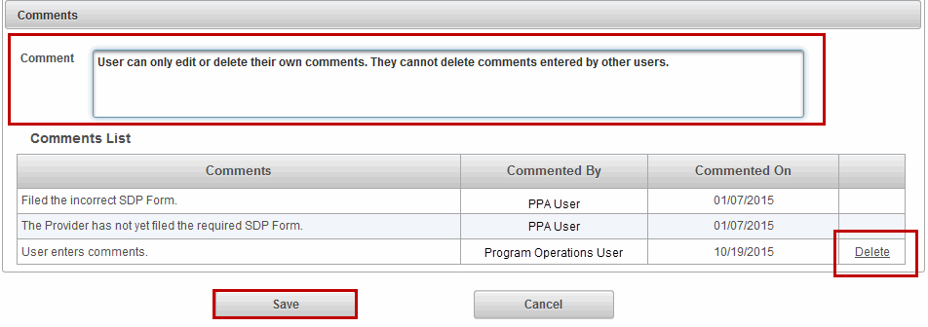
Figure 18: Comments section on the Qualification page.
Note: A reminder that if you navigate away from any page while in Edit mode without saving, PDM will prompt a Warning screen.

PDM Qualification – Financial Ratios
The Financial Ratios page contains vital financial ratios for current and past two years.
- Select the Financial Ratios link
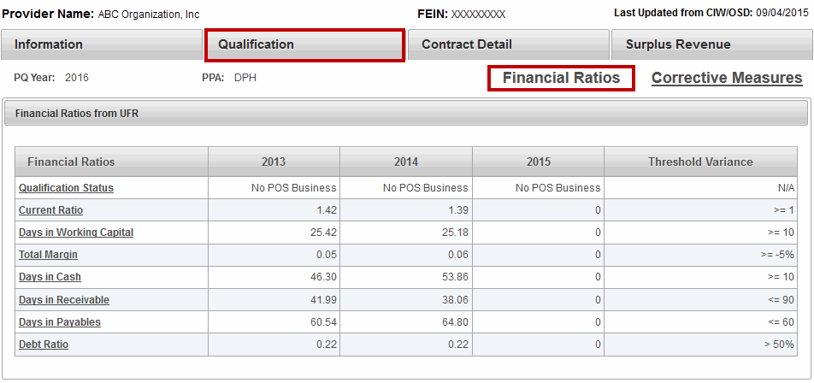
Figure 19: Highlighting the Financial Ratios page from the Qualification page.
The Financial Ratios page displays the last 3 fiscal years prior to the PQ year selected.
- Select any one of the links in the first column to open the Financial Ratios Definitions page.
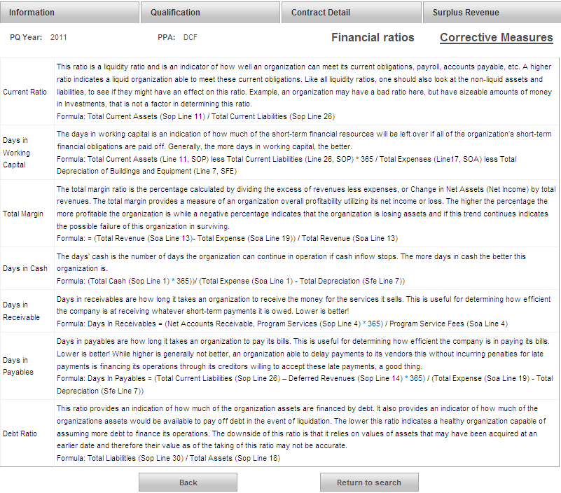
Figure 20: Financial Ratios page which is under Qualification.
- Select Back to open the Financial Ratios page or select Return to search to open the Provider Search page.

PDM Qualification – Corrective Measures
The Corrective Measures page is part of Provider Profile and contains corrective measures.
Under the UFR Audit Findings section, if the Status field has a ‘YES’ this indicates that a checkmark was entered selected under the Qualification page for the Internal Control, Compliance, Financial Ratios, Management Letter, Notes to Financials, or Other. While an optional field, it is recommended that the PPA enter an explanation under UFR Audit Findings when the status is ‘YES’.
- Select Edit at the bottom of the page.
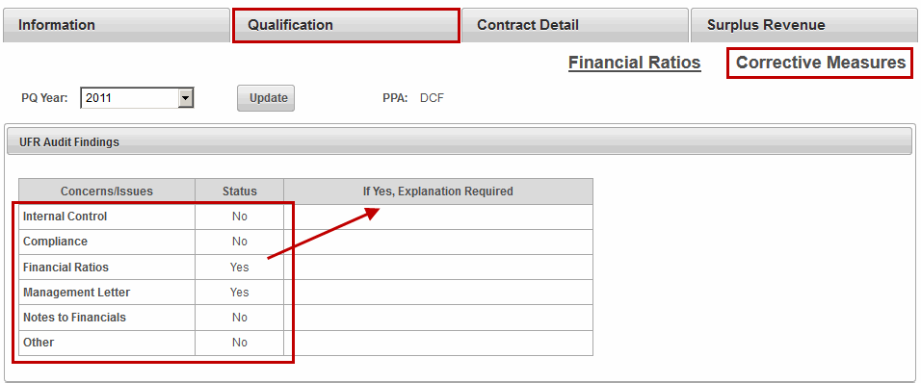
Figure 21: Corrective Measures page highlighting the Concerns/Issues section which requires explanation when "Yes" is displayed.
- Type an explanation for each Concerns/Issues with a ‘Yes’ in the Status field.
- Select the Save button.
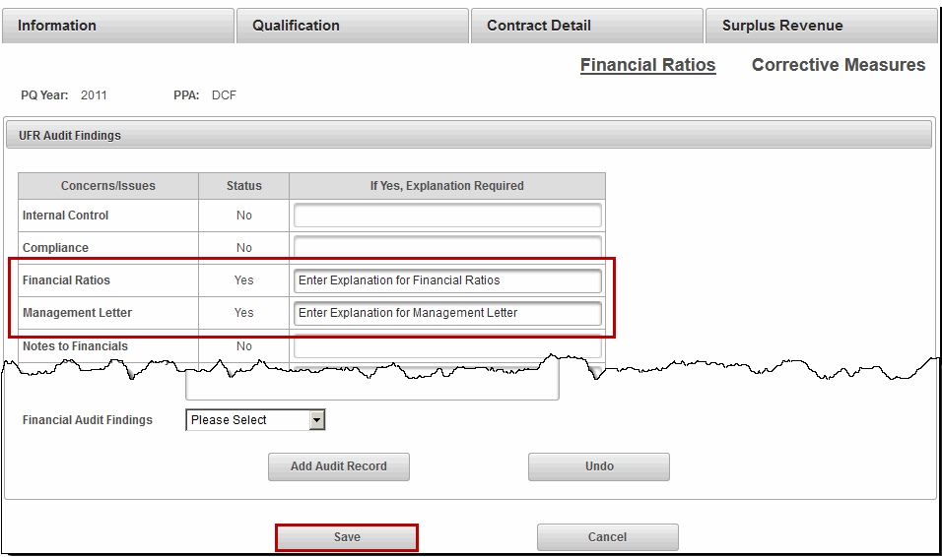
Figure 22: Completed Concerns/Issues section under Corrective Measures page.
The Corrective Action Plan is updated by data on the UFR and by OSD/CIW. This is a View only section.
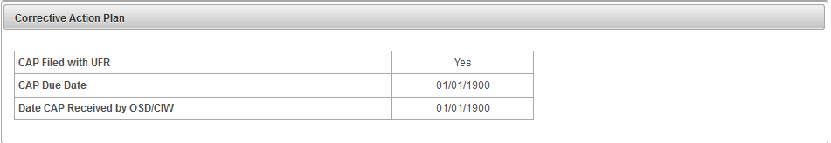
Figure 23: Corrective Action Plan section under the Corrective Measures page.
The Audit Records (OSA AUDIT) section can be updated by the PPA.
- Type the Audit Number.
- Type the Issue Date. (Format: DD/MM/YYYY or
- Select the CAP Status. (Options: Open or Close)
- Type the Audit Resolution Summary.
- Select Financial Audit Findings. (Options: Yes or No)
- Select the Add Audit Record.
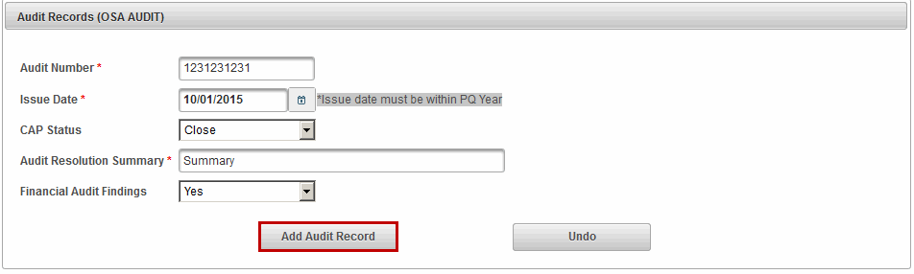
Figure 24: Audit Records (OSA Audit) section under the Corrective Measures page.

PDM CONTRACT DETAILS
The Contract Detail page stores information about the POS Provider’s contracts for the current fiscal year such as Activity Code, Activity Name, Doc ID, Object Code, Maximum Contract Obligation, Expended to Date, and Unexpended Amount. For Release 5.0 PDM will only display contracts with Object Codes MM3 and M03.
The Principal Purchasing Agency (PPA) and Agency Observer roles allow designated staff from within the organization to view this page. These roles do not have Edit rights on this page.
Note: The information found under Contract Details is sourced from the Commonwealth’s Information Warehouse. Information about services offered, but not contracted through EOHHS is entered by the provider.
This page provides the Purchasing Agency (PPA) and Agency Observer with a snapshot of all of current year contracts, by EOHHS agency.
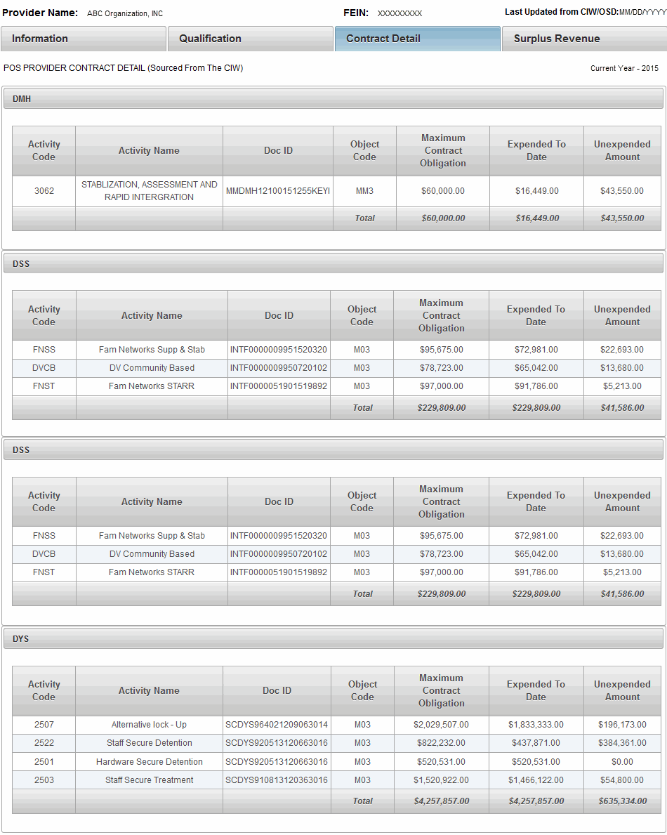
Figure 25: Contract Detail page lists all contracts a provider has with EOHHS agencies.

PDM SURPLUS REVENUE
The Surplus Revenue page is primarily used by the Principal Purchasing Agency (PPA) to record and retain an account of the surplus revenue liability based on the Annual SSR of 5% limit. If an excess 5% Surplus Revenue Liability exists, the Principal Purchasing Agency utilizes the corresponding fields below to provide an accounting of the negotiation with the Provider to satisfy the liability owed the Commonwealth.
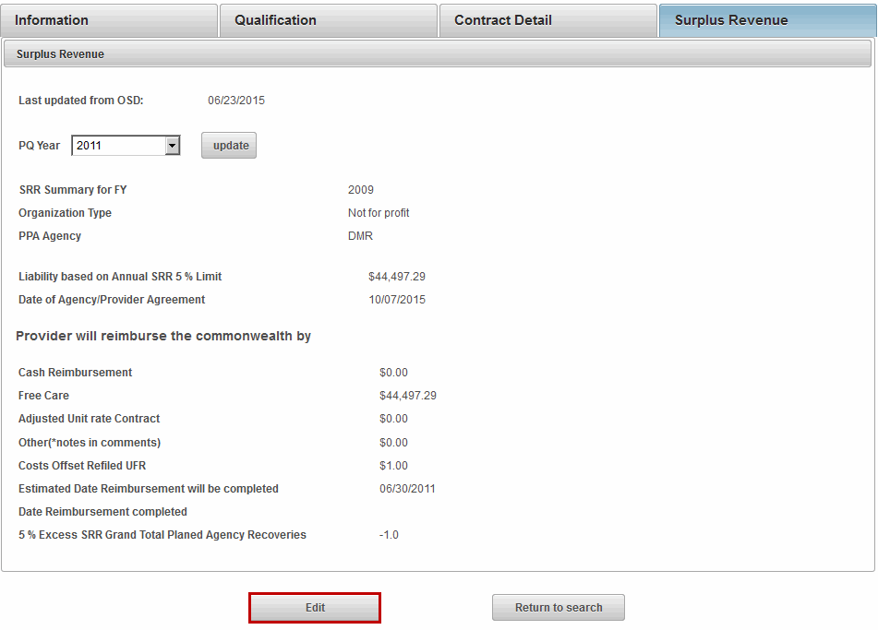
Figure 26: PDM Surplus Revenue page.
The Principal Purchasing Agency (PPA) can edit the following fields on the Surplus Revenue page:
- Date of Agency/Provider Agreement
- Cash Reimbursement
- Free Care
- Adjusted Unit Rate Contract
- Other (*notes in comments)
- Costs Offset Refiled UFR
- Estimated Date Reimbursement will be completed
- Date Reimbursement completed
- Comments
After entering in the information, the PPA selects the Save button.
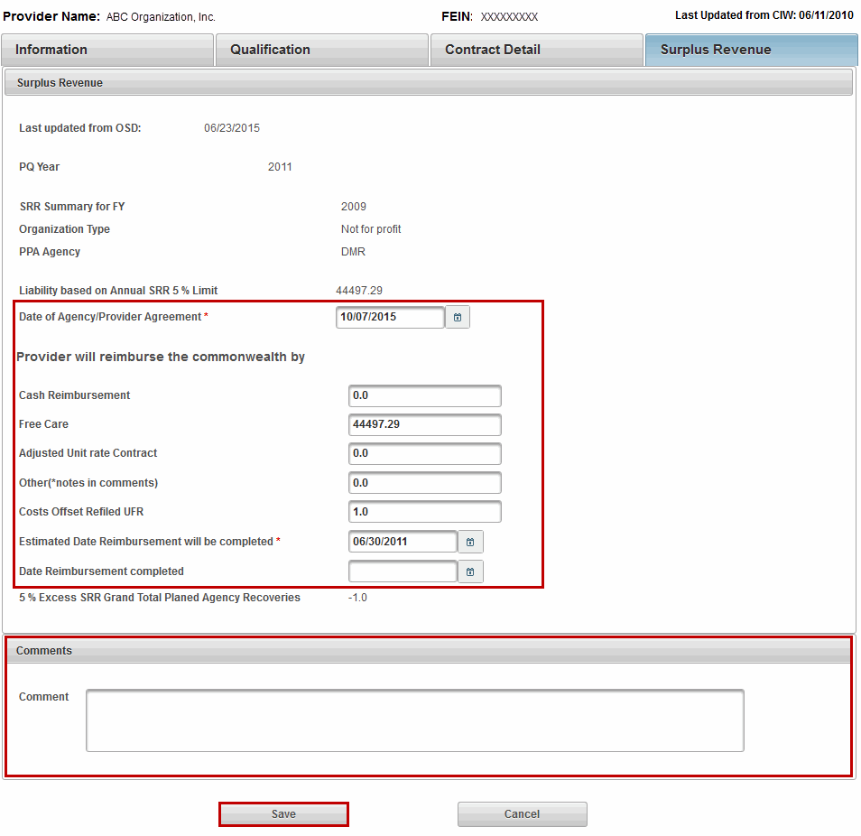
Figure 27: PDM Surplus Revenue page in Edit mode.

Chapter 4: POS Program Operations Role

OVERVIEW
This role allows POS Operations staff to Add and Manage Providers in the system. This role also has access to edit capability and the ability to assign PPAs. In addition this role has access to the reports menu.
POS Program Operations This role allows POS Program Operations access the provider PDM records. POS Program Operations with this access have the capability to edit and update information.
PDM Role | Information | Qualifications  (Including Financial Ratio and Corrective Measures) | Contract Detail | Surplus Revenue
POS Program Operations | View/Edit | View/Edit | View | View/Edit
Reminders When Using PDM:
- All fields denoted with an asterisk (*) are required fields and must be completed in order to save the record.
- Do not save a record until all sections are completed. If the user tries to save before completing all required fields within each section, the user will receive error messages at the top of the page listing the missing data.
- If you attempt to navigate to another page while in Edit mode without first saving you will receive a warning message (different text depending on the web browser you are working in) such as:
  - Firefox: “This page is asking you to confirm that you want to leave – data you have entered may not be saved.”
  - Internet Explorer: “Are you sure you want to navigate away from this page? This page is asking you to confirm that you want to leave – data you have entered may not be saved. Press OK to continue, or Cancel to stay on the current page.”
For guidance on using JAWS with PDM, refer to Appendix B: JAWS Commands.

PROVIDER SEARCH
A user with the POS Program Operations role has the ability to search for providers. It is important to know how to search for providers within the database. The search page allows the user to search for an existing Provider in order to manage or view (dependent on role) an existing provider who is active for the current PQ year and who has had a contract with the Commonwealth in the past five years.
Using a name, a portion of a name or an alphabetical listing the search engine conducts a search of the database to display a provider’s profile.
The Search page is accessed by selecting Manage Provider from the Navigation menu.
Figure 28: Welcome to the Provider Data Management Information System page.
The Provider Search page allows users to search for entries in two ways:
- Search By Provider
- Search Alphabetically
Figure 29: Provider Search page

Search By Provider
- Select the Search By Provider radio button.
- Select the Search button.
Figure 30: Searching by Provider option.
Note: The Provider Search page allows users to search for records in three ways. Users can search by using one option or a combination of options.
- FEIN # (Federal Employment Identification Number)
- Name (Provider Name)
- PPA (Principal Purchase Agency)
- Type the Name. (Full or Partial name).
There are three buttons under the Provider Search section:
- Search: To conduct a search per entered criteria.
- Clear: To clear criteria from fields.
- Return: To return to the Search option page.

- Select the Search button.
The search results page open.
Figure 31: Provider Search page returns with results based off of entered criteria
- Select record to view. The user will be redirected to the PDM Information page.
Note: Wildcard Search, the * (asterisk) can be used as a wildcard in the name field to search for a provider. If you are unsure of the full name of the provider, or want to see all the options using a portion of a name , use the wild card to search. (i.e. *key will produce Catherine Key, Berkshire* will produce Berkshire Community Center etc., *education* will produce any provider who has the word education in their organization name.)
Search Alphabetically
- Select Search Alphabetically radio button.
- Select the Search button.
Figure 32: Provider Search - Search Alphabetically
- Select the Select drop down menu to select the corresponding letter for the Provider Name.
- Select the Search button.
Figure 33: Provider Search - Search Alphabetically by Provider Name.
The Provider Search page returns with results based off of entered criteria.
Figure 34: Search Alphabetically - The Provider Search page returns with results based off of entered criteria.

- Select record to view. The user will be redirected to the PDM Information page.

PDM INFORMATION
The Information page stores demographic information about a Provider such as Corporate Contact Information, Provider’s PDM Contact, Executive Contact, and General Corporate Information (Mission Statement and Corporate Description).
After a user with the POS Program Operation role searches for and selects a provider record they are redirected to the PDM Information page.
Users assigned the POS Program Operations role have View and Edit rights on the Information page.
The Information page has two buttons located at the bottom of the page:
- Edit: The Edit button will appear for users with the PDM Contracted Providers Operations role.
- Return to Search: Returns user to the Provider Search page.
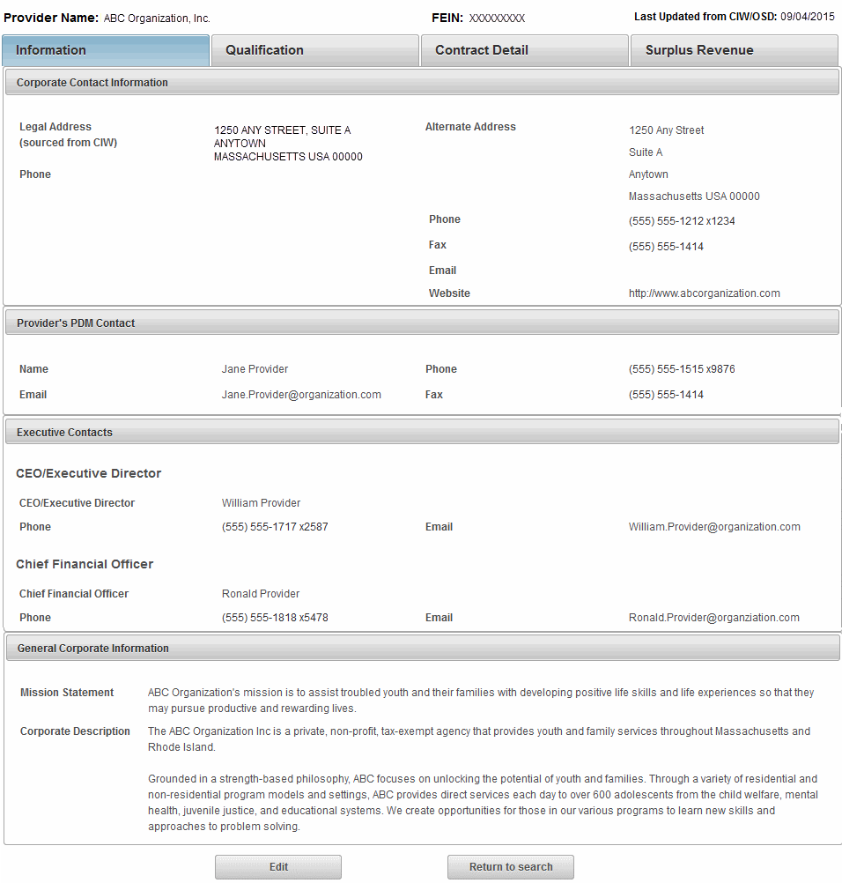
Figure 35: PDM Information page.
Corporate Contact Information
Under Corporate Contact Information the following fields can be edited by a user with the POS Program Operation role:
- Alternate Address
- Phone, Fax
- Email, Website
Note: The Provider Name, FEIN and Legal Address fields are not editable. This data comes from the Commonwealth’s Information Warehouse (CIW).
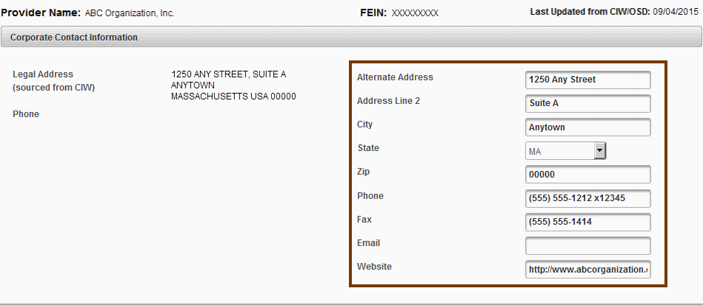
Figure 36: Fields that can be updated on Information > Corporate Contact Information section of the Information page.
If only updates to the Corporate Contact Information section are needed, select the Save button at the bottom of the page.
Provider’s PDM Contact
Under Provider’s PDM Contact the following fields can be edited by a user with the POS Program Operation role:
- First, Middle, and Last
- Phone, Email, Fax
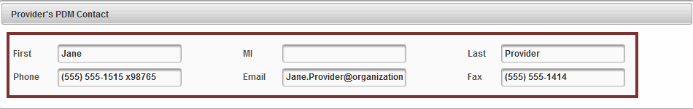
Figure 37: Fields that can be updated on Information > Provider's PDM Contact section of the Information page.
If only updates to the Provider’s PDM Contact section are needed, select the Save button at the bottom of page.

Executive Contacts
Under Executive Contacts > CEO/Executive Director the following fields can be edited by a user with the POS Program Operation role:
- First, Middle, and Last
- Phone, Email
Under Executive Contacts > Chief Financial Officer the following fields can be edited by a user with the POS Program Operation role:
- First, Middle, and Last
- Phone, Email
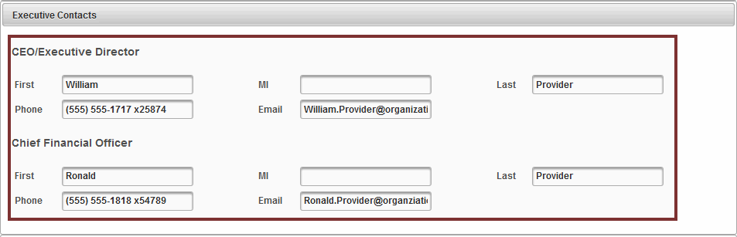
Figure 38: Fields that can be updated on Information > Executive Contacts section of the Information page.
If only updates to the Executive Contacts section are needed, select the Save button at the bottom of page.
General Corporate Information/ Mission Statement
Under General Corporate Information the following field can be edited by a user with the POS Program Operation role:
- Mission Statement
- Corporate Description
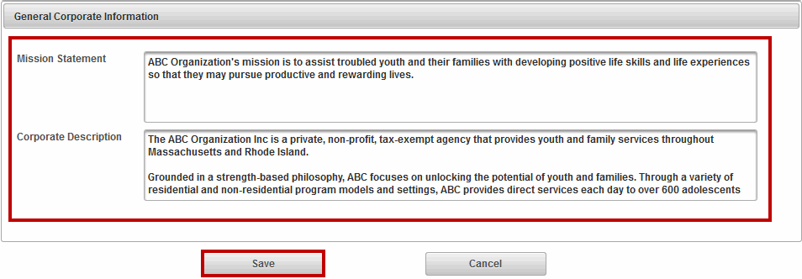
Figure 39: Fields that can be updated on Information > General Corporate Information section on the Information page.
If only updates to the General Corporate Information section are needed, select the Save button at the bottom of page.

PDM Qualification
The PDM Qualification page is populated when the EOHHS Principal Purchasing Agency (PPA) Provider Qualification Officer (PQO) completes the review process. The PDM system calculates the financial ratios field using data from Provider’s UFR filing from OSD data feed and cannot be edited.
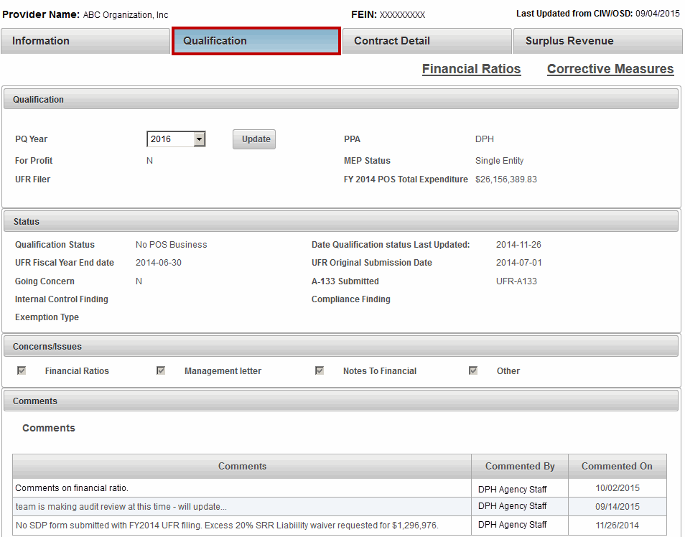
Figure 40: PDM Qualification page.
Qualification – Viewing PQ Year
PDM maintains the current PQ year along with previous years. The Qualifications page defaults to the current PQ Year.
To view a prior PQ Year,
- Select the PQ Year drop down arrow and select the Year to be viewed.
- Select the Update button.
Figure 41: Under the Qualifications page, changing the PQ Year to 2011 and selecting the Update button.
Note: Each time the PQ Year is selected it must be followed by selecting the update button to ensure all data is up to date per the selection.
The Qualification page now displays the data corresponding to PQ Year 2011.
A user assigned the POS Program Operation role can update the following fields:
- PPA, MEP Status, Qualification Status
- Concerns / Issues, Comments
- Select the Edit button at the bottom of the page.
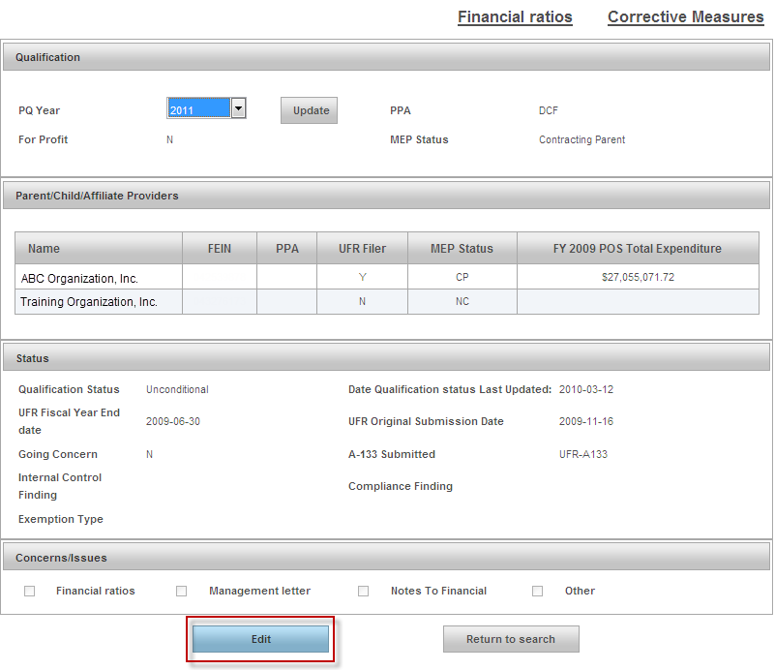
Figure 42: Selecting the Edit button on the Qualification page.

Qualification
Under the Qualification section, a user with the POS Program Operation role can edit and update the following fields:
- PPA (Principal Purchasing Agent)
- MEP Status (Multiply Entity Provider)
- Qualification Status
- Concerns/Issues/Comments
Note: The PPA field displays the agency associated to the contract in PDM. Contracts feed over from the CIW with DMR, DSS and WEL associated with the contract, but those department names have changed. For prequalification purposes DMR contracts need to be associated with DDS contract, DSS contracts with DCF; and WEL contracts with DTA.
- Select the PPA drop down arrow and select correct agency code.
- Select the Save button.
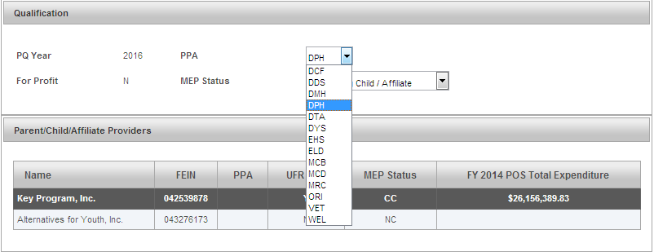
Figure 43: Selecting the PPA on the Qualification page.
The MEP Status field can be updated.
- Select the MEP Status drop down arrow and select the MEP Status.
MEP Status field has the following options:
- Contracting Child/Affiliate
- Contracting Parent
- Non Contracting Child/Affiliate
- Non Contracting Parent
- Single Entity
- Select the Save button.
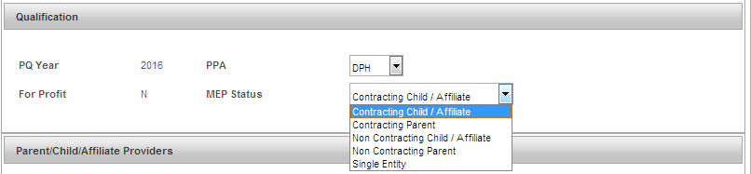
Figure 44: Selecting the MEP Status on the Qualification page.
Parent/Child/Affiliate Providers
The Parent/Child/Affiliate Providers section allows the POS Program Operation staff person to view and update, if needed, the other providers associated to this provider.
Note: Parent/Child/Affiliate Providers information will only be visible if the Provider has Child or Affiliate Providers.
Figure 45: Parent/Child/Affiliate Providers section under the Qualification page.
- Select record to view. The user will be redirected to the PDM Information page for that provider organization.
Status
The Status section allows the POS Program Operation staff person to update the Qualification Status.
- Select the Qualification Status drop down arrow and select one of the following options:
  - Conditional
  - Limited
  - No POS Business
  - Pending
  - Provisional
  - Public Entity
  - Qualification with CAP
  - Rejected
  - Unconditional
- Select the Save button.
Figure 46: Status section under the Qualification page.

Concerns/Issues
A user with the Principal Purchasing Agency (PPA) role can edit the Concerns/Issues section. If a checkmark is placed in any one of the checkboxes, the user will need to add an explanation one the Corrective Measures page. Refer to the Corrective Measures in this chapter for more information.
Figure 47: Concerns/Issues section under the Qualification page.
Comments
A user with the Principal Purchasing Agency (PPA) role can add /delete comments in this section.
To Add a Comment:
- Type the Comments you desire in the Comment field.
- Select the Save button.
The comment will display in the comments dialog box.
To Delete a Comment:
- Select the Delete link.
- Select the Save button.
Note: Only the author can edit and/or delete his or her own comments.
The graphic below represents comments added along with highlighting the Delete option.
Figure 48: Comments section under the Qualification page.

Note: A reminder that if you navigate away from any page while in Edit mode without saving, PDM will prompt a Warning screen.

PDM Qualification – Financial Ratios
The Financial Ratios tab contains vital financial ratios for current and previous two fiscal years.
- Select the Financial Ratios link.
Figure 49: Highlighting the Financial Ratios page from the Qualification page.
- Select any of the links in the first column to open the definitions page.
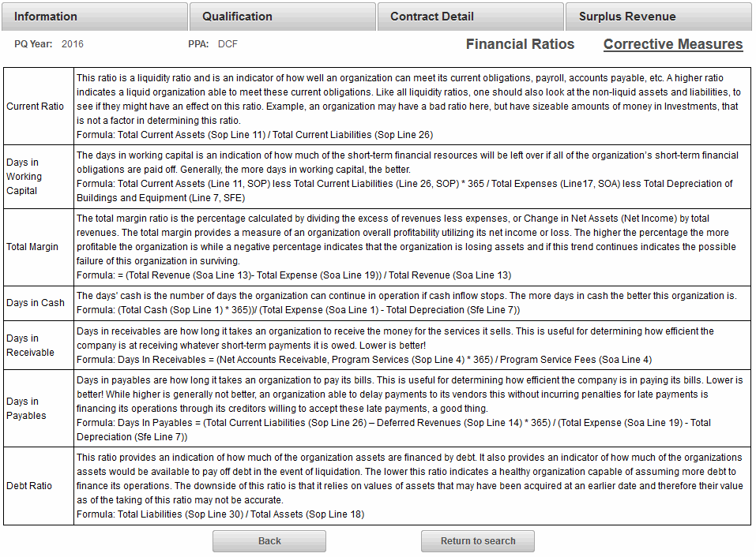
Figure 50: Financial Ratios page which is under Qualification.
- Select Back to return to the main Qualification page or select Return to search to open the search page.

PDM Qualification – Corrective Measures
The Corrective Measures page is part of Provider Profile and contains Corrective measures along with comments.
Under the UFR Audit Findings section, if the Status field has a ‘YES’ this indicates that a checkmark was entered selected under the Qualification page for the Financial Ratios, Management Letter, Notes to Financials, or Other. While an optional field, it is recommended that the PPA enter an explanation under UFR Audit Findings when the status is ‘YES’. Select Edit at the bottom of the page
Figure 51: Corrective Measures page highlighting the Concerns/Issues which requires explanation when "Yes" is displayed.
- Type an explanation for each Concerns/Issues with a ‘Yes’ in the Status field.
- Select the Save button.
Figure 52: Completed Concerns/Issues section under Corrective Measures page.
The Corrective Action Plan is updated by data on the UFR and by OSD/CIW. This is a View only section.
Figure 53: Corrective Action Plan section under the Corrective Measures page.
The Audit Records (OSA AUDIT) section can be updated by the PPA.
- Type the Audit Number.
- Type the Issue Date. (Format: DD/MM/YYYY or
- Select the CAP Status. (Options: Open or Close)
- Type the Audit Resolution Summary.
- Select Financial Audit Findings. (Options: Yes or No)
- Select the Add Audit Record.
Figure 54: Audit Records (OSA Audit) section under the Corrective Measures page.

PDM CONTRACT DETAILS
The Contract Detail page stores information about the POS Provider’s contracts for the current fiscal year such as Activity Code, Activity Name, Doc ID, Object Code, Maximum Contract Obligation, Expended to Date, and Unexpended Amount. For Release 5.0 PDM will only display contracts with Object Codes MM3 and M03. The POS Program Operation role allows designated staff from within the organization to view this page. This role does not have Edit rights on this page.
Note: The information found under Contract Details is sourced from the Commonwealth’s Information Warehouse. Information about services offered, but not contracted through EOHHS is entered by the provider.
This page provides the POS Program Operations staff with a snapshot of all of current year contracts, by EOHHS agency.
Figure 55: Contract Detail page lists all contracts a provider has with EOHHS agencies.

PDM SURPLUS REVENUE
The Surplus Revenue page is primarily used by the Principal Purchasing Agency (PPA) to record and retain an account of the surplus revenue liability based on the Annual SSR of 5% limit. If an excess 5% Surplus Revenue Liability exists, the Principal Purchasing Agency utilizes the corresponding fields below to provide an accounting of the negotiation with the Provider to satisfy the liability owed the Commonwealth.
Figure 56: PDM Surplus Revenue page.
A user assigned the POS Program Operation role can edit the following fields on the Surplus Revenue page:
- Date of Agency/Provider Agreement
- Cash Reimbursement
- Free Care
- Adjusted Unit Rate Contract
- Other (*notes in comments)
- Costs Offset Refiled UFR
- Estimated Date Reimbursement will be completed
- Date Reimbursement completed
- Comments
After entering in the information, the PPA selects the Save button.
Figure 57: PDM Surplus Revenue page in Edit mode.

This page is intentionally left blank

Chapter 5: DDS Program Operations and DDS Operations Observer Roles

OVERVIEW
The DDS Program Operations and DDS Operations Observer have access to and maintain the Service Directory in PDM. The Service Directory is a tool for consumers, their families, and circle of support to search for services and service providers in the Commonwealth of Massachusetts. The data in the Service Directory is maintained in PDM by users assigned the DDS Program Operations role and they have the ability to add, modify and delete data in the Service Directory pending approval from appropriate source within DDS. Clients looking for provider services in their area can be referred to the Service Directory website at https://service.hhs.state.ma.us/pdm4public/ssdHome.jsp.
DDS Program Operations: This role allows designated DDS Program staff access to the Providers associated to DDS waivers and services. These users will have access to add and manage providers, as well as waiver services. In addition they will have the capability to manage the Providers Service Directory Profile. Finally, they will have access to reports menu.
DDS Operations Observer: This role allows designated DDS staff to view only Provider information and predefined reports.
PDM Security Role | Service Directory
DDS Program Operations | Add/Edit/Delete/View
DDS Operations Observer | View
Reminders When Using PDM:
- All fields denoted with an asterisk (*) are required fields and must be completed in order to save the record.
- Do not save a record until all sections are completed. If the user tries to save before completing all required fields within each section, the user will receive error messages at the top of the page listing the missing data.
- If you attempt to navigate to another page while in Edit mode without saving, you will receive a warning message (different text depending on the web browser you are working in) such as:
  - Firefox: “This page is asking you to confirm that you want to leave – data you have entered may not be saved.”
  - Internet Explorer: “Are you sure you want to navigate away from this page? This page is asking you to confirm that you want to leave – data you have entered may not be saved. Press OK to continue, or Cancel to stay on the current page.”
For guidance on using JAWS with PDM, refer to Appendix B: JAWS Commands.

PROVIDER SEARCH
The DDS Program Operations and DDS Operations Observer both have the ability to search for providers. In order to view provider records in PDM a search is required. The Search page is accessed by selecting Manage Provider from the Navigation menu.
Figure 58: Welcome to the Provider Data Management Information System page.
The Provider Search page allows users to search for entries in three ways:
- FEIN (Federal Employee Identification Number)
- Name (Provider Name)
- Waiver Program (Specific DDS program)
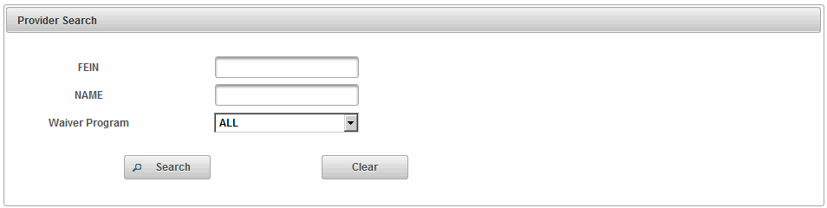
Figure 59: Provider Search page.
Search by FEIN:
- Type in FEIN. (9-digits in length)
- Select the Search button.
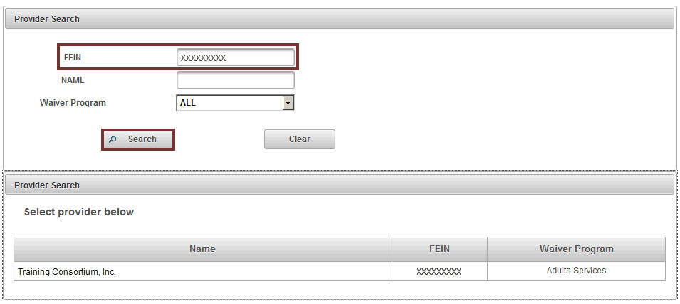
Figure 60: Provider Search page returns with results based off of entered criteria - FEIN.
Search by Name:
- Type in Name (Full or Partial name).
Note: Wildcard Search, the * (asterisk) can be used as a wildcard in the name field to search for a provider. If you are unsure of the full name of the provider, or want to see all the options using a portion of a name , use the wild card to search. (i.e. *key will produce Catherine Key, Berkshire* will produce Berkshire Community Center etc., *education* will produce any provider who has the word education in their organization name.)
- Select the Search button.
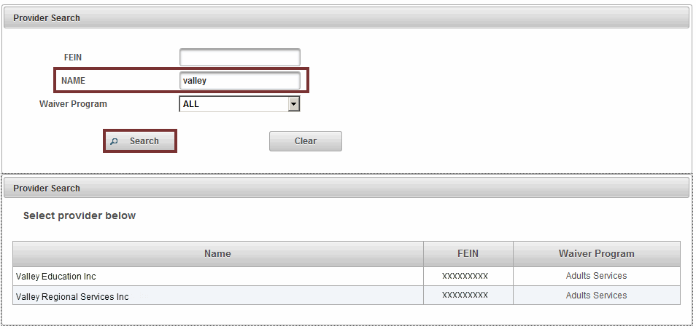
Figure 61: Provider Search page returns with results based off of entered criteria - Name.
Search by Waiver:
- Select the Waiver Program drop down menu.
Available Programs:
- ALL (Default)
- Adults Services
- Autism Spectrum Services
- Select the Search button.
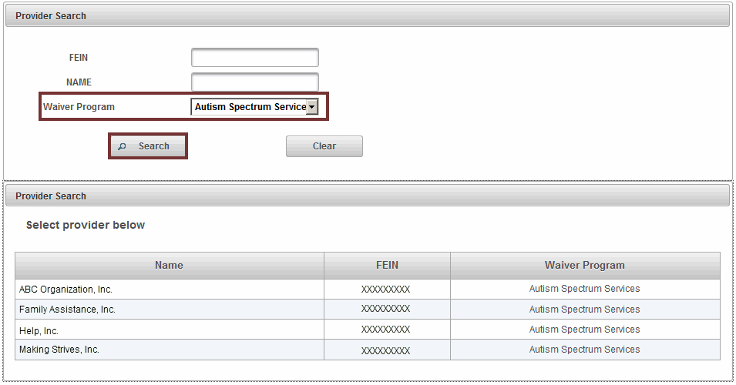
Figure 62: Provider Search page returns with results based off of entered criteria - Waiver Program.

SERVICE DIRECTORY
Once the Provider Search is executed and requested results are displayed, the user selects the Provider record by clicking in the row which redirects the user to the Service Directory page.
The Service Directory page lists the following information:
- Provider’s Details
- Other Contact Information
- Service Information
Users assigned the DDS Program Operations role have Read rights access along with add/modify in the Service Directory. The DDS Observer has Read rights only.
Based on assigned role, the Service Directory page will display the following buttons at the bottom of the page:
- DDS Program Operations: Edit and Return to Search
- DDS Observer: Return to Search
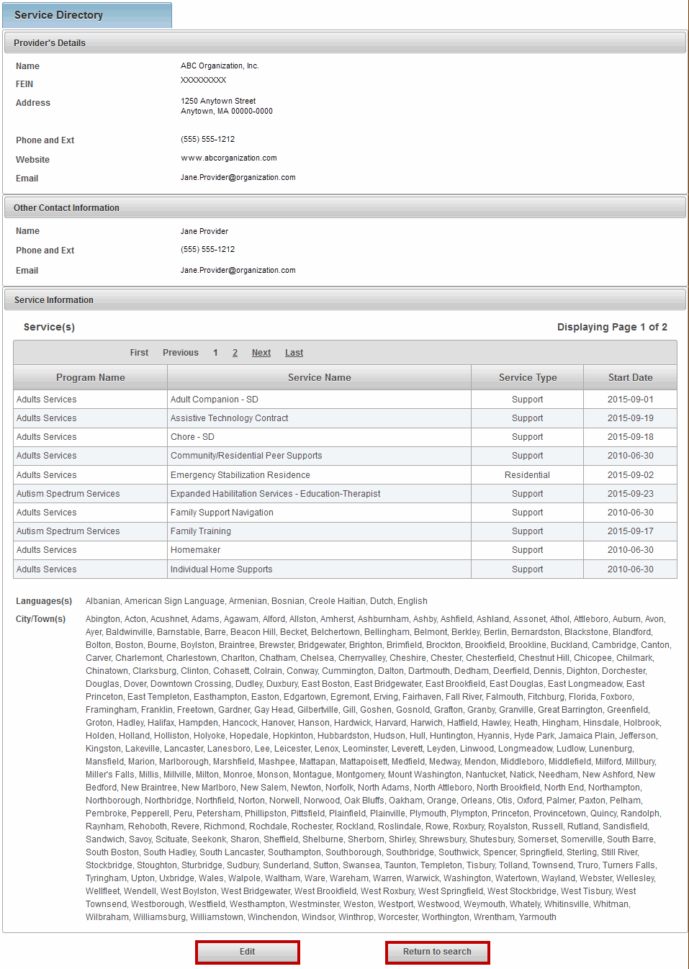
Figure 63: Service Directory page with Edit button highlighted.

UPDATE SERVICE DIRECTORY
A user with the DDS Program Operations role has the access rights to add/modify/delete information on the Service Directory page.

Provider's Details
Note: The Name and FEIN fields are not editable. The data comes from the Commonwealth’s Information Warehouse (CIW).
Under Provider’s Detail the following fields can be edited by a user with the DDS Program Operations role:
- Address Line 1 *, Address Line 2
- City *, State *, Zip *
- Phone and Ext *
- Website, Email
If only updates to the Provider’s Detail section are needed,
- Select the Edit button.
- Update information as needed.
- Select the Save button.

Other Contact Information
Under Other Contact Information the following fields can be edited by a user with the DDS Program Operations role:
- First *, Last *
- Phone and Ext *
- Email
If only updates to the Other Contact Information section are needed,
- Select the Edit button.
- Update information as needed.
- Select the Save button.
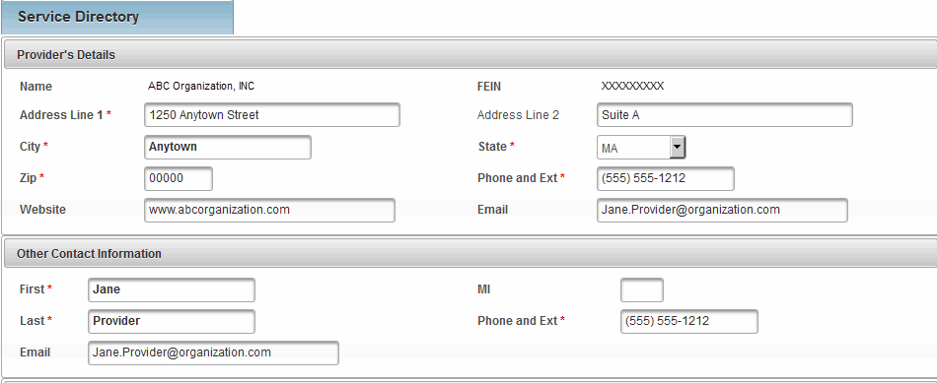
Figure 64: Service Directory page with Provider's Details and Other Contact Information displayed.

Service Information
The Service Information section (when in Edit mode) allows a user to add/modify/delete service information.
Searching for an Existing Service
The Select Service section in the Service Directory displays 10 records at a time on the page. If more than 10 records exist the user should use the link First Previous 1 2 Next Last to navigate and locate the record.
There are two buttons under the Service Information section:
- Add/Modify Service: To save or modify a record in Service Directory.
- Delete Service: To delete a record in Service Directory.
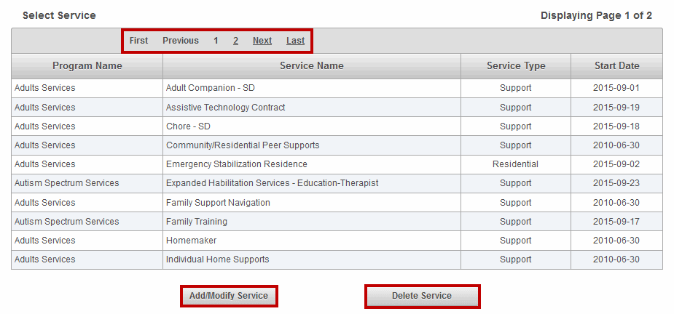
Figure 65: Service Directory page displayed with highlight around First Previous Next Last navigation links and the Add/Modify Service and Delete buttons.

ADD SERVICE
When a new service needs to be added a user with the DDS Program Operations role can add the service to the Service Directory.
- Search and select Provider from the Provider Search page.
- Select the Edit button from the Service Directory page.
- Select the Program Type * from the drop down menu.
- Select the Service Type * from the drop down menu.
- Type in the Start Date * (Format: MM/DD/YYYY or select the Calendar icon to select the date)
- Select the City * (To select multiple cities use Shift + click).
- Select the Language * (To select multiple languages use Shift + click).
- Select the Add/Modify Service button.
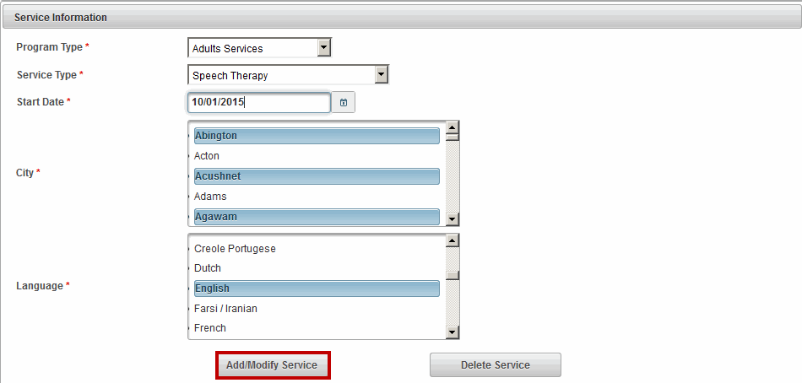
Figure 66: Service Directory page displayed with highlight around Add/Modify Service button.
PDM will return the validation message “Service added successfully.”

MODIFY SERVICE
If a service needs to be modified due to a change in the Start Date or when an additional City or Language needs to be added a user with the DDS Program Operations role can modify an existing service on the Service Directory.
- Search and select Provider from the Provider Search page.
- Select the Edit button.
- Locate and select service to be modified from the Select Service section.
Note: The Program Type and Service Type fields are not editable when modifying a service.
- Update the Start Date * field, if needed (Format: MM/DD/YYYY or select the Calendar icon to select the date)
- Update the City * field, if needed (To select multiple cities use Shift + click).
- Update the Language * field, if needed (To select multiple languages use Shift + click).
- Select the Add/Modify Service button.
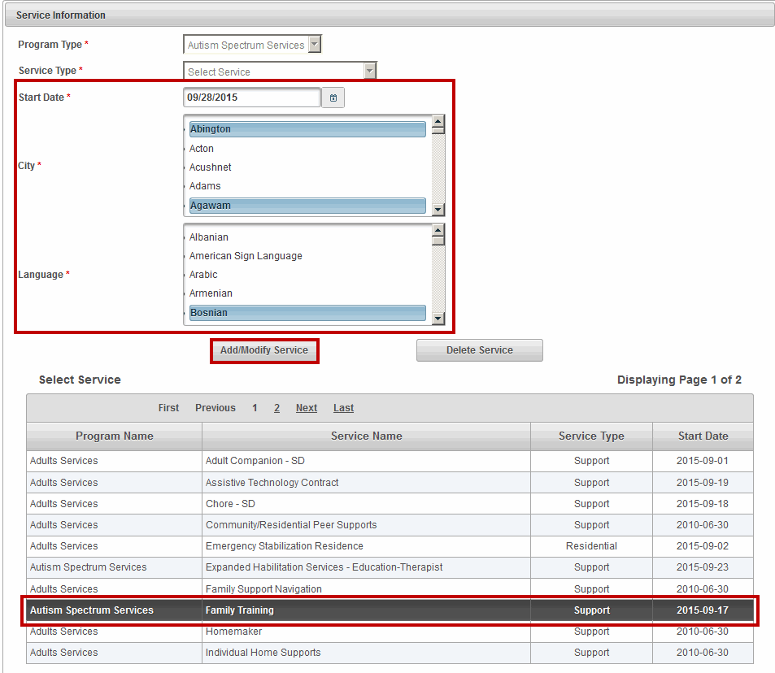
Figure 67: Service Directory page displayed with highlights around Add/Modify Service fields.
PDM will return the validation message “Service modified successfully.”

DELETE SERVICE
If a service needs to be deleted a user with the DDS Program Operations role has the access to delete a service from the Service Directory.
- Search and select the provider from Provide Search page.
- Under Service Information, locate and select the service to be deleted from the Select Service listing.
- Select the Delete Service button.
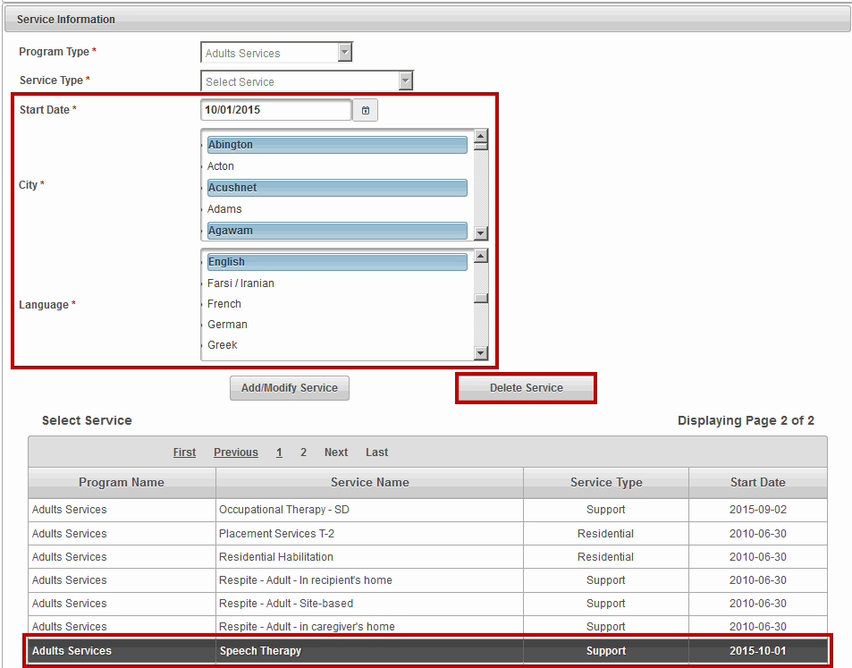
Figure 68: Service Directory page displayed with highlights around the Delete Service fields.
PDM will return the validation message: “Service deleted successfully.”
Note: All fields denoted with an asterisk (*) are required fields and must be completed in order to save the record.

Chapter 6: PDM Contracted Providers Operations and Observer Provider Roles

OVERVIEW
The PDM Contracted Providers Operations and PDM Observer Provider roles allow designated staff from within their organization to view and edit information in PDM.
PDM Contracted Providers Operations: This role allows providers access to their PDM record only. Providers with this access have the capability to edit and update company profile information. Access will include the ability to upload and replace required documents. This role will also have access to provider specific reports. (May have access to Salary Reserve functionality - to follow in later release).
PDM Observer Provider: This role allows providers access to VIEW only the provider's PDM company profile information. This role will have access to designated reports specific to the provider's company business with EOHHS.
PDM Role | Information | Qualifications  (Including Financial Ratio and Corrective Measures) | Contract Detail | Surplus Revenue
PDM Contracted Providers Operations | View/Edit | View | View | View
PDM Observer Provider | View | View | View | View
Reminders When Using PDM:
- All fields denoted with an asterisk (*) are required fields and must be completed in order to save the record.
- Do not save a record until all sections are completed. If the user tries to save before completing all required fields within each section, the user will receive error messages at the top of the page listing the missing data.
- If you attempt to navigate to another page while in Edit mode without first saving you will receive a warning message (different text depending on the web browser you are working in) such as:
- Firefox: “This page is asking you to confirm that you want to leave – data you have entered may not be saved.”
- Internet Explorer: “Are you sure you want to navigate away from this page? This page is asking you to confirm that you want to leave – data you have entered may not be saved. Press OK to continue, or Cancel to stay on the current page.”
For guidance on using JAWS with PDM, refer to Appendix B: JAWS Commands.

PDM INFORMATION
The Information tab stores information about a Provider such as Corporate Contact Information, Provider’s PDM Contact, Executive Contact, and General Corporate Information (Mission Statement and Corporate Description).
When a provider selects the ‘Manage Provider’ from the Welcome page they are automatically redirected to the Provider page (no search is required) and defaults to the Information page.
Users assigned the PDM Contracted Providers Operations role have Edit and Read rights on the Information page. The PDM Observer Provider has View rights only.
The Information page has the following button located at the bottom of the page:
- Edit: The Edit button will appear for users with the PDM Contracted Providers Operations role.
- No button will display for users with the PDM Observer Provider role.
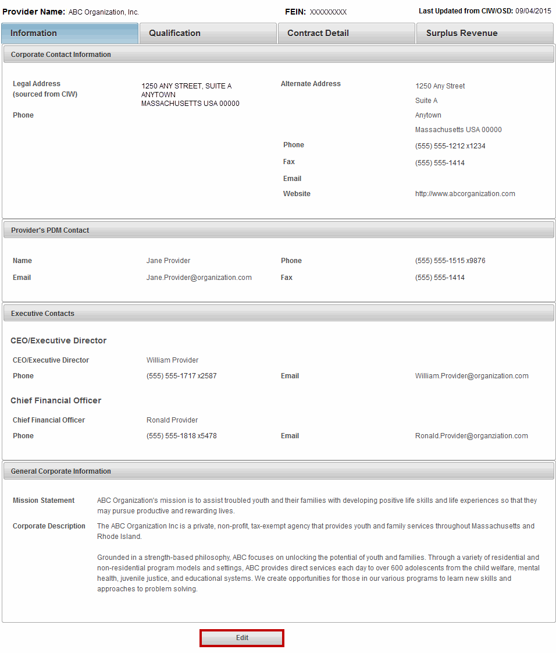
Figure 69: PDM Information page with Edit button highlighted.
Corporate Contact Information
Under Corporate Contact Information the following fields can be edited by a user with the PDM Contracted Providers Operations role:
- Alternate Address
- Phone, Fax
- Email, Website
Note: The Provider Name, FEIN and Legal Address fields are not editable. This data comes from the Commonwealth’s Information Warehouse (CIW).
Figure 70: Fields that can be updated on Information > Corporate Contact Information section of the Information page.
If only updates to the Corporate Contact Information section are needed, select the Save button at the bottom of the page.
Provider’s PDM Contact
Under Provider’s PDM Contact the following fields can be edited by a user with the PDM Contracted Providers Operations role:
- First, Middle, and Last
- Phone, Email, Fax
Figure 71: Fields that can be updated on Information > Provider's PDM Contact section of the Information page.
If only updates to the Provider’s PDM Contact section are needed, select the Save button at the bottom of page.

Executive Contacts
Under Executive Contacts > CEO/Executive Director the following fields can be edited by a user with the PDM Contracted Providers Operations role:
- First, Middle, and Last
- Phone, Email
Under Executive Contacts > Chief Financial Officer the following fields can be edited by a user with the PDM Contracted Providers Operations role:
- First, Middle, and Last
- Phone, Email
If only updates to the Executive Contacts section are needed, select the Save button at the bottom of page.
Figure 72: Fields that can be updated on Information > Executive Contacts section of the Information page.
General Corporate Information
Under General Corporate Information the following field can be edited by a user with the PDM Contracted Providers Operations role:
- Mission Statement
- Corporate Description
If only updates to the General Corporate Information section are needed, select the Save button at the bottom of page.
Figure 73: Fields that can be updated on Information > General Corporate Information section on the Information page.

SERVICE DIRECTORY
Note: Only provider organizations that have contracts with DDS will see the Service Directory link under the Information page.
Once the Provider Search is executed and requested results are displayed, the user selects the Provider record by clicking in the row to display the Corporate Information page. To the right of the information page is the Service Directory link.
- Select the Service Directory link.
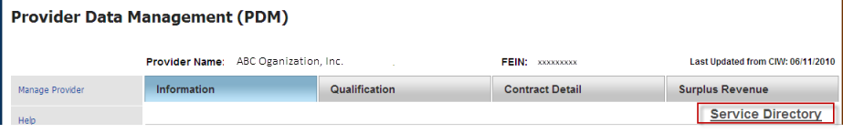
Figure 74: Service Directory link on the Information page.
The Service Directory page lists the following information:
- Provider’s Details
- Other Contact Information
- Service Information
The Provider Organization with DDS contracts has Read rights only to this information.
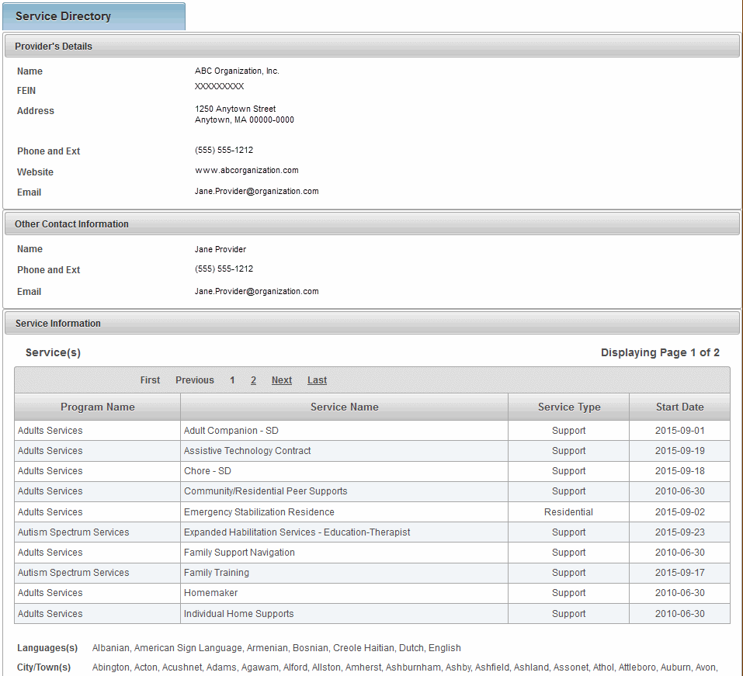
Figure 75: Service Directory page (view only).
Searching for an Existing Service
The Select Service section in the Service Directory displays 10 records at a time on the page. If more than 10 records exist the user should use the link First Previous 1 2 Next Last to navigate and locate the record.
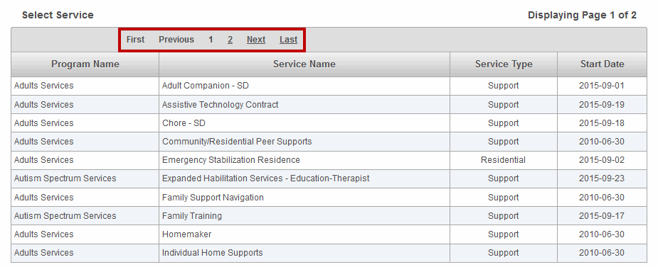
Figure 76: Service Directory page displayed with highlight around First Previous Next Last navigation links.

PDM QUALIFICATION
The PDM Qualification page is populated when the EOHHS Principal Purchasing Agency (PPA) Provider Qualification Officer (PQO) completes the review process. The PDM system calculates the financial ratios field using data from Provider’s UFR filing from OSD data feed and cannot be edited.
Users assigned the PDM Contracted Providers Operations role and PDM Observer Provider have View rights only to the Qualification page and associated links.
Figure 77: PDM Qualification page.
Qualification – Viewing PQ Year
PDM maintains the current PQ year along with previous years. The Qualifications page defaults to the current PQ Year.
To view a prior PQ Year,
- Select the PQ Year drop down arrow and select the Year to be viewed. (This example will select 2011).
- Select the Update button.
Figure 78: Under the Qualifications page, changing the PQ Year to 2011 and selecting the Update button.
Note: Each time the PQ Year is selected it must be followed by selecting the update button to ensure all data is up to date per the selection.
Parent/Child/Affiliate Providers
The Parent/Child/Affiliate Providers section allows the user to view the other provider organizations associated to this provider.
Note: Parent/Child/Affiliate Providers information will only be visible if the Provider has Child or Affiliate Providers.
Figure 79: Parent/Child/Affiliate Providers section under the Qualification page.
- Select record to view. The user will be redirected to the PDM Information page for that provider organization.

PDM Qualification - Financial Ratios
The Financial Ratios page assists agencies in assessing the financial stability of a provider. The EOHHS Purchase of Service (POS) Integrity Unit established the standard Financial Assessment Measures and benchmarks. The Financial Ratios page is pre-populated when the Operational Services Division (OSD) receives a provider’s annual Uniform Financial Report (UFR) and parses the information into the OSD database.
The PDM Contracted Providers Operations and PDM Observer Provider roles allow designated staff from within the organization to view this page. This page is View only for all associated roles.
- Select the Financial Ratios link
Figure 80: Highlighting the Financial Ratios link on the Qualification page.
The Financial Ratio page displays the last 3 fiscal years prior to the PQ year selected.
- Select any one of the links in the first column to open the Financial Ratios Definitions page.
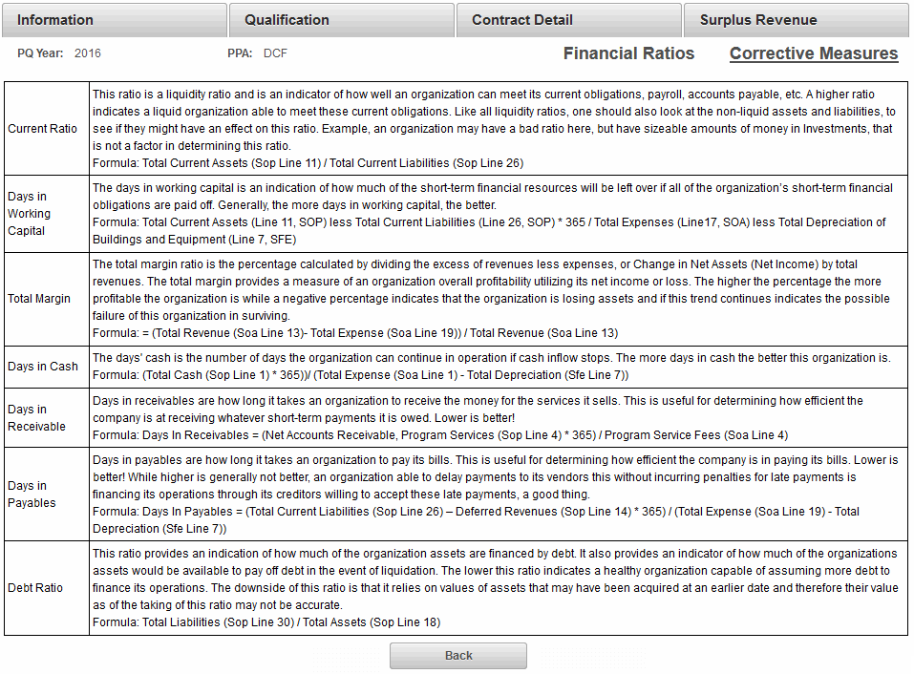
Figure 81: Financial Ratios page which is located under the Qualification page.
- Select Back to return to the Financial Ratio page.

PDM Qualification - Corrective Measures
The Corrective Measures page displays, by PQ Fiscal Year, the UFR Audit Findings, the Corrective Action Plan, and Audit Records (OSA Audit).
The PDM Contracted Providers Operations and PDM Observer Provider roles allow designated staff from within the organization to view this page. This page is View only for all associated roles.
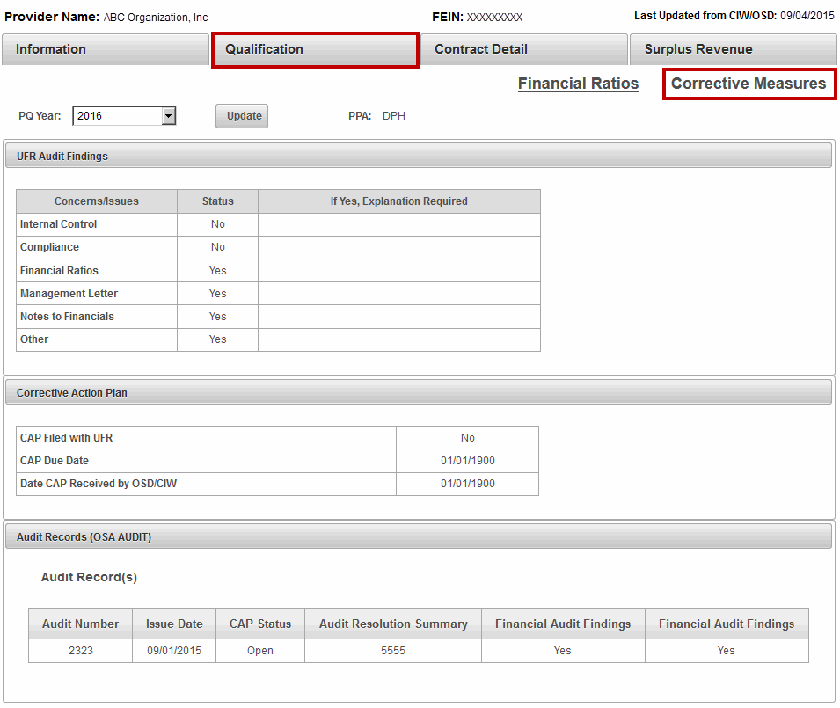
Figure 82: Corrective Measures page.
Qualification – Viewing PQ Year
PDM maintains the current PQ year along with previous years. The Qualifications page defaults to the current PQ Year.
To view a prior PQ Year,
- Select the PQ Year drop down arrow and select the Year to be viewed.
- Select the Update button.
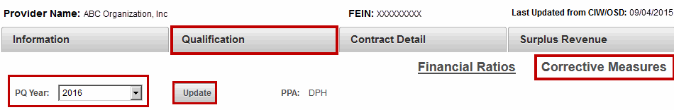
Figure 83: Corrective Measures page with the PQ Year highlighted.
Note: Each time the PQ Year is selected it must be followed by selecting the update button to ensure all data is up to date per the selection.

PDM CONTRACT DETAILS
The Contract Detail page stores information about the POS Provider’s contracts for the current fiscal year such as Activity Code, Activity Name, Doc ID, Object Code, Maximum Contract Obligation, Expended to Date, and Unexpended Amount. For Release 5.0 PDM will only display contracts with Object Codes MM3 and M03.
The PDM Contracted Providers Operations and PDM Observer Provider roles allow designated staff from within the organization to view this page. These roles do not have Edit rights on this page.
Note: The information found under Contract Details is sourced from the Commonwealth’s Information Warehouse. Information about services offered, but not contracted through EOHHS is entered by the provider.
This page provides the Provider with a snapshot of all of current year contracts, by EOHHS agency.
Figure 84: Contract Detail page lists all contracts a provider has with EOHHS agencies.

PDM SURPLUS REVENUE
The Surplus Revenue page is primarily used by the Principal Purchasing Agency (PPA) to record and retain an account of the surplus revenue liability based on the Annual SSR of 5% limit. If an excess 5% Surplus Revenue Liability exists, the Principal Purchasing Agency utilizes the corresponding fields below to provide an accounting of the negotiation with the Provider to satisfy the liability owed the Commonwealth.
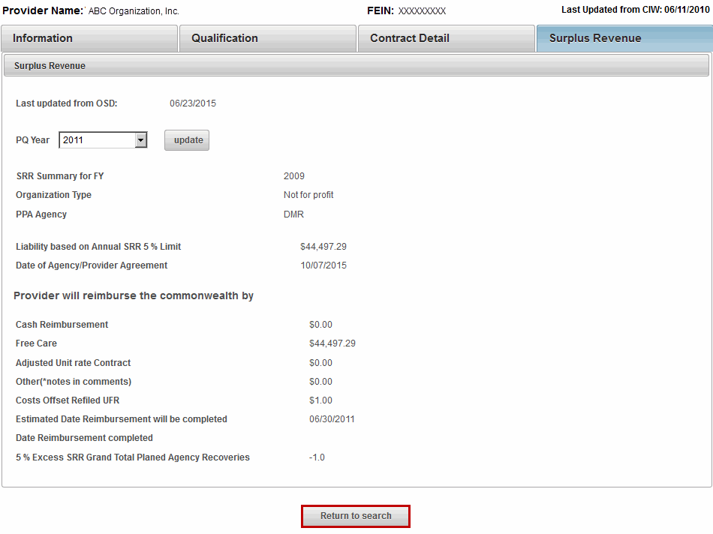
Figure 85: PDM Surplus Revenue page.

Provider Data Management (PDM)
PDM Roles | Information | Qualifications | Financial Ratios | Correction Measures | Contract Detail | Surplus Revenue | Service Directory
Principle Purchasing Agency | View | Edit  Update | View | Edit  Update | View | Edit  Update | NA
State Agency Observer | View | View | View | View | View | View | NA
POS Program Operations | Edit  Update | Edit  Update | View | Edit  Update | View | Edit  Update | NA
DDS Program Operations | NA | NA | Na | NA | NA | NA | Add  Edit  Update
DDS Operations Observer | NA | NA | NA | NA | NA | NA | View
PDM Contracted Providers Operations | Edit  Update | View | View | View | View | View | View
PDM Provider Observer | View | View | View | View | View | View | View

Appendix A: PDM Security Matrix

This page is intentionally left blank

Appendix B: JAWS COMMANDS
READING TEXT
Command | Description
 | Say Prior Character
 | Say Next Character
Num Pad 5 | Say Character
Num Pad 5 twice quickly | Say Character Phonetically
Insert + | Say Prior Word
Insert + | Say Next Word
Insert + Num Pad 5 | Say Word
Insert + Num Pad 5 twice quickly | Spell Word
 | Say Prior Line
 | Say Next Line
Insert + | Say Current Line
Insert + twice quickly | Spell Current Line
Alt + | Say Prior Sentence
Alt + | Say Next Sentence
Alt+Num Pad 5 | Say Current Sentence
Insert + Home | Say to Cursor
Insert + Page Up | Say from Cursor
Insert + Home twice quickly | Spell to Cursor
Insert + Page Up twice quickly | Spell from Cursor
Insert + | Say All
 | Fast Forward during a Say All
 | Rewind during a Say All
Insert + 5 | Say Color
Num Pad 5 three times quickly | Say ASCII or Hexadecimal Value
Insert + F, twice quickly | Say Font
Ctrl + Insert + | Start Skim Reading
Ctrl + Insert + Shift + | Skim Reading dialog box
Insert + Windows Key + | Display Skim Reading Summary
Voice Rate
Command | Description
Ctrl + Alt + Page Down | Decrease Voice Rate
Ctrl + Alt + Page Up | Increase Voice Rate
Page Down | Decrease Voice Rate (when using SayAll)
Page Up | Increase Voice Rate (when using SayAll)
Headings and Lists
Command | Description
H | Headings Quick Key
1-6 | Headings level 1-6
Insert + F6 | List of Headings
L | List Quick Key
I | List Item Quick Key
Tables
Moving within Tables
Command | Description
T | Table Quick Key
Ctrl + Alt + | Cell to Right
Ctrl + Alt + | Cell to Left
Ctrl + Alt + | Cell Below
Ctrl + Alt + | Cell Above
Ctrl + Alt + Home | First Cell
Ctrl + Alt+END | Last Cell
Ctrl + Alt + Shift + | First Cell in Column
Ctrl + Alt + Shift + | Last Cell in Column
Ctrl + Alt + Shift + | First Cell in Row
Ctrl + Alt + Shift + | Last Cell in Row
Table Reading
Command | Description
Ctrl + Alt+Num Pad 5 | Say Current Cell
Insert + Shift + | Read Current Row
Insert + Shift + Home | Read from Start of Row
Insert + Shift + Page Up | Read to End of Row
Insert + Shift+Num Pad 5 | Read Current Column
Insert + Shift + End | Read from Top of Column
Insert + Shift + Page Down | Read to Bottom of Column
Forms
Command | Description
F | Form Quick Key
B | Button Quick Key
R | Radio Button
Enter (in a form element) | Enter Forms Mode
Tab | Navigate to Next Form Control
Shift + Tab | Navigate to Previous Form Control
Spacebar | Select and Deselect Checkboxes
Alt + | Open Combo Box/Jump Menu
Ctrl + Shift or Ctrl + Spacebar | Select Multiple List Items
Ctrl+ \ | Unselect All But Current
/ | Select Radio Button
/ or the First letter | Select Element in Combo Box
Enter (in forms mode) | Submit Form
+ key | Exit Forms Mode
Insert + F5 | List of Form Elements
Links
Command | Description
Tab | Jump from link/Form element next one
Shift + Tab | Jump from link/Form element next previous one
Ins + F7 | Bring up a list of links within the page
U | Unvisited Link Quick Key
V | Visited Link Quick Key
Frames
Command | Description
Ctrl + Tab | Move from one frame to the next frame within the page.
Ctrl + Shift + Tab | Move from one frame to the previous frame within the page.
Ins + F9 | Bring up a list of frames that are present within the page
Other Commands
Command | Description
Ctrl + F | Search for a word or a phrase
Ins + Esc | Refresh Screen, i.e. repaint all the currently displayed items on the screen
Ins + F5 | Reformat documents, i.e. reformat multiple column pages to be more readable with speech
Insert + F1 | Help with current element
Shift + Tab and press | To read error message for “New” Search page
Shift + Tab and press and again press | To read error message for “Manage” Search page
JAWS commands to open the document:
- ‘Alt’ button will display shortcut keys.
- Use ‘Alt + O’ to open the document.
- ‘.doc’ or Word documents by default open in ‘Non-editable’ mode.
- ‘Alt +S’ will enable the document to ‘Save’, displays message ‘Enable Saving’.
  - Clicking on ‘Enable Saving’ will open the document in edit mode.
  - Clicking on ‘Cancel’, will let the user remain on the same page in non-editable mode.
Service Directory:
To read and select multi select combo box:
- Keyboard users can press the Internet Explorer keystroke SHIFT+F8 to turn on extended selection mode. While this mode is on, move up or down the list of choices and press SPACEBAR to select as many items as desired. To unselect a previously selected item, press SPACEBAR again on the item.

Appendix C: Listing of Figures

Figure 1: Welcome to the Virtual Gateway page. 9
Figure 2: Virtual Gateway Business Service page. 10
Figure 3: Welcome to the Provider Data Management Information System page. 10
Figure 4: Welcome to the Provider Data Management System page. 14
Figure 5: Provider Search page. 14
Figure 6: Searching by Provider option. 15
Figure 7: Provider Search page returns with results based off of entered criteria. 15
Figure 8: Provider Search - Search Alphabetically. 16
Figure 9: Provider Search - Search Alphabetically by Provider Name. 16
Figure 10: Search Alphabetically - The Provider Search page returns with results based off of entered criteria. 16
Figure 11: PDM Information page. 17
Figure 12: PDM Qualification page. 18
Figure 13: Under the Qualifications page, changing the PQ Year to 2011 and selecting the Update button. 19
Figure 14: Selecting the Edit button on the Qualification page. 19
Figure 15: Parent/Child/Affiliate Providers section under the Qualification page. 20
Figure 16: Status section under the Qualification page. 20
Figure 17: Concerns/Issues section on the Qualification page. 21
Figure 18: Comments section on the Qualification page. 21
Figure 19: Highlighting the Financial Ratios page from the Qualification page. 22
Figure 20: Financial Ratios page which is under Qualification. 22
Figure 21: Corrective Measures page highlighting the Concerns/Issues section which requires explanation when "Yes" is displayed. 23
Figure 22: Completed Concerns/Issues section under Corrective Measures page. 23
Figure 23: Corrective Action Plan section under the Corrective Measures page. 24
Figure 24: Audit Records (OSA Audit) section under the Corrective Measures page. 24
Figure 25: Contract Detail page lists all contracts a provider has with EOHHS agencies. 25
Figure 26: PDM Surplus Revenue page. 26
Figure 27: PDM Surplus Revenue page in Edit mode. 27
Figure 28: Welcome to the Provider Data Management Information System page. 29
Figure 29: Provider Search page 29
Figure 30: Searching by Provider option. 30
Figure 31: Provider Search page returns with results based off of entered criteria 30
Figure 32: Provider Search - Search Alphabetically 31
Figure 33: Provider Search - Search Alphabetically by Provider Name. 31
Figure 34: Search Alphabetically - The Provider Search page returns with results based off of entered criteria. 31
Figure 35: PDM Information page. 32
Figure 36: Fields that can be updated on Information > Corporate Contact Information section of the Information page. 33
Figure 37: Fields that can be updated on Information > Provider's PDM Contact section of the Information page. 33
Figure 38: Fields that can be updated on Information > Executive Contacts section of the Information page. 34
Figure 39: Fields that can be updated on Information > General Corporate Information section on the Information page. 34
Figure 40: PDM Qualification page. 35
Figure 41: Under the Qualifications page, changing the PQ Year to 2011 and selecting the Update button. 36
Figure 42: Selecting the Edit button on the Qualification page. 36
Figure 43: Selecting the PPA on the Qualification page. 37
Figure 44: Selecting the MEP Status on the Qualification page. 37
Figure 45: Parent/Child/Affiliate Providers section under the Qualification page. 38
Figure 46: Status section under the Qualification page. 38
Figure 47: Concerns/Issues section under the Qualification page. 39
Figure 48: Comments section under the Qualification page. 39
Figure 49: Highlighting the Financial Ratios page from the Qualification page. 40
Figure 50: Financial Ratios page which is under Qualification. 40
Figure 51: Corrective Measures page highlighting the Concerns/Issues which requires explanation when "Yes" is displayed. 41
Figure 52: Completed Concerns/Issues section under Corrective Measures page. 41
Figure 53: Corrective Action Plan section under the Corrective Measures page. 42
Figure 54: Audit Records (OSA Audit) section under the Corrective Measures page. 42
Figure 55: Contract Detail page lists all contracts a provider has with EOHHS agencies. 43
Figure 56: PDM Surplus Revenue page. 44
Figure 57: PDM Surplus Revenue page in Edit mode. 45
Figure 58: Welcome to the Provider Data Management Information System page. 48
Figure 59: Provider Search page. 48
Figure 60: Provider Search page returns with results based off of entered criteria - FEIN. 49
Figure 61: Provider Search page returns with results based off of entered criteria - Name. 49
Figure 62: Provider Search page returns with results based off of entered criteria - Waiver Program. 50
Figure 63: Service Directory page with Edit button highlighted. 51
Figure 64: Service Directory page with Provider's Details and Other Contact Information displayed. 53
Figure 65: Service Directory page displayed with highlight around First Previous Next Last navigation links and the Add/Modify Service and Delete buttons. 53
Figure 66: Service Directory page displayed with highlight around Add/Modify Service button. 54
Figure 67: Service Directory page displayed with highlights around Add/Modify Service fields. 55
Figure 68: Service Directory page displayed with highlights around the Delete Service fields. 56
Figure 69: PDM Information page with Edit button highlighted. 58
Figure 70: Fields that can be updated on Information > Corporate Contact Information section of the Information page. 59
Figure 71: Fields that can be updated on Information > Provider's PDM Contact section of the Information page. 59
Figure 72: Fields that can be updated on Information > Executive Contacts section of the Information page. 60
Figure 73: Fields that can be updated on Information > General Corporate Information section on the Information page. 60
Figure 74: Service Directory link on the Information page. 61
Figure 75: Service Directory page (view only). 61
Figure 76: Service Directory page displayed with highlight around First Previous Next Last navigation links. 62
Figure 77: PDM Qualification page. 63
Figure 78: Under the Qualifications page, changing the PQ Year to 2011 and selecting the Update button. 64
Figure 79: Parent/Child/Affiliate Providers section under the Qualification page. 64
Figure 80: Highlighting the Financial Ratios link on the Qualification page. 65
Figure 81: Financial Ratios page which is located under the Qualification page. 66
Figure 82: Corrective Measures page. 67
Figure 83: Corrective Measures page with the PQ Year highlighted. 68
Figure 84: Contract Detail page lists all contracts a provider has with EOHHS agencies. 70
Figure 85: PDM Surplus Revenue page. 70

