Searching for and Viewing a Ready Pay Invoice
To search for and view a Ready Pay Invoice:  - Select the Billing module.  - Click Ready Pay Invoice Search from the navigation bar.  The Ready Pay Search page appears.  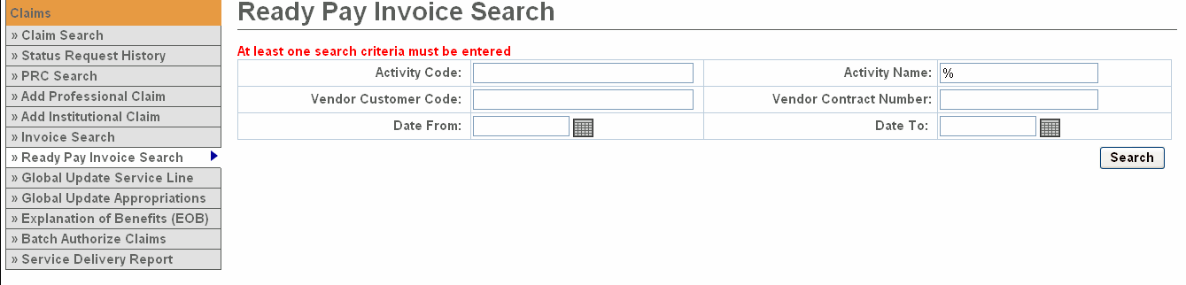  - Enter criteria.  - Click .  The search results appear below.  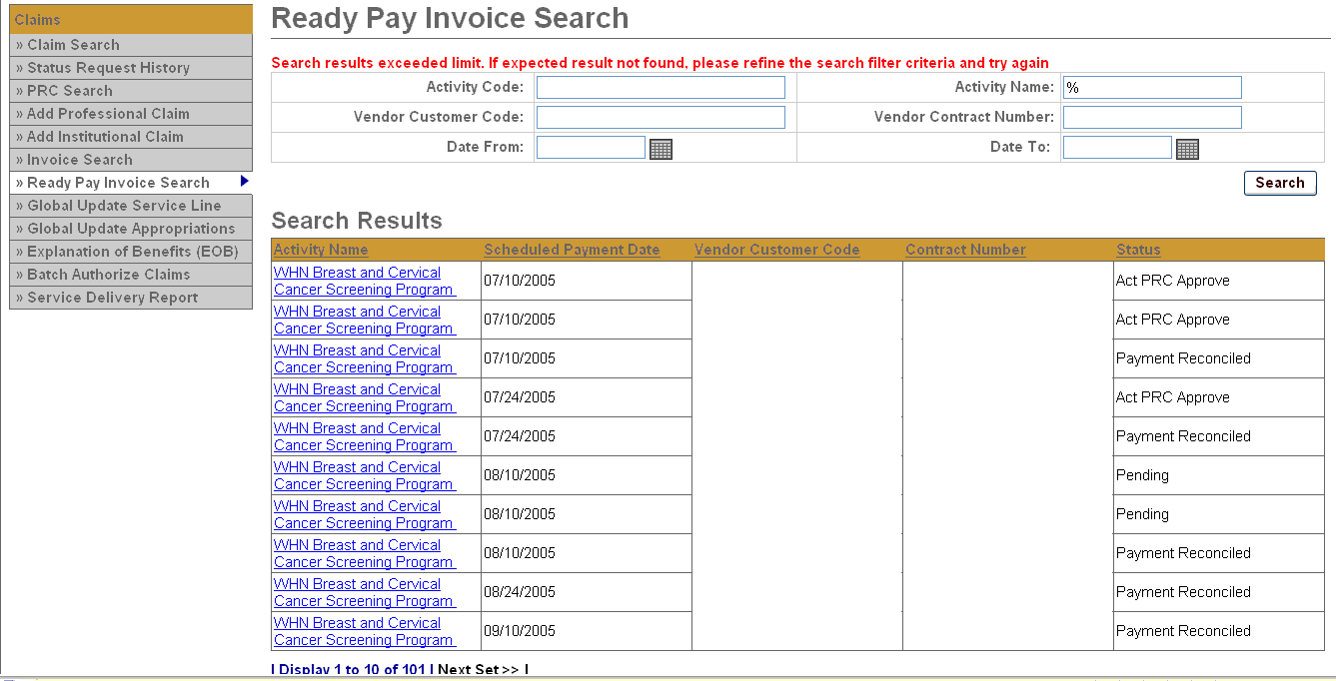 | - Click the Activity Name link.  The Ready Pay Invoice Summary page appears.  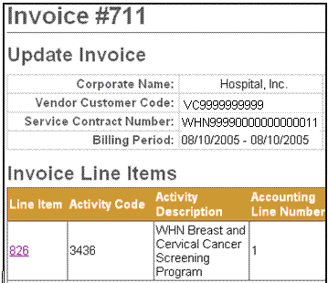  Hospital, Inc.  Hospital, Inc.  - Click the Line Item link.  The Ready Pay Line Item Summary page appears.  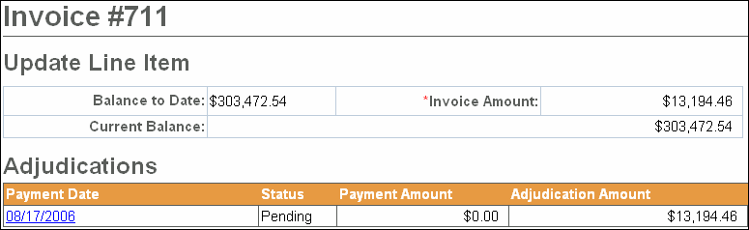

Viewing a Ready Pay Invoice Adjustment
To view a Ready Pay Invoice Adjustment:  - Access the Ready Pay Line Item Summary Page.  - Click the Payment Date link.  The Ready Pay Adjudication Summary page appears.  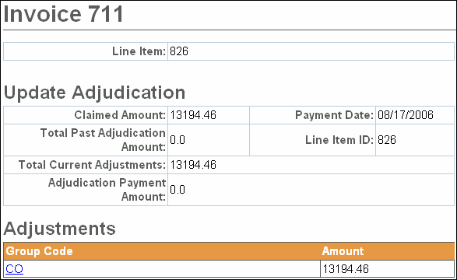 | - Click the Group Code link.  The Ready Pay Update Adjustment Summary page appears.  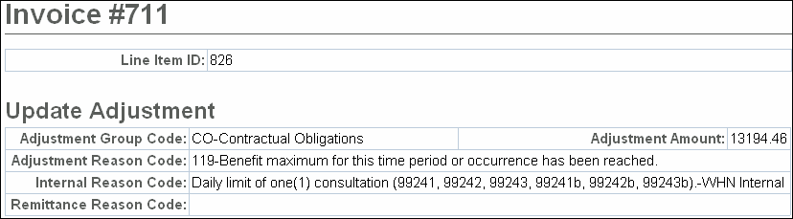
Questions or need assistance?
Call Virtual Gateway Customer Service
1-800-421-0938
(617-847-6578 - TTY for the deaf and hard of hearing)
8:30 am to 5:00 pm Monday through Friday

If a provider is consistently billing for less than the monthly RP amount, it may make sense to adjust the ready pay schedule. To minimize the need to recoup funds, you can lower the ready payment amounts in the ready pay rate schedule. This should be coordinated with the Accounting Department.
Scenario 1: When Billed Amount is Greater than Ready Payments
July
10 | $1000 Ready Payment issued
24 | $1000 Ready Payment issued | Ready pay total: $2000 for July
August
10 | $2500 July invoice submitted by provider | Billed amount is $500 more than total July Ready Payments ($2500 July invoice - $2000 July Ready Payments)
10 | $1000 Ready Payment issued | This payment is triggered by the receipt of the July invoice
24 | $500 Additional July Payment  $1000 Ready Payment  $1500 Payment Total | A PRC is created for $500; agency staff must approve.  The payment includes Ready Payment plus additional payment for remainder of July services
Scenario 2: When Billed Amount is Less than Ready Payments
July
10 | $1000 Ready Payment issued
24 | $1000 Ready Payment issued | Ready pay total: $2000 for July
August
10 | $1800 July invoice submitted | Billed amount is $200 less than July Ready Payments ($1800 July invoice - $2000 July Ready Payments)
10 | $1000 Ready Payment issued | This payment is triggered by the receipt of the July invoice
24 | $1000 Ready Payment  - $200 Payment for July  $800 Payment Total | A Zero Expenditure PRC (ZEP) for $200 is created in EIM; agency staff must approve.  This payment includes Ready Payment minus difference between July Ready Payments and July billed amount.
Questions or need assistance? Call Virtual Gateway Customer Service
1-800-421-0938 (617-847-6578 - TTY for the deaf and hard of hearing)
8:30 am to 5:00 pm Monday through Friday

