|  |  |
| --- | --- |
|  | ***Commonwealth of Massachusetts***  ***Executive Office of Health and Human Services*** Office of Medicaid *www.mass.gov/masshealth* |

MassHealth

Transmittal Letter PSY-23

January 2018

**TO:** Psychologists Participating in MassHealth

**FROM:** Daniel Tsai, Assistant Secretary for MassHealth 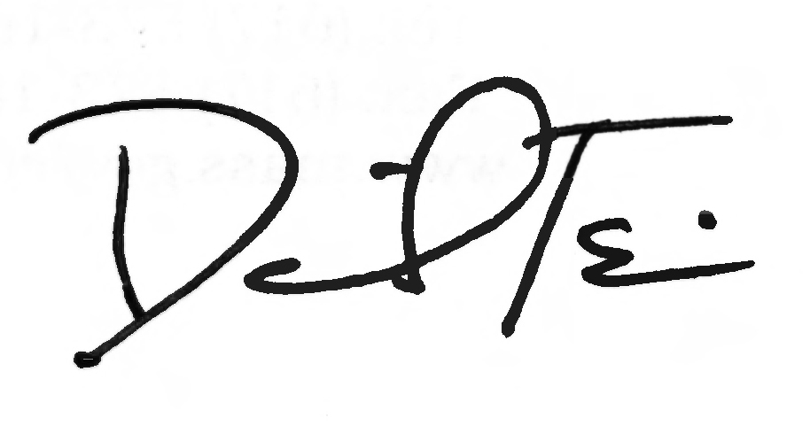

**RE:** Psychologist *Manual* 2019 (Revised Service Codes and Descriptions)

This letter transmits revisions to the service codes and descriptions listed in Subchapter 6 of the *Psychologist Manual*. These codes and descriptions are effective for dates of service on or after January 1, 2019.

**MassHealth Website**

This transmittal letter and attached pages are available on the MassHealth website at [www.mass.gov/masshealth-transmittal-letters](http://www.mass.gov/masshealth-transmittal-letters).

To sign up to receive email alerts when MassHealth issues new transmittal letters and provider bulletins, send a blank email to [join-masshealth-provider-pubs@listserv.state.ma.us](mailto:join-masshealth-provider-pubs@listserv.state.ma.us). No text in the body or subject line is needed.

**Questions**

If you have any questions about this transmittal letter, please contact the MassHealth Customer Service Center at (800) 841-2900, email your inquiry to [providersupport@mahealth.net](mailto:providersupport@mahealth.net), or fax your inquiry to (617) 988-8974.

NEW MATERIAL

(The pages listed here contain new or revised language.)

Psychologist Manual

Pages vi, 6-1, and 6-2

OBSOLETE MATERIAL

(The pages listed here are no longer in effect.)

Psychologist Manual

Page vi — transmitted by Transmittal Letter PSY-20

Pages 6-1 and 6-2 — transmitted by Transmittal Letter PSY-21

|  |  |  |
| --- | --- | --- |
| **Commonwealth of Massachusetts**  **MassHealth**  **Provider Manual Series** | **Subchapter Number and Title**  Table of Contents | **Page**  vi |
| Psychologist Manual | **Transmittal Letter**  PSY-23 | **Date**  01/01/19 |

6. Service Codes and Descriptions

Psychological Testing 6-1

Appendix A. Directory A‑1

Appendix C. Third‑Party-Liability Codes C‑1

Appendix T. CMSP Covered Codes T-1

Appendix U. DPH-Designated Serious Reportable Events That Are Not Provider Preventable

Conditions U-1

Appendix V. MassHealth Billing Instructions for Provider Preventable Conditions V-1

Appendix W. EPSDT Services Medical and Dental Protocol and Periodicity Schedules W-1

Appendix X. Family Assistance Copayments and Deductibles X-1

Appendix Y. EVS Codes and Messages Y-1

Appendix Z. EPSDT/PPHSD Screening Services Codes Z-1

**Psychological Testing Evaluation Services by Professional**

96130 Psychological testing evaluation services by physician or other qualified health care professional, including integration of patient data, interpretation of standardized test results and clinical data, clinical decision making, treatment planning and report and interactive feedback to the patient, family member(s) or caregiver(s), when performed; first hour.

96131 Each additional hour. (List separately in addition to code for primary procedure.) (Add-on code to 96130).

**Neuropsychological Testing Evaluation Services by Professional**

96132 Neuropsychological testing evaluation services by physician or other qualified health care professional, including integration of patient data, interpretation of standardized test results and clinical data, clinical decision making, treatment planning and report and interactive feedback to the patient, family member(s) or caregiver(s), when performed; first hour.

96133 Each additional hour. (List separately in addition to code for primary procedures.) (Add-on code to 96132.)

**Test Administration and Scoring by Professional**

96136 Psychological or neuropsychological test administration and scoring by physician or other qualified health care professional, two or more tests, any method; first 30 minutes.

96137 Each additional 30 minutes. (List separately in addition to code for primary procedure.) (Add-on code to 96136.)

This publication contains codes that are copyrighted by the American Medical Association. Certain terms

used in the service descriptions for HCPCS codes are defined in the Current Procedural Terminology (CPT) code book.

This page is reserved.