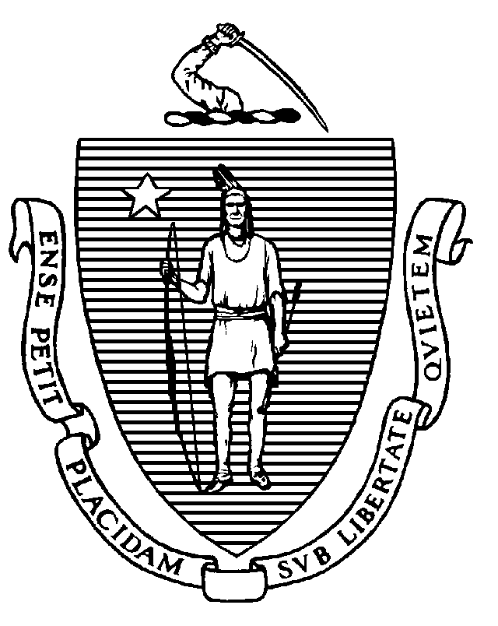
The Commonwealth of Massachusetts
Executive Office of Health and Human Services
Department of Public Health
250 Washington Street, Boston, MA 02108-4619

MAURA T. HEALEY
Governor
KIMBERLEY DRISCOLL
Lieutenant Governor

MARY A. BECKMAN
Acting Secretary
MARGRET R. COOKE Commissioner

Tel: 617-624-6000
www.mass.gov/dph

BOARD OF REGISTRATION OF PSYCHOLOGISTS

Public Meeting Minutes of January 13, 2023

Board Members Present: Robert Carey, Jr., Ph.D., Chair (left meeting at 9:35 a.m., returned at 9:40 a.m.)
Vicky Anderson, Psy.D., Vice Chair
John Marshall, D.C., Secretary
William Hudgins, Ph.D. (arrived at 9:09 a.m.)
Jessica Edwards George, Ph.D.
Jeffrey Brown, Psy.D.
Michael O’Halloran

Staff Present: Brian Bialas, Executive Director
Sheila York, Board Counsel
Marine Jardonnet, Board Counsel
Lauren McShane, Investigative Supervisor
Doris Lugo, Investigator

All Board members and staff appeared by videoconference.

At 9:03 a.m., the meeting was called to order by Dr. Carey.

Board Business

- Roll Call for Attendance: All board members except Dr. Hudgins were present.

- Public Meeting Minutes of November 4, 2022: After a brief discussion, a motion was made by Dr. Marshall, seconded by Dr. Brown, to approve the Public Meeting Minutes of November 4, 2022. The motion passed unanimously by a roll call vote.

Dr. Hudgins arrived at 9:09 a.m.

- Public Meeting Minutes of December 9, 2022: After a brief discussion, a motion was made by Dr. Anderson, seconded by Dr. Edwards George, to approve the Public Meeting Minutes of December 9, 2022 with changes. The motion passed unanimously by a roll call vote, with Dr. Marshall abstaining.

- Executive Session Minutes of December 9, 2022: After a brief discussion, a motion was made by Mr. O’Halloran, seconded by Dr. Hudgins, to approve the Executive Session Minutes of December 9, 2022. The motion passed unanimously by a roll call vote.

- Welcome to the Department of Public Health, Bureau of Health Professions Licensure

  - James Lavery, Director and Lauren Nelson, Acting Deputy Director: Mr. Lavery and Ms. Nelson introduced themselves and welcomed the Board to the Department of Public Health, Bureau of Health Professions Licensure.

Monitoring Reports

- Ricky Greenwald, 2017-000912-IT-ENF, 11th and 12th Quarterly Monitoring Reports: The Board reviewed the reports. After a brief discussion, a motion was made by Dr. Marshall, seconded by Dr. Anderson, to accept the reports. The motion passed unanimously by a roll call vote.

The Board directed Mr. Bialas to ask Dr. Greenwald’s supervisor for the total number of supervision sessions she has had with Dr. Greenwald.

Dr. Carey recused himself from consideration of the next matter and left the meeting at 9:35 a.m.

- Mitchell Gurk, 2021-000548-IT-ENF, Submission of Proposed Supervisors: The Board reviewed Dr. Gurk’s proposed supervisors. After a brief discussion, a motion was made by Mr. O’Halloran, seconded by Dr. Anderson, to approve Dr. Stuart Fisher as Dr. Gurk’s supervisor. The motion passed unanimously by a roll call vote with Dr. Carey recused.

Dr. Carey returned to the meeting at 9:40 a.m.

Executive Session (closed under G.L. c. 30A, § 21(a)(7) to comply with G.L. c. 4, § 7, ¶ 26(c) and G.L. c. 214, § 1B – adhering to the public records law and to preserve the confidentiality of medical record information)

At 9:40 a.m., a motion was made by Mr. O’Halloran, seconded by Dr. Anderson, to (1) exit the public meeting; (2) enter into executive session under G.L. c. 30A, § 21(a)(7) to comply with G.L. c. 4, § 7, ¶ 26(c) and G.L. c. 214, § 1B – adhering to the public records law and to preserve the confidentiality of medical record information to review an examination request; then (3) enter into investigative conference under G.L. c. 112, § 65C to review cases; and (4) at the conclusion of the investigative conference, not return to the public meeting. The motion passed unanimously by a roll call vote with Dr. Carey absent.

The Board entered executive session at 9:40 a.m.

Investigative Conference (closed to conduct investigatory conferences, pursuant to G.L. c. 112, § 65C)

The Board entered investigative conference at 9:59 a.m.

During the investigative conference, the Board took the following actions:

Cases

2022-000646-IT-ENF (PM): Invite respondent to a board meeting for an interview
2022-000649-IT-ENF (CB): Invite respondent to a board meeting for an interview
2022-000820-IT-ENF (AB): Dismiss

Adjournment

At 10:50 a.m., a motion was made by Mr. O’Halloran, seconded by Dr. Brown, to adjourn the meeting. The motion passed unanimously. The meeting adjourned at 10:50 a.m.

The above minutes were approved at the public meeting held on February 10, 2023.

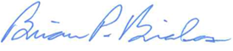
__________________________
Brian Bialas, Executive Director

List of Documents Used During the Public Meeting

- Agenda of January 13, 2023 Meeting
- Public Meeting Minutes of November 4, 2022
- Public Meeting Minutes of December 9, 2022
- Executive Session Minutes of December 9, 2022
- Ricky Greenwald, 2017-000912-IT-ENF, 11th and 12th Quarterly Monitoring Reports
- Mitchell Gurk, 2021-000548-IT-ENF, Submission of Proposed Supervisors

