COVID-19 FEMA Public Assistance:
Best Practices, Available Guidance, and Compiled Resources
for Massachusetts State Agencies

Version 3 (RDU State Agency) – Released 5/20/2020

This document provides information specific to Massachusetts State Agencies who may be eligible for FEMA Public Assistance (PA) funding related to the COVID-19 emergency. This document includes answers to common questions, immediate steps your agency can take to prepare for the FEMA Public Assistance process, and guidance on tracking costs, collecting required documentation, and navigating procurement during COVID-19. It outlines steps that state agencies can take today to best position agencies to apply for FEMA PA funds, but these best practices may apply to other sources of COVID-19 funding as they become available.
This document references numerous resources and fact sheets issued during the COVID-19 emergency including those distributed by FEMA, MEMA, the Comptroller’s Office, and Administration and Finance (A&F). For a complete list of sources and references for this document review the “Compiled Resources” section.
This document may be updated as additional FEMA Guidance is published.
Document Contents
Introduction 2
FEMA PA Process and Eligibility Overview 2
Immediate Action Items for State Agencies 5
Guidance: Tracking Expenses and Documentation 7
Guidance: Costs 10
Guidance: Procurement for State Entities 11
Frequently Asked Questions 12
Compiled Resources and Links 13

Introduction
The COVID-19 emergency is unprecedented in scale. As state agencies currently respond to the crisis, they must also consider long-term planning and prepare to apply for state and federal financial support. Federal Emergency Management Agency (MEMA) Public Assistance (PA) is one source of available funding within what is likely to be a complicated environment of state and federal COVID-19 recovery programs. This document is tailored to available information on FEMA PA, but best practices in document management, records retention, and data tracking may apply to other sources of funding as they become available.

FEMA PA Process and Eligibility Overview
FEMA’s PA Grant Program supports communities’ recovery from major disasters and emergencies by providing financial assistance for eligible expenses. It is FEMA’s largest grant program and is meant to serve as a last resort after exhausting other sources of funding such as insurance and other federal grant programs. Local governments, states, tribes, territories and certain private nonprofit organizations are eligible to apply. FEMA PA in Massachusetts is administered and disbursed by the Massachusetts Emergency Management Agency (MEMA).

What is the process to receive assistance through FEMA PA?
FEMA and MEMA both empower applicants to drive their own recovery and directly apply for assistance through FEMA’s online Grants Portal. The graphic below and this FEMA factsheet outlines the general process and key steps for Massachusetts State Agencies.
Given the complexities of the COVID-19 emergency, MEMA has established a Reimbursement and Documentation Unit (RDU), led by Guidehouse, a consulting firm, to provide tailored technical assistance to your agency and guide you through the application process. Submitting an application with the support of the RDU will reduce applicant burden and streamline the application process as shown in the bottom process diagram in the graphic below. This process will be introduced in a MEMA webinar to state agencies on June 3rd.
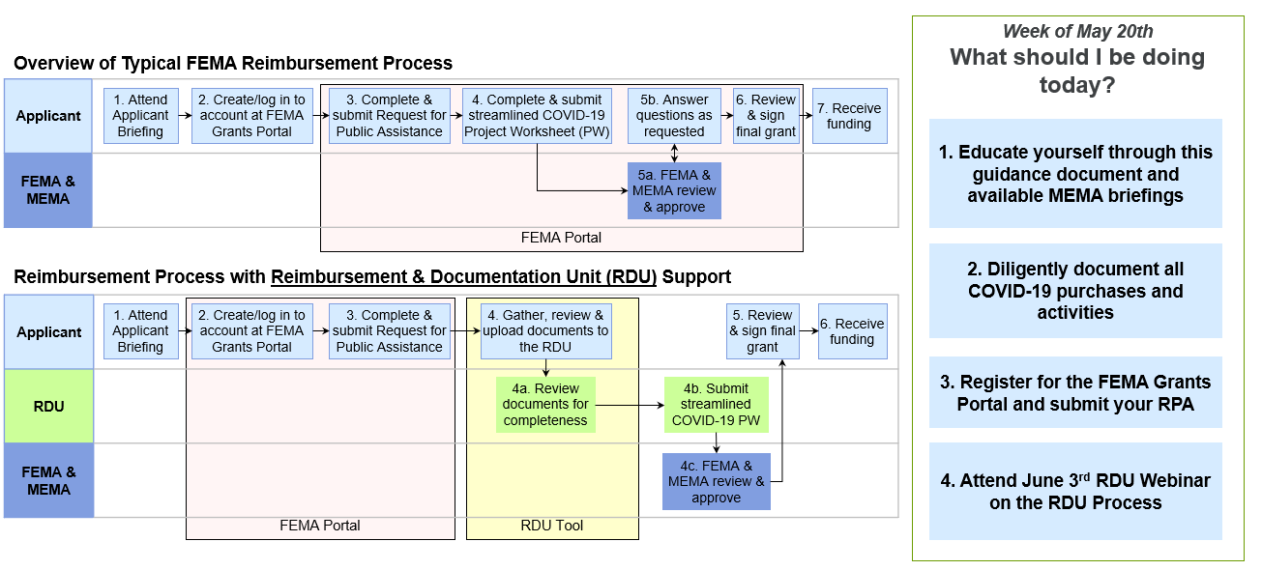

What do I need to do today to prepare for the application process?
Register for your FEMA Grants Portal ID and submit a request for public assistance (RPA). This will kick-off the process and alert MEMA that you plan to apply for FEMA reimbursement. For instructions on this process, watch a how to video here and see FEMA’s Grants Portal Account and Request for Public Assistance. Agencies are also encouraged to educate themselves on the FEMA PA process and preparing supporting documentation based on guidance in this document and from FEMA.

Can I submit my application now? If I submit now, can I update it later?

FEMA’s COVID-19 Streamlined Project Application Template has been posted as a PDF document for guidance and the application is now live in the FEMA Grants Portal. However, MEMA has established a Reimbursement and Documentation Unit (RDU) to support state agencies in preparing their applications and strongly encourages all state agencies to wait to upload documents to the Grants Portal and preparing their application until an initial consultation with the RDU. MEMA will host a webinar on Wednesday June 3rd from 2 – 3:30PM to introduce the RDU support process for state agencies and answer any questions.

What costs related to COVID-19 are reimbursable through FEMA PA funding?
Given the evolving nature of the emergency, FEMA frequently issues new guidance, including defining eligible costs and expenses, and posts these updates to the FEMA Grants Portal for applicant review. The following costs related to COVID-19 have been identified as reimbursable through FEMA PA:
Emergency protective measures including, but not limited to:
- Management, control, and reduction of immediate threats to public health and safety
- Emergency medical care (refer to FEMA: Coronavirus (COVID-19) Pandemic: Emergency Medical Care)
- Medical sheltering (for non-congregate sheltering, refer to FEMA: Coronavirus (COVID-19) Pandemic: Non-Congregate Sheltering)
- Purchase and distribution of food, water, ice, medicine, and other consumable supplies (refer to FEMA: COVID-19: Purchase and Distribution of Food Eligible for Public Assistance, reference pg. 4)
  - Be sure to submit the FEMA Request for Approval Form before purchasing this type of supplies.
- Movement of supplies and persons
- Security and law enforcement
- Communications of general health and safety information to the public
- Administrative project management costs (Category Z costs, reference slide 5-6)
Within the above protective measures, eligible expenses include:
- Force Account Labor (Permanent, Part-time, Seasonal, Re-assigned, Disaster Hires, Backfill Employees)
  - Overtime costs ONLY, for regularly budgeted staff
- Force Account Equipment and Leased Equipment
- Material (Purchased supplies and/or taken from stock)
- Contract Services
- Mutual Aid – mutual aid agreement must reference compensation
All costs must be reasonable and equitable for the type of work performed. To avoid duplication of benefits, all eligible costs will be reduced by all other funding and revenue sources with the remainder requested as FEMA PA.
For information on what costs are eligible, please see FEMA’s COVID-19 Pandemic: Eligible Emergency Protective Measures and MEMA’s Guidance on Eligible Costs.

What costs are NOT reimbursable through FEMA PA?
The following are examples of expenses that are not reimbursable at this time:
- Damages covered by insurance (considered Duplication of Benefits – FEMA funds cannot duplicate funds received by or available to applicants or sub-applicants from other sources for the same purpose.)
- Reimbursement to donors for donated items or services
- Workforce bonuses (other than hazard pay or overtime)
- Severance pay
- Legal settlements

How do I identify and prove to FEMA that my costs and expenses are eligible?
Agencies must prepare a narrative and provide supporting documentation as part of the Project Application in order to identify and prove eligibility for reimbursement. The graphic below outlines key questions that you should be prepared to answer and supporting documentation that should be maintained to facilitate your application for FEMA PA funding.
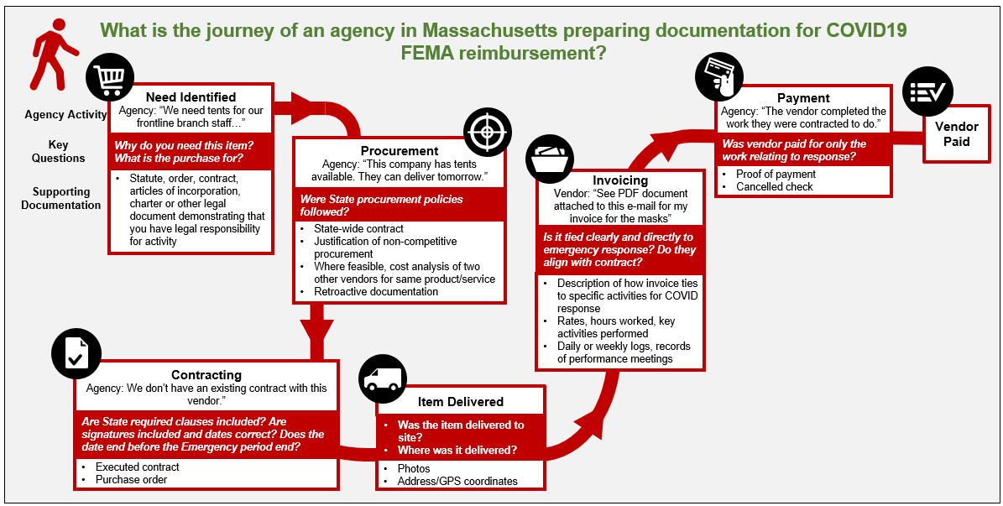
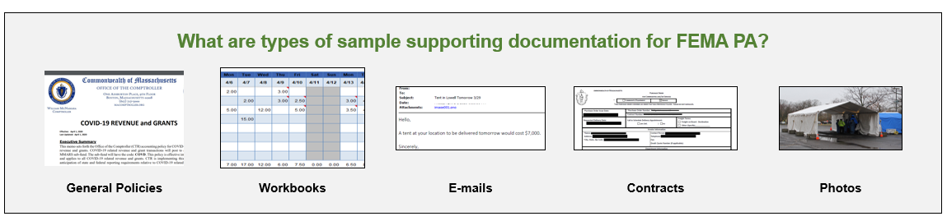

What is the FEMA PA Portal and how should it be used?
The FEMA Grants Portal is the system used by applicants to apply to FEMA for reimbursement. Before submitting a request for public assistance, you will need to create a FEMA Grants Portal account. Use this webinar and this FEMA Guidance to learn how to create a Grants Portal account or identify if you have an existing account from a previous disaster recovery effort. Creating and accessing a Grants Portal account can be done on FEMA’s website.
For more information on how to use the portal, please view the informational videos titled Grants Portal Training How to Submit a RPA, Grants Portal Training Adding New Users, and Grants Portal Training Where to Locate Resources, which are available on the MEMA website.

How can I obtain FEMA-PA funding quickly to continue my COVID-19 response?
Applicants that have a need for immediate funding in order to continue response activities related to COVID-19 can submit an application for an Expedited Project to MEMA through this link. Please see FEMA’s Expedited Funding Job Aid and MEMA’s webinar for more information.

Immediate Action Items for State Agencies
The following action items are recommended next steps for state agencies. They identify activities your agency can perform today to best prepare your agency and team for applying for FEMA grant funding tomorrow.

To ensure eligibility to apply for FEMA-PA:
- Educate yourself on the process by reviewing this document, MEMA Guidance, and available webinars to keep up to date.
- Register for your Grants Portal IDs and submit a request for public assistance (RPA), (watch a how to video here and see FEMA’s Grants Portal Account and Request for Public Assistance).
- Begin collecting supporting documentation and recording your expenses. See the following sections, and “Guidance: Tracking Expenses and Documentation” for tips and information on requirements.

To track and collect required documents:
- Set-up and manage a secure and centralized database/data repository, accessible by your Administrative team.
  - Communicate a clear process to update and input information.
  - Establish naming conventions, file storage and folder structure protocols, and upload procedures/timelines. The FEMA Grants Portal provides some guidance on naming conventions.
  - Define roles and responsibilities for managing and updating the database.
- Define and communicate list of COVID-19 related costs and revenue to Administrative staff. Review the Process Overview section above for guidance on allowable costs.
- Follow the CTR COVID-19 Payment Coding Policy: all payments for COVID-19 related expenditures must include the code COVID19 in the “Reporting” field of the Detailed Accounting section of the payment document
- Follow the CTR COVID-19 Revenue and Grants Policy: Include the code COVD in the subject line of COVID-19 related email correspondence with CTR and A&F. In addition, if your department receives a COVID-19 related award increase to an existing grant, request a new appropriation from A&F for the COVID-19 related award and create a Major Program for the COVID-19 related portion of the award.
- Follow the CTR Federal Reimbursements for COVID-19 Capital Expenditures: Reserve an account with A&F, submit account information, authorization, and amount to CTR.
- Collect data and documentation for eligible expenditures to date (See Comptroller Guidance in “Compiled Resources” below).

To meet FEMA requirements around documenting costs and expenses:
- Document every expenditure related to response and recovery, such that each expenditure is related to the incident response.
- Differentiate response costs from general operating costs occurring concurrent with the response.
- Communicate timekeeping practices for employee labor across the system specifically related to COVID-19 activities.
- Integrate cost tracking mechanisms to track COVID-19 activities and expenditures (cost codes, tools, templates).
- Develop process/rules for costs going forward and a process to review past costs.
- Develop cost estimates and projections for future expenditures.
- Review Emergency Procurement guidance and prepare policies for submission to FEMA/

Guidance: Tracking Expenses and Documentation

What do I need to track and collect now?
Reference the MEMA State Workbook for recommended data to capture and the Category Z Management Cost Workbook for recommended administrative expense data to capture.
In addition to tracking costs for the duration of the response, applicants must prepare documentation to submit for reimbursement. Eligible costs will be denied reimbursement if documentation is not adequate. Key information to include on the documentation, where applicable, includes document date and number, vendor name, and amount paid out.
Disclaimer: This list includes documents that FEMA has requested in a project’s lifecycle after past disasters and may request during or after COVID-19. As FEMA continues to revise COVID-19 guidance and release new requirements, it is possible that not all documents listed below will be applicable. However, the following documents are examples that are recommended for agencies to collect and store in preparation for reimbursement.
Document Category | Document Type [FEMA’s Suggested Naming Convention]
General Policies | Employee/Labor Pay Policy
 | Overtime Policy
 | Fringe Benefits Policy
 | Procurement Policy [“Project # - DRxxxx(MA) - Procurement Policy”]
 | Insurance Policy [“Project # - DRxxxx(MA) - Insurance Policy, Findings & Declaration”
Reimbursement Request | FEMA Schedules in the Streamlined Project Application
 | Deductions to offset costs: Insurance, Disposition, Medical Payments, Other Proceeds/Payments recovered
 | COVID-19 Contracts Report [“Project # - DRxxxx(MA) - Contract Document”]
Expense Information
Contracts | Request for Proposals
 | Invoice / Summaries of Invoices [“Project # - DRxxxx(MA) – Invoices”]
 | Emergency Procurement Memo
 | Competitive Process / Justification for non-competitive procurement
 | Bid Advertisement
 | Bid/Quote Responses [“Project # - DRxxxx(MA) – Bids”]
 | Selection Process
 | Contract / Purchase Order [“Project # - DRxxxx(MA) - Purchase Order”]
 | Amendments & Change Orders [“Project # - DRxxxx(MA) - Amendment Documentation”]
 | Notice to Proceed
 | Proof of Payment
 | Contract Work Summary Record
 | Cost or price analysis (if over $250,000)
 | Contractor Oversight (logs, records of performance meetings)
Force Account Labor  [FEMA Resource: Benefit Calculation Worksheet] | Force Account Labor Summary
 | Pay rate schedules and Fringe Benefits Breakdown
 | Timesheets (Summary list for Sampling, Sample set of timesheets and sampling methodology)
 | Employee Details (Name, Job Function, Title, Type of Employee)
 | Payroll record (proof of payment)
 | Justification for any standby time claimed
 | Daily logs or activity reports, include days and hours worked and a description of the work performed with an activity log (Summary list for Sampling, Sample set of timesheets and sampling methodology)
 | If applicable, Mutual Aid Agreement
Force Account Equipment  [FEMA Resource: Rented Equipment Summary Record] | Proof of Ownership
 | Force Account Equipment Summary (Year, make, model, size, and capacity of equipment)
 | Schedule of Equipment Rates
 | Operator Summary (Name, Job Function, Title, Timesheets)
 | Usage/Activity logs (include description of work performed)
Purchased / Rental Equipment | Invoice [“Project # - DRxxxx(MA) – Invoices”]
 | Emergency Procurement Memo
 | Competitive Process
 | Bid Advertisement
 | Bid/Quote Response [“Project # - DRxxxx(MA) – Bids”]
 | Selection Process
 | Contract / Purchase Order [“Project # - DRxxxx(MA) - Purchase Order”]
 | Amendments & Change Order [“Project # - DRxxxx(MA) - Amendment Documentation”]
 | Notice to Proceed
 | Proof of Payment
Force Account Materials  [FEMA Resource:  Materials and Summary Record] | Proof of Ownership
 | Force Account Materials Summary [“Project # - DRxxxx(State Abrv) - Material Summary”]
 | Purchase order [“Project # - DRxxxx(State Abrv) - Purchase Order”]
 | General Ledger (GL)
 | Stock inventory record (pre-event)
 | Material usage and inventory withdrawal records (types of supplies, quantities used)
 | Original Invoices [“Project # - DRxxxx(MA) – Invoices”]
 | Material Summary Record [“Project # - DRxxxx(State Abrv) - Material Summary”]
 | Historical Cost Records [“Project # - DRxxxx(MA) - Historical Cost Previous Disaster”]
 | Inventory Records
Purchased Materials / Supplies [if above $250,000, refer to Contract requirements] | Invoice/Receipts and Proof of Payment [“Project # - DRxxxx(MA) – Invoices”]
 | Emergency Procurement Memo
 | Competitive Process
 | Bid Advertisement
 | Bid/Quote Responses [“Project # - DRxxxx(MA) – Bids”]
 | Selection Process
 | Contract / Purchase Order [“Project # - DRxxxx(MA) - Purchase Order”]
 | Amendments & Change Orders [“Project # - DRxxxx(MA) - Amendment Documentation”]
 | Notice to Proceed
 | Justification if items not used

Guidance: Costs

What costs are eligible?
At a minimum, work must meet each of the following three general criteria to be eligible.
- Be required as a result of the declared incident.
- Be located within the designated area, with the exception of sheltering and evacuation activities.
- Be the legal responsibility of an eligible applicant.
Please note, the Applicant is responsible for showing that work is required due to an immediate threat resulting from the declared incident.
Not all costs incurred as a result of the incident are eligible. To be eligible, costs must be:
- Directly tied to the performance of eligible work
- Adequately documented
- Reduced by all applicable credits, such as insurance proceeds and salvage values
- Authorized and not prohibited under Federal, State, Territorial, Tribal, or local government laws or regulations
- Consistent with the applicant’s internal policies, regulations, and procedures that apply uniformly to both federal awards and other activities of the applicant
- Necessary and reasonable to accomplish the work properly and efficiently
The cost of supplies, including materials, is eligible if:
- Purchased and justifiably needed to effectively respond to and/or recover from the incident
- Taken from the Applicant’s stock and used for the incident
Below are sample eligible costs, subject to the 3 requirements above, and ineligible costs:
Ineligible
- Damages covered by insurance
- Reimbursement to donors for donated items or services
- Workforce bonuses (other than hazard pay or overtime)
- Severance pay
- Legal settlements
Likely Eligible
- Communication and enforcement of COVID-related public health orders
- Technical assistance costs to entities on mitigation of threats to public health and safety
- Payroll expenses for public safety, public health, human services, or other employees whose services are substantially dedicated to mitigating or responding to the emergency
- Overtime for hourly fulltime employees who were assigned to perform emergency protective measures
- Overtime for salaried fulltime employees who were assigned to perform emergency protective measures, only if the the applicants standard pay/labor policy allowed for OT for salaried employees.
- Emergency response equipment usage (such as an ambulance) tied to COVID-19

Guidance: Procurement for State Entities
FEMA’s PA program maintains guidelines for states to follow regarding procurement policies and contracting activities an emergency. Commonwealth state agencies, as eligible state entity applicants, should review procurement guidance below to identify and ensure compliance with applicable federal procurement policies.
What are the procurement standards for states?
State entities must follow three overarching procurement standards found in the Uniform Rules listed in various sections of the Electronic Code of Federal Regulations:
- Follow the same policies and procedures your agency uses for their non-Federal funds (2 C.F.R. 200.317).
- Comply with the procurement of recovered materials guidelines (C.F.R. 200.322).
- Ensure every purchase order or other contract includes contract clauses and any additional FEMA recommended provisions (2 C.F.R 200.326 and Appendix II).

What are procurement best practices?
- Follow guidance specifically for states: State are required to follow state procurement rules. Be sure that you follow the guidance listed above and these specific tips.
- Use contracts you already have in place: Understand what your emergency procurement policies are currently and follow them to the best of your abilities. For procurements where you have more time, get written quotes or follow normal procurement guidelines as much as possible.
- Understand Exigency and Emergency Exceptions: Review FEMA guidance for a description, documentation requirements, and types of contracts allowed and prohibited under these exceptions.
- Prepare justification for Noncompetitive Procurement: Review FEMA guidance on this.
- Document everything: Document all the steps you took to comply with your own procurement policies and procedures, as well as the procurement of recovered materials standard. If you cannot follow your policies, document the reasons or circumstances that prevented you. FEMA will review this to determine whether you are eligible for reimbursement.
- Review common procurement mistakes: Avoid top mistakes that can cause state entities to lose FEMA funding. Namely, these include not following your own procurement policies and procedures and not including required contract provisions.
- Consult your attorneys: Consult your attorney to determine how the different parts of the Uniform Rules in the language linked above applies to your entity or agency.
Need additional procurement guidance?
For additional information on Best Practices and Frequently Asked Questions in Procurement, please review FEMA’s Procurement Standards for States and Public Assistance Contracting Requirements Checklist.

Frequently Asked Questions
- Do I need to create a FEMA Grants Portal account and apply or will it be handled by A&F or MEMA?
  - Each state agency must create their own account directly in the Grants Portal if they have not done so previously. They must submit their own request for public assistance (RPA).
- Can I create an account now? If so, how do I do that?
  - Yes, you should create an account now. Instructions are provided in the FEMA PA Overview section within this guidance document.
- Can I start submitting requests now? If I submit requests now, can I update it later?

FEMA’s COVID-19 Streamlined Project Application Template has been posted as a PDF document for guidance and the application is now live in the FEMA Grants Portal. However, MEMA has established a Reimbursement and Documentation Unit (RDU) to support state agencies in preparing their applications and strongly encourages all state agencies to wait to upload documents to the Grants Portal and preparing their application until an initial consultation with the RDU. MEMA will host a webinar on Wednesday June 3rd from 2 – 3:30PM to introduce the RDU support process for state agencies and answer any questions.
- What is sufficient documentation, and can you provide some examples?
  - Documentation requirements vary by expense type. Examples are provided above.
- How do I know if my documentation is complete and accurate?
  - FEMA and MEMA will both review documentation submitted FEMA prior to grant award.
- Does FEMA just determine eligibility by expense type or does the use of the product/service matter?
  - To be eligible, an expense must at a minimum, meet three criteria: be required as a result of the declared incident, be located within the designated area, with the exception of sheltering and evacuation activities, and be the legal responsibility of an eligible applicant. Additional information on eligible expenses is included above.
- If I have questions about eligibility, whom do I email or call?
  - Please submit eligibility questions directly to MEMA using the following form: https://massgov.formstack.com/forms/em3438_declaration_fema_pa_questions. Following the June 3rd RDU introductory webinar, state agencies may contact their designated RDU Point of Contact for eligibility questions.
- If I am dealing with a larger, complex project, can MEMA provide additional support?
  - Yes, MEMA has established the RDU to provide advanced support. Instructions on this process will be shared in the June 3rd RDU introductory webinar. More information is available from RDU Project Lead Hunter Richard (hrichard@guidehouse.com).

Compiled Resources and Links
Below are some clickable additional resources related to FEMA-PA and COVID-19.
FEMA-PA
- FEMA COVID-19 Website
- COVID-19 Emergency Declaration
- Massachusetts COVID-19: Emergency Declaration (EM-3438)
- Massachusetts COVID-19 Pandemic: Major Disaster Declaration (DR-4496)
- FEMA Public Assistance Program and Policy Guide (FP 104-009-2)
- FEMA Grants Portal
- Cost Estimating Format for Large Projects
- Procurement Under Grants Conducted Under Exigent or Emergency Circumstances
  - Procurement Under Grants Conducted Under Emergency or Exigent Circumstances for COVID-19 (Memo)
  - Procurement Under Grants: Under Exigent or Emergency Circumstances
- Fact Sheets
  - Coronavirus (COVID-19) Pandemic: Eligible Emergency Protective Measures
  - Coronavirus (COVID-19) Pandemic: Emergency Medical Care
  - Coronavirus (COVID-19) Pandemic: Non-Congregate Sheltering
  - Coronavirus (COVID-19) Pandemic: Public Assistance Simplified Application
  - Coronavirus (COVID-19) Pandemic: Purchase and Distribution of Food Eligible for Public Assistance
  - Public Assistance: Contracting Requirements Checklist
- Frequently Asked Questions: Procurement Standards for States under FEMA PA Awards
- Public Assistance Contracting Requirements Checklist
- Available on MEMA Website
  - Expedited Funding for COVID-19: FEMA Job Aid
  - Completing and Submitting a COVID-19 Project Application.pdf
  - Applicant Quick Guide COVID19 Process Overview.pdf
  - Grants Portal Account and Request for Public Assistance.pdf
  - Submitting a Public Assistance Funding Request for COVID-19.pdf

MEMA
- MEMA Federal PA website (info and resources to complete public assistance applications)
- Massachusetts’s Emergency Management Agency Website
  - MEMA COVID-19 Federal Disaster Declaration Website (info and webinars on the public assistance grant process and eligible costs)
  - Baker-Politico Administration Announces Federal Disaster Declaration for COVID-19 Response
  - Webinars: COVID 19 FEMA PA Resources, Major Disaster Declaration DR 4496, Grants Portal Account, and RPA Submission; Expedited Projects; Non-Congregate Medical Sheltering and Eligibility & Questions
  - How to Videos: Grants Portal Training How to Submit a RPA; Grants Portal Training Adding New Users; Grants Portal Training Where to Locate Resources
- MEMA Coronavirus Pandemic Guidance on Eligible Costs
- MEMA Disaster Declaration Eligible Costs
- State Workbook and Category Z Management Cost Workbook
- Expedited Application for FEMA Public Assistance Funding in Massachusetts

Office of the Comptroller (CTR)
- Policy for coding all COVID-19 related payments
- COVID-19 Revenue and Grants Policy
- Federal Reimbursements for COVID-19 Capital Expenditures

Electronic Code of Federal Regulations
- C.F.R. 200.317-326: Procurement Standards (of Uniform Administrative Requirements, Cost Principles, and Audit Requirements for Federal Awards)
- 2 C.F.R 200. 326 and Appendix II Required Contract Clauses
U.S. Department of Health and Human Services
- Office of the Assistant Secretary for Preparedness and Response (ASPR): ASPR Responds to the Pandemic: 2019 Novel Coronavirus

Authenticated U.S. Government Information
- Public Law 116-123—March 6, 2020: Coronavirus Preparedness and Response Supplemental Appropriations Act, 2020
- Public Law 116-127—March 18, 2020: Families First Coronavirus Response Act
- H.R. 748—Coronavirus Aid, Relief, and Economic Security Act (CARES Act)
Other
- Crisis Counseling, Massachusetts Department of Mental Health (DMH)

If you have questions about this guidance or need additional support, please submit your question to MEMA.

Key Events
- January 31, 2020: Public Health Emergency began.
- March 6, 2020: Coronavirus Preparedness and Response Supplemental Appropriations Act (H.R. 6074) became law.
- March 18, 2020: Family First Coronavirus Response (H.R. 2601) became law.
- March 13, 2020: President declared an Emergency Declaration for the Commonwealth of Massachusetts, EM-3438.
- March 27, 2020: President declared a Major Disaster Declaration for the Commonwealth of Massachusetts, DR-4496.
- March 27, 2020: Coronavirus Aid, Relief, and Economic Security (CARES) Act (H.R. 748) became law.

Key Information on Available FEMA Funding
- FEMA Public Assistance Category B - Emergency Protective Measures and Category Z – Recipient Management Costs funding is available to all state agencies, as well as local governments and eligible private non-profit organizations.
- If costs are submitted and documented properly, FEMA may reimburse 75% of COVID-19 costs and up to a 5% management cost fee.
- Applicants that have a need for immediate funding in order to continue response activities related to COVID-19 can submit an application for an Expedited Project to MEMA. Applicants may request 50% of the amount submitted in the initial project worksheet (PW), for projects that are greater than or equal to $131,100, as expedited funding (see FEMA’s Expedited Funding Job Aid for more information).

FEMA Terms to Know
- Recipients: State entities that receive and administer Public Assistance federal awards, such as MEMA.
- Applicants: State or local governments or private non-profit entities that may request and receive subawards under a Recipient’s award.
- Subrecipients: Applicants once they are approved for funding from FEMA PA.
- Projects and Subawards: Groups of activities that become a subaward under the Recipient’s award when approved.

States entities include U.S. states and territories and any agency or instrumentality of that state or territory. https://www.fema.gov/media-library-data/1539875905022-5a.

