From: Jami Osborne
To: DPH-DL - DoN Program
Subject: Norwood Hospital? Steward"s plans
Date: Thursday, September 21, 2023 9:37:21 AM

CAUTION: This email originated from a sender outside of the Commonwealth of Massachusetts mail system. Do not click on links or open attachments unless you recognize the sender and know the content is safe.

To whom it may concern,

I am writing to you as a long-time resident of Norwood who lives less than a half mile from the site of Norwood Hospital, as a former midwife and current Licensed Mental Health Counselor. I would like to briefly address the lack of maternity care here, and then focus on the elimination of all mental health care.

With the elimination of maternity care here in Norwood, much as in Leominster, expectant families will have to travel to Attleborough, Newton, Boston or, maybe Milton for emergency or high risk pregnancy care. As a midwife who often attended women and families opting to have their baby at home, the proximity of quality maternity care made their decisions easier and safer. Now, unfortunately, I fear most will be forced to have scheduled c-sections to avoid the panic of trying to get to a hospital 20+ miles away - especially in rush hour.

Now let's look at the issue of eliminating mental health care here in Norwood. Norwood has served this community as a FULL SERVICE high level facility since 1902. During most of this time, certainly for the last 50+ years, there have been beds for In-Patient Psychiatric care for adolescents and adults. Most recently, there were at least 70 beds. When the LoRusso building was erected [eliminating our indoor town pool!] the emergency department was constructed with a specific mental health area, isolated from the rest of the department, because the then- owners of the facility recognized the need for different care within this community. Our community houses a large Community Mental Health agency [Riverside Community Care], an Adult Day Treatment center and many licensed professionals focusing on mental health services. This is, in part, because we all knew Norwood Hospital would be there to help our clients should they experience any level of mental health crisis or emergency.

As a clinician in the community, I have referred clients to Norwood on several occasions, knowing they would receive compassionate, quality care, and their families would be able to get to the hospital quickly and easily via public or private transportation. On the few occasions when my clients were referred to other facilities [Attleborough, Boston, Middleboro for example] they and their families felt cut off from one another, and the clients reported to me that they
felt abandoned.

In my role as President of the Massachusetts Mental Health Counselors Association, I am well aware of the Chapter 177 of the Acts of 2022, signed into law last August. This legislation is focused on increasing access to mental health care at all levels, from improving the workforce [more therapists] to increasing the number of psychiatric beds available for clients of all ages, and within easy access to those clients and their families. I question Steward's plan to 'consolidate' care in Brockton, arguably a community that needs more services, while simultaneously cutting Norwood and the communities it serves from access to this crucial service.

The refusal of the Steward organization to recognize this need, and in fact, to down- play it, is irresponsible. The initial DON seemed not to acknowledge the prior existence of the beds there before the flood. Their slogan "New Hospital, Same Commitment" seems false under the current circumstances.

I therefore, respectfully recommend that the DON eliminating maternity and psychiatric care in Norwood be denied, and Steward be instructed to find space for these crucial and life saving services in the new facility. Let their motto "New Hospital, Same Commitment" mean something to the people of Norwood and the surrounding towns. Let that motto foster trust and confidence in the Steward system, instead of resentment.

Jami Osborne LMHC, MACCS, DCMHS-Trauma, RDT/BCT, RfGCT EMDRIA Certified Therapist

[redacted]
From: Madeline Eysie
To: Clarke, Lucy (DPH); DPH-DL - DoN Program
Subject: Re: Norwood Hospital
Date: Friday, September 22, 2023 9:28:37 AM

CAUTION: This email originated from a sender outside of the Commonwealth of Massachusetts mail system. Do not click on links or open attachments unless you recognize the sender and know the content is safe.

Madeline Eysie
[redacted]

On Fri, Sep 22, 2023 at 9:15 AM Madeline Eysie [redacted] wrote:

September 21, 2023
This document is about restoring a high standard for Norwood Hospital in Norwood, Massachusetts, a Steward property.
After the unfortunate environment/flood crisis in 2021, Steward
implemented a tagline that is "Same Hospital, Same Commitment". These words are not truthful, but Steward is a financial company with millions to spend on marketing/advertising. They only make 80 billionper year.
Norwood Strong is a unique community that upholds a very high standard of care for it's residents and all the towns in Norfolk County. It is strategically located in a prime town that is able to take advantage of Boston Hospitals when necessary. If you view Steward's website you will notice most of the upper level of leadership is originally from Boston, MA. Since most of them are from Massachusetts you would think they know the difference between a rebuild for Norwood, bigger and better, rather than Brockton that is not is not geographically ideal and has a rather high crime rate in comparison to other Towns in Massachusetts.
Brockton is in fact a City. To invest max. 76 million dollars in a new building adjacent to Good Sam is a very poor decision. Decision is the keyword. Today we encourage young and old to think about the decisions they make. It usually gets down to ACTION VS.
CONSEQUENCE. Whether you are 5 years old or 95 years of wisdom, your action does result in a consequence and I'm promoting a result that is positive for all concerned.
Department of Health has a new head honcho and perhaps the poor decision to not support Maternity and Mental Health at Norwood Hospital may be in his TO DO Basket. Robbie Goldstein was appointed by Governor Maura Healey in April 2023, just a few months ago.
The decision to not fund the contruction back to it's original state is ludicruous and disgusting. Even in a hotel room they post a notice- "please restore this room to it's original state".

No intelligent person that is educated whether locally or globally would not agree that suicide and mental health is a crisis. Balance provided by Medical professionals for Good and Balanced Mental Health and Maternity is essential, not questionable. Currently many women go to Newton/Wellesley for birthing and maternity services. I was born in Norwood Hospital (the original brick bldg.,) and it's sad to realize there will be no babies born in such a decent upstand town in Massachusetts.
Rural hospitals are closing and encouraging maternity patients to use other resources. Many families are moving to be closer to a hospital that provides full service maternity. This decision to eliminate rather than restore and let's do this restoration at a higher level than average.
Getting back to Brockton, my dad worked at the Brockton Enterprise for 42 years and my mom worked in a shoe factory that made the special shoes that JFK wore. It's always been a hard working yet struggling city to raise the bar. Investing 70 billion in a building that doesn't even include Maternity is truly a poor investment of Steward and State funds. This is not rocket science. It's so simple that a few degreed folks got wrapped around the axle. The Department of Public Health should be ashamed that they were persuaded to put blinders on when it came to original restoration of services in Norwood.
I was thrilled to be hired at enjoyed my job in the gift shop (not affiliated with Steward). My observation of folks in and out of the gift shop had me in doubt as to whether or not the people employed were "happy". I can tell you that my smile was not always welcome. I will assume that they were qualified to be in the jobs they were employed in, but moral was at a alltime low. It was definitely from the top down that a "charisma bypass" was necessary.
If you review the Mission Charter for the Dept. Public Health and Steward you will find lovely words, but no action to complement the words. In fact on one of the Steward websites, I think it was Dallas they depict a young man cuddling an infant. A real oxymoron.
Same Hospital, Same Commitment. For whom I would ask? It is shocking when you chat about the elimination of Maternity and Mental Health by Steward as it is hard to believe in this society today. We are all at risk. A huge drug bust was had the day before yesterday in Brockton. This may be a mother on drugs and needing Maternity and Mental Health.
We are Norwood Strong! We are capable of being caretakers for a high standard of Maternity and Mental Health. Perhaps Steward doesn't want to participate because it will require a 200% commitment and Steward only makes 80 billion a year $$$$$$
Sincerely hoping for a progressive outcome that makes sense. Madeline Eysie
[redacted]

Madeline Eysie
[redacted]

From: Trish Monahan
To: DPH-DL - DoN Program
Subject: DoN #22111156 in Brockton
Date: Friday, September 22, 2023 9:41:11 AM

CAUTION: This email originated from a sender outside of the Commonwealth of Massachusetts mail system. Do not click on links or open attachments unless you recognize the sender and know the content is safe.

To whom it may concern,

I write not in opposition to the building in Brockton (the more services available, the better) but in opposition to moving services out of Norwood and into any other location. It is well known that the need for behavioral health services is on the rise, for a myriad of reasons. To call this plan an expansion of services is a disservice to the general public. There is no expansion of services, Steward will be keeping the same number of beds but they will be in a different location. This is nothing more than geography.

I'd like to refer you to page 8 of Steward's Community Benefits Report for 2022, please, where Steward recognizes the need for behavioral health services and then to page 9 where the statement is made that Norwood Hospital can make a positive impact, etc and again to page 10 where the page title is Priority Area 1: Behavioral Health:

https://content.steward.org/sites/default/files/inline-files/CHIS_2022.pdf

I maintain moving the very services out that they are naming is NOT making a positive impact, ignores their own study, and will in fact make situations more difficult, especially for the patients' loved ones. As an advocate, I have worked with families who are left with no option but to race around the state trying to keep in contact with, and sometimes just to locate, a patient. I can offer that not all facilities are efficient at keeping loved ones informed. As an advocate, I could not in good conscience refer a client to anywhere I knew would only add stress and heartache to the problem.

Questions have been submitted to Steward asking what happens when there are 77 beds but 78 patients, how patients get from the ER in Norwood to the building in Brockton and how they get home when discharged, as well as other questions. We were referred to a video but that did not address any of the questions. Is this plan well thought out enough to address these questions?

Lastly, the leaky roof has already caused the need to demolish the hospital and rebuild. Endless costs have been added to municipal budgets while ambulances are out of town, other towns cover each other's emergencies, costs for wear and tear on emergency equipment increase, as do response times, and towns will now be left with fewer services provided by Steward. While the population served is grateful the hospital will be rebuilt, it is shameful the new hospital will not provide the same services the old hospital did, especially when the unmet needs have clearly been recognized. Perhaps another hospital will step forward and fill that void.

Thank you for your time and for this opportunity for me to be heard. Patricia J Monahan

[redacted]

From: George Sigel
To: DPH-DL - DoN Program; norwoodmaadvocatescoregroup@gmail.com
Cc: Mermelstein, Bruce; Larry Janowitz; C W Carl; Richard Morrill
Subject: DoN 22111516Comments on Hearing held 9/20/2023
Date: Friday, September 22, 2023 5:50:41 PM

CAUTION: This email originated from a sender outside of the Commonwealth of Massachusetts mail system. Do not click on links or open attachments unless you recognize the sender and know the content is safe.

I represent the Ten Taxpayer Group that participated in the so-called Public Hearing held on Steward DoN 22111516.

- Hardly a Public Hearing. Phone only, no questions, no idea if proper Steward Administration present.Was no way to evoke a concern that this DoN application was being used to mask over deficiencies in their previous Don 20121611 (Norwood Hospital). Application , for example, reported 0 Psychiatric beds before the flood, and then stated that there would be 0 after the rebuild of the hospital. Further the applicant left blank the question of a community feedback process had been completed on their proposal. This ought to be of concern to the DPH, and the Governor. In 2022, Steward and Norwood Hospital completed a “Norwood Hospital Community Benefits” report and concluded that Behavioral Health was the biggest unmet need in the service are of the hospital. Only following a very public picket did Steward publically announce that their plan was to consolidate behavioral services in Brockton, and that the new hospital may include 10 holding rooms in the emergency department for patients whose primary needs were mental illness or substance abuse.

- Steward refused to meet with the Norwood Hospital Advocates. Asked the group to submit a small list of questions. A short list of questions was as requested submitted.No response was forthcoming despite two meetings at Library set aside to receive responses. Essentially we have been ignored by Steward. Yet they advertised “New Hospital, Same commitments”. Hardly.

- The Brockton proposal is ok, for an entirely different service area outside the Norwood Hospital service area. As a response to elimination of services in Norwood service area, it is a nonsequeter. In the same way, their sale of a hospital in Utah makes no difference to Norwood.

- Where is the state oversight? Is it possible that DPH dropped the ball in its review of the Steward DoN for Norwood? For example, the Commissioner of Mental Health is by law the State’s Mental Health Authority, with responsibility for mental health services in Massachusetts, both public and private. Did DMH stand aside and without comment support the elimination of all mental health services in Norwood, including an excellent 22 bed inpatient unit for adults? Brockton does not replace those beds, and at a time when almost daily we are reminded that there is a mental health pandemic impacting the entire country.

- There was no opportunity to ask how the needs of the Norwood service area can be met 11 miles away. Is any one besides our Advocacy Group concerned about cost of transportation from the Norwood ED? Or how patients are to get there for follow up? How do family members visit loved ones, and be included in discharge planning when that becomes clinically warranted? Not all insurance covers ambulance charges, by the way.

- The so-called public hearing was attended by state and local officials representing the Brockton area. Of course they all were enthusiastic and happy to see the services coming to their community. The State of Massachusetts is remiss in witnessing and endorsing the loss of those services in the Norwood areas of service. No Norwood officials were in attendance to register concern that similar services were leaving Norwood.

George Sigel, MD
Norwood Regional Behavioral Health Advocacy
[redacted]
Sent from my iPad

From: Michael Thornton
To: DPH-DL - DoN Program
Subject: Steward"s Commitment to the Norwood Community
Date: Sunday, September 24, 2023 7:28:57 AM

CAUTION: This email originated from a sender outside of the Commonwealth of Massachusetts mail system. Do not click on links or open attachments unless you recognize the sender and know the content is safe.

To whom it may concern.

I was born and raised in Norwood. My wife and I raised our three children there, and both of us work in Norwood as well. Over the span of several decades, my family and I have been afforded high quality health care from Norwood Hospital, a health facility where, in fact, I was born. Currently, however, I have issues with facility owners, the Steward organization out of Houston, Texas. For the contemporary Norwood community to receive "...world class health care where you live...", as proffered by Steward, then that organization needs to deliver on its currently disingenuous slogan "...New Hospital, Same Commitment...". Recent legislation passed in the Commonwealth of Massachusetts was intended to increase local access to additional mental health benefits, including an increasing number of psychiatric beds within that local community. Instead, by reducing the new Norwood Hospital's footprint of psychiatric beds from 60 to 10, the math here suggests an 83% reduction in the level of commitment to psychiatric care here in Norwood, as proposed for Steward's new Norwood Hospital.

In offering my comments regarding Steward's deficient plans for the new Norwood Hospital, I am in no way attempting to denigrate Good Samaritan Hospital, or the good community of Brockton. What I specifically address in my comments here is the deficiency that Steward offers the community of Norwood. I am a current member of the Impact Norwood Coalition. This group is dedicated to the promotion of healthy living and activities throughout our community. From surveys available to Impact Norwood, I can attest to the daunting mental health challenges that Norwood's youth face daily, particularly in a post-COVID world. Statistically, per a 2021 Metro West student survey, 27% of all Norwood students in grades 6 to 12 have reported depressive symptoms, 36% of females at Norwood High School report depressive symptoms, and 21% of all female students in grades 6 to 8 have reported suicidal ideation. This isn't speculation. These are facts reported honestly and anonymously by the students themselves. With all due respect to Brockton, shipping off Norwood residents with acute mental health needs to a hospital several miles and several minutes away from Norwood negates Steward's proposal to provide "world class healthcare" and "Same Commitment" to all who currently live in Norwood.

Ironically, the very same Suffolk Construction workers who have done such a

magnificent job of erecting the new Norwood Hospital have posted at the work site a message to the Norwood community which cites the following: “...Your mental health is vital...nearly 60% of construction workers report struggling with their mental health...construction has the highest suicide rate of any profession...”.
This heartfelt message is posted just inside the hospital's East Hoyle Street construction gate. No community is immune to the mental health challenges that exist across America. Steward must do what's right for ALL in our community of Norwood, and adequately address the mental health needs of the community in which the hospital lives. .

I therefore urge DPH to reject Steward's DON for Norwood, and insist on the restoration of 60 available psychiatric beds in the new Norwood Hospital. When this finally occurs, Steward can then rightfully employ their slogan (New Hospital, Same Commitment...". Thank you for your consideration.

Regards,

Michael J. Thornton, Jr.
Member – Impact Norwood Coalition

[redacted]

From: George Sigel
To: DPH-DL - DoN Program
Subject: Fwd: Well done!
Date: Monday, September 25, 2023 2:00:11 PM
Attachments: Suffolk Workers - Norwood Hospital #1.PNG

CAUTION: This email originated from a sender outside of the Commonwealth of Massachusetts mail system. Do not click on links or open attachments unless you recognize the sender and know the content is safe.

Please add this to commentary on Brockton / Steward DON.

Sent from my iPhone

Begin forwarded message:

From: Michael Thornton
Date: September 24, 2023 at 1:11:39 PM EDT
To: George Sigel
Cc: Joseph Breton >, Jeff Sullivan Ann Schkuta Anne Marie Flaherty Barbara Clark Barbara Harrington Bob Blood Bruce Mermelstein Can't read name Carol Thornton , Claire Tolias Denise Cronin Diane West Donna Montgomery[redacted]; Jami Osborne Jean Palmateer Jill Mazzola Joan White Kathleen Rooney , Lanette Sigel Linda Nolan Madeline Eysie Maureen Marsters Michael Donovan "Monica Phillips-Young (prefers text or call)" Neil Patterson Nina Sullivan Norwood Advocates Core Group Pam Callaway Pam Chubet Susan Flaherty Susan Flaherty Trish Monahan

FYI group,
Attached are the two shots that I took recently at the Norwood Hospital, which capture the Suffolk Construction work site posting regarding the devastating effects of mental health struggles within its industry. These pictures were taken just inside the new hospital's East Hoyle Street construction gate.
I too am hearing that Suffolk Construction's subs are currently NOT getting paid by Steward, and are pulling their workers off the job. I haven't yet had this confirmed officially, but I'm told recently that this is a very typical Steward business practice. This is NOT the old Norwood Hospital regime...rather, this is a Houston, Texas non-empathetic corporate entity, seemingly attempting to do all that it can to maximize profits on the backs of the community it serves, while reducing community mental health care in the process.

Mike Thornton

On Sun, Sep 24, 2023 at 12:19 PM George Sigel [redacted] wrote:
Maybe Neil you could visit the building site and look for sign a union posted on depression among construction workers. Please get name of union. I can then reach out to them to see if they can support our protest of Steward leaving these services out. Maybe we have Allies on the site. Thank you Ray.

Sent from my iPhone

On Sep 24, 2023, at 11:33 AM, Joseph Breton [redacted] wrote:

AMDG
Rumor has it that construction at Norwood Hospital has stopped due to a conflict with the construction company. If you can confirm this rumor please let me know.
While this may be just a normal occurrence in the construction industry, it may also portend something larger. Having met with significant local resistance, Steward may look to leave the project to others. This conclusion would be enhanced if DPH agrees to conditions for the approval of the GSMC DON. Let's be vigilant; we may again get a chance to revisit the Norwood DON
Regards,
Ray Breton

On Thu, Sep 21, 2023 at 7:13 PM George Sigel [redacted] wrote:
Thank you Michael. Key is to make our Governor as concerned as we are. Good luck to us all.

Sent from my iPhone

On Sep 21, 2023, at 6:40 PM, Michael Thornton [redacted] wrote:

All speakers did an excellent job in making their individual points on last night’s call. I fully agree with George’s comment that last night’s format was in no way a real meeting. Because I was traveling last night, when I called into the meeting from my car, an auto attendant told me that I was in ‘Listen Only’ mode, and no matter how many time I hit *1 while unmuting my phone, I couldn’t make a statement last night…so frustrating!!!
I believe that your individual messages effectively focused not so much as an opposition to expansion in Brockton, but rather on what Steward did to neglect the needs and community of Norwood. The 83% planned reduction in Norwood Hospital psych beds underscores Steward’s disingenuous slogan of “New Hospital…Same Commitment”…nonsense!!! I recently wrote in a letter to the Record’s editor that, ironically, Suffolk Construction iron workers at Norwood Hospital posted a sign just inside the East Hoyle Street gate citing that “Your mental health is vital…nearly 60% of construction workers report struggling with their mental health…construction had the highest suicide rate of any profession…”. Apparently that message has fallen among deaf ears at Steward.
Not sure what evolves from last night’s meeting, but I’m quite proud of the effort displayed by callers last night. Well done.

Mike Thornton

On Wed, Sep 20, 2023 at 9:26 PM George Sigel [redacted] wrote:
Yes, all we can do is hope!

Lanette

>On Sep 20, 2023, at 6:58 PM, Norwood Advocates Core Group [redacted] > wrote:
>
>
>Hello,
>
>A great big thank you to all who took the time to call in to the public hearing tonight. There's no telling what will come of it (Eh, who are we kidding?!) but we have made a great effort. Great points were made, we can only hope DPH listened.
>
>Thank you again,
>
>Trish
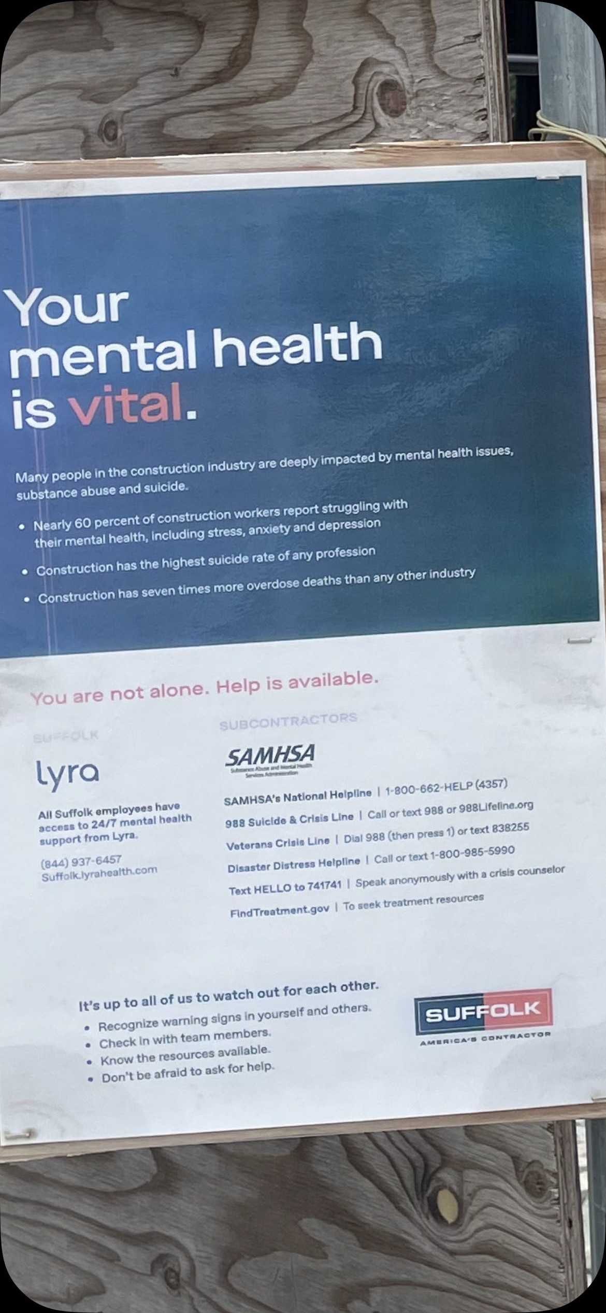

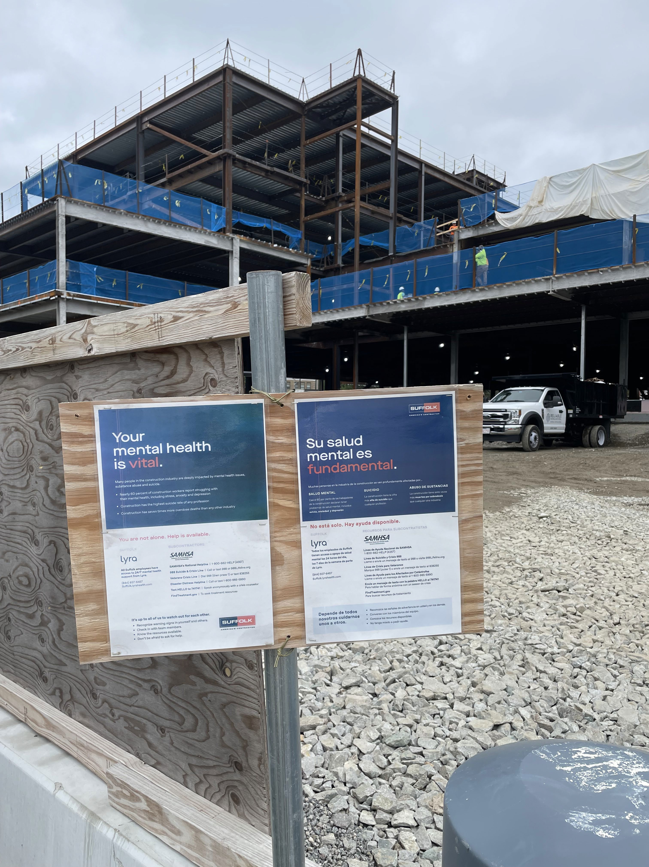

From: Michael Thornton
To: DPH-DL - DoN Program
Subject: Supplemental Comments re Norwood DoN
Date: Tuesday, September 26, 2023 6:27:48 PM
Attachments: Suffolk Workers - Norwood Hospital #1.PNG

CAUTION: This email originated from a sender outside of the Commonwealth of Massachusetts mail system. Do not click on links or open attachments unless you recognize the sender and know the content is safe.

To whom it may concern.

As a supplement to comments that I sent you on September 24, 2023, I would simply add a few pictures that capture my sentiments regarding the poignant statement that Suffolk Construction workers made to the entire community of Norwood, in the form of signs that they posted in English and Spanish on the new Norwood Hospital property (see pictures attached).

The message reads as follows:
“...Your mental health is vital...nearly 60% of construction workers report struggling with their mental health...construction has the highest suicide rate of any profession...”.
This heartfelt message is posted just inside the hospital's East Hoyle Street construction gate. The message is seemingly lost on Steward, as indicated by the Norwood DON. To date, Steward has turned a blind eye to the mental health of the Norwood community, and has essentially rejected the pleas of the very workers who are advocating for adequate mental health standards while constructing Steward's new hospital in Norwood!

I therefore urge DPH to reject Steward's DON for Norwood, and insist on the restoration of 60 available psychiatric beds in the new Norwood Hospital. Until this happens, Steward can then rightfully employ their slogan (New Hospital, Same Commitment...". Thank you for your consideration.

Regards,

Michael J. Thornton, Jr.
Member – Impact Norwood Coalition

[retracted]

From: Kathleen Rooney
To: DPH-DL - DoN Program
Subject: DON Public Hearing September 20,2023
Date: Sunday, October 1, 2023 4:49:18 PM

CAUTION: This email originated from a sender outside of the Commonwealth of Massachusetts mail system. Do not click on links or open attachments unless you recognize the sender and know the content is safe.

Hello,

This is a follow up email to further explain points I made during the Public Hearing held on September 20, 2023 re: Steward Health Care System/Good Samaritan Medical Center - Determination of Need.

I am a Norwood resident and former Steward Healthcare employee. I am not opposed to the behavioral health facility planned for Good Samaritan Hospital in Brockton especially if the new facility includes inpatient beds as well as TMS, ECT and a partial hospitalization program. Per Matt Hesketh, President of Good Samaritan, "the project is proposed in response to DPH's request that the beds previously operated in Norwood be replaced by Steward Health Care." Matt Hesketh also went on to explain that the new facility will accommodate the 61 beds from Norwood Hospital and that 16 beds will move from the Good Samaritan main campus to the new facility. This is misleading as the 16 bed geri psych unit that was at the Good Samaritan Medical Center has been closed for quite some time.

My concern is that DPH doesn't realize how many unused psychiatric beds Steward has in their system. Prior to Norwood Hospital closing due to a flood, Steward operated 18 psychiatric units in 10 hospitals in Massachusetts. The total amount of beds available to patients equaled 335. Since the closure of the 3 units at Norwood Hospital, Steward has closed 3 additional units. The closed units are at Good Samaritan Medical Center, Mt Sinai Hospital and Holy Family in Haverhill. The number of beds unavailable to psychiatric patients in Massachusetts Steward Hospitals amounts to 104 beds in those 6 units. In addition to the closed units, Steward has "capped" most of their other units so they do not fill to capacity.
Currently there are 49 beds that Steward could place patients in but for whatever reason they are not using because the units are capped. I feel it is unconscionable for DPH to allow this to continue.

Construction on the new facility has not started and I don't recall a completion date mentioned on the public hearing conference call. As mentioned repeatedly on this conference call and in the news, this country is going through a mental health crisis. Matt Hesketh mentioned that the weekend prior to the public hearing, Steward had 113 patients boarding in their Emergency Departments. Almost half of those patients would have been placed in an inpatient bed if all of Steward open units were filled to capacity. I ask DPH to look into this in order to reduce the wait times for psychiatric patients in the Emergency Departments.

I would also ask DPH to ask Steward to place their new Behavioral Health Facility wherever it can be built quicker. Whether that is on the Good Samaritan campus or the Norwood Hospital campus.

Thank you, Kathleen Rooney

