Massachusetts Department of Environmental Protection
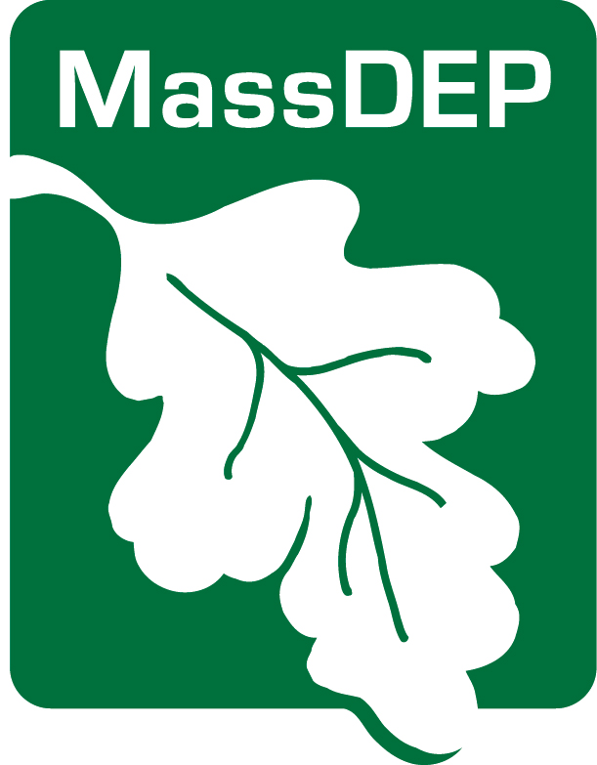
Drinking Water Program
PFAS Public Education

CERTIFICATION

Make sure to send your MassDEP Drinking Water Program regional office and local board of health a copy of each type of notice with this completed certification upon issuance to demonstrate you have met all of the PFAS Public Education requirements [310 CMR 22.07G(7)(e)].

PWS ID City/Town:

PWS Name: |  | Community Non-community
Describe the violation or situation specified by MassDEP:
PFAS Detection(s) requiring issuance of Public Education
Date Confirmatory PFAS result(s) received: | NON-Number  If applicable:
Public Education materials shall be provided to all persons served by the affected Public Water System, including without limitation consumers who do not receive water bills; as soon as practical and no later than 30 days after receipt of Confirmatory Sample results from the laboratory. The water supplier indicated above hereby affirms that public notice has been provided to consumers in accordance with 310 CMR 22.07G including: delivery, content, format requirements, notification deadlines.
Consultation with MassDEP on
date
Notice distributed by on
method date
AND

Notice distributed by on
method date
I certify under penalty of law that I am the person authorized to fill out this form and the information contained herein is true, accurate and complete to the best of my knowledge and belief.

date name

______________________________________________________________
Signature of owner or operator

Western Regional Office, 436 Dwight St., Springfield, MA 01103
Central Regional Office, 8 New Bond St., Worcester, MA 01606
Northeast Regional Office, 205B Lowell St. Wilmington, MA 01887
Southeast Regional Office 20 Riverside Dr., Lakeville, MA 02347
Boston – Program.Director-DWP@mass.gov

Rev. Feb 2021

