The Commonwealth of Massachusetts
Executive Office of Health and Human Services
Department of Public Health
250 Washington Street, Boston, MA 02108-4619
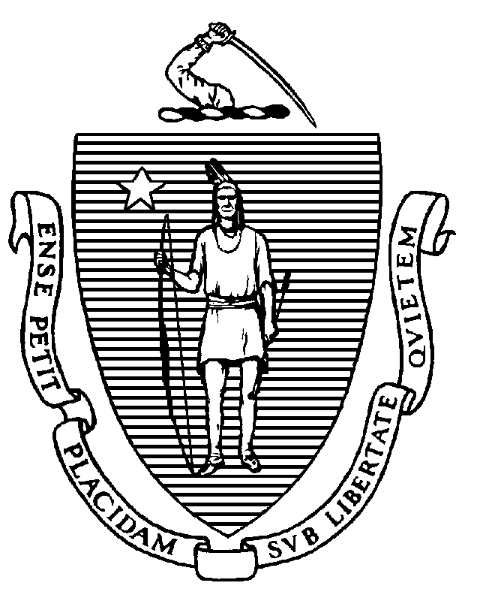

MARYLOU SUDDERS
Secretary
MARGRET R. COOKE Acting Commissioner

Tel: 617-624-6000
www.mass.gov/dph

MARYLOU SUDDERS
Secretary
MARGRET R. COOKE Acting Commissioner

Tel: 617-624-6000
www.mass.gov/dph

MARYLOU SUDDERS
Secretary
MARGRET R. COOKE Acting Commissioner

Tel: 617-624-6000
www.mass.gov/dph

MARYLOU SUDDERS
Secretary
MARGRET R. COOKE Acting Commissioner

Tel: 617-624-6000
www.mass.gov/dph

CHARLES D. BAKER
Governor
KARYN E. POLITO
Lieutenant Governor

PUBLIC HEALTH ADVISORY REGARDING COVID-19 TESTING
Issued January 11, 2022

When should I get tested?

The Massachusetts Department of Public Health advises all residents to seek COVID-19 tests when exhibiting COVID symptoms, or five days following a known close contact with someone diagnosed with COVID pursuant to MA DPH quarantine and isolation protocols, updated in accordance with the new CDC guidance.
The new isolation protocols released on December 29 do not require a COVID-19 test to exit isolation after having COVID. This general rule also applies to childcare and K-12. Additional information on testing protocols for specific situations in childcare can be found here and for K-12 can be found here.
The new quarantine protocols recommend, but do not require, all exposed individuals get a test five days after exposure. Exposed individuals do not need to quarantine in the following circumstances:
- If fully vaccinated and not yet eligible to receive a booster OR
- If fully vaccinated and have received their booster OR
- If they had COVID and it is less than 90 days since they were diagnosed. For more details visit Massachusetts Isolation and Quarantine Guidance for the General Public.

What kind of test should I get?

There are two types of COVID-19 tests that are widely available to the public: rapid antigen tests, which are available as take-home tests and can be self-administered, and PCR tests, which are a clinically administered test.

DPH advises that rapid antigen tests are an acceptable alternative to a PCR test in most situations, including in the following scenarios:
- To exit isolation or quarantine, in line with DPH guidance
- To receive therapeutics like monoclonal antibodies or antiviral medications if the patient is at high risk for severe outcomes

DPH advises that a positive COVID-19 rapid antigen does not need to be confirmed with a PCR test.

DPH recommends individuals that have COVID symptoms and test negative with a rapid antigen test should isolate and either repeat an antigen test or get a PCR test in 24-48 hours if they continue to exhibit symptoms.
DPH advises that employers, or schools and childcare providers should not require a test as a condition of returning to work, school, or childcare.
Please refer to DESE or EEC protocols to determine appropriate use for tests in those settings. If an employer chooses to require testing, a PCR should not be required. For some workers at nursing homes or other long term care facilities, a PCR test is required. (Workers should check with their employer.)

Some countries require a negative PCR test for entry. Travelers should check requirements prior to travel.

What is the difference between PCR tests and rapid tests?

While PCR tests were the first tests available and the most commonly used COVID-19 diagnostic tool up to this point, rapid antigen tests are now more widely available, and have clear advantages over PCR tests in many contexts.
Rapid antigen tests (such as at-home testing kits) can be easily used, and the results are available in as few as 15 minutes. Because antigen tests can be done anywhere and do not require laboratory analysis or trained personnel to collect the sample, they are convenient and accessible.
Antigen tests are well suited for diagnostic testing in people who are symptomatic or who have been exposed to COVID-19 and as screening tests for asymptomatic people in specific settings (e.g., K-12 schools or daycare settings). PCR tests can also be used for these purposes but may indicate a positive result long after someone has stopped being infectious. As a result, PCR tests are not recommended for use when making decisions about returning to work or school or when making decisions about whether someone without known exposure or new symptoms should isolate.

Rapid antigen tests have a low rate of false positives. As a result, a person who tests positive on a rapid antigen test, almost certainly has COVID-19 and must follow isolation guidance. A PCR test is not necessary or recommended to confirm a positive result on a rapid antigen test. If a person with COVID-19-like symptoms tests negative on a rapid antigen test, DPH recommends repeating an antigen test in the next 24-48 hours. Alternatively, these individuals could consider getting a PCR test. In the meantime, while waiting to take the additional rapid test or while waiting for the PCR results (which can take 24-72 hours) these individuals should assume they are positive and follow the isolation guidance.

Employers, schools, and daycare settings should not require PCR tests to return to those settings. Employees, students, and children may return to these settings when they have met the state guidelines for isolation or quarantine. Please refer to DESE or EEC protocols for appropriate use of tests in those settings. Current DPH guidance is that people in quarantine are recommended, but not required, to get a viral test (rapid antigen or PCR) on Day 5 of their quarantine and only exit quarantine if negative. The Department of Public Health’s protocols do not require a return to work or school letter for anyone returning from isolation or quarantine; clearance letters are not necessary, and this requirement is discouraged. Neither local boards of health nor the Department of Public Health provide these letters and, if required, employees would need to obtain any return-to-work letters from their health care provider.
COVID-19 vaccines and vaccine boosters are the most effective tool for protecting against serious illness, hospitalization, and death if infection does occur. Every individual who is eligible is strongly urged to get vaccinated and boosted according to the Centers for Disease Control and Prevention recommendations. Those who live, work, or study in Massachusetts can receive free vaccine and booster at hundreds of sites across the Commonwealth.

Other important public health measures to help prevent the spread of COVID-19, including the Omicron variant, include:
- Staying home when sick and testing for COVID-19;
- Wearing a face mask that covers the nose and mouth consistently when indoors and around other people;
- Isolating if test positive for COVID-19 (or if test results are pending) and notifying close contacts;
- Quarantining if not vaccinated and boosted and have been exposed to COVID-19.
- Increasing ventilation by bringing fresh outdoor air inside when weather permits;
- Covering coughs and sneezes; and
- Practicing good hand hygiene by washing hands frequently with soap and water, if soap and water are not available, use hand sanitizer containing at least 60% alcohol; and
- Enabling MassNotify on a personal smartphone to receive messages when a potential exposure has occurred and alert others if tested positive.

