Serious Reportable Events:
Calendar Year 2021

Katherine T. Fillo, Ph.D., MPH, RN-BC
Bureau of Health Care Safety and Quality

Katherine Saunders, M.S.
Bureau of Health Care Safety and Quality

Overview

- Purpose
- Background
- Serious Reportable Event Category Definitions
- Findings
- Quality Improvement Activities

Purpose

This presentation is given for the following purposes:

- To provide an update of the Serious Reportable Event program and related quality improvement activities at the Bureau of Health Care Safety and Quality; and

- To share the trends in the types and volume of Serious Reportable Events reported in 2021 and previous years.

Background

Adverse events that occur in the health care setting are a patient safety concern and public health issue.

- The Office of the Inspector General found that adverse events occur in 13.5% of hospital admissions of Medicare beneficiaries (2010).

- It is also projected that 10% of Medicare patients nationally experience an adverse event during a rehabilitation hospital stay (OIG, 2016).

Section 51H of chapter 111 of the Massachusetts General Laws authorizes the Department to collect adverse medical event data and disseminate the information publicly to encourage quality improvement.

Background

- The National Quality Forum (NQF) has operationalized a group of adverse events into measurable, evidence-based outcomes called Serious Reportable Events (SRE).
- MA adopted SREs as its adverse event reporting framework in 2008.
- There is no federal adverse event reporting system. Twenty-seven other states developed and implemented state-based adverse event reporting programs.
‒ Over half of those use the SRE framework including Connecticut, Minnesota and New Hampshire.

SREs and the COVID-19 Public Health Emergency

- In 2021, nonessential and elective invasive procedures were reduced by:
  - Order Of The Commissioner Of Public Health Regarding Scheduling And Performance Of Elective Invasive Procedures (June 24, 2020 - March 1, 2021)
  - COVID-19 Public Health Emergency Order No. 2021-14 (November 23, 2021)

- Very few SREs were reported by ambulatory surgical centers in calendar year 2021 and the number of SREs associated with surgical or invasive procedures was slightly diminished overall as compared to pre- pandemic levels.

SREs Defined

Section 51H of Chapter 111 of the General Laws:
- “Serious reportable event”, an event that results in a serious adverse patient outcome that is clearly identifiable and measurable, reasonably preventable, and that meets any other criteria established by the department in regulations.

105 CMR 130.332 and 105 CMR 140.308:
- Serious Reportable Event (SRE) means an event that occurs on premises covered by a hospital's license that results in an adverse patient outcome, is clearly identifiable and measurable, has been identified to be in a class of events that are that are largely preventable and harmful, and of a nature such that the risk of occurrence is significantly influenced by the policies and procedures of the hospital. The Department issued a list of SREs based on those events included on the NQF table of reportable events to which 105 CMR 130.332 and 105 CMR 140.308 apply in guidance.

Reporting Requirements

- Hospitals and ambulatory surgical centers (ASCs) are required to report SREs to the patient/family and the Bureau of Health Care Safety and Quality (BHCSQ) within seven days of the incident.
- An updated report to BHCSQ, the patient/family and the insurer is required within 30 days of the incident, including documentation of the root cause analysis findings and determination of preventability as required by 105 CMR 130.332(c) & 105 CMR 140.308(c).
- In June 2009, the Department implemented regulations prohibiting health care facilities from charging for services provided as a result of preventable SREs.
- Amendments adopted as part of the hospital regulatory review completed in 2017 streamlined the reporting process without removing transparency.

Surgical or Invasive Procedure Events
- Wrong Site Surgery or Procedure
- Surgery or Procedure on Wrong Patient
- Wrong Surgery or Procedure
- Unintended Retention of a Foreign Object
- Intraoperative or Immediate Postoperative Death of an ASA Class 1 Patient

Product or Device Events
- Death or Serious Injury Related to Contaminated Drugs, Biologics, or Devices
- Death or Serious Injury Related to Device Misuse or Malfunction
- Death or Serious Injury Due to Intravascular Air Embolism

Patient Protection Events
SRE Types
- Discharge of a Patient/Resident of Any Age to Other Than Authorized Person
- Death or Serious Injury Associated with Patient Elopement
- Patient Suicide, Attempted Suicide, or Self-Harm That Results in Serious Injury

SRE Types

Care Management Events
  - Death or Serious Injury Associated with a Medication Error
  - Death or Serious Injury Associated with Unsafe Blood Product Administration
  - Maternal Death or Serious Injury Associated with Low-Risk Pregnancy Labor or Delivery
  - Death or Serious Injury of a Neonate
  - Death or Serious Injury Associated with a Fall
  - Stage 3, Stage 4 or Unstageable Pressure Ulcer
  - Artificial Insemination With Wrong Donor Sperm or Egg
  - Death or Serious Injury from Irretrievable Loss of a Specimen
  - Death or Serious Injury from Failure to Follow Up on Test Result

Environmental Events
- Patient or Staff Death or Serious Injury Associated with an Electric Shock
- Any Incident In Which No Gas, Wrong Gas or Contaminated Gas Delivered to Patient
- Patient or Staff Death or Serious Injury Associated with a Burn
- Death or Serious Injury Associated with Restraints or Bedrails

Radiologic Events
  - Death or Serious Injury of Patient or Staff Associated with Introduction of a Metallic Object Into MRI Area

Potential Criminal Events
SRE Types
- Any Instance of Care Provided by Someone Impersonating a Health Care Provider
- Resident/Patient Abduction
- Sexual Abuse/Assault on a Patient or Staff Member
- Death or Serious Injury of Patient or Staff Member as a Result of Physical Assault

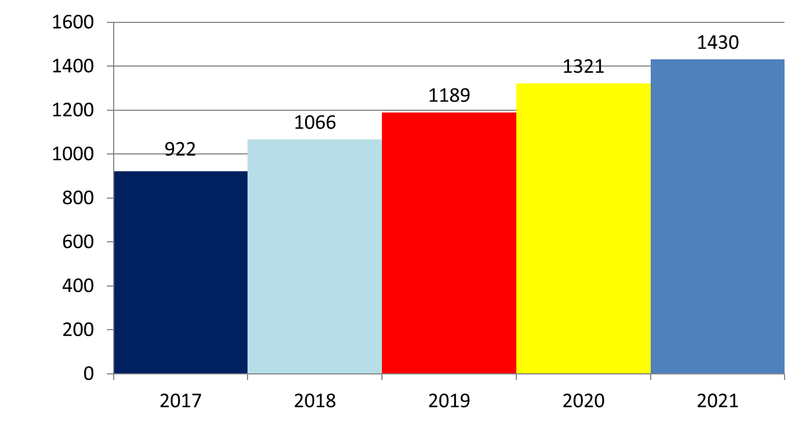
Total Number of SREs in Acute Care Hospitals by Year
Acute Care Hospital: Total SREs

Data abstracted April 22, 2022 from the Health Care Facility Reporting System

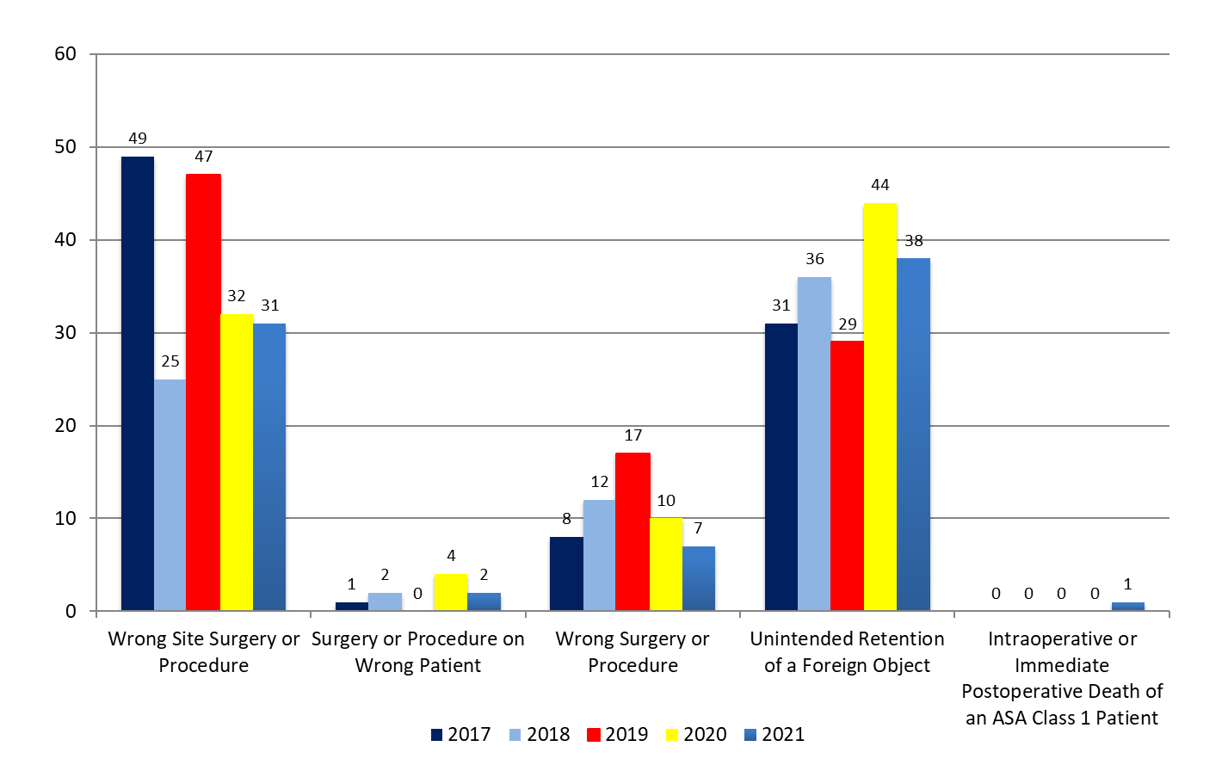Acute Care Hospital: Surgical Event SREs

Key Findings

For 2021, there was a decrease in the total number of surgical events reported, compared to 2020.

The most frequently reported outcome is that patients require an additional surgery or procedure to remove the foreign object that was unintentionally retained.

Data abstracted April 22, 2022 from the Health Care Facility Reporting System

Acute Care Hospital: Environmental Event SREs

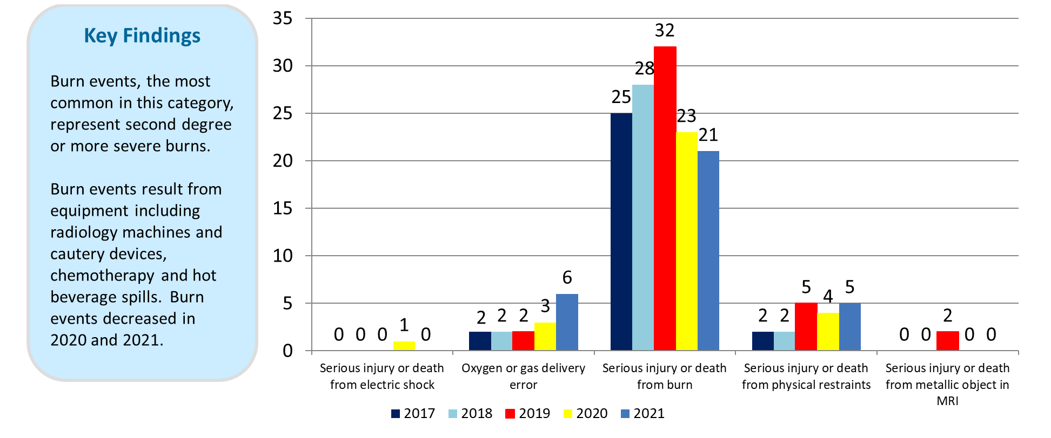
Data abstracted April 22, 2022 from the Health Care Facility Reporting System

Acute Care Hospital: Patient Protection Event SREs

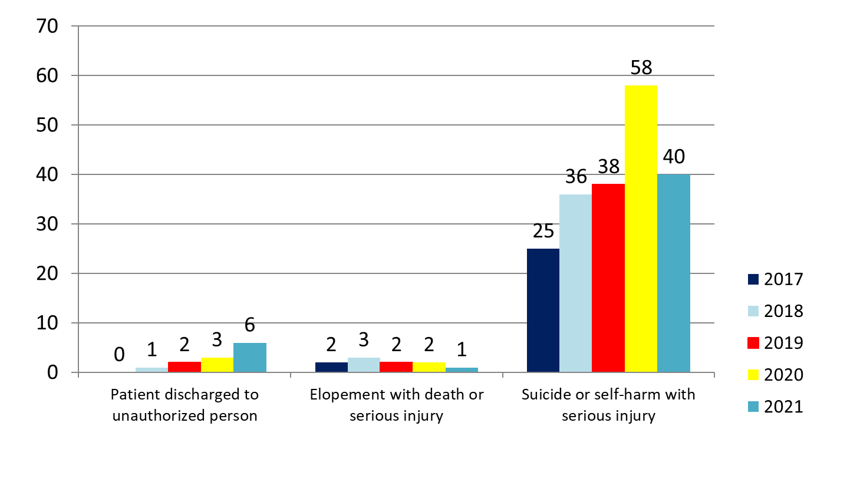Key Findings

There was 1 completed suicide event and 39 self- harm or attempted suicide events in 2021 which was a decrease over 2020.

Cutting and ingesting objects are the methods reported as having the highest incidence in the suicide and self-harm events.

Data abstracted April 22, 2022 from the Health Care Facility Reporting System

Acute Care Hospital: Potential Criminal Event SREs

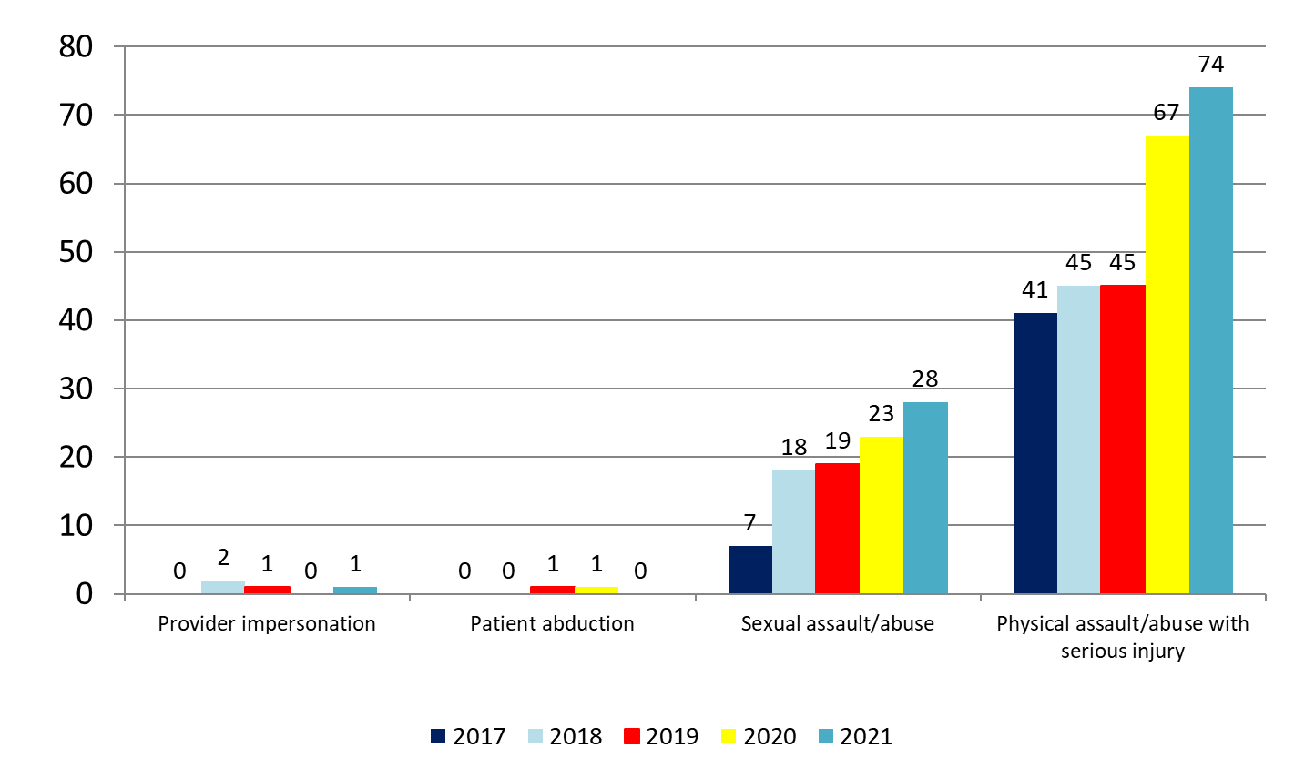Key Findings
Over half of the physical assaults or abuse events that resulted in serious injury were patient on staff member encounters, often resulting in lost work days.

Emergency departments followed by inpatient psychiatric units are the most frequently reported location within the hospital for these events to occur.

Physical assaults and sexual assaults reported increased in 2021.

Data abstracted April 22, 2022 from the Health Care Facility Reporting System

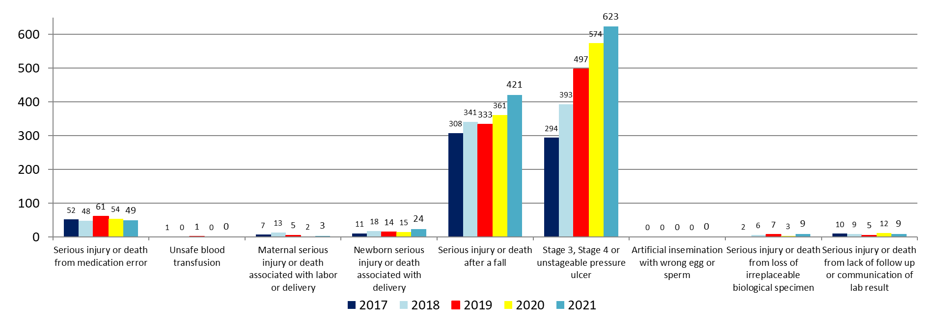Acute Care Hospital: Care Management SREs

Key Findings
Pressure injuries and falls that result in serious injury are the two most commonly reported events. Pressure ulcers are the most common serious injury and Falls are the second most common. Both have increased over the observed time period.

Data abstracted April 22, 2022 from the Health Care Facility Reporting System

Non-Acute Care Hospital: Total SREs

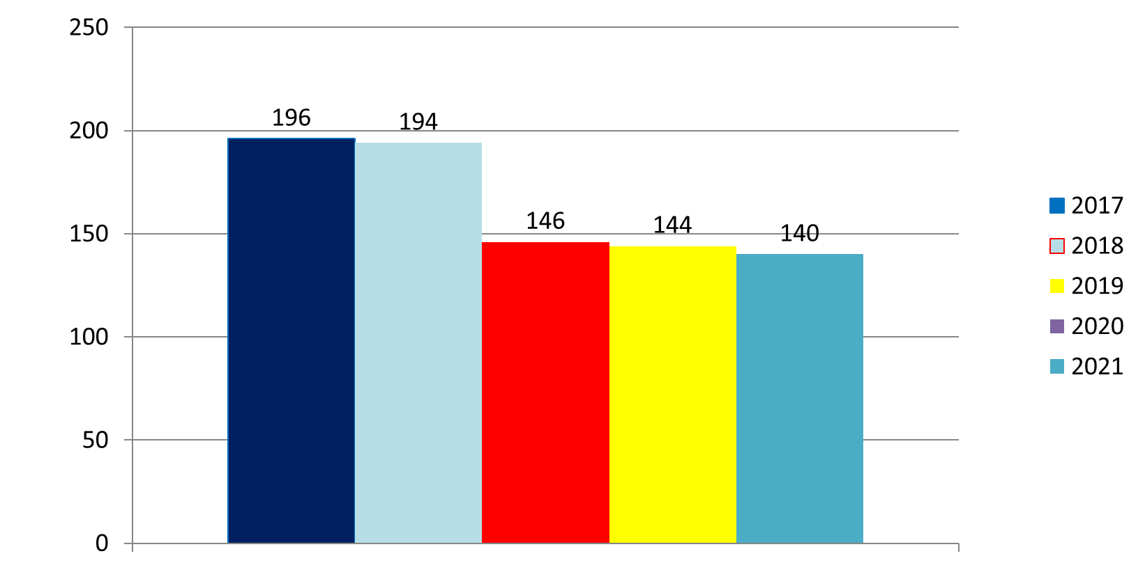
Data abstracted April 22, 2022 from the Health Care Facility Reporting System

Key Findings
There are three types of hospitals: public health, rehabilitation or psychiatric.

Like acute care hospitals, falls and pressure ulcers continue to be the most common events.
Reported SREs 2017-2021 (Non-acute care hospitals)

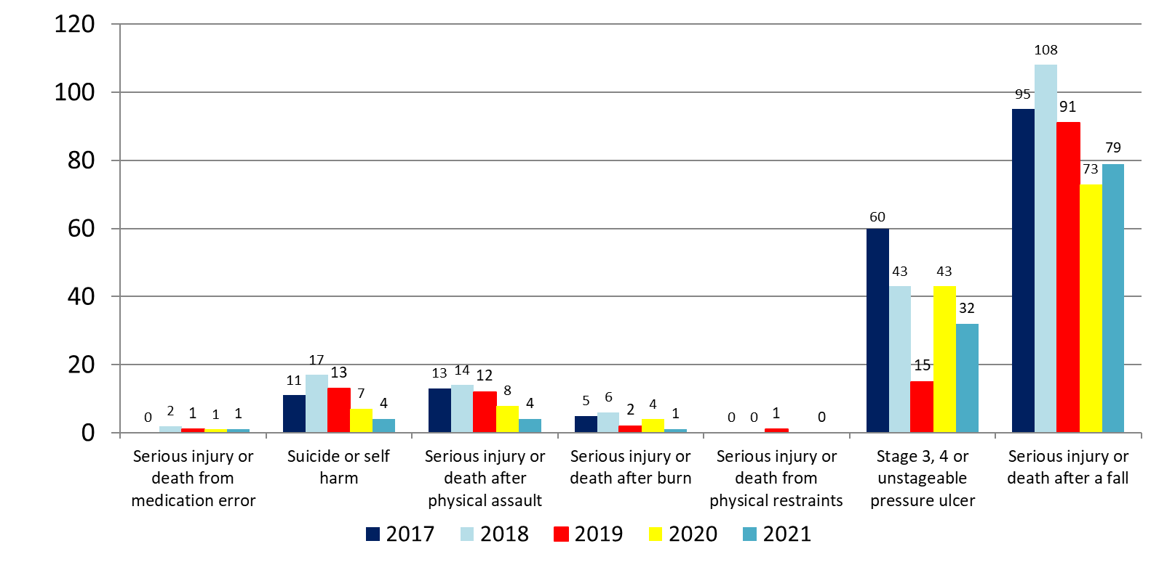
Non-Acute Care Hospital: SREs by Category

Data abstracted April 22, 2022 from the Health Care Facility Reporting System

SRE Types by Race

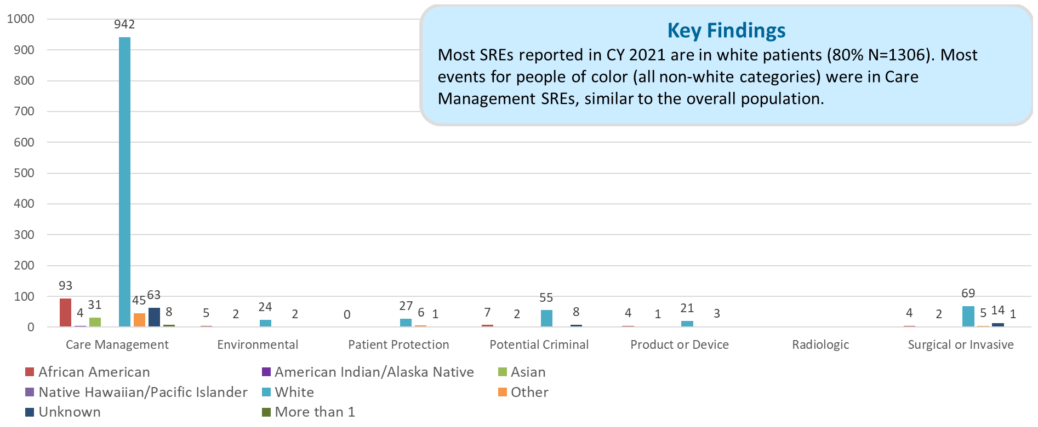
Data abstracted April 22, 2022 from the Health Care Facility Reporting System

SRE Types by Ethnicity

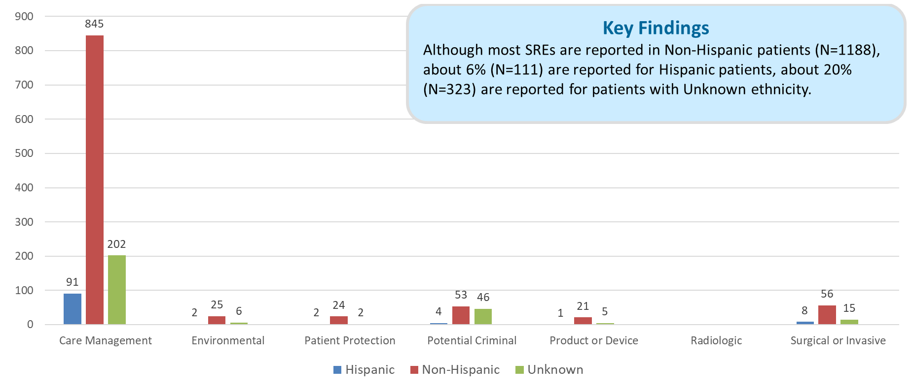
Data abstracted April 22, 2022 from the Health Care Facility Reporting System

Quality Improvement Activities

- Working with individual facilities after an SRE occurs to develop corrective action plans and prevent an event of a similar type from happening in the future.
- Continued collaboration with DPH’s Suicide Prevention Program to share event data and promote use of online curriculum detailing best practices for reducing suicide and self-harm in the facility setting.
- Collaborating with EHS agencies to ensure patient safety maintained during COVID-19 pandemic.
- Actively participating in MA Coalition for the Prevention of Medical Errors.
- Sharing electronic health system related events and opportunities to address causal factors.
- Partnering with Betsy Lehman Center to address the following:
‒ Utilize their monthly newsletter to share patient safety trends; and
‒ Maintaining an Interagency Service Agreement to allow for more seamless data sharing, as intended by the 2012 cost containment act.
- Utilizing DPH list servs for widespread education and to share appropriate guidance.
- Exploring opportunities to collaborate with stakeholders to decrease incidence of pressure injuries and falls.

Thank you for the opportunity to present this information today. Please direct any questions to:
Katherine Saunders, M.S.
Manager, Data Analysis and Integrity Bureau of Health Care Safety and Quality katherine.saunders@mass.gov

