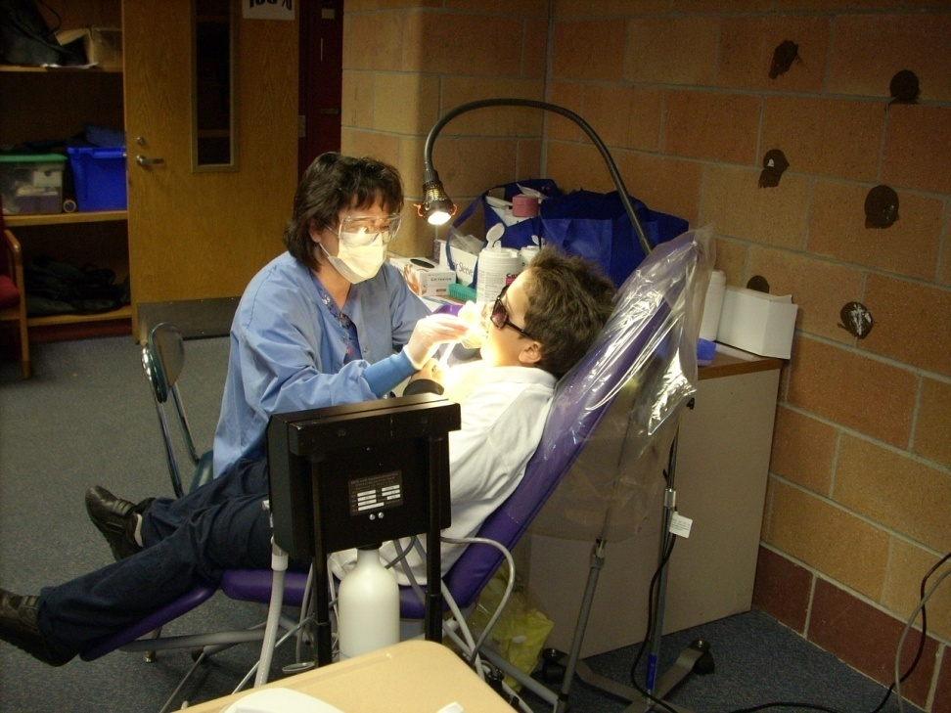
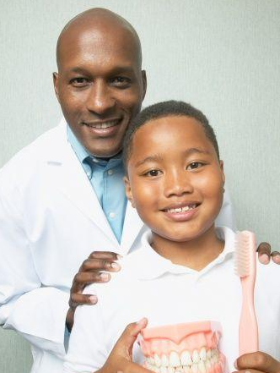

Public Health Dental Hygienist

A category of dental professional

Oral Health in Massachusetts: A Fact Sheet
What is the public health issue?
A public health dental hygienist may work in public health settings such as schools, nursing homes and long-term care facilities, clinics, hospitals, medical facilities, community health centers, and mobile and portable dental programs.
While the majority of oral and dental diseases are preventable, accessing dental care for many residents of the Commonwealth can be difficult. Access to preventive dental care helps to avoid dental problems before they begin, and, by identifying dental problems early, treatment can be less expensive, time-consuming, and invasive.

What is a public health dental hygienist?
A public health dental hygienist is a practicing registered dental hygienist who may perform dental hygiene procedures in a public health setting without the supervision or direction of a dentist. These procedures are authorized as a delegable procedure for licensed dental hygienists in private practice under general supervision.
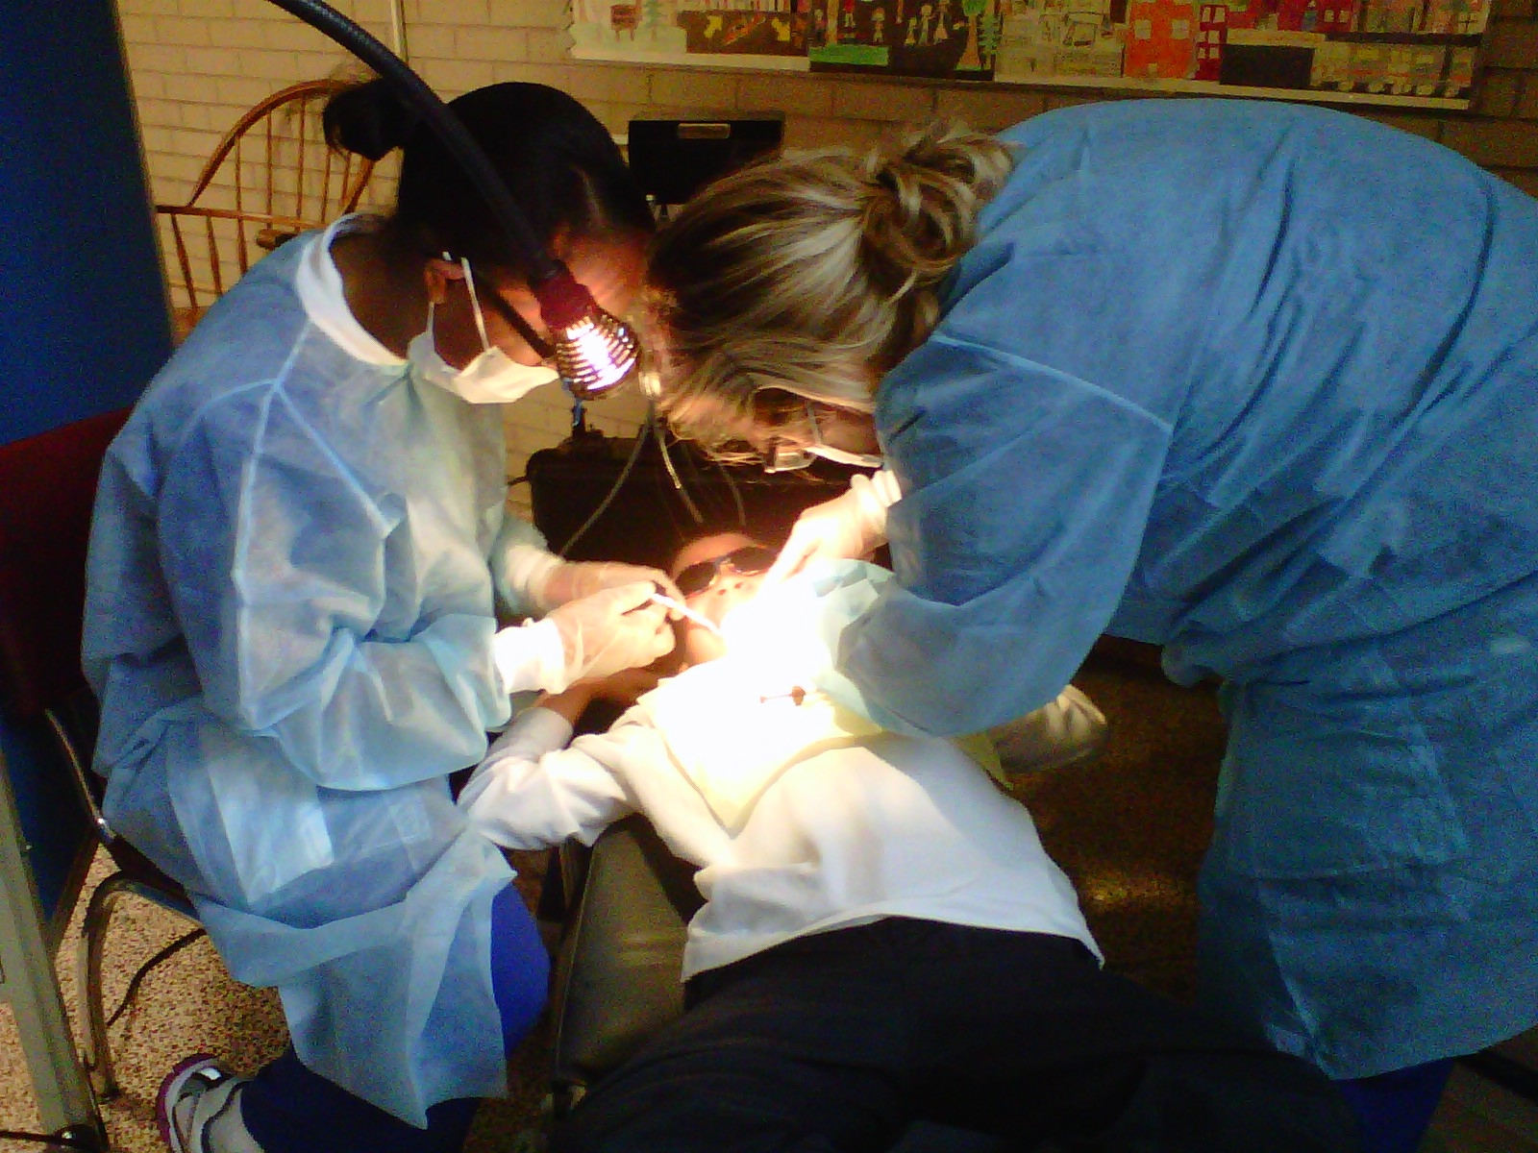
A public health dental hygienist must have at least 3 years of full-time clinical experience and must have received appropriate training as determined by the Board of Registration in Dentistry, (see 234 CMR 5.07(2)). Public health dental hygienists must have a written collaborative agreement with a licensed dentist and may work in a variety of public health settings determined by the Department of Public Health. They may also be directly reimbursed by MassHealth (Medicaid) and Commonwealth Care insurance for the preventive services they provide.
It is believed that this new category of dental professionals will improve direct access to preventive dental care for those residents of the state at and people who are at increased/higher risk for dental disease—such as MassHealth recipients, people with low income, children, older adults, and people with developmental disabilities—and therefore, reduce disparities in oral health.

What is required of a public health dental hygienist?**
- Obtain written, signed informed consent of the patient or legal representative, which informs the patient or legal representative that the services provided by the public health dental hygienist are not a substitute for a dental examination by a dentist.
- The written, signed informed consent should let the patient or legal representative know that the patient should obtain, or should have had, a dental examination by a dentist within 90 days.
- The written, signed informed consent should notify the patient that they may continue to seek dental care from any other provider, the treatment received may affect future rights and benefits under private insurance, Medicaid, or the children’s health insurance program, and if applicable, request permission to allow the patient’s dental insurance carrier to be billed for treatment.
- Upon request, provide a complete copy of the patient’s dental record. A reasonable fee may be charged to the patient, not in excess of the cost of copying the record.
- If applicable, follow the Board’s requirements and regulations for mobile dental facility (MDF) and/or portable dental operation (PDO) permits.
- Provide a written Information Sheet at the conclusion of the patient’s visit.

What is a Written Information Sheet?**
The written information sheet is given to the patient at the conclusion of each visit and should include:
- The results of the dental hygienists’ oral evaluation;

- A description of the dental services provided, including, but not limited to, billed service codes and fees associated with the treatment, and tooth numbers where appropriate;
- Information on how to contact the public health dental hygienist(s);
- The name(s) and signature(s) of the public health dental hygienist providing the services; and
- Referrals to dentist or dental program for an examination and treatment, if needed.

With consent from the patient or legal representative, the public health dental hygienist must provide a copy of the Information Sheet to the official(s) designated by schools, nursing homes and other facilities.

Referrals for dental treatment?**
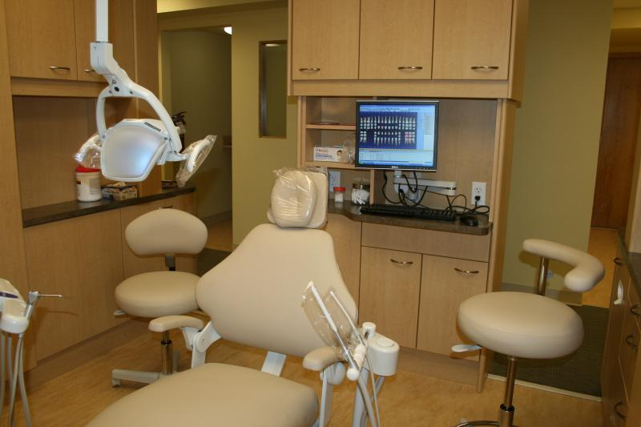
Public health dental hygienists must provide referrals for assessments by a dentist, including those for emergent issues. The public health dental hygienist must refer the patient or their legal representative to the patient’s regular dentist if one is identified. If no regular dentist is identified, then the public health dental hygienist must provide the names of dentist(s), community health center(s) or dental school clinic(s) located within a reasonable geographic distance from the patient’s home and with whom the public health dental hygienist has communicated with regarding acceptance of the referrals.

Reporting?**
Public health dental hygienists are required to provide information to the Massachusetts Department of Public Health, including the sites they are serving, demographic information, and information about the services they are providing. This will help the Department in identifying areas of the state that may be in need of services, as well as identify the oral health needs of our residents.

Want more information?
Public Health Dental Hygienist E-Toolkit: The Massachusetts Department of Public Health’s Office of Oral Health has an e-toolkit with more information on public health dental hygiene. The Toolkit may be accessed on the Office of Oral Health website.
**Massachusetts Board of Registration in Dentistry: For the complete requirements and regulations governing the practice of dentistry, including public health dental hygiene practice, go to www.mass.gov/dph/dentalboard or call the Board at 617-973-0971.

For more information, contact:
Massachusetts Department of Public Health
Office of Oral Health
250 Washington Street
Boston, MA 02108-4619
Oral.health@mass.gov
