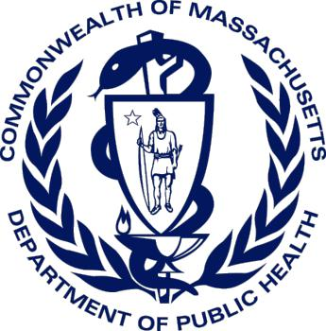

MASSACHUSETTS DEPARTMENT OF PUBLIC HEALTH

Public Health Planning Toolkit for
At-Risk Individuals with
Access and Functional Needs

November 2019

Version 1.0

Contents
Notes for Users 2
Guide to Acronyms 2
Introduction 3
Key Definitions 4
Planning Concepts 7
Identifying and Locating At-Risk Individuals 7
Additional Planning Resources 9
CMIST Framework 11
Resources for how to support those with access and functional needs 12
- Communication: 12
- Maintaining Health 14
- Independence 16
- Services and Support 17
- Transportation 18
Recommended Reading, Mobile Applications and Trainings 19
Recommended Readings 19
Mobile Applications 20
Trainings 20
Appendix A – Considerations/Questions 22

Notes for Users
This toolkit is a public domain resource. Feel free to utilize and share it, using the recommended citation: https://www.mass.gov/orgs/office-of-preparedness-and-emergency-management. A downloadable version in PDF format is available at: https://www.mass.gov/orgs/office-of- preparedness-and-emergency-management.
Navigation links for resources can be found throughout this toolkit in standard hyperlink format (blue underlined text), as well as in QR code (black and white square). Verification of external links for this edition was last completed on September 25, 2019.
We welcome your feedback regarding the toolkit’s usefulness, as well as your suggestions for improvements or updates. Please share your comments by emailing: dph.emergencypreparedness@mass.gov
Funding for this toolkit was provided by the U.S. Department of Health and Human Services’ (HHS) Office of the Assistant Secretary for Preparedness and Response (ASPR) and the Centers for Disease Control and Prevention (CDC), and was executed by the Massachusetts Department of Public Health’s (MDPH) Office of Preparedness and Emergency Management (OPEM).

OPEM is grateful to the members of the Massachusetts Emergency Management Agency’s (MEMA) Access and Functional Needs Advisory Committee for their contributions to the resource guide which assisted in the creation of this document.

HYPERLINKS and QR CODES

- Utilize this toolkit document in either print or digital format
- Each section will have referenced hyperlinks with relevant resources and/or documents. In addition, QR codes have been added so that users can access hyperlinks from print versions.
- To use a QR Code, 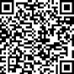 simply take out your smart phone, go to the camera app and hold your device over the QR code. Your device will automatically scan the code once detected
- Upon scan, tap the link that pops up to utilize website/document
- Make sure only one QR code is in the frame of the camera each time

Guide to Acronyms

ADA: Americans with Disabilities Act
CDC: Centers for Disease Control and Prevention MDPH: Massachusetts Department of Public Health
NACCHO: National Association of County and City Health Officials OPEM: MDPH’s Office of Preparedness and Emergency Management
ASPR: HHS's Assistant Secretary for Preparedness and Emergency Management HHS: Department of Health and Human Services

Introduction

Purpose
The purpose of this toolkit is to provide tools and resources to assist local public health (LPH) in supporting individuals who have access and functional needs before, during, and after a public health disaster. Every community should have an understanding of their own unique demographics. In general, the individuals that this toolkit was created to support are those who, either temporarily or permanently, require assistance receiving or accessing medical care, social services, or daily living activities before, during, or after a disaster.

Considerations for Whole Community Planning
Rather than creating a separate plan or annex that is specific to at-risk individuals who have access and functional needs, your preparedness plans and efforts should be inclusive and comprehensive. This toolkit will introduce and describe the idea of a Whole Community approach to planning. Using this approach, the plans you create will be more inclusive and collaborative, thus making your community more resilient as a whole. Your community will have:
- inclusion in preparedness
- non-disaster or populous specific planning
- increased community resilience, and thus preparedness

“The benefits of Whole Community include a more informed, shared understanding of community risks, needs, and capabilities; an increase in resources through the empowerment of community members; and, in the end, more resilient communities…Building community resilience in this manner requires emergency management practitioners to effectively engage with and holistically plan for the needs of the whole community. This includes but is not limited to accommodating people who speak languages other than English, those from diverse cultures or economic backgrounds, people of all ages (i.e., from children and youth to seniors), people with disabilities and other access and functional needs, and populations traditionally underrepresented in civic governance”

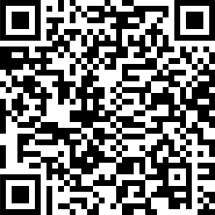
www.fema.gov/media-library-data/20130726-1813-25045- 3330/whole_community_dec2011 2_.pdf

Key Definitions
Below are some key definitions when considering supporting at-risk individuals who have access and functional needs.

At-Risk Individuals:
As defined by the U.S. Department of Health and Human Services’ (HHS) Office of the Assistant Secretary for Preparedness and Response (ASPR), at-risk individuals are
People with access and functional needs (AFN) (temporary or permanent) that may interfere with their ability to access or receive medical care before, during, or after a disaster or public health emergency

HHS further states that:

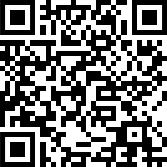
[t]he 2019 Pandemic and All-Hazards Preparedness and Advancing Innovation Act requires taking into account the public health and medical needs of at-risk individuals. It defines at-risk individuals as children, pregnant women, older adults, individuals with disabilities, or others who may have access or functional needs in the event of a public health emergency, as determined by the Secretary of Health and Human Services. Examples of other populations may include but are not limited to individuals from diverse cultures, individuals who have limited English proficiency or are non-English speaking, individuals who are transportation disadvantaged, individuals experiencing homelessness, individuals who have chronic health conditions, and individuals who have pharmacological dependency”

- https://www.phe.gov/Preparedness/planning/abc/Pages/at-risk.aspx

Access and Functional Needs:
In their capacity-building toolkit, the National Association of County and City Health Officials (NACCHO) states that this term
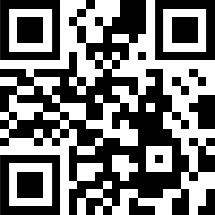
“Broadly describe[s] populations that may need assistance due to any condition (temporary or permanent) that limits their ability to take action, or may limit their ability to access or receive medical care before, during, or after an emergency”

www.naccho.org/uploads/downloadable-resources/Capacity-Building- Toolkit-for-Aging-and-Disability-Networks-2-5-19.pdf

ASPR goes further by stating: “Irrespective of specific diagnosis, status, or label, the term access and functional needs is used to describe a broad set of common and crosscutting access and functional needs:

Access-based needs: All people must have access to certain resources, such as social services, accommodations, information, transportation, medications to maintain health, and so on.
Function-based needs: Function-based needs refer to restrictions or limitations an individual may have that requires assistance before, during, and/or after a disaster or public health emergency”

- https://www.phe.gov/Preparedness/planning/abc/Pages/at-risk.aspx

CMIST Framework:
CMIST is an acronym that stands for Communication, Maintaining Health, Independence, Support/Services, and Transportation. ASPR further describes CMIST:
Communication
Individuals who speak sign language, who have limited English proficiency (LEP), or who have limited ability to speak, see, hear, or understand.
People with communication needs may have limited ability to hear announcements, see signs, understand messages, or verbalize their concerns.

Maintaining Health
Individuals who may require specific medications, supplies, services, durable medical equipment, electricity for life-maintaining equipment, breastfeeding and infant/childcare, or nutrition, etc.
Early identification and planning for AFN can help to reduce the negative impacts of a disaster on individuals’ health. This includes:
  - Maintaining chronic health conditions
  - Minimizing preventable medical conditions
  - Avoiding decompensation or worsening of an individual’s health status

Independence
Individuals who function independently with assistance from mobility devices or assistive technology, vision and communication aids, services animals, etc.
Independence is the outcome of ensuring that a person’s AFN are addressed as long as they are not separated from their devices, assistive technology, service animals, etc.

Support and Safety
Some individuals may become separated from caregivers and need additional personal care assistance; experience higher levels of distress and need support for anxiety, psychological, or behavioral health needs; or require a trauma-informed approach or support for personal safety.
Early identification and planning for AFN can help to reduce the negative impacts of a disaster on individuals’ wellbeing. Some people may have lost caregiver assistance and require additional support; some individuals may find it difficult to cope in a new or strange environment or have difficulty understanding or remembering; and some individuals may have experienced trauma or be victims of abuse.

Transportation
Individuals who lack access to personal transportation, are unable to drive due to decreased or impaired mobility that may come with age and/or disability, temporary conditions, injury, or legal restriction. Disasters can significantly reduce transportation options, inhibiting individuals from accessing services, staying connected, etc. Disaster planning requires coordination with mass transit and accessible transportation services providers.

“At-risk individuals may have a number of additional needs that must be considered in planning for, responding to, and recovering from a disaster or public health emergency. The CMIST Framework is a recommended approach for integrating the AFN of these individuals”

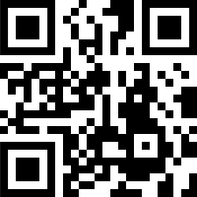
- https://www.phe.gov/Preparedness/planning/abc/Pages/at- risk.aspx

Vulnerable Populations:
The Centers for Disease Control and Prevention (CDC) has used this term to incorporate a broader view of the population we are trying to define. The CDC states vulnerable populations may include anyone who: has difficulty communicating,; has difficulty accessing medical care; may need help maintaining independence; requires constant supervision; may need help accessing transportation. This definition includes connections to access and functional needs.

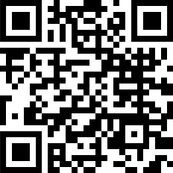
- https://www.cdc.gov/cpr/whatwedo/vulnerable.htm

Whole Community Approach:
“As a concept, Whole Community is a means by which residents, emergency management practitioners, organizational and community leaders, and government officials can collectively understand and assess the needs of their respective communities and determine the best ways to organize and strengthen their assets, capacities, and interests”

- A Whole Community Approach to Emergency Management: Principles, Themes, and Pathways for Action www.fema.gov/media-library-data/20130726-1813-25045- 3330/whole_community_dec2011 2_.pdf

Planning Concepts

Identifying and Locating At-Risk Individuals
As discussed in the Key Definitions section, an at-risk individual could have temporary or permanent needs during, before, or after a disaster or emergency. Additionally, each community may have individuals who are working or visiting temporarily that could have access or functional needs.
Therefore, identifying individuals can be a challenge. Consider partnerships with community resources, organizations, and networks that already support at-risk individuals. These community resources and networks could include, but are not limited to, community health centers, centers for independent living, group homes, supportive housing, accessible housing providers, assisted living facilities, senior centers, Big Brothers Big Sisters of America, local council on aging, community health workers, parent/caregiver support programs, child and adult daycare, faith-based organizations, etc.
Who is at-risk?
Below are some examples of individuals who could be at-risk and/or have access and functional needs. They include, but are not limited to, those who:
  - have medical issue/s (chronic or temporary)
  - have a disability
  - have mental/cognitive or behavioral health issues
  - are economically disadvantaged
  - have language and literacy challenges
  - are isolated
  - are older adults
  - are children/teens
  - are nursing and Pregnant Mothers

This is by no means an all-inclusive or exhaustive list. Many of these categories have subcategories. Additionally, individuals may span multiple categories (i.e., individuals experiencing homelessness could be included under isolated or economically disadvantaged) or could bounce in and out of categories (i.e., individuals who are independent with eyeglasses may be impaired if they lose their glasses in an emergency). Additionally, the type of emergency can also define additional individuals who are at-risk.
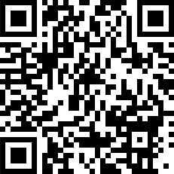
The CDC Public Health Workbook for At Risk Populations in an Emergency can walk you through defining, locating, and reaching populations that could be at-risk.

https://emergency.cdc.gov/workbook/pdf/ph_workbookFINAL.pdf

Additional resources that can help you understand more about your community’s population and possible needs include:
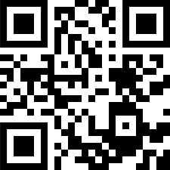
- MDPH/OPEM, Emergency Preparedness Populations Planning Tool:
https://tinyurl.com/y3e22amk

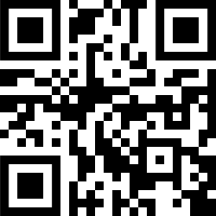
- HHS, emPOWER Map 3.0:
https://empowermap.hhs.gov/

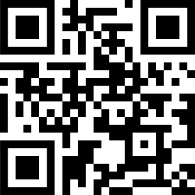
- CDC, Social Vulnerability Index:
https://svi.cdc.gov/

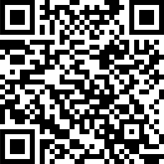
- CDC, National Environmental Public Health Tracking Network: https://ephtracking.cdc.gov/DataExplorer/index.html?c=13&i=- 1&m=-1#/

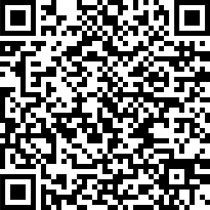
- NACCHO, Capacity-Building Toolkit for including Aging & Disability Networks in Emergency Planning: https://www.naccho.org/uploads/downloadable-resources/Capacity- Building-Toolkit-for-Aging-and-Disability-Networks-2-5-19.pdf

Additional Planning Resources

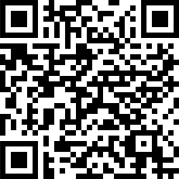
- CDC, Disability & Health Resources for Facilitating Inclusion and Overcoming Barriers (includes ADA’s recommendations for preparedness planning): https://www.cdc.gov/ncbddd/disabilityandhealth/disability- resources.html

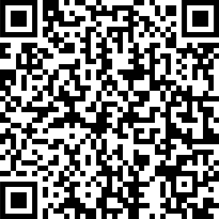
- HHS, Office of Minority Health, Guidance for Integrating Culturally Diverse Communities into Planning for and Responding to Emergencies: A Toolkit (aims to help improve existing activities and develop new programs to meet the needs of racially and ethnically diverse populations): https://www.hhs.gov/sites/default/files/ocr/civilrights/resources/special topics/emergencypre/omh_diversitytoolkit.pdf

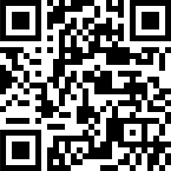
- Harris Family Center for Disability and Health Policy, Checklist for Integrating People with Disabilities and Others with Access and Functional Needs into Emergency Preparedness, Planning, Response & Recovery: http://www.jik.com/plancklst.pdf

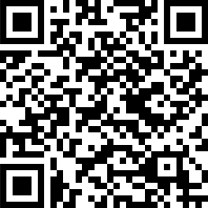
- FEMA, Make a Plan: Individuals with Disabilities:
https://www.ready.gov/individuals-access-functional-needs

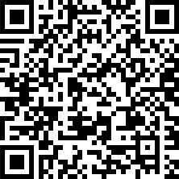
- National Fire Protection Association, Emergency Evacuation Planning Guide for People with Disabilities:
https://www.nfpa.org/-/media/Files/Public-Education/By-topic/ Disabilities/EvacuationGuidePDF.ashx?la=en

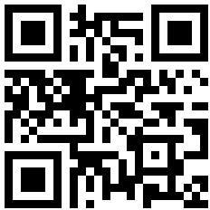
- Massachusetts Emergency Management Agency, Access and Functional Needs
https://www.mass.gov/info-details/local-emergency- management-planning-guidance#access-and-functional- needs-resource-guide-for-local-officials-

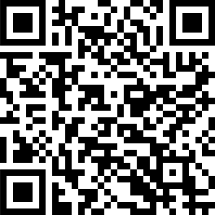
- Massachusetts Office on Disability, Disability Emergency Preparedness:

https://www.mass.gov/disability-emergency-preparedness

CMIST Framework
The CMIST Framework is referenced in many of our federal partners’ resources. It helps operationalize access and functional needs during planning efforts to support individuals during, before, or after an emergency or disaster. Consider using the CMIST Framework as a tool to drive thinking through preparedness, response, and recovery planning efforts. For more information on CMIST, visit:

- ASPR, The CMSIT Framework website:
https://www.phe.gov/Preparedness/planning/abc/Pages/at-risk.aspx

The following sections are organized using the CMIST Framework and include questions for you to consider during the planning phase of creating, revising, or updating your emergency plans, and resources to use when doing so. While not every question will apply to each plan, the goal is to start thinking about the CMIST Framework (by category), and including it in your plans.

Resources for how to support those with access and functional needs

Communication:

Communication Considerations
Does your plan include outreach to local community networks that support at-risk individuals (such as those you may have used to assist in identifying who is at-risk)?
ϒ
ϒ
Does your plan include communication paths that reach individuals who have limited English proficiency, are deaf or hard of hearing, and are blind or have low vision? These communication channels should be used before, during, and after an emergency.
ϒ
Does your plan include multiple delivery channels for emergency/alert messaging (such as television, radio, social media, internet pages, texting, reverse 911, ethnic media, HAM radio networks, etc.)?

How to Reach At-Risk Individuals
A central theme of Whole Community planning is building relationships within the community, and ensuring that support also comes from the community. The CDC workbook details how to build a Community Outreach Information Network (COIN) at the local level. This concept is also included in NACCHO’s toolkit.
As stated in the CDC notebook:
Regardless of terminology, trust plays a critical role in reaching at-risk populations. Reaching people through trusted channels has shown to be much more effective than through mainstream channels. For some people, trusted information comes more readily from within their communities than from external sources.

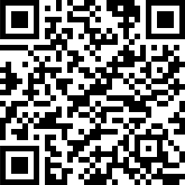
- To Define, Locate, and Reach Special, Vulnerable, and At-risk Populations, in an Emergency https://emergency.cdc.gov/workbook/pdf/ph_workbookfinal.pdf

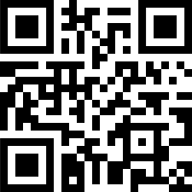
- Capacity-Building Toolkit for including Aging & Disability Networks in Emergency Planning
https://www.naccho.org/uploads/downloadable-resources/Capacity- Building-Toolkit-for-Aging-and-Disability-Networks-2-5-19.pdf

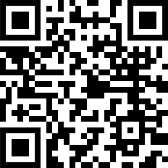
- The At-Risk Population eTool

https://www.orau.gov/SNS/AtRiskTool/

Additional Communication Resources:

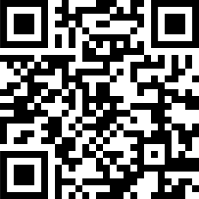
- Preparedness4Deaf, preparedness & response sign language videos:
http://www.youtube.com/user/preparedness4deaf

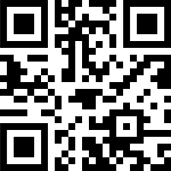
- OPEM, Show Me (a suite of tools designed to enhance communication between individuals with communication challenges and public health and emergency management personnel and volunteers during times of emergencies):
http://www.mass.gov/dph/showme

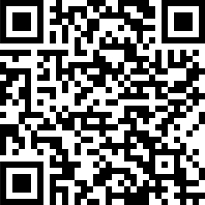
- Massachusetts Commission for the Blind (MCB):
https://www.mass.gov/orgs/massachusetts-commission-for-the-blind

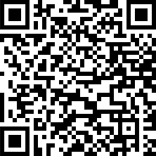
  - Massachusetts Commission for the Deaf and Hard of Hearing (MCDHH): https://www.mass.gov/orgs/massachusetts-commission-for-the- deaf- and- hard-of-hearing

Maintaining Health

Maintaining Health Considerations:
Does your plan include considerations for those who need assistance to maintain activities of daily living (such as toileting, eating, or dressing)?
▫
Depending on the type of plan, do you have appropriate supplies (or a plan for obtaining them) that support daily living to assist individuals who might not have been able to bring supplies with them (such as extra feeding tubes, diapers, formula, bandages, etc.)?
▫
Does your plan include resources to find the availability of open pharmacies that individuals can use to obtain daily medication, if applicable?

Does your plan encourage individuals receiving recurring medical services to prepare with their care team (such as dialysis or medication assisted treatment, or other ongoing treatment for behavior health and/or substance use disorder)?
Does your plan include considerations for medical conditions individuals of any age may have (such as infants or older adults)? For example, do you have common durable medical equipment that could support your at-risk population?

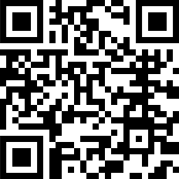
Medication Resources
- Healthcare Ready, RX on the Run (helps individuals document what medications they are taking and other helpful links to assist providers in case of disasters): https://www.healthcareready.org/rx-on-the-run

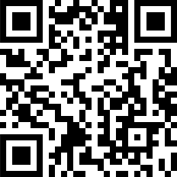
- Healthcare Ready, RX Open (helps locate open pharmacies in areas impacted by disaster): https://www.healthcareready.org/rxopen

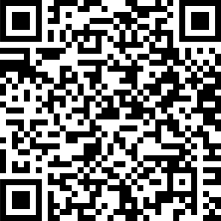
- U.S. Food and Drug Administration (FDA), Natural Disaster Preparedness and Response, Drugs: https://www.fda.gov/drugs/emergency- preparedness-drugs/natural-disaster-preparedness-and-response-drugs

Additional Maintaining Health Resources
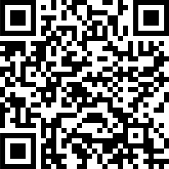
- MDPH, Bureau of Family Health and Nutrition, Women, Infants, & Children (WIC) Nutrition Program: https://www.mass.gov/women-infants-children- wic-nutrition-program

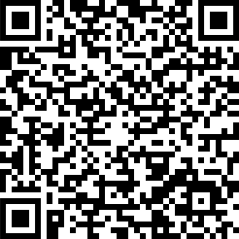
- MDPH, Division for Children & Youth with Special Health Needs (information on contacting resource specialists): https://www.mass.gov/service-details/contact-a-resource-specialist-for- information-on-state-and-community-based

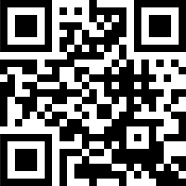
- Diversity RX:
http://www.diversityrx.org/

Independence
Independence Considerations:
Does your plan appropriately support individuals who use mobility devices or assistive technology in daily living (such as wheelchairs or walkers, vision and communication aids, etc.)? Does your plan take into account support or access for service animals (such as clarifying for volunteers/staff the definition of a service animal, and the difference between a service and an assistance animal)?
ϒ

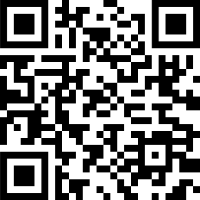
Assistive Technology
- GetAtStuff, Assistive Technology Exchange in Massachusetts:
https://getatstuff.massmatch.org/

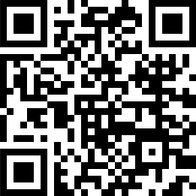
- MassMatch:
https://www.massmatch.org/find_at/borrow.php

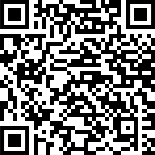
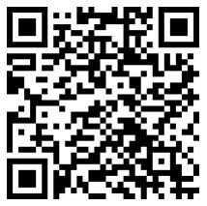
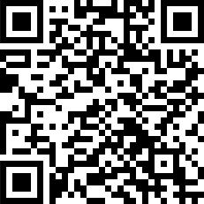
Additional Independence Resources
- Massachusetts Office on Disability, About service and assistance animals: https://www.mass.gov/service-details/about-service-and- assistance-animals

Services and Support

Service and Support Considerations:
Does your plan include providing behavioral health support for those who are affected by an emergency? This could include supporting existing needs, such as a diagnosed condition, or new needs as a result of an emergency.
ϒ
ϒ
Does your plan include information on where or how individuals can receive behavioral health support?
ϒ
Does your plan include processes to support the needs of pregnant women, nursing mothers and infants, or children (such as a location to care for infant/children, or a location to pump/nurse, etc.)?

Additional Service & Support Resources

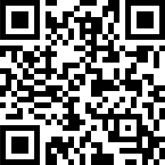
- Substance Abuse and Mental Health Service Administration(SAMHSA), Finding Treatment: https://www.samhsa.gov/find-treatment

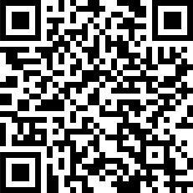
- Massachusetts Department of Mental Health: https://www.mass.gov/orgs/massachusetts-department-of-mental- health

Transportation

Transportation Considerations:
Does your plan incorporate mass transit needs or considerations?
ϒ

Does your plan outline contracts or have a memorandum of understanding in place for transportation resources in the case of an emergency?
ϒ
ϒ
Does your plan include alternate transportation resources should primary resources be affected or unavailable due to the emergency?
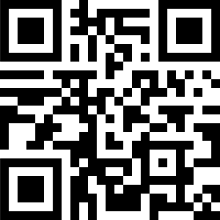
Additional Transportation Resources
- Massachusetts Department of Transportation (MassDOT)/MassMobility, Community transportation coordination: https://www.mass.gov/info- details/community-transportation-coordination

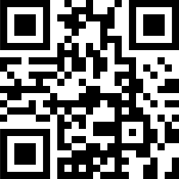
- MassDOT/Massachusetts Bay Transportation Authority(MBTA):
https://www.mbta.com/

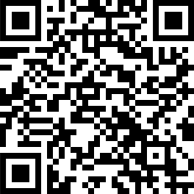
- HHS/MassMobility, Health care transportation:
https://www.mass.gov/service-details/health-care-transportation

Recommended Reading, Mobile Applications and Trainings

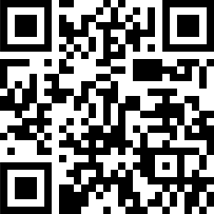
Recommended Reading
- Kailes, J.I, Enders, A. (2007). Moving Beyond “Special Needs.” A Function- Based Framework for Emergency Management and Planning. Journal of Disability Policy Studies, 17(4). 230-237. Accessed May 29, 2019. http://www.jik.com/KailesEndersbeyond.pdf

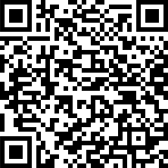
- U.S. Department of Homeland Security, Communicating with Persons with Access and Functional Needs. Recorded June 4, 2014. Accessed January 15, 2015. https://share.dhs.gov/p7d56x492el/?launcher

=false&fcsContent=true&pbMode=normal

Mobile Applications (Apps)

American Red Cross Disaster apps (Apple and Android devices)
The American Red Cross has a range of mobile apps, from an all-inclusive emergency app to hazard- specific apps, as well as a fun and informative app for kids to use with their parents.

ASL Dictionary (Apple and Android devices)
Translate English into ASL, from A to Z, the entire numerical system, common English phrases, symbols, and much more.

Autism 5-Point Scale Emergency (Apple)
The Autism Help App assists individuals with Autism Spectrum Disorders (ASD) and other disabilities to communicate and regulate in emergency situations. With a touch of the screen, information is provided and can help facilitate interactions for a “safe” outcome for both the individual and the first responder.

EyeNote (Apple devices)
EyeNote is a mobile device app that denominates Federal Reserve Notes (U.S. paper currency) as an aid for the blind or visually impaired to increase accessibility. Users can scan the note and the denomination will be communicated back to them.

FEMA’s Mobile App (Apple)
Receive weather alerts from the National Weather Service for up to five different locations in the United States, and learn safety tips for various disasters.

PFA Mobile (Apple and Android devices)
PFA Mobile was designed to assist responders who provide psychological first aid (PFA) to adults, families, and children as part of an organized response effort. This app provides responders with summaries of PFA fundamentals, PFA interventions matched to specific concerns and needs of survivors, mentor tips for applying PFA in the field, a self-assessment tool for readiness to conduct PFA, and a survivors' needs form for simplified data collection and easy referral.

SAMHSA Behavioral Health Disaster Response (Apple, Android, and Blackberry devices)
The SAMHSA Behavioral Health Disaster Response App is designed for behavioral health professionals and provides access to evidenced-based mental health and substance use information, tools, and resources for use in the field.

Show Me for Emergencies and Show Me for Emergencies: FAC (Family Assistance Center) (Apple and Android devices)
Show Me for Emergencies is an essential free app for emergency workers and people with communication needs, such as difficulty understanding English, hearing impairments, and cognitive disabilities. It uses easy-to-understand icons for two-way communication during an emergency.

Trainings

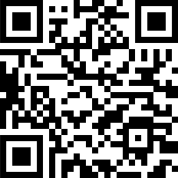
- DelValle Institute for Emergency Preparedness, Individuals Requiring Additional Assistance (IRAA) course: https://delvalle.bphc.org/enrol/index.php?id=685

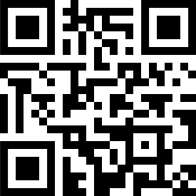
- Uniformed Services University of the Health Sciences, National Center for Disaster Medicine and Public Health, Caring for Older Adults in Disasters: A Curriculum for Health Professionals course (much of the curriculum can be applied to other at-risk individuals as well): https://www.usuhs.edu/ncdmph-learn/KnowledgeLearning/2015- OAC.htm

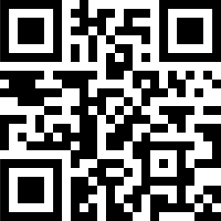
  - Johns Hopkins, Bloomberg School of Public Health, Introduction to Mental Health and Disaster Preparedness course: https://www.jhsph.edu/research/centers-and-institutes/johns-hopkins- center-for-public-health- preparedness/training/online/mental_hlth_intro.html

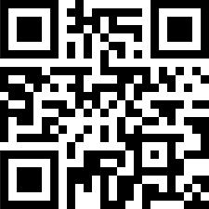
  - FEMA, IS-366.A: Planning for the Needs of Children in Disasters course:
https://training.fema.gov/is/courseoverview.aspx?code=IS-366.a

  - FEMA, IS-368: Including People With Disabilities & Others With Access & Functional Needs in Disaster Operations course: https://training.fema.gov/is/courseoverview.aspx?code=IS-368

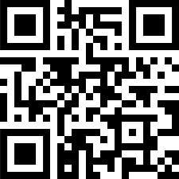
  - HHS/ASPR, Access and Functional Needs course:
https://www.train.org/main/admin/course/1083869/?activeTab=reviews

Appendix A
CMIST Consideration Questions

All of the questions from each CMIST category are listed below . The goal of these questions is to get you thinking about the CMIST Framework as you create, revise, or update your emergency plans. Using the questions is not required, but is helpful in encouraging thoughtful consideration for each CMIST category.

Communication:
Communication Considerations
Does your plan include outreach to local community networks that support at-risk individuals (such as those you may have used to assist in identifying who is at-risk)?
ϒ
ϒ
Does your plan include communication paths that reach individuals who have limited English proficiency, are deaf or hard of hearing, and are blind or have low vision? These communication channels should be used before, during, and after an emergency.
ϒ
Does your plan include multiple delivery channels for emergency/alert messaging (such as television, radio, social media, internet pages, texting, reverse 911, ethnic media, HAM radio networks, etc.)?

Maintaining Health

Maintaining Health Considerations:
Does your plan include considerations for those who need assistance to maintain activities of daily living (such as toileting, eating, or dressing)?
▫
Depending on the type of plan, do you have appropriate supplies (or a plan for obtaining them) that support daily living to assist individuals who might not have been able to bring supplies with them (such as extra feeding tubes, diapers, formula, bandages, etc.)?
Does your plan include resources to find the availability of open pharmacies that individuals can use to obtain daily medication, if applicable?
▫
Does your plan encourage individuals receiving recurring medical services to prepare with their care team (such as dialysis or medication assisted treatment, or other ongoing treatment for behavior health and/or substance use disorder)?
Does your plan include considerations for medical conditions individuals of any age may have (such as infants or older adults)? For example, do you have common durable medical equipment that could support your at-risk population?
▫

Independence

Independence Considerations:
Does your plan appropriately support individuals who use mobility devices or assistive technology in daily living (such as wheelchairs or walkers, vision and communication aids, etc.)? Does your plan take into account support or access for service animals (such as clarifying for volunteers/staff the definition of a service animal, and the difference between a service and an assistance animal)?
ϒ
ϒ

Services and Support

Service and Support Considerations:
Does your plan include providing behavioral health support for those who are affected by an emergency? This could include supporting existing needs, such as a diagnosed condition, or new needs as a result of an emergency.
ϒ
ϒ
Does your plan include information on where or how individuals can receive behavioral health support?
ϒ
Does your plan include processes to support the needs of pregnant women, nursing mothers and infants, or children (such as a location to care for infant/children, or a location to pump/nurse, etc.)?

Transportation
Transportation Considerations:
Does your plan incorporate mass transit needs or considerations?
ϒ
Does your plan outline contracts or have a memorandum of understanding in place for transportation resources in the case of an emergency?
ϒ
ϒ
Does your plan include alternate transportation resources should primary resources be affected or unavailable due to the emergency?

Notes:

Notes:

