 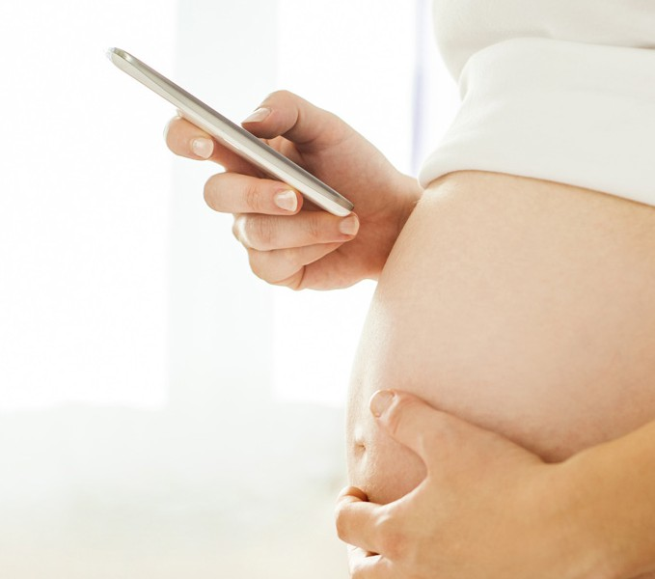



What: WIC Public Hearing Date: September 13, 2024

Time: 2:30 - 3:30 pm

Location: WIC Learning Center

63 Fountain St. 3rd Fl. Framingham, MA 01702

--OR--

[Click here to join the meeting](https://teams.microsoft.com/l/meetup-join/19%3ameeting_MmNjNTFkZTMtYWY5NS00ODRkLWEyZGUtYmUxZjAzNjdkMzQ2%40thread.v2/0?context=%7b%22Tid%22%3a%223e861d16-48b7-4a0e-9806-8c04d81b7b2a%22%2c%22Oid%22%3a%22c35d2218-f765-47c6-8df7-06baf09e0b43%22%7d)

Meeting ID: 237 703 982 460 Passcode: PJpQLL

Or call in (audio only) 1 857-327-9245; Meeting code 224 872 260#

If you are deaf, hard of hearing or a person with a disability who requires accommodation, please contact Diana Hoek at [diana.hoek@mass.gov](mailto:diana.hoek@mass.gov) at least two weeks prior to the event.





The Massachusetts Department of Public Health Wants to Hear from You to Identify Priorities for the Women, Infants and Children (WIC) Nutrition Program.