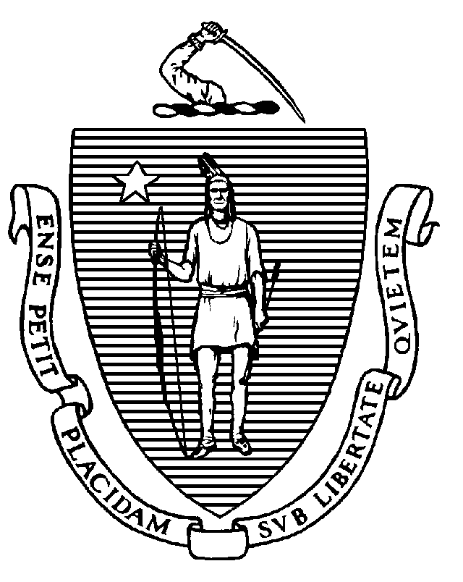
The Commonwealth of Massachusetts
Executive Office of Health and Human Services
Department of Public Health
250 Washington Street, Boston, MA 02108-4619

CHARLES D. BAKER
Governor
KARYN E. POLITO
Lieutenant Governor

MARYLOU SUDDERS
Secretary
MONICA BHAREL, MD, MPH Commissioner

Tel: 617-624-6000
www.mass.gov/dph

May 8, 2017

Dear Friends of Public Health,

The Massachusetts Department of Public Health is seeking public comments for the State Plan for the Women, Infants, and Children Nutrition Program (WIC) for federal fiscal year 2018.

Enclosed you will find a WIC Nutrition Program summary, which includes federal fiscal year 2017 funding and identified program priorities for your information.

We have scheduled a public hearing on Friday, June 16, 2017 from 3:00 PM – 4:00 PM at The WIC Learning Center, 63 Fountain Street, 3rd floor, Framingham (directions attached). Written comments may also be sent to:

Judy Hause, Director - Nutrition Division
Massachusetts WIC Nutrition Program
Bureau of Family Health & Nutrition
250 Washington Street, 6th floor
Boston, MA 02108-4619

Email: Judy.Hause@state.ma.us

This hearing provides a forum for WIC local programs and agencies as well as other public health professionals and consumers to share their thoughts with the Department concerning priorities for the WIC program. I encourage you to participate on June 16th.

If you have any questions about the public hearing, you may contact me at 617-624-6145 or by email (see above). Thank you.

Sincerely,
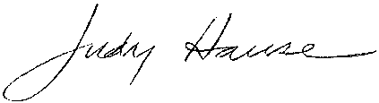
Judy Hause, MPH
Director – Nutrition Division
Massachusetts WIC Program

Directions to The WIC Learning Center
63 Fountain Street, Framingham, MA 01702

Telephone: (508) 875-8700

Public Transportation: The Purple Line Commuter Rail from South Station stops at Framingham. From the Commuter Rail station, it is a 0.6 mile walk to The Learning Center. (Approximately 10 minutes). Walk WEST up Route 135 to the traffic light at FOUNTAIN St. (Long Auto Body and Gulf Station are at the intersection). Walk RIGHT up to the hill. First driveway on you RIGHT is Kenwood Centre:
63 Fountain St. and The Fitness Company. The WIC Learning Center is on the THIRD floor of the beige high-rise building.

From Route 128 (I-95)  - Take Exit 20B to Route 9 West  (Framingham/Worcester).  - Drive 7.6 miles to Speen St. Exit  Stay on your left, follow Speen St. signs.  - Proceed on Speen St. 1.3 miles to Route 135. Go RIGHT onto 135 (Waverly Ave.)  - Drive 2.2 miles to intersection of Route 126. Cross 126 and continue on Route 135 past the train station. At the traffic light, about 0.4 miles after the train station, bear RIGHT onto FOUNTAIN St.  - Drive up the short hill; First driveway on RIGHT is Kenwood Centre: 63 Fountain Street The Learning Center is on THIRD floor of the beige high-rise building. | From the Mass. Pike (traveling West)  - Take Exit 13 (Natick/Framingham) to Route 30 West.  - Drive 1.5 miles (you will see Shopper’s World on your left, and Target mall on your right. Continue on Route 30 past a Shell gas-station on your left, the road then merges with Route 9 West.  - Drive west on Route 9 for about a mile. Take Exit 30 (Framingham/Southboro). Trolley Square will be on your right. (Same exit as Framingham State College.)  - At the traffic light, turn LEFT. Go straight past the next set of lights to cross over Route 9, and proceed 0.2 miles to FRANKLIN St.  - Turn RIGHT on Franklin & drive 0.6 miles to the intersection of MOUNT WAYTE Ave. At the Shell Station (Mt. Wayte) turn RIGHT.  - Stay on this road (Mt. Wayte turns into Dudley St.) to the end. You will see the Barbieri School on your right and a park and Farm Pond on your left. At the end of this road, turn LEFT onto FOUNTAIN Street.  - First driveway on your LEFT is Kenwood Centre. The Learning Center is on THIRD floor of the beige high-rise building.
From Route 495 (North or South)  - Take Exit 23A (Route 9 East: Southboro/Framingham) onto Route 9 East and travel 6.2 miles. Edgewater Plaza and CVS Pharmacy are on your right.  - Turn RIGHT at CVS Pharmacy onto TEMPLE St. and travel 0.2 miles to a Stop sign: SALEM END ROAD.  - Turn LEFT onto Salem End Rd. and travel 0.3 miles to WINTER St. Turn RIGHT onto Winter St. and continue for 1.7 miles past Keefe Tech School to a traffic light: FOUNTAIN St.  - Turn LEFT onto Fountain St., travel 0.5 miles you will see the Loring Arena and Dudley Rd. on your left  - Immediately after you pass Dudley road, take the first driveway on your LEFT: Kenwood Centre:  63 Fountain Street The Learning Center is on THIRD floor of the beige high-rise building. | From the Mass. Pike (traveling East)  - Take Exit 12 (Route 9, Framingham), onto Route 9 East and travel 1.5 miles. Edgewater Plaza and CVS Pharmacy are on your right.  - Take RIGHT at CVS Pharmacy onto TEMPLE St. and travel 0.2 miles to a Stop sign: SALEM END ROAD.  - Turn LEFT onto Salem End Rd and travel 0.3 miles to WINTER St. Turn RIGHT onto Winter St. and continue for 1.7 miles past Keefe Tech School to a traffic light:  FOUNTAIN St.  - Turn LEFT onto Fountain St., travel 0.5 miles you will see the Loring Arena and Dudley Rd. on your left.  - Immediately after you pass Dudley road, take the first driveway on your LEFT: Kenwood Centre:  63 Fountain Street The Learning Center is on THIRD floor of the beige high-rise building.

