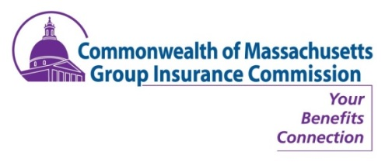

PUBLIC NOTICE
GIC COMMISSION MEETING
THURSDAY, FEBRUARY 22, 2018
8:30 A.M.

State Transportation Building
Transportation Board Room, Second Floor,
10 Park Plaza, Boston, MA 02116

February 22 Commission Meeting Agenda

  - Approval of January 18, 2018 Minutes (VOTE)
  - Director’s Report (INFORM)
  - Functional Reviews (INFORM & VOTE)
    - Vote to approve March estimated premium payments
    - January Claim reimbursements report
    - Updated FY18 state share expense for all accounts
    - Updated budget charts
    - FY18 state share premium budget for all accounts
  - Dental & Vision (VOTE)
    - Approval of FY19 Retiree Dental Premium
    - Approval of FY19 Active Dental & Vision Rates
  - V. Employee Assistance Plan (EAP) Recommendation: Vendor & Rates (VOTE)
Presentation and approval of staff recommendation for an Employee Assistance Plan vendor and plan rate
  - FY19 Full Cost Premiums (VOTE)
    - Authorize the GIC to maintain the FY19 Municipal Administrative fee at 0.35% of the full cost premiums.
    - Approve recommended spending from The Elderly Government Retirees (EGRs) and The Retired Municipal Teachers (RMTs) claim stabilization reserve trusts to subsidize the FY19 premiums
    - Approve recommended FY19 individual Pool 1 and Pool 2 full cost premiums
  - In Closing: Out & About, Misc. Updates, Wrap-Up & Discussion & Other Business

