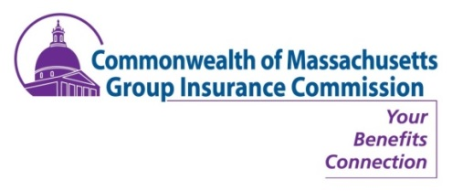

PUBLIC NOTICE
GIC COMMISSION MEETING
THURSDAY, April 5, 2018
8:30 A.M.

State Transportation Building
Transportation Board Room, Second Floor,
10 Park Plaza, Boston, MA 02116

  - Approval of February 1, 2018 Minutes (VOTE)
  - Director’s Report (INFORM)
- Review of meeting goals
- Update on recent Pool 2 legislation passage and other legislative meetings
- Commissioner & staff transitions
  - Functional Reviews (INFORM)
- Budget & Financial
  - April estimated premium payments
  - February claim report
- Human Resources Quarterly Temporary Employment Report
  - Out of Pocket Expenses (INFORM)
- Comparison of distribution of total member out of pocket costs for FY15 – FY17
  - Annual Enrollment Update (INFORM)
  - High level timeline for next year (INFORM & DISCUSS)
  - Governance & Commissioner Expectations (INFORM)
- Guide for Members of Public Boards and Commissions
- Rules of Order
- Commissioner Tim Sullivan’s Motion
  - Affordability Task Force Reset (INFORM)
  - In Closing: Out & About, Misc. Updates, Wrap-Up & Discussion & Other Business

