Massachusetts Department of Environmental Protection
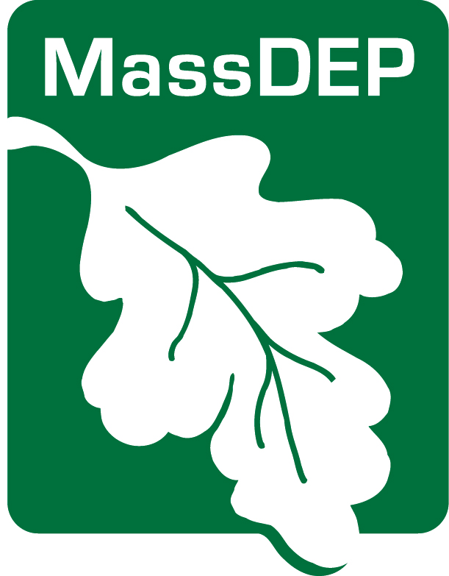
Drinking Water Program
Combination PFAS Public Notification & Education

CERTIFICATION

Make sure to send your MassDEP Drinking Water Program regional office and local board of health a copy of each type of notice with this completed certification upon issuance to demonstrate you have met all of the PFAS Public Education requirements [310 CMR 22.07G(7)(e)] and Public Notice requirements [310 CMR 22.15XXX],. When you certify, you are also stating that you will meet future requirements for notifying new billable customers of the violation or situation specified by MassDEP.

PWS ID City/Town:

PWS Name: |  | Community Non-community
Describe the violation orsituation specified by MassDEP:
PFAS Detection(s) requiring issuance of Public Education and Public Notice
Occurring on:  Date(s) of violation or situation | NON-Number  If applicable:
The water supplier indicated above hereby affirms that public education materials and public notice have been provided to consumers in accordance with 310 CMR 22.07G and 310 CMR 22.16 including: delivery, content, format requirements, notification deadlines and that the public water system will meet future requirements for notifying new billing units and new customers of the violation.
Consultation with MassDEP on
date
Notice distributed by on
method date
AND

Notice distributed by on
method date
I certify under penalty of law that I am the person authorized to fill out this form and the information contained herein is true, accurate and complete to the best of my knowledge and belief.

date name

______________________________________________________________
Signature of owner or operator

Western Regional Office, 436 Dwight St., Springfield, MA 01103
Central Regional Office, 8 New Bond St., Worcester, MA 01606
Northeast Regional Office, 205B Lowell St. Wilmington, MA 01887
Southeast Regional Office 20 Riverside Dr., Lakeville, MA 02347
Boston – Program.Director-DWP@mass.gov

Rev. Feb 2021

