Mass.Gov Logo

**UFR *e* Filing**

**OSD**

July 1, 2002

User Guide for the Public

Objectives 1

Introduction 1

Assumptions 1

System Requirements 1

General Public – Basic UFR Search 2

Basic Search for UFRs 2

Subscriber Functions 7

How to become a Subscriber 7

Log Into UFR eFiling System 7

* Log In From eFiling Home 7

Advanced Search for UFRs (Subscribers Only) 10

Update User Profile 15

* Receive Profile 15
* Change Password 15
* Change Contact Information 17

Forgot Password 20

* New Password Request 20
* Receive E-mail Notification 21

# Objectives

* Guide the Public through searching for UFRs
* Guide the Subscriber through Advanced Search functions and the profile maintenance process

# Introduction

As the UFR filing is a public document, citizens and the general public have the ability to request and acquire information on the UFR filing. With the implementation of the new UFR eFiling system, citizens and the general public will be able to make inquiries online and view the UFR information electronically; thereby significantly reducing the time, effort, and costs associated with manually fulfilling these information requests. This is facilitated by two types of searches that a public user can conduct on the eFiling system:

1. Basic UFR Search
2. Advanced UFR Search

The Basic UFR Search capability is accessible by all Public Users. A subset of the general public include the set of users that pay a subscription fee for extended services, which includes the Advanced UFR Search. Subscribers to the UFR eFiling system receive a profile with the system as well as the following services:

* Complete access to the advanced search querying capabilities on filing and UFR Excel template information as stored in the UFR Database
* Access to customized reports and analysis of the UFR Data
* Ability to maintain their profile in the UFR eFiling System

# Assumptions

Before the Public User can begin using the UFR eFiling system, several prerequisites must be satisfied:

* The Public User has the proper means to access the UFR eFiling System (i.e. ISP, compatible browser, operating system, office suite)
* All Users have access to the Basic UFR Search, but only Subscribers have access to the Advanced UFR Search

# System Requirements

The following system requirements must be met to utilize the features of the eFiling System:

* Internet Access through an ISP (e.g. dial-up, ISDN, cable modem, etc.) or LAN
* Microsoft Internet Explorer 4.0 or Netscape Navigator 4.5 (For best results, MS IE 5.0 or Netscape 6.0 or above are recommended)
* Microsoft Office 97 or greater (MS Excel, MS Outlook)

# General Public – Basic UFR Search

After concluding this section, the Public User should have the ability to:

* Conduct UFR Basic Searches

## Basic Search for UFRs

1. Click on the **Basic UFR Search** link. This link is found on the Home Page as well as any non-transactional page.

The Basic UFR Search window appears

Click on the Basic UFR Search link. This link is found on the Home Page as well as any non-transactional page.

The Basic UFR Search window appears

To search for a Contractor’s UFR, enter criteria relevant to the search. You can provide any or all of the following criteria:

• Contractor FEIN
• Contractor Name
• Fiscal Year

Wildcard searches are permitted (by appending an “*” to any criteria entered) and values for any or all criteria can be entered. Click the Search button to search for a UFR.  Search results will appear in blue at the bottom of the screen.


1. To search for a Contractor’s UFR, enter criteria relevant to the search. You can provide any or all of the following criteria:
   * Contractor FEIN
   * Contractor Name
   * Fiscal Year

Wildcard searches are permitted (by appending an “*” to any criteria entered) and values for any or all criteria can be entered. Click the **Search** button to search for a UFR. Search results will appear in blue at the bottom of the screen.

Clicking on any of the column headings sorts the results ascending/descending on that column. The number of pages appears at the bottom right. Clicking on the page number will cause the selected page to appear. 

To view filings submitted for a UFR in the search results, click on a Contractor’s name in the search results.

The UFR Details page for that contractor’s fiscal year will appear.


Clicking on any of the column headings sorts the results ascending/descending on that column. The number of pages appears at the bottom right. Clicking on the page number will cause the selected page to appear.

1. To view filings submitted for a UFR in the search results, click on a Contractor’s name in the search results.

The **UFR Details** page for that contractor’s fiscal year will appear.

Clicking on any of the column headings sorts the results ascending/descending in that column. The number of pages appears at the bottom right. Clicking on the page number will cause the selected page to appear. 

Click on a filing type in the Filings list to view all documents submitted for the filing.  The UFR Documents Page will appear.


Clicking on any of the column headings sorts the results ascending/descending in that column. The number of pages appears at the bottom right. Clicking on the page number will cause the selected page to appear.

1. Click on a filing type in the **Filings** list to view all documents submitted for the filing. The UFR Documents Page will appear.

To view a document, click on the document’s file name.

The OSD e-Filing Document Viewer will appear in a separate window. The selected document, by default will appear exactly as it was uploaded, under the Native viewing type. Two other viewing methods are possible:

• FulView – FulView is a free-downloadable viewer which will render the document in its own format. If the computer downloading the document does not have the appropriate software such as Microsoft Office, FulView can be used to view the document. 

NOTE: FulView will not render Adobe Acrobat files unless Acrobat Reader is installed on the viewing computer.

• HTML – The document can also be rendered in HTML which can be viewed in a web browser. 

NOTE: HTML rendering is not possible for Adobe files.


1. To view a document, click on the document’s file name.

The **OSD e-Filing Document Viewer** will appear in a separate window. The selected document, by default will appear exactly as it was uploaded, under the **Native** viewing type. Two other viewing methods are possible:

* **FulView** – FulView is a free-downloadable viewer which will render the document in its own format. If the computer downloading the document does not have the appropriate software such as Microsoft Office, FulView can be used to view the document.

**NOTE:** FulView will not render Adobe Acrobat files unless Acrobat Reader is installed on the viewing computer.

* **HTML** – The document can also be rendered in HTML which can be viewed in a web browser.

**NOTE:** HTML rendering is not possible for Adobe files.

A .xls file viewed in the OSD eFiling Document Viewer

NOTE: The document that is viewed may be accessed as a Read Only file. Changes may be made, but if saved will only be saved to the local computer. No changes are transmitted to the Server where the original document resides.


A *.xls* file viewed in the OSD eFiling Document Viewer

**NOTE:** The document that is viewed may be accessed as a Read Only file. Changes may be made, but if saved will only be saved to the local computer. No changes are transmitted to the Server where the original document resides.

# Subscriber Functions

## How to become a Subscriber

To become a subscriber complete the form located at: [Uniform Financial Statements & Independent Auditor's Report Subscription Service for an Advanced UFR Search](https://training.ufr.osd.state.ma.us/Subscribe.asp). Send a check for the subscription to OSD. Complete details are available Online.

After concluding this section, the Public Access Subscription User should have the ability to:

* Log into the UFR eFiling System
* Conduct UFR Advanced Searches (Subscribers Only)
* Maintain their user profile
* Request a new password

## Log Into UFR eFiling System

After concluding this section, the user should be capable of:

* Logging into UFR eFiling System
* Viewing the Public Subscriber Anchor Page

### Log In From eFiling Home

1. Open up the local browser (i.e. Internet Explorer, Netscape Navigator) and type the UFR eFiling URL, [Welcome to the Operational Services Division (OSD) UFR eFiling System](https://ufr.osd.state.ma.us/home.asp) into the **Address** box.


Open up the local browser (i.e. Internet Explorer, Netscape Navigator) and type the UFR eFiling URL, https://ufr.osd.state.ma.us/home.asp, into the Address box.

Enter the Login ID and password into the Login ID and Password fields in the Registered User Login box. 

The login information is the same as was provided to you in an  E-mail sent by the UFR eFiling administrator when your profile was approved. 

Click the Login button


1. Enter the Login ID and password into the **Login ID** and **Password** fields in the **Registered User Login** box.

The login information is the same as was provided to you in an E-mail sent by the UFR eFiling administrator when your profile was approved.

1. Click the **Login** button.

Upon a successful login, the **Advanced UFR Search** page will appear.

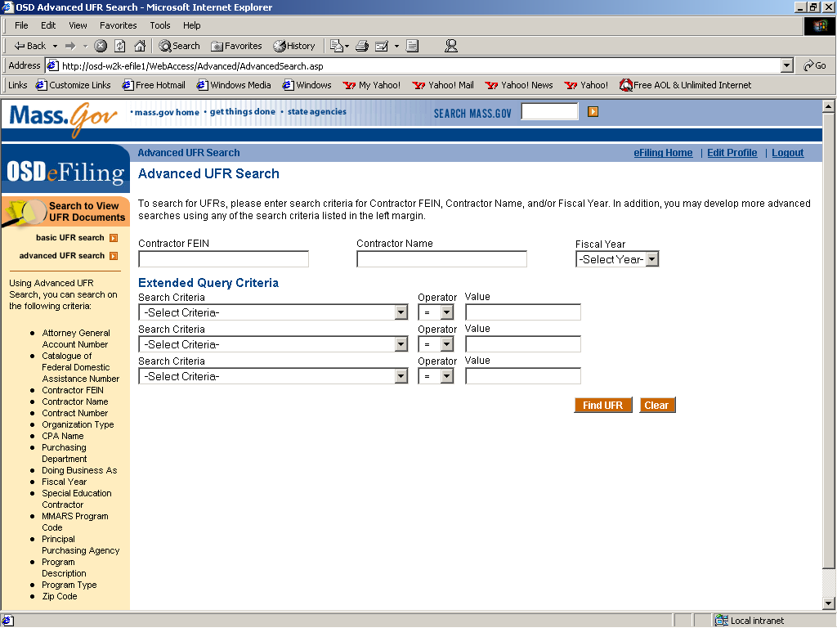

## Advanced Search for UFRs (Subscribers Only)

1. Click on the **Advanced UFR Search** link. This link is found on the Home Page as well as any user-accessible page.

**NOTE:** This page is available only to subscribers to the OSD eFiling system. For more details, please refer to the subscription details page.

The Advanced UFR Search window appears

Click on the Advanced UFR Search link. This link is found on the Home Page as well as any user-accessible page.

NOTE: This page is available only to subscribers to the OSD eFiling system. For more details, please refer to the subscription details page.

The Advanced UFR Search window appears


**NOTE:** Basic UFR Search is also accessible to any subscriber, but with reduced functionality from Advanced UFR Search.

1. To search for a Contractor’s UFR, enter criteria for a Contractor’s FEIN, Contractor’s Name, or the UFR Fiscal Year and/or develop up to three of your own queries under the Extended Query Criteria.

To develop your own query, under “Extended Query Criteria,” select a **Search Criteria** from the drop down list box, an **Operator** (i.e., “=”, “>”,”<”, etc.), and a **Value**. For example, if you select “CPA” for the **Search Criteria**, “=” for the **Operator**, and “Deloitte & Touche” for the **Value**, then you will find all UFRs where the Contractor designated “Deloitte & Touche” as the CPA for at least one filing.

The following table outlines all the Search Criteria on which you can search:

* + Contractor FEIN
  + Contractor Name
  + Fiscal Year
  + Attorney General Account Number
  + Catalogue of Federal Domestic Assistance Number
  + Organization Type
  + CPA Name
  + Purchasing Department
  + Doing Business As
  + Fiscal Year
  + Special Education Contractor
  + MMARS Program Code
  + Principal Purchasing Agency
  + Program Description
  + Program Type
  + Zip Code

**Note:** Wildcard searches are permitted and any or all criteria can be entered.

Click the **Search** button to search for all UFRs that match the search criteria you entered. All the UFRs that match will appear in the **Search Results**.

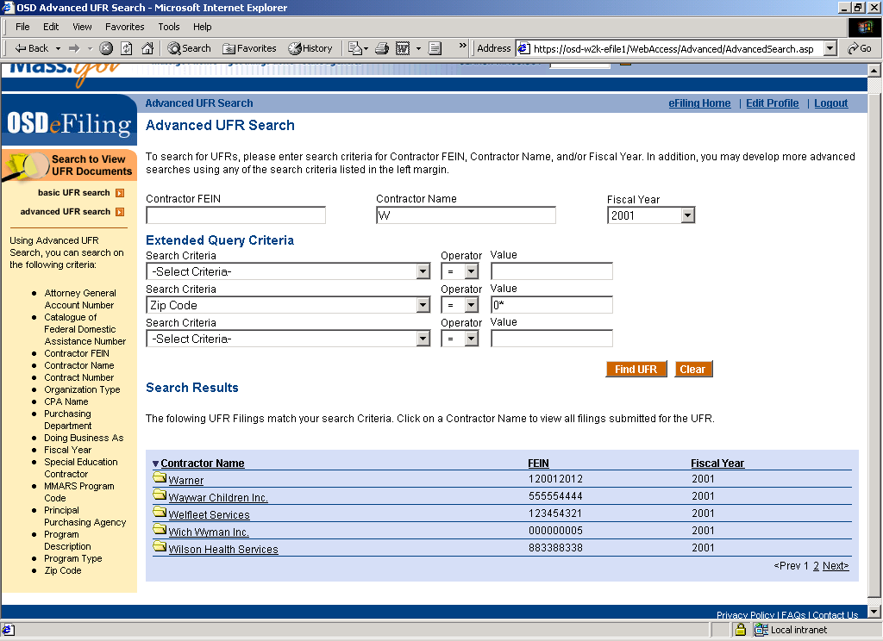

Clicking on any of the column headings sorts the results ascending/descending on that column. The number of pages appears at the bottom right. Clicking on the page number will cause the selected page to appear.

1. To view filings submitted for a UFR in the search results, click on a Contractor’s name in the search results.

The **UFR Details** page for that contractor’s fiscal year will appear.

To view filings submitted for a UFR in the search results, click on a Contractor’s name in the search results.

The UFR Details page for that contractor’s fiscal year will appear.


Clicking on any of the column headings sorts the results ascending/descending on that column. The number of pages appears at the bottom right. Clicking on the page number will cause the selected page to appear.

1. Click on a filing type in the **Filings** list to view all documents submitted for the filing. The UFR Documents page will appear.

To view a document, click on the document’s file name.

The OSD e-Filing Document Viewer will appear in a separate window. The selected document, by default, will appear exactly as it was uploaded, under the Native viewing type. Two other viewing methods are possible:

• FulView – FulView is a free-downloadable viewer which will render the document in its own format. If the computer downloading the document does not have the appropriate software such as Microsoft Office, FulView can be used to view the document. 

NOTE: FulView will not render Adobe Acrobat files unless Acrobat Reader is installed on the viewing computer.

• HTML – The document can also be rendered in HTML which can be viewed in a web browser. 

NOTE: HTML rendering is not possible for Adobe files.


1. To view a document, click on the document’s file name.

The **OSD e-Filing Document Viewer** will appear in a separate window. The selected document, by default, will appear exactly as it was uploaded, under the **Native** viewing type. Two other viewing methods are possible:

* **FulView** – FulView is a free-downloadable viewer which will render the document in its own format. If the computer downloading the document does not have the appropriate software such as Microsoft Office, FulView can be used to view the document.

**NOTE:** FulView will not render Adobe Acrobat files unless Acrobat Reader is installed on the viewing computer.

* **HTML** – The document can also be rendered in HTML which can be viewed in a web browser.

**NOTE:** HTML rendering is not possible for Adobe files.

A .xls file viewed in the OSD eFiling Document Viewer

NOTE: The document that is viewed may be accessed as a Read Only file. Changes may be made, but if saved will only be saved to the local computer. No changes are transmitted to the Server where the original document resides.


A *.xls* file viewed in the OSD eFiling Document Viewer

**NOTE:** The document that is viewed may be accessed as a Read Only file. Changes may be made, but if saved will only be saved to the local computer. No changes are transmitted to the Server where the original document resides.

## Update User Profile

After concluding this section, the subscriber will be able to perform all functions relating to the maintenance of their user profile including:

* Receiving their profile
* Changing their password
* Modifying their profile

### Receive Profile

1. Open your local E-mail program (i.e. MS Outlook, Eudora, Netscape Messenger) assigned to the E-mail address that is stored in you UFR eFiling profile.

An E-mail entitled **Password Approved** will appear, sent from the UFR eFiling Administrator address. Enclosed is the username and password that you may use to log into the eFiling application.

Open your local E-mail program (i.e. MS Outlook, Eudora, Netscape Messenger) assigned to the E-mail address that is stored in you UFR eFiling profile. 

An E-mail entitled Password Approved will appear, sent from the UFR eFiling Administrator address. Enclosed is the username and password that you may use to log into the eFiling application.

Use this information when logging into the UFR eFiling System.

1. Use this information when logging into the UFR eFiling System.

### Change Password

1. At any accessible page, click the **Edit Profile** link on the top left of the page.

The Edit Your Profile screen will appear. All the fields will contain the most current data.

At any accessible page, click the Edit Profile link on the top left of the page.

The Edit Your Profile screen will appear. All the fields will contain the most current data.

Enter your current password into the Old Password field.

Enter your new password into the New Password field.

Retype this password in the Retype New Password field to ensure there is no mistake.


1. Enter your current password into the **Old Password** field.
2. Enter your new password into the **New Password** field.

Retype this password in the **Retype New Password** field to ensure there is no mistake.

1. Click **Submit**.

The **Review Edit Profile** screen will appear.

The Review Edit Profile screen will appear.

After the information has been verified as correct, click Proceed.

The User Profile Update Confirmation screen will appear.


1. After the information has been verified as correct, click **Proceed**.

The **User Profile Update Confirmation** screen will appear.

Click on the Go Back to eFiling Home to go back to your anchor page.



1. Click on the **Go Back to eFiling Home** to go back to your anchor page.

**NOTE:** It is recommended that on your first entry into the eFiling application that you change your password.

An E-mail will also be sent to the address listed in the Profile entitled **Profile Updated** from the UFR eFiling administrator address. Enclosed is the summary of the profile changes, in this case only, the new password will also be enclosed.

At any non-transactional page, click the Edit Profile link on the top left of the page.

The Edit Your Profile screen will appear. All the fields will contain the most current data.


### Change Contact Information

1. At any non-transactional page, click the **Edit Profile** link on the top left of the page.

The Edit Your Profile screen will appear. All the fields will contain the most current data.

Enter your new information into the designated field.

The fields that can be edited are:

• Organization Information (Name, Address)
• Contact Information (Title, Name, Phone, E-mail)
• Password Information

NOTE: The Login ID is a unique identifier of the user in the eFiling system. This value cannot be changed.

11. Click Submit. 


1. Enter your new information into the designated field.

The fields that can be edited are:

* + Organization Information (Name, Address)
  + Contact Information (Title, Name, Phone, E-mail)
  + Password Information

**NOTE:** The Login ID is a unique identifier of the user in the eFiling system. This value cannot be changed.

1. Click **Submit**.

The **Review Edit Profile** screen will appear.

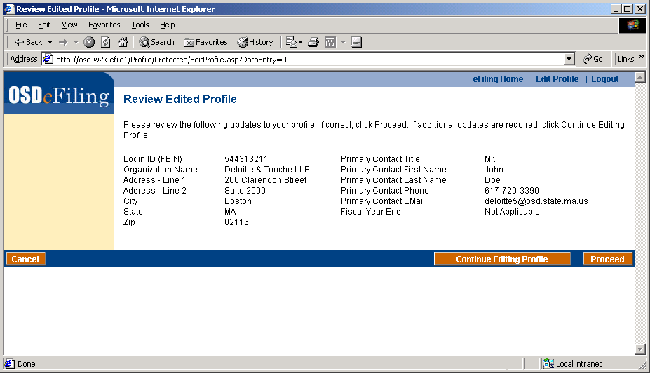

1. After the information has been verified as correct, click **Proceed**.

The **User Profile Update Confirmation** screen will appear.

After the information has been verified as correct, click Proceed.

The User Profile Update Confirmation screen will appear.


An E-mail will also be sent to the address listed in the Profile entitled **Profile Updated** from the UFR eFiling administrator address. Enclosed is the summary of the profile changes.

An E-mail will also be sent to the address listed in the Profile entitled Profile Updated from the UFR eFiling administrator address. Enclosed is the summary of the profile changes.
Click on the Go Back to eFiling Home to go back to your anchor page (Advanced UFR Search).

Click on the **Go Back to eFiling Home** to go back to your anchor page (**Advanced UFR Search**).

## Forgot Password

After this section is complete, the user will be able to request a new password from the UFR eFiling system and log back in.

### New Password Request

1. At the eFiling homepage, click the **Forgot Password** link in the **Registered User Login** box.

Forgot Password

After this section is complete, the user will be able to request a new password from the UFR eFiling system and log back in.

At the eFiling homepage, click the Forgot Password link in the Registered User Login box.

Enter your Login ID into the Login ID field and your E-mail address as it is in your user profile into the E-mail Address field.

Click Submit.



1. Enter your Login ID into the **Login ID** field and your E-mail address as it is in your user profile into the E-mail **Address** field.
2. Click **Submit**.

The Password Request Confirmation screen will appear.

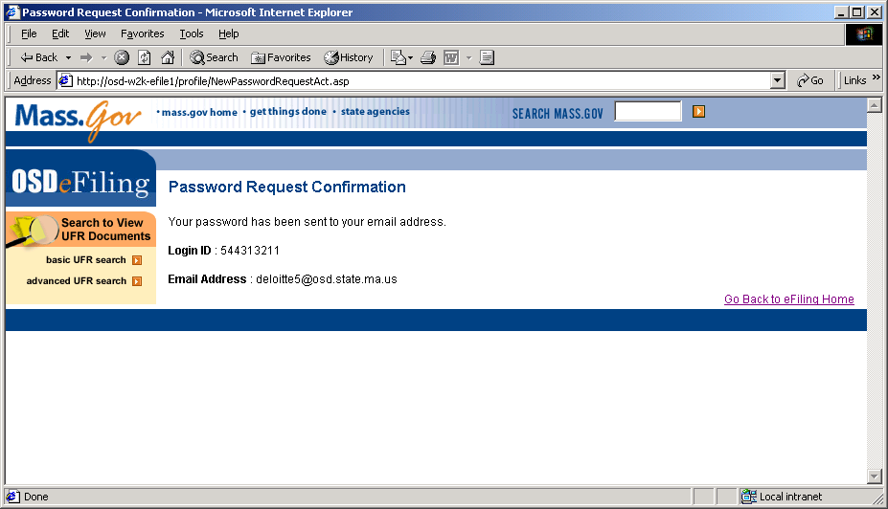

### Receive E-mail Notification

4. Open your local E-mail program (i.e. MS Outlook, Eudora, Netscape Messenger) assigned to the E-mail address that is stored in you UFR eFiling profile.

An E-mail entitled Password Enclosed will appear, sent from the UFR eFiling Administrator address. Enclosed is the reset password that you may use to log into the eFiling application.

**NOTE:** For security, it is recommended that you change your password again when logging into the eFIling application.

Open your local E-mail program (i.e. MS Outlook, Eudora, Netscape Messenger) assigned to the E-mail  address that is stored in you UFR eFiling profile. 

An E-mail entitled Password Enclosed will appear, sent from the UFR eFiling Administrator address. Enclosed is the reset password that you may use to log into the eFiling application.
