Hi Mike, I am not sure where you are at with Ch1…and this may be a little late in the game, but I was wondering if the dropping of the Certificate of Approval (7th edition) was a conscious choice or a miss? Thanks
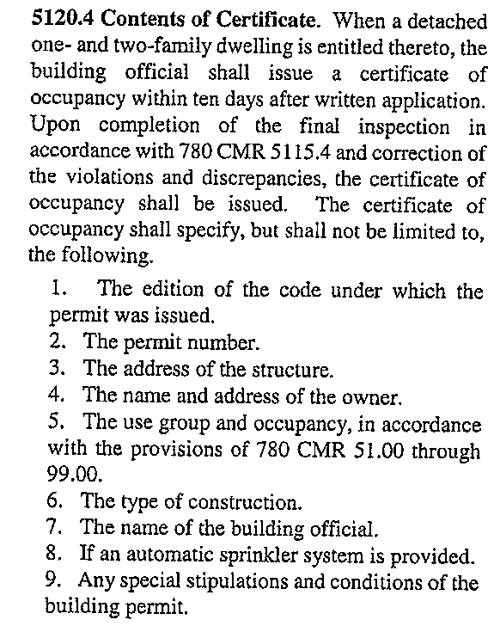

James A. Cerone
Local Inspector
FCCIP
12 Olive St., Greenfield MA, 01301
(413) 774-3167 Ext. 110

Mike, Please consider the following change to Section 107, giving the building official the ability to waive controlled construction requirements for minor work. Without this amendment it appears that the building official is required to ask for controlled construction services for even minor work as:
- Replacement windows
- Roof recovering
- The removal of a non load-bearing wall
- The re-arrangement of office cubicles.
While it may be true, that there are code issues to consider with this type of work, it is our opinion that this type of work does not always require a design professional. In some cases, the cost to higher the design professional may exceed the cost of the work and really cannot be justified.

107.6 Construction Control.
107.6.1 General. This section shall apply to the construction controls, professional services
and contractor services required for buildings and structures needing registered design
professional services.
The following structures are exempt from the requirements of this section:
1. Any building containing less than 35,000 cubic feet of enclosed space, measured to
the exterior surfaces of walls and roofs and to the top of a ground supported floor, or in
the case of a crawl space, to the bottom surface of the crawl space. In the case of
basement floors or levels, the calculation of enclosed space shall include such spaces. For
additions to existing buildings, the volume of enclosed space shall include the entire
existing building and all proposed additions.
2. Any one- or two-family dwelling or any accessory building thereto.
3. Any building used exclusively for agricultural purposes. See Appendix C for occupancy
and other limitations.
4. Retaining walls less than ten feet in height at all points along the wall as measured
from the base of the footing to the top of the wall.
5. Structures where the building official determines that the scope of work is minor in nature and not needing registered design professional services.

James A. Cerone
Local Inspector
FCCIP
12 Olive St., Greenfield MA, 01301
(413) 774-3167 Ext. 110

Mike,

Per your suggestion at the SEMBOA meeting last week I am submitting a comment on a proposed change to the code.

I'd like to see a change to the exemptions for permits section. Most of the insp. I talk to require permits for kitchen remodels. It is rare that it is strictly a cabinet for cabinet replacement and not a gut rehab with the apprentice plumber and his new hole saw reeking havoc on joists and studs.. The most popular addition to a kitchen is an island in the middle of the room with a granite or cement counter top. It has been my experience that many of these installation have required reinforcing of the existing floor joists to support the new concentrated load of over 800 lbs plus 4 - 6 people on stools around the island. In then past the code has exempted "cabinetry" which I have interpreted as built in bookcases, window seats, etc. not kitchen cabinets. I would like to suggest that this proposed section use language that continues tio exempt those items while specifically excluding kitchen cabinets and counter tops from the exemption. Also delete the entire exemption for counter tops.

e.g. Exemptions ........ "Cabinetry including built in bookcases, display cabinets and shelving, and similar installations but not kitchen cabinets and counter tops."

Or similar language.

Your counter, no pun intended, comments would be greatly appreciated.
Thanx
Joseph F. Doyle, Jr.
Building Commissioner
Town of Westwood
781-320-1091

Mike:
Construction Documents:
The Seventh Edition of the code- which I have attached required 7 items for permit submittal. We have lost this in the current edition. I have had more architects and engineers not know what was required when submitting a permit application. The homeowner is also not aware, if we could put this language back into Chapter 1 it would be most helpful to the public and building officials.
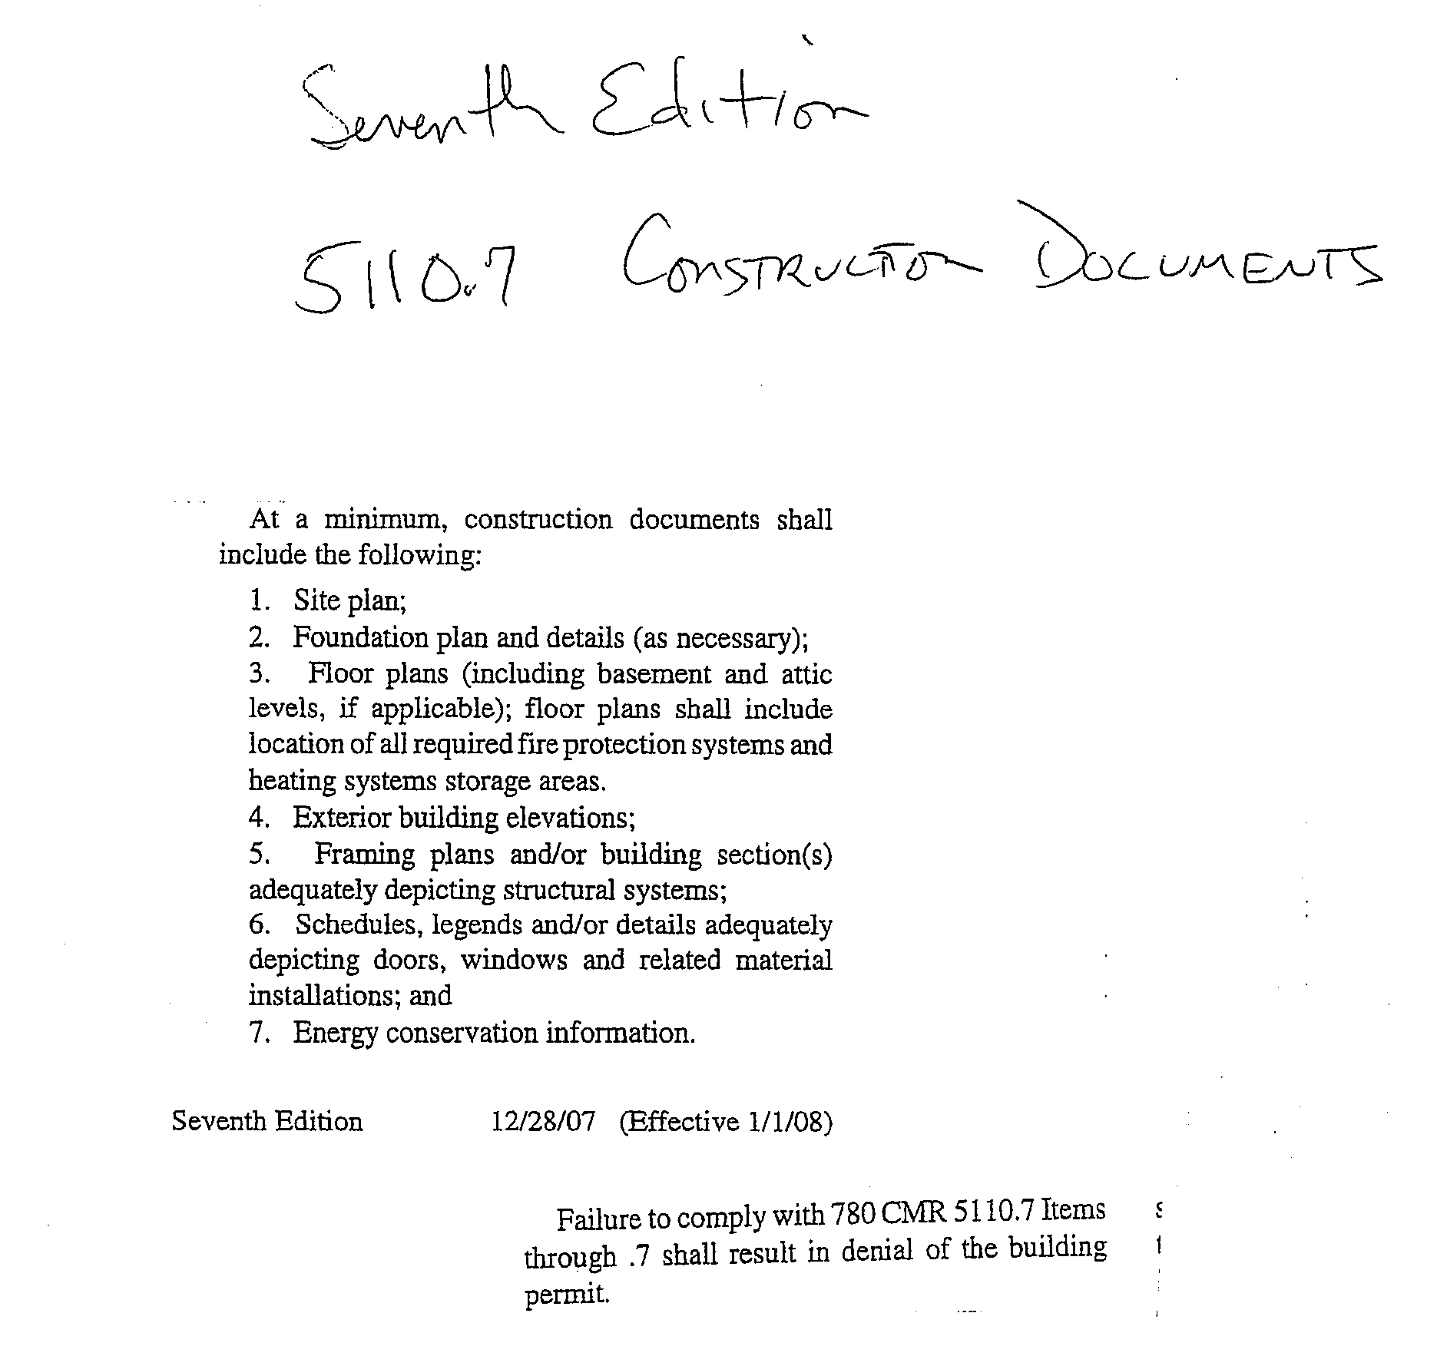

On-Site Presence of Construction Supervisor:

The second change in the current code pertains to R109.1. I have always required the licensed CSL or the Homeowner, if they have taken on that responsibility to be on site for my inspection to give me the tour and answer questions I may have .

R 109.1 affords the permit holder or his representative to be on site for these inspections no longer requiring the licensed construction supervisor to be present. We as building officials have questions for these permit holders or representatives pertaing to the inspection and rarely do they have the answer. I would like to require the Construction Supervisor to be on site or the Homeowner if they are acting as the Supervisor.

The Seventh Edition, 5115.3 afforded the building official, "To require the construction supervisor to be present during such inspections". I speak from experience and frustration that the LCS should be required to be present or again, the homeowner if they have taken on that responsibility.

The Sixth, Seventh and Eighth Edition contained language in R5 under the "On- site Presence of Supervisor" which gave the building official latitude to require the LCS to be on site if we requested it. Currently this language can be found in 110.R5.2.12 in the last paragraph.

Call me if you have questions.
Thanks,
Don

Donald R.Torrico C.B.O.
Building Commissioner
Zoning Enforcement Officer
Sign Officer

32 Main Street
Lee, MA 01238
Phone 413-243-5518 Fax 413- 243-5523

Mike,

As an additional public comment I would like to see language similar to 7th edition 780 CMR §112.0 Demolition of Structures reinserted into the 8th edition. There is currently no requirement (that I am aware of) in the 8th edition that states “A permit to demolish or remove a building or structure shall not be issued until a release is obtained from the utilities, stating that their respective service connections and appurtenant equipment such as meters and regulators have been removed or sealed and plugged in a safe manner.”

Thank you,

Chris Clemente
Inspector of Buildings
36 Bartlet Street
Andover, MA. 01810
978-623-8304 Office
978-623-8320 Fax

Dear Mr. Riley:

Upon review of the proposed code changes for the November 2013 public hearing, I would like to comment on the following:

- Section 107.3 Deferred Submittals- This section allows for construction documents to be submitted at various times though the course of a project. This will result in many reviews of the plans, which is unnecessary. The building official is required to have a clear understanding of the building design prior to the issuance of the building permit. This change will result in the building official trying to play ketch up all the time and allows the contractor (in the field) to proceed without the jurisdictions approval of said plans. Overall this section reduces Public Safety.
- Section 110.3 Inspections- Mandates certain required inspections. Inspections and inspection schedules should be determined by local jurisdictions based upon their community needs, amount of construction and types of construction. For example, if an inspector in a costal community requires/mandates certain required inspections due the local flooding conditions, then let that local department determine his/her required inspection needs.
- 107.6 Construction Control. This section overall needs to be strengthened through changes that require the design professional to take responsibility for the review of the completed project (Final Construction Control Document). The design professional should be required to submit on the final document when he/she performed a final inspection (date of inspection) on the project and determined compliance. We deal with hundreds of design professional during the course of a year and have found many times that the architect and/or engineer or their designee has never been on the site! It is not the job of the building official to do the design professionals job.
- Section 105.3.1 and Section 111.2 must be amended to include language regarding compliance with MGL Chapter 148. Again we as building officials are looking for compliance prior to the issuance of a permit and prior to issuance of an occupancy permit that the project meets the standards of the commonwealth. Without reference to MGL Chapter 148, building officials are placed in middle between the owners and the Fire Services and in the end the building official is trying to resolve the matter because that building official issued the building permit.
- Section 116- Unsafe Structures and Equipment- This section has been deleted and must remain. It must be clear that the building official is the authority to decide whether a building/structure is unsafe. Deletion of this section makes for bad public safety enforcement across the Commonwealth.

I would ask that you read this letter into the record at the Public Hearing on November 12, 2103. Please feel free to contact me of you should have any questions. Thank you.

Sincerely,
John J. Clancy, CBO
Inspector of Buildings Burlington

Mike,

I was looking at the proposed code changes. I know it’s late, but I have a recommendation. In “105.2 - Work exempt from permit”, sidewalks and driveways are not listed as being exempt. I know that we have always considered them to be exempt, but not specifically listing them creates confusion, particularly when they are listed as being exempt in IBC. Why would we take it of IBC if we treat them as being exempt? Also, sidewalks and driveways are listed as being exempt in the IRC (and in the Mass. Amendments) so why wouldn’t we list them in the IBC? I’ve talked to architects who are under the opinion that they are not exempt in the IBC (under Mass. Amendments) because of the Access Board regulations, which makes some sense.

I just think it’s something that needs to be clarified.

Thanks

Steve Frederickson, P.E.
Director/Building Commissioner
Municipal Inspections
City of Beverly, MA

This 102.6.3 Less Stringent – This allows designers/consultants to pick or choose what code situation best serves them. The IEBC 604.1 clearly states you must maintain the level of protection provided from past construction projects. We all know these codes are getting weaker as they move forward. This allows the code consultants to get around the IEBC. If one wants to design an existing building to today’s code- go for it, but it needs to be in the entirety (loads, bracing) not just this and that.
From: Sullivan, Dan <dsullivan@bedfordma.gov>

See attached word file from Al

November 1, 2013
Mike,
Attached, please find my comments on the proposed amendments to Chapter One.
Thank you very much for the opportunity to have input in the process.
Albert Leu
Local Building Inspector

Mike
My comments on chapter 1; highlighted in yellow

The premises of most of my comments are the Chapter 1 is identical for both the IBC and IRC

Note to the reader: Chapter 1 of the national code (IBC) add “and the IRC” is replaced below in its entirety. Chapter 1 is the only Chapter in 780 CMR that contains all of the IBC/IRC requirements and the MA amendments to those requirements in one place. The two codes were collected in one place for convenience because Chapter 1 is the most amended IBC/IRC chapter. The MA amendments are indicated with a sidebar.

101.2 Scope. This code shall be the building code for all towns, cities, state agencies or authorities in accordance with M.G.L. c. 143, §§ 93 to 100 . This code, and other referenced specialized codes as applicable, shall apply to:

- the construction, reconstruction, alteration, repair, demolition, removal, inspection, add “change of use, change in the number of occupants”, issuance and revocation of permits or licenses, installation of equipment, classification and definition of any building or structure and use or occupancy of all buildings and structures or parts thereof except bridges and appurtenant supporting structures which have been or are to be constructed by, or are under the custody and control of the Massachusetts Highway Department, the Massachusetts Turnpike Authority, the Massachusetts Bay Transportation Authority, the Department of Conservation and Recreation, or the Massachusetts Port Authority or for which said agencies have maintenance responsibility;

101.4.4 Property Maintenance. Reference to the International Property Maintenance Code shall be considered reference to this code (780 CMR) and within the jurisdiction of the building official. (Is this saying the IPM is not part of our jurisdiction?) Also see 105 CMR410: Minimum Standards of Fitness for Human Habitation (State Sanitary Code, Chapter II), which are enforced by the public health official.

101.4.6 Energy. Chapter 13 of this code shall apply to all matters governing the design and construction of buildings for energy efficiency. (Should this say the IECC insisted? And the this would include the IRC

104.11.2 Tests. Whenever there is insufficient evidence of compliance with the provisions of this code, or evidence that a material or method does not conform to the requirements of this code, or in order to substantiate claims for alternative materials or methods, the building official shall have the authority to require tests as evidence of compliance to be made at no expense to the jurisdiction. Test methods shall be as specified in this code or by other recognized test standards. In the absence of recognized and accepted test methods, the building official shall approve the testing procedures. Tests shall be performed by an approved agency. Reports of such tests shall be retained by the building official for the period required for retention of public records. (Should say the owner/applicant is responsible for the cost of tests)

105.2 Work Exempt from Permit. Except for activities which may require a permit pursuant to other laws, by-laws, rules and the specialized codes of M.G.L. c. 143, § 96, a building permit is not required for the following activities:
- One story detached accessory buildings used as tool or storage sheds, playhouses and similar uses, provided the floor area does not exceed 120 square feet.
- Fences not over 6 feet (1829 mm) high.
- Retaining walls which retain less than four feet of unbalanced fill.
Retaining walls that are not over four feet (1219 mm) in height measured from the bottom of the footing to the top of the wall, unless supporting a surcharge, or that retain over four feet of unbalanced fill.
- Greenhouses covered exclusively with plastic film intended for agricultural use (in accordance with St. 1983, c. 671). This exemption does not apply if the greenhouse is to be used for large assemblies of people or uses other than normally expected for this purpose.
- Painting, papering, tiling, leave in carpeting, cabinets, counter tops and similar finish work.t required they have no ability to enforce.)
- Swings and other playground equipment.
- Window awnings supported by an exterior wall that do not project more than 54 inches (1372 mm) from the exterior wall and do not require additional support of Groups R-3 and U occupancies.
- Sidewalks and driveways.
- Residential prefabricated swimming pools that are less than 24 inches (610 mm) deep.
- Residential decks not exceeding 200 square feet (18.58 m2) in area, that are not more than 30 inches (762 mm) above grade at any point, are not attached to a dwelling and do not serve the exit door required by subsection R311.4.
- Ordinary repairs.

107.1.1 Professional Seal and Signature. All plans and specifications shall bear a seal and signature of the responsible registered design professional in accordance with M.G.L. c. 143, § 54A. See also www.mass.gov/dpl for policy on electronic seal and signature for certain registered design professionals.

Exception: The building official is authorized to waive the submission of construction documents and other data not required to be prepared by a registered design professional if it is found that the nature of the work applied for is such that reviewing of construction documents is not necessary to obtain compliance with this code.

For portions of one or two family homes constructed in accordance with the prescriptive requirements of the IRC, the preparation of construction documents and other data is not required to be done by a registered design professional.

Add in an appropriate location
Coordination of Inspections. Whenever in the enforcement of this code, or another code or ordinance, the responsibility of more than one enforcement official of the jurisdiction is involved, it shall be the duty of the enforcement officials involved to coordinate their inspections and administrative orders as fully as practicable so that the owners and occupants of the building or structure shall not be subjected to visits by numerous inspectors or multiple or conflicting orders. Whenever an enforcement official observes an apparent or actual violation not within the official’s authority, the official shall report the findings to the official having jurisdiction.

Add in
108.6 Work Commencing Before Building Permit Issued. Any person who commences any work on a building or structure governed by this code before obtaining the necessary building permit shall be in violation of this code and subject to penalties. See Section 114.

110.3 Required Inspections. The building official shall conduct inspections during construction at intervals sufficient to ensure compliance with the provisions of this code which may include inspections set forth in sections 110.3.1 through 110.3.10 (Also 110.4). The building official shall inform the applicant of the required points of inspection at the time of permit issuance. The building official may designate specific inspection points in the course of construction that require the contractor or builder to give the building official 24 hours notice prior to the time when those inspections need to be performed. The building official shall make the inspections within 48 hours after notification.

It shall be the duty of the permit holder to provide access to and means for inspections of work required by this code. The building official may require the permit holder or his representative to attend these inspections.

Curtis Meskus
Building Commissioner/ZEO
Town of Charlton
508-248-2241
Curtis.Meskus@townofcharlton.net

See attached word file from Al

10/17/13
Mike,
As discussed at Wednesday’s BOWM meeting, attached, please find a copy of an amendment proposed for Chapter 9, with my comment included.
I am working on my review and comments for the proposed amendment to Chapter 1, and will respond shortly.
Albert Leu
Local Building Inspector

Mike I just wanted to point out an omission they left out in 107.6.1 I have it highlighted below:

It should read. “ except as provided in M.G.L. c.143 §§ 54A “ …. they forgot the chapter number 143

107.6 Construction Control.
107.6.1 General. This section shall apply to the construction controls, professional services and contractor services required for buildings and structures needing registered design professional services.
The following structures are exempt from the requirements of this section:
1. Any building containing less than 35,000 cubic feet of enclosed space, measured to the exterior surfaces of walls and roofs and to the top of a ground supported floor, or in the case of a crawl space, to the bottom surface of the crawl space. In the case of basement floors or levels, the calculation of enclosed space shall include such spaces. For additions to existing buildings, the volume of enclosed space shall include the entire existing building and all proposed additions.
2. Any one- or two-family dwelling or any accessory building thereto.
3. Any building used exclusively for agricultural purposes. See Appendix C for occupancy and other limitations.
4. Retaining walls less than ten feet in height at all points along the wall as measured from the base of the footing to the top of the wall.
Notwithstanding these exemptions, registered design professional services shall be required for activities which are deemed to constitute the practice of architecture or engineering as defined in M.G.L. c. 112, §§ 60A or 81D, except as provided in M.G.L. c. 54A and any legally required profession or as provided in M.G.L. c. 112, § 81R. Where work is performed by licensed trades people pursuant to M.G.L. c. 112, § 81R, shop drawings or plans and specifications prepared to document that work shall not be required to bear the seal or signature of a registered design professional. In lieu of a seal and signature the building official may require that the registered design professional review and approve shop or record drawings for general conformance to the design concept.
Michael Greaney
r.k. Miles, Inc.
21 west St.
West Hatfield, Ma. 01088
413.247.8300 x-472
413.247.8338 fax
413.210.8851 cell

Hi Mike, You asked for chapter one feelback…

In the 7th Edition of 780 CMR section 112 Demolition. This section is well written and gives concise requirements for obtaining a demolition permit but is missing from the 8th Edition.

The 8th Edition has demolition in Chapter 3303 is vague, poorly written and is difficult to work with.

For what its worth I would like to see Demolition and its verbiage brought back from the 7th Edition and put back into Chapter one of the 8th Edith where I believe it belongs.

Sincerely,

Richard Leibowitz
Local Building Inspector
2198 Main Street
Brewster MA 02631
508 896 3701 x1125
rleibowitz@town.brewster.ma.us

Hello Mike,
On the BBRS web site, there appears a code change relative to draftstopping, however, it appears to have a 2011 date (2011-05-04-51-0-r3-02-12a).
If this is a current proposal, please accept this email as my opposition to the proposed change. Section 302.12 applies fairly to all spaces where draftstopping is needed within a floor/ceiling assembly, whether the structural members supporting the ceiling are independent of those supporting the floor or not. This increased requirement seems over-burdensome with no clear benefit.
With respect to code change 2013-04-1-0-embeded-amends-and-constrctn-contrl, I respectfully request that at Section 105.3.1, Action on Application, add a # 8 (after #7) to read “ Hospital, nursing and convalescent homes to be of Type I construction in accordance with MGL ch.111, sections 51 and 71. This change would be redundant/ duplicative to language currently found in the note of Section 407.1 of the Mass amendments, but given the implication of this requirement, this redundancy/duplication could be substantially beneficial to all users of the Code. It could help to prevent a serious omission.

Joseph Prondak
Milton Building Commissioner
617-898-4926
Hi Mike,
I attended the seminar yesterday at Kittys and found your presentation extremely interesting and informative. I asked the question on permits for commercial carpeting. I would ask the BBRS to consider for other than one and two family, requiring a permit for carpeting. Here is what happened to me; there was an I-2 mom and pop nursing home that installed carpeting on the corridor walls under the hand rails as the wallpaper was damaged by nursing cards and food carts, they thought it would be a good idea however that interior finish didn’t meet requirements of Table 803.9 for corridors nor did it meet flame spread or smoke development index. (not unlike conditions at the Station night club fire) this was only uncovered at their two year periodic inspection.
Granted this example is not the norm but if there were permit requirements ,this may have been discovered during plan review and a simple suggestion from the building official to either use a different material or require the contractor to provide paperwork on the smoke development and flame spread would be helpful.
Currently there are different requirements for when permits are required in the one and two family and base codes (sheds come to mind) it could be exempt for single family and added to the base code.
Many Thanks for considering this and I apologize for the long winded e-mail.
Mark
Mark Robidoux ,CBO
Building Commissioner / Zoning Officer
Town of Southborough
17 Common Street
Southborough , MA 01772
508-281-8982
mrobidoux@southboroughma.com

