[www.mass.gov/jdai](http://www.mass.gov/jdai)

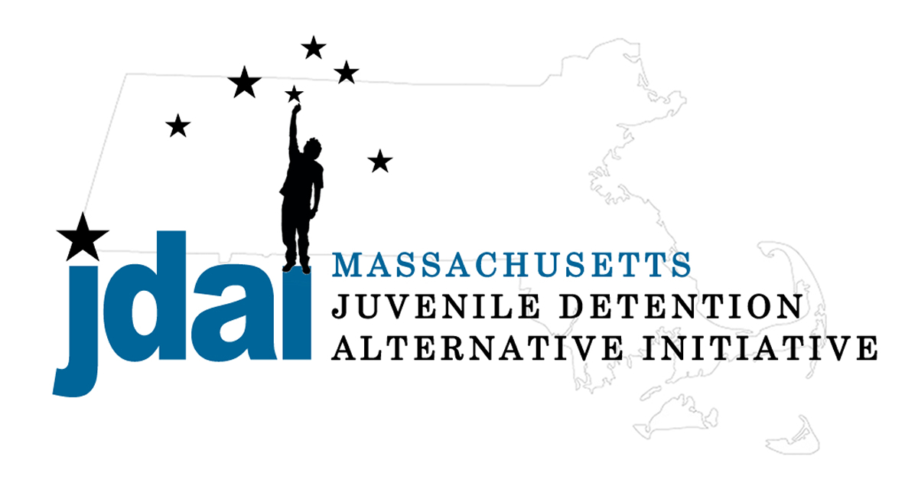

### juvenile Detention Alternative Initiative Massachusetts

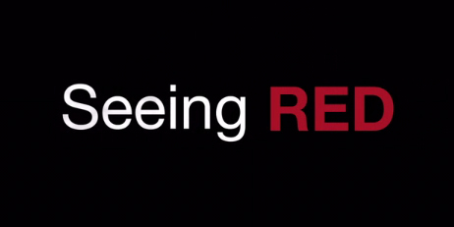

**Join us for a screening of the *Seeing RED*, directed by Casey Hayward, followed by a facilitated conversation of how our communities can respond to increase equity for all young people.**

Film Screening & Discussion

*Seeing Racial and Ethnic Disparities (RED) in the Massachusetts Juvenile Justice System*

We know that nearly all youth, as part of typical adolescent development, engage in some type of delinquency. Unfortunately data reflects that the Massachusetts Juvenile Justice system impacts youth of color more often, and more harshly, at nearly every decision point than is does for white youth in our communities. *Seeing RED* explores this upsetting phenomena, dissects solutions which can be implemented, and challenges everyone to be part of reversing this trajectory which pushes some youth deeper and deeper into our juvenile justice system.

# nt Name]

Say more about your event here.   
Your Event Details:

Location, Time, RSVP information (if desired:) the plans you are making or items attendees not need to provide more information about your event, delete this text.