Massachusetts Department of Environmental Protection
P.V. Attachment For Reporting DMBE/DWBE Activity
 | Grantee/Contractor Requisition Information
Important: When filling out forms on the computer, use only the tab key to move your cursor - do not use the return key.
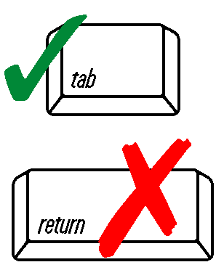
 | Grantee/Contractor Name |  |  |  |  |  |  |  | Vendor Code |  |  |  | Project Number
 | BG9918789  Federal Financial Assistance Agreement I.D. No. |  |  |  |  |  |  |  |  |  |  |  | Contract Number
 | Goals: | 3.4%  DMBE $ |  |  |  | 3.8%  DWBE $ |  |  |  |  |  |  | Invoice Number Invoice Date
 | DMBE/DWBE  Firm Name, Address, Phone # |  |  | MBE | WBE |  | Category |  |  |  |  | Sub-Contract  Amount |  | Previously  Invoiced |  | This  Invoice |  | Balance  Amount
 | Categories:
 | 1 = Construction |  | 2 = Supplies |  |  |  |  | Services: |  |  | 3A= Business Services |  |  |  | 3C= Repair Services |  | 4 = Equipment
 |  |  |  |  |  |  |  |  |  |  | 3B= Professional Services |  |  |  | 3D= Personal Services
 | Name of Grantee/Contractor’s Representative |  |  |  |  |  |  |  |  | Signature of Grantee/Contractor’s Representative/Title |  |  |  |  |  |  | Date (Month, Day, Year)

