

Performance Assessment Methodology Manual for the MassHealth Cambridge Health Alliance Hospital Quality and Equity Incentive Program (CHA-QEIP)
Performance Years 3-5 (Calendar Years 2025-2027)
Version: December 15, 2025

Table of Contents
A. Individual Measure Scoring Approaches 3
B. Performance Assessment Methodology 6
i. RELDSOGI, HRSN, Language Access, Disability Competent Care, Disability Accommodation Needs, and Patient Experience 6
ii. Quality Performance Disparities Reduction and CHA-HQEIP Ambulatory Quality Performance Disparities Reduction 17
iii. Equity Improvement Interventions 21
iv. Equity Improvement Interventions & Community Collaboration Equity Improvement Interventions: Ambulatory 23
v. Achievement of External Standards for Health Equity 24
vi. Collaboration 25
vii. Needs Assessment and Analysis of Served Uninsured Patient Population and Health Equity Strategic Plan Supplement 25
C. Performance Measure, Domain, and Health Equity Scoring 25
i. Measure Scoring 25
ii. Domain Scoring 26
iii. Health Equity Scoring 28
D. Appendix A: Performance Measure Score Point Flowchart 29
E. Appendix B: Scoring Examples 30
Example 1. PY3 – Disability Competent Care: Not Meet Attainment Threshold and Improvement Target 30
Example 2. PY3 – Disability Competent Care: Not Meet Attainment Threshold and Improvement Target 31
Example 3. PY3 – Achievement of External Standards for Health Equity (TJC’s Health Care Equity Certification (HCE) 32
Example 4. PY4 – Health-Related Social Needs (HRSN) Screening 33
F. Appendix C: Quality Performance Disparities Reduction Measure Logic Selection 36
G. Appendix D: Quality Performance Disparities Reduction Measure Scoring Examples 37
Example 1. Statewide SUB-2 Measure Performance 37
Example 2. Statewide & Hospital SUB-2 Measure Performance 38
Example 3. Statewide FUA Measure Performance 40

MassHealth will hold Cambridge Health Alliance accountable for its performance on the Cambridge Health Alliance Hospital Quality and Equity Incentive Program (CHA-HQEIP) performance measures, and will make incentive payments based on such performance. This document describes MassHealth’s CHA-HQEIP Performance Assessment Methodology (PAM) for Performance Years (PY) 3-5.

Individual Measure Scoring Approaches
CHA performance assessment will be based on a point scoring approach for each measure type across the HQEIP’s three domains. The maximum number of points that CHA may attain for each measure is 10 points based on thresholds, goals, and, as applicable, improvement targets. Further, bonus points may be earned for select pay-for-performance measures. Bonus points will be applied to the respective measure domain score.
There are two types of performance status:
- Pay-for-reporting (P4R) measures. P4R measures will be assessed on a complete/incomplete basis for which CHA successfully submits timely, complete, and responsive information based on each measure’s technical specifications will earn 10 points for the measure. CHA submissions that were not timely, complete, and responsive will earn 0 points for the measure. In other words, CHA will receive either 0 or 10 points for P4R measures; MassHealth will not award partial credit for P4R measures.

- Pay-for-performance (P4P) measures. CHA may receive 0-10 points depending on each measure’s performance compared to set performance thresholds, goals, and/or improvement targets for the individual measures. If the measure performance goal is exceeded, bonus points (which are applied to domain score) may be earned for select P4P measures.

Performance thresholds, goals, and improvement targets will be monitored and may be adjusted as needed.
Table 1a and Table 1b, below, list the performance status by measure, for Hospital and Ambulatory components, respectively.

Table 1. PY3-5 CHA-HQEIP Measures & Performance Status: Hospital
Measures | Measure Component(s)/ Submeasures | PY3  2025 | PY4  2026 | PY5  2027
Race, Ethnicity, Language, Disability, Sexual Orientation, & Gender Identity Data Completeness  (MassHealth and Served Uninsured patient populations) | 1. Race  2. Ethnicity  3. Language  4. Disability  5. Sexual Orientation  6. Gender Identity | P4P | P4P | P4P
Screening for Social Drivers of Health and Screen Positive Rate for Social Drivers of Health  (MassHealth and Served Uninsured patient populations) | 1. Screening rate  2. Screen positive rate  a. food insecurity  b. housing instability  c. transportation needs  d. utility difficulties | P4P (Component 1, Inpatient/ Observation Stay)  P4R (Component 1, ED)  P4R (Component 2, Inpatient/ Observation Stay & ED) | P4P (Component 1)  P4R (Component 2) | P4P (Component 1)  P4R (Component 2)
Quality Performance Disparities Reduction | 1. Quality measure 1  2. Quality measure 2 | P4R | P4P | P4P
Equity Improvement Interventions | 1. Performance Improvement Project (PIP) 1  2. PIP 2 | P4P | P4P | P4P
Meaningful Access to Healthcare Services for Persons with a Preferred Language Other than English  (MassHealth and Served Uninsured patient populations) | 1. Self-assessment survey (only PY2 & PY3)  2. Addressing language access needs | P4P (Self-Assessment Survey)  P4P (Inpatient/Observation Stay)  P4R (ED) | P4P | P4P
Disability Competent Care | 1. Staff training rate | P4P | P4P | P4P
Disability Accommodation Needs  (MassHealth and Served Uninsured patient populations) | 1. Accommodation needs screening rate  2. Accommodation needs related to a disability documentation rate | P4P | P4P | P4P
Achievement of External Standards for Health Equity | 1. The Joint Commission Health Care Equity certification | P4P | P4P | P4P
Patient Experience: Communication, Courtesy, and Respect | 1. HCAHPS Questions Related to Nurse Communication (Composite 1)  2. HCAHPS Questions Related to Doctor Communication (Composite 2) | P4P | P4P | P4P
Joint Accountability | 1. Partnered-ACO score | P4P | P4P | P4P

Table 1b. PY3-5 CHA-HQEIP Measures & Performance Status: Ambulatory
Measures | Measure Component(s)/ Submeasures | PY3  2025 | PY4  2026 | PY5  2027
Screening for Social Drivers of Health and Screen Positive Rate for Social Drivers of Health | 1. Screening rate  2. Screen positive rate  a. food insecurity  b. housing instability  c. transportation needs  d. utility difficulties | P4R | P4P (Component 1)  P4R (Component 2) | P4P (Component 1)  P4R (Component 2)
Quality Performance Disparities Reduction | 1. Quality measure 1  2. Quality measure 2 | P4R | P4P | P4P
Needs Assessment and Analysis of Served Uninsured Patient Population | 1. Needs Assessment and Analysis of Served Uninsured Patient Population Report | P4R | P4R | P4R
Equity Improvement Interventions | 1. Equity Improvement Intervention | P4P | P4P | P4P
Community Collaboration Equity Improvement Interventions | 1. Community Collaboration Equity Improvement Intervention | P4P | P4P | P4P
Health Equity Strategic Plan ​Supplement |  | P4R | P4R | P4R

Performance Assessment Methodology
- RELDSOGI, HRSN, Language Access, Disability Competent Care, Disability Accommodation Needs, and Patient Experience

Measure Assessment Overview and Scoring
As stated above, for P4R measures, CHA may achieve 10 points for timely, complete, and responsive submissions, or 0 points for untimely, incomplete, or unresponsive submissions. For P4P measures, CHA’s performance on measures will be assessed based on meeting a minimum attainment threshold and towards meeting a performance goal to determine points. In addition to reaching the performance goal, submissions must be complete, timely, and responsive in order to earn the full 10 points. If the performance goal is not reached, partial credit may be earned (outlined below). Improvement points may also be earned by reaching improvement targets, whether CHA reaches the attainment threshold or not. CHA will earn 0 points if it does not complete the required submission(s).
Hospitals must meet the minimum denominator of at least 30 MassHealth patients in the PY to be eligible for scoring on each measure, submeasure, or setting (when applicable) If Hospitals do not meet the minimum denominator, the weighting of the measure, submeasure, or setting will be redistributed equally to the remaining eligible performance measures, submeasures, or settings in the domain.
For the measures listed in Table 2, three types of benchmarks have been established:
- Attainment Threshold: The attainment threshold represents the minimum level of performance that must be attained on each individual measure to earn between 1-10 points.

- Performance Goal: The performance goal represents the level of performance on each individual measure CHA must attain to score the maximum 10 points.

- Improvement Target: The improvement target represents a specified percentage point improvement for each applicable measure where CHA may earn improvement points. Improvement Targets are established by taking the difference between the attainment threshold and PY5 performance goal divided by number of program years (5 years):
Improvement Target = $\frac{\text{(PY5 Performance Goal – PY3-5 Attainment Threshold)}}{\text{\# of program years}}$.
- The baseline period for all measures except Disability Competent Care is the first full year of complete data in which the hospital also meets the minimum denominator threshold for the measure. The Disability Competent Care measure will use PY2 data as the baseline period. Effective beginning PY3, improvement points may be earned for Disability Competent Care and Patient Experience, if the minimum denominator is met and
- Effective beginning PY4, improvement points may be earned for RELDSOGI, HRSN (Hospital and Ambulatory components), Language Access, and Disability Accommodation Needs, if the minimum denominator is met.
The comparison year for improvement points is initially the baseline year for the measure. If the improvement target is reached, the comparison year then becomes the most recent highest-performing year (the year that the improvement points were earned).
- Interaction of Attainment Threshold, Performance Goal, and Improvement Threshold
In PY3-5, if CHA does not reach performance goal(s), it may earn partial credit by the following opportunities:

- If attainment threshold is met
- attainment points will be earned, which is calculated as: % of PY Performance Goal * 10;
- and if improvement target is also met, 7 improvement points will be earned in addition to attainment points. The maximum number of points a Hospital can earn on a measure is capped at 10 points.
OR
- If attainment threshold is not met, but improvement target is met, 7 improvement points will be earned.
OR
- If attainment threshold and improvement target are not met, partial improvement points proportional to the improvement target may be earned (see Example 1 in Appendix: Scoring Examples).

Partial improvement points may not be earned in PYs 3 or 4 if the attainment threshold is met. However a stepwise approach is used so that if the target is met (e.g., cumulatively over multiple performance periods), the full 7 points are earned in the performance period in which the improvement target is attained.

In PY5 only, if attainment threshold is met, and CHA improves but does not reach the improvement target may earn partial improvement points. These points are proportional to the improvement target, with the maximum points available being the difference between CHA’s measure score and 10. To illustrate the application of partial improvement points in PY5, is see Example 2 in Appendix B: Scoring Examples.
The flowchart in Appendix A illustrates how points may be earned for a performance measure score in PY3-5.
Measure performance rates achieved by CHA will be rounded to the nearest whole number. For example, an ethnicity data completeness rate of 74.3% will be rounded to 74%, and an ethnicity data completeness rate of 74.5% will be rounded to 75%. This rule will apply to all rounding for the HQEIP PAM.

Table 2, below, details the attainment thresholds, performance goals, and improvement targets for select P4P measures. Table 3 summarizes the submeasure or components of each measure, setting weights, and population.

Patient Experience: Communication, Courtesy, and Respect
The patient experience measure utilizes the same attainment threshold, performance goal, and improvement target as above with the following modifications:
  - CHA will be scored based on the higher of their individual performance or aggregate statewide performance on each composite. Doctor and Nurse Communication composites will be calculated using the submitted member level data. CHA must have a minimum denominator of at least 30 MassHealth patients to be scored on an individual basis and to be eligible for improvement points.
  - The improvement target is a 0.01 improvement for each CHA composite score (nurse communication and doctor communication) calculated using submitted member level data.

Composites will be rounded to the nearest hundredth decimal place.

Table 2 and Table 3, below, also include details for the Patient Experience measures.

Table 2. PY3-5 Benchmarks by Measure
Measure | Attainment Threshold | Performance Goal |  | Performance Goal |  | Performance Goal | Improvement Target | Bonus Points | Additional Measure Requirement
 |  | PY3 (2025) | PY4 (2026) |  | PY5 (2027)
Race, Ethnicity, Language, Disability, Sexual Orientation, & Gender Identity Data Completeness¥  (MassHealth and Served Uninsured patient populations) | R: 40%  E: 40%  L: 15%  D: 15%  SO: 15%  GI: 15% | R: 80%  E: 80%  L: 30%  D: 30%  SO: 30%  GI: 30% | R: 80%  E: 80%  L: 50%  D: 50%  SO: 50%  GI: 50% |  | R: 80%  E: 80%  L: 80%  D: 80%  SO: 80%  GI: 80% |  | R: 8%  E: 8%  L: 13%  D: 13%  SO: 13%  GI: 13% | +0.5 point if exceed goals on any 3 of 6 submeasures (Inpatient);  +0.5 point if exceed goals on any 3 of 6 submeasures (ED)  +1 point if exceed goals on all submeasures (Inpatient); +1 point if exceed goals on all submeasures (ED) | CHA must submit and pass mapping and verification tool for PAM to be applied; failure to pass mapping and verification on a data element/ category will result in a 0 score for the applicable sub-measure(s);  In PY5 Update Date and/or Verification Date must be submitted in the Enhanced Demographics Data File for each data element, but will not be used for data completeness calculations
Health-Related Social Needs (HRSN) Screening±  (MassHealth and Served Uninsured patient populations) | Component 1  Inpatient/ Observation Stay: 10%  ED: 10%  Component 2 N/A (P4R) | Component 1  Inpatient/ Observation Stay: 30%  ED: N/A  Component 2 N/A (P4R) | Component 1  Inpatient/ Observation Stay: 45%  ED: 30%  Component 2 N/A (P4R) |  | Component 1  Inpatient/ Observation Stay: 60%  ED: 45%  Component 2 N/A (P4R) |  | Component 1  Inpatient/ Observation Stay: 10% pts.  ED: 7% pts.  Component 2 N/A (P4R) | +0.5 point if exceed PY performance goal (Inpatient/ Observation Stay)  +0.5 point if exceed PY performance goal (ED) | CHA will report Component-2 rates, which will be P4R;  CHA may be required to pass an audit^{Ω} of its data; failure to pass the audit will result in a 0 score for the P4P component of the measure and impact improvement point eligibility in the following year
Health-Related Social Needs (HRSN) Screening: Ambulatory | Component 1  10%  Component 2 N/A (P4R) | Component 1  N/A  Component 2 N/A (P4R) | Component 1  45%  Component 2 N/A (P4R) |  | Component 1  60%  Component 2 N/A (P4R) |  | Component 1  10%  Component 2 N/A (P4R) | +1 point if exceed PY performance goal | CHA will report Component-2 rates, which will be P4R;  CHA may be required to pass an audit^{Ω} of its data; failure to pass the audit will result in a 0 score for the P4P component of the measure and impact improvement point eligibility in the following year
Meaningful Access to Healthcare Services for Persons with a preferred language other than English  (MassHealth and Served Uninsured patient populations) | Inpatient/ Observation Stay: 25%  ED: 25% | Inpatient/ Observation Stay: 50%  ED: N/A | Inpatient/ Observation Stay: 75%  ED: 50% |  | Inpatient/ Observation Stay: 85%  ED: 75% |  | Inpatient/ Observation Stay: 12% pts.  ED: 10% pts. | +0.5 point if exceed PY performance goal (Inpatient/ Observation Stay)  +0.5 point if exceed PY performance goal (ED) | CHA must submit Language Access Self-Assessment Survey€  (PY3: P4P; PY4 & 5: N/A);  CHA may be required to pass an audit^{Ω} of its data; failure to pass the audit will result in a 0 score for the measure and impact improvement point eligibility in the following year (may still be eligible for points on Survey component in PY3)
Disability Competent Care | 25% | 45% | 65% |  | 85% |  | 12% pts. | +1 point if exceed PY performance goal | N/A
Disability Accommodation Needs*  (MassHealth and Served Uninsured patient populations) | Rate 1: 25%  Rate 2: 25% | Rate 1: 45%  Rate 2: 50% | Rate 1: 65%  Rate 2: 75% |  | Rate 1: 85%  Rate 2: 85% |  | Rate 1: 12% pts.  Rate 2: 12% pts. | +0.5 point if exceed PY performance goals for Rate 1 and Rate 2 (Inpatient/Observation Stay)  +0.5 point if exceed PY performance goals for Rate 1 and Rate 2 (Ambulatory Radiology) | CHA may be required to pass an audit of their data; failure to pass the audit^{Ω} will result in a 0 score for the measure and impact improvement point eligibility in the following year
Patient Experience: Communication, Courtesy, and Respect^ | Composite 1: 0.50  Composite 2: 0.50 | Composite 1: 0.84  Composite 2: 0.84 |  | Composite 1: 0.84  Composite 2: 0.84 |  | Composite 1: 0.84  Composite 2: 0.84 | Composite 1: 0.01 pts.  Composite 2: 0.01 pts. | N/A | CHA must also submit MassHealth only patient-level data
¥ R=Race; E=Ethnicity; L=Language; D=Disability; SO=Sexual Orientation; GI=Gender Identity
±Component 1: HRSN screening rate; Component 2: HRSN screen positive rates
€ Scoring details included below
*Rate 1: Screening for accommodation needs; and Rate 2: Accommodation needs documented

^ Performance will be assessed based on statewide rates; if CHA has sufficient denominator (n=25), it may be assessed on the higher of individual or statewide performance and may also earn improvement points
^{Ω} Reference the QEIP User Guide on the Hospital Quality and Equity Incentive Program (HQEIP) webpage under the CQMV Portal Reporting System section for more information on audit

Table 3. Measure Weights for Settings, Submeasures, and/or Population (as applicable)
Measure | PY3 (2025) | PY4 (2026) | PY5 (2027)
Race, Ethnicity, Language, Disability, Sexual Orientation, & Gender Identity Data Completeness | Submeasure weights:  - Race (~16.7%)  - Ethnicity (~16.7%)  - Language [with two equal sub-components of written and spoken – averaged] (~16.7%)  - Disability [with 6 equal sub-components – averaged] (~16.7%)  - Sexual Orientation (~16.7%)  - Gender Identity (~16.7%)  Setting weights:  - Inpatient (50%)  - ED (50%)  Population weights:  - Medicaid (75%)  - Served Uninsured (25%) | Submeasure weights:  - Race (~16.7%)  - Ethnicity (~16.7%)  - Language [with two equal sub-components of written and spoken – averaged] (~16.7%)  - Disability [with 6 equal sub-components – averaged] (~16.7%)  - Sexual Orientation (~16.7%)  - Gender Identity (~16.7%)  Setting weights:  - Inpatient (50%)  - ED (50%)  Population weights:  - Medicaid (75%)  - Served Uninsured (25%) | Submeasure weights:  - Race (~16.7%)  - Ethnicity (~16.7%)  - Language [with two equal sub-components of written and spoken – averaged] (~16.7%)  - Disability [with 6 equal sub-components – averaged] (~16.7%)  - Sexual Orientation (~16.7%)  - Gender Identity (~16.7%)  Setting weights:  - Inpatient (50%)  - ED (50%)  Population weights:  - Medicaid (75%)  - Served Uninsured (25%)
Health-Related Social Needs (HRSN) Screening± | - Component 1 Inpatient/ Observation Stay (50%)  - Component 2 Inpatient/ Observation Stay (25%)  - Components 1 & 2 ED (25%)  Population weights:  - Medicaid (75%)  - Served Uninsured (25%) | Submeasure weights:  Component 1 (75%)  Component 2 (25%)  Setting weights:  - Inpatient/Observation Stay (50%)  - ED (50%)  Population weights:  - Medicaid (75%)  - Served Uninsured (25%) | Submeasure weights:  Component 1 (75%)  Component 2 (25%)  Setting weights:  - Inpatient/Observation Stay (50%)  - ED (50%)  Population weights:  - Medicaid (75%)  - Served Uninsured (25%)
Health-Related Social Needs (HRSN) Screening±: Ambulatory | N/A | Submeasure weights:  Component 1 (75%)  Component 2 (25%)  Setting weights:  N/A  Population weights:  N/A | Submeasure weights:  Component 1 (75%)  Component 2 (25%)  Setting weights:  N/A  Population weights:  N/A
Meaningful Access to Healthcare Services for Persons with a preferred language other than English | - Language Self-Assessment Survey (25%)  - Provision of Interpreter Services Inpatient/Observation Stay (50%)  - Medicaid (75%) and Served Uninsured (25%)  - Provision of Interpreter Services ED (25%)  - Medicaid (75%) and Served Uninsured (25%) | Submeasure weights:  N/A  Setting weights:  - Inpatient/Observation Stay (50%)  - ED (50%) | Submeasure weights:  N/A  Setting weights:  - Inpatient/Observation Stay (50%)  - ED (50%)
Disability Competent Care | N/A | N/A | N/A
Disability Accommodation Needs* | Submeasure weights:  - Rate 1 (50%)  - Rate 2 (50%)  Setting weights:  - Inpatient/Observation Stay (50%)  - Ambulatory Radiology (50%)  Population weights:  - Medicaid (75%)  - Served Uninsured (25%) | Submeasure weights:  - Rate 1 (50%)  - Rate 2 (50%)  Setting weights:  - Inpatient/Observation Stay (50%)  - Ambulatory Radiology (50%)  Population weights:  - Medicaid (75%)  Served Uninsured (25%) | Submeasure weights:  - Rate 1 (50%)  - Rate 2 (50%)  Setting weights:  - Inpatient/Observation Stay (50%)  - Ambulatory Radiology (50%)  Population weights:  - Medicaid (75%)  Served Uninsured (25%)
Patient Experience | Submeasure weights:  - Composite 1 (50%)  - Composite 2 (50%)  Population weights:  N/A | Submeasure weights:  - Composite 1 (50%)  - Composite 2 (50%)  Population weights:  N/A | Submeasure weights:  - Composite 1 (50%)  - Composite 2 (50%)  Population weights:  N/A
±Component 1: HRSN screening rate; Component 2: HRSN screen positive rates
*Rate 1: Screening for accommodation needs; and Rate 2: Accommodation needs documented

Meaningful Access to Healthcare Services for Persons with a Preferred Language other than English: Language Access Self-Assessment Survey (PY3 only)
The responses to the Language Access Self-Assessment Survey for Hospitals (the “Survey”) will be used to determine whether CHA meets the submeasure reporting requirement for PY3. The Survey consists of five domains, and CHA must score the points required in each domain to pass that domain. The following table, Table 4, indicates the points for each Survey question that will be scored in PY3 and the points required to pass each domain. CHA must pass all five domains to receive full credit for this deliverable. However, if CHA does not pass all five domains, it may receive partial credit for passing each domain. For each domain passed, CHA will earn a fifth of the full credit (e.g., if full credit = 10 points, CHA passes only Domain 1, it will receive 2 points).
Table 4. Language Access Self-Assessment Survey Scoring
Domain | Survey Question | Scoring | Points Required to Pass Domain
Domain 1 | A10 | 1 point will be awarded for answering “Yes” to any of the six items in the grid | 2 points
 | A13 | 1 point will be awarded for answering “Yes”
Domain 2 | B3 | 1 point will be awarded for answering “Yes” to any of the seven items in the grid | 4 points
 | B18a | 1 point will be awarded for answering “Yes”
 | B18b | 1 point will be awarded for answering “Yes”
 | B18c | 1 point will be awarded for answering “Yes”
Domain 3 | C1 | 1 point will be awarded for answering “Yes” | 1 point
Domain 4 | D18 | 1 point will be awarded for answering “Yes” | 1 point
Domain 5 | E5 | 1 point will be awarded for answering “Yes” | 1 point

Quality Performance Disparities Reduction and CHA-HQEIP Ambulatory Quality Performance Disparities Reduction

Hospital Component – Medicaid & Served Uninsured Population
For the Medicaid population, CHA will be assessed on the two best performing measures for which they are eligible from the CHA-HQEIP quality measures listed in Table 5. This slate lists measures that have statistically significant race and/or ethnicity gaps for patient populations that met the minimum denominator (n >= 30) at the statewide level during the baseline period. The baseline period is CY2023 for all measures except SUB-2 for which it is CY2024. To be eligible for scoring on the included measures, CHA must meet the minimum denominator of 30 (non-stratified) for the measure. If CHA does not qualify for at least two measures on the slate, CHA will be ineligible for the Medicaid portion of the disparities reduction measure, with associated measure weighting redistributed to the served uninsured component of the measure.

Table 5. Eligible CHA-HQEIP Quality Measures and Statistically Significant Racial/Ethnic Disparities – Medicaid Population
Eligible Measures | Eligible Disparity Gaps  Statewide Statistically Significant Disparities
Cesarean Birth, NTSV (MAT-4) | - Asian (reference group) and African American
AIM Severe Maternal Morbidity (SMM) | - White (reference group) and African American
Follow-up After ED Visit for Substance Use (FUA) – 7 and 30 Day  (7 and 30 day submeasures equally weighted) | - Non-Hispanic (reference group) and Hispanic  - White (reference group) and African American  - White (reference group) and Asian
Follow-up After Hospitalization for Mental Illness (FUH) – 7 and 30 Day  (7 and 30 day submeasures equally weighted) | - White (reference group) and African American  - White (reference group) and Asian
Alcohol Use – Brief Intervention Provided or Offered (SUB-2) | - Non-Hispanic (reference group) and Hispanic  - White (reference group) and African American  - White (reference group) and Asian

CHA will be assessed on performance on the measures above, with the opportunity to be scored on the higher of their individual hospital performance or statewide performance, for all measures except SMM. The SMM measure will be assessed only at the statewide level. To be assessed at the hospital level, the hospital must have sufficient volume (n >= 30) for the measure for the patient populations included in the eligible disparity gap(s) and have a baseline gap of at least 2%.

Birthing hospitals will be assessed on the higher of MAT-4 or SMM and their next highest-performing eligible measure. Note that this second measure may be the other maternal health measure. For example, if SMM is the better performing as compared to MAT-4, then SMM will be the first assessed measure. If MAT-4 is the next best performing measure, it will be the second assessed measure. Non-birthing hospitals eligible for FUH will be scored on FUH and their next highest-performing eligible measure from the slate. Please reference Appendix C for a diagram outlining the measure selection logic.

The disparity gap will be evaluated by comparing the reference group (highest performing group at baseline) to the statistically significantly lower performing racial or ethnic comparison group at baseline. Racial and ethnic disparities will be assessed separately (e.g., SUB-2 Hispanic vs. non-Hispanic, SUB-2 White vs. African American), and each individual disparity for a measure will be assessed separately (e.g., SUB-2 White vs. Asian, White vs. African American). Additionally, for FUA and FUH, there will be equal weighting on the 7-day and 30-day sub-measures.
Table 6 outlines the point scoring for this measure, including the threshold, goal, partial credit, and bonus opportunities. CHA will receive points for their two best statewide eligible measures by assessing the gap closure in absolute or relative percentage points between the reference and comparison group as compared to baseline. Note that the gap closure cannot be at the expense of the higher-performing group at baseline. Percentage points will be rounded to the nearest whole number (e.g., 1.5% rounds to 2%).
Please see Appendix D for scoring examples.

Table 6. Points Scoring for the CHA-HQEIP Quality Performance Disparities Reduction Measure – Medicaid Population
Threshold | Goal | Partial Credit | Bonus Points
All measures:  Statewide or hospital* gap size has not  widened from  baseline = 4 points | All measures except SMM:  2% point absolute  closure of statewide or hospital* baseline  gap = 10 points  SMM:  2% point± relative closure of statewide baseline gap = 10 points | All measures except SMM: >=1% point but <2% point absolute closure of statewide or hospital* baseline gap = 7 points  SMM:  >=1% point but <2% point relative closure of statewide baseline gap = 7 points | +1 point if state or hospital* exceeds performance goal
*CHA must meet have sufficient volume (n >= 30) for the measure for the patient populations included in the eligible disparity gap(s) and have a baseline gap of at least 2%. Does not apply to SMM measure.
±For example, if the baseline gap for SMM is 141 (per 10,000 deliveries), then 2% absolute closure would be 141 x 2% = 2.82 (rounded to 3).

For the served uninsured population, CHA will be assessed on the one best performing measure for which they are eligible from the CHA-HQEIP quality measures listed in Table 7. This slate lists measures that met the minimum denominator (n >= 30) during the baseline period (CY2023).

Table 7. Eligible CHA-HQEIP Measures for Served Uninsured Population – Hospital Component
Domain | Eligible Measures
Care Coordination | TOB-2: Tobacco U/se Treatment Provided or Offered (for CHA medical, surgical, and maternity inpatient units)
Care Coordination | TOB-3: Tobacco Use Treatment Provided or Offered at Discharge (for CHA medical, surgical, and maternity inpatient units)
Care Coordination | NCQA: Follow-up After ED Visit for Mental Illness (7 Day)
Care Coordination | NCQA: Follow-up After ED Visit for Substance Use (7 Day)
Behavioral Health | CMS IPFQR: Follow-up After Psychiatric Hospitalization (7 Day and 30 Day)
Acute & Chronic Conditions | SUB-2: Alcohol Use – Brief Intervention Provided or Offered
Acute & Chronic Conditions | SUB-3: Alcohol & Other Drug Use Disorder – Treatment provided/offered at discharge

The disparity will be evaluated by assessing CHA’s improvement over self for this patient population, when comparing the measure results from the baseline year and the performance year. Table 8 outlines the point scoring for this measure, including the threshold, goal, partial credit, and bonus point opportunity.

Table 8. Points Scoring for the CHA-HQEIP Served Uninsured Quality Performance Disparities Reduction Measure – Hospital Component
Threshold | Goal | Partial Credit | Bonus Points
Measure performance is the same as baseline = 4 points | 2% point absolute  Improvement over baseline = 10 points | >=1% point but <2% point absolute improvement over baseline = 7 points | +1 point if CHA exceeds the performance goal

The hospital component of the disparities reduction measure will be weighted as follows:
- 75% for the Medicaid population
- 25% for the served uninsured population

Ambulatory Component – Served Uninsured Population
For the served uninsured population, CHA will be assessed on the best performing measure in PY4 and the two best performing measures in PY5 for which they are eligible from the CHA-HQEIP quality measures listed in Table 9. This slate lists measures that met the minimum denominator (n >= 30) during the baseline period (CY2023).

Table 9. Eligible CHA-HQEIP Measures for Served Uninsured Population – Ambulatory Component
Domain | Measure ID/Steward | Measure
Wellness, Prevention, and Screening | HEDIS 2022 (W30) NQF 1392, NCQA (adapted to apply to the served uninsured population) | Well-Child Visits in the First 30 Months of Life (Total Rate)
Wellness, Prevention, and Screening | HEDIS 2022 (WCV) NQF 1516, NCQA (adapted to apply to the served uninsured population) | Child and Adolescent Well Care Visit (Total Rate)
Wellness, Prevention, and Screening | NQF 0038, NCQA (adapted to apply to the served uninsured population) | Childhood Immunization - Combo 10
Wellness, Prevention, and Screening | NQF 1407, NCQA (adapted to apply to the served uninsured population)* | Immunization for Adolescents - Combo 2
Wellness, Prevention, and Screening | HEDIS 2022 (adapted to apply to the served uninsured population) | Cancer Screening Measures  - Breast cancer screening (NQF 2372),  - Cervical cancer screening (CCS) (NQF 0032), and  - Colorectal cancer screening (NQF 0034) (COL)
Chronic Health Conditions | HEDIS 2022, NQF 0018, NCQA (adapted to apply to the served uninsured population) | Hypertension: Controlling High Blood Pressure
Chronic Health Conditions | HEDIS 2022, NQF 0059, NCQA (adapted to apply to the served uninsured population) | Comprehensive Diabetes Care: Poor Control (>9%)
Wellness, Prevention, and Screening | CMS measure (Adapted to apply to the served uninsured population) | Depression Screening and Follow-Up

The measure will be evaluated by assessing CHA’s improvement over self for this patient population, when comparing the measure results from the baseline year and the performance year. Table 10 outlines the point scoring for this measure, including the threshold, goal, partial credit, and bonus point opportunity.

Table 10. Points Scoring for the CHA - HQEIP Served Uninsured Quality Performance Disparities Reduction Measure – Ambulatory Component
Threshold | Goal | Partial Credit | Bonus Points
Measure performance is the same as  baseline = 4 points | 2% point absolute  Improvement over baseline = 10 points | >=1% point but <2% point absolute improvement over baseline = 7 points | +1 point if CHA exceeds the performance goal

In PY5, the two scored measures will be equally weighted.

Equity Improvement Interventions
For each Performance Improvement Project (PIP), there are three required reports.
The required reports will be scored as follows:

- The Remeasurement 1 and 2 Reports will be scored as follows:
Planning Section (25%):
  - Project Topic/Equity Statement [Topic/Rationale/ Shared Equity Statement] (15 pts)
  - Aim [Vision, Aim Statement(s), and Goal(s)] (10 pts)
Implementation Section (50%):
  - Methodology (10 pts)
  - Barrier Analysis, Interventions, and Monitoring (update) (10 pts)
  - Interventions (15 pts)
  - Results (15 pts)
Validity and Sustainability (25%)
- Discussion [Discussion and Validity of Reported Improvement] (15 pts)
- Sustainability (10 pts) Only scored in Closure Report
Total = 90 pts
Overall Rating = Actual Weighted Score/ Max Possible Weighted Score

- The Closure Reports will be scored as follows:
Abstract: N/A, not scored
Planning Section (25%):
  - Project Topic/Equity Statement [Topic/Rationale/ Shared Equity Statement] (15 pts)
  - Aim [Vision, Aim Statement(s), and Goal(s)] (10 pts)
Implementation Section (50%):
  - Methodology (10 pts)
  - Barrier Analysis, Interventions, and Monitoring (update) (10 pts)
  - Intervention (15 pts)
  - Results (15 pts)
Validity & Sustainability Section (25%):
  - Discussion [Discussion and Validity of Reported Improvement]​ (15 pts)
  - Next Steps [Sustainability] (10 pts)
Total = 100 pts
Overall Rating = Actual Weighted Score/ Max Possible Weighted Score

Measure Points
- Overall Rating of >= 85% meets the goal score for the report and will earn 10 points.
- An Overall Rating of 50-84% partially meets the goal score for the report and will contribute partially to the eligible weight that the report contributes to the measure score as follows: PIP Overall Rating * 10.
- An Overall Rating of less than 50% does not meet the threshold score for the report and will earn 0 points.

Note: one re-submission is permitted, and the re-submitted report score will be re-scored. The revised report score will be used to calculate the measure score. Report score will be rounded to the nearest whole number.

In PY3 and PY4, two reports are due in each PY, and the two Overall Ratings will equally contribute to the measure score (50% each). In PY5, one report is due for the PY, and the single Overall Rating will constitute the measure score. Table 11 below outlines the measure weighting for the PIP reports.

Table 11. Measure Weighting for PIP Reports by PY
 | PY3 (2025) | PY4 (2026) | PY5 (2027)
PIP1 Reporting | Remeasurement 1 Report | Closure Report | None
PIP2 Reporting | Remeasurement 1 Report | Remeasurement 2 Report | Closure Report
Weighting | PIP1 (50% weight)  PIP2 (50% weight)  e.g., (PIP1 Overall Rating + PIP2 Overall Rating)/2 | PIP1 (50% weight)  PIP2 (50% weight)  e.g., (PIP1 Overall Rating + PIP2 Overall Rating)/2 | PIP2 (100% weight)

Equity Improvement Interventions & Community Collaboration Equity Improvement Interventions: Ambulatory
For each Equity Improvement Intervention (EII), there are three required reports. A total of 10 points may be earned on each report.
- Planning Report
Elements:
  - Aim, Objective, Goals
  - Problem Statement, Scope of Opportunity
  - Approach – Project Summary
  - Barrier analysis and intervention
  - Definition of 1-2 Milestones and 1-2 Year-end Goals

- Mid-Point Report
Mid-year progress summary report narrative
Elements:
  - Summary of implementation and milestones
  - Success and barriers identified
  - Course correction identified as appropriate

- Performance Period-End Report
Year-end progress report narrative
Elements:
  - Achievement of milestone(s) and goal(s)
  - Lessons learned identified

Measure Points
- Total Points of >= 8 points meets the goal score for the report and will earn 10 points.
- A Total Points of 5-7.9 points partially meets the goal score for the report and will contribute partially to the eligible weight that the report contributes to the measure score as follows: EII Report Total Points * 10.
- An Overall Rating of less than 5 points does not meet the threshold score for the report and will earn 0 points.

Note: one re-submission is permitted, and the re-submitted report score will be re-scored. The revised report score will be used to calculate the measure score.
Table 12 below outlines the measure weighting for each EII report.
Table 12. Weighting for EII Reports by PY
 | PY3 (2025) | PY4 (2026) | PY5 (2027)
Planning Report | 40% weight | 40% weight | 40% weight
Mid-Point Report | 30% weight | 30% weight | 30% weight
Performance Period-End Report | 30% weight | 30% weight | 30% weight

Achievement of External Standards for Health Equity
The goal for this measure is for CHA, including additional acute hospital site(s) to achieve The Joint Commission’s (TJC) Health Care Equity Certification (HCE) by the end of PY3 and re-certification by the end of PY5. At minimum (threshold), CHA is to achieve TJC’s HCE by end of PY5. CHA will earn 100% of the points attributed to the measure for certification, maintenance of certification, or re-certification in the PY. If certification is not achieved by end of PY3 (e.g., in PY4 or PY5), CHA may earn partial credit for progress towards initial certification. Table 13 outlines the points scoring for this measure.
Table 13. Points Scoring for Achievement of TJC’s HCE by PY
PY3 (2025) | PY4 (2026) | PY5 (2027)
- Achieve HCE certification = 10 points  OR  - Progress towards HCE certification = 5 points (TJC review conducted)  OR  - Not achieve or make progress towards HCE certification = 0 points  OR  - Maintenance of HCE certification achieved in PY2 = 10 points + 1 bonus point | - Maintain or achieve HCE certification = 10 points  OR  - Progress towards HCE certification = 5 points (TJC review conducted)  OR  - Not achieve or make progress towards HCE certification = 0 points | - Maintain or achieve HCE certification = 10 points  OR  - Progress towards HCE certification = 5 points (TJC review conducted)  OR  - Not achieve or make progress towards HCE certification = 0 points

Collaboration
CHA’s performance on the Collaboration measure for a given Performance Year will equal the Health Equity Score of its Partnered ACO(s) for the same Performance Year. If CHA has more than one ACO Partner, its measure score for a given Performance Year will equal the average of each Partnered ACO’s Health Equity Score for the same Performance Year. Please refer to the PY1-5 ACO Quality and Equity Incentive Program (QEIP) Implementation Plan and associated program documents for more information on ACO Health Equity scoring.
  - CHA with one ACO partner = (ACO partner Health Equity Score) / 10
  - CHA with two ACO partners = [(ACO partner1 Health Equity Score + ACO partner2 Health Equity Score) / 2] / 10

Needs Assessment and Analysis of Served Uninsured Patient Population and Health Equity Strategic Plan Supplement
The Needs Assessment and Analysis of Served Uninsured Patient Population and the Supplement to the Health Equity Strategic Plan are P4R measures and will be assessed on a complete/incomplete basis for which CHA will earn 10 points for the measure if it successfully submits timely, complete, and responsive information based on the deliverable’s instructions. If the submission is not timely, complete, and responsive, CHA will earn 0 points for the measure.

Performance Measure, Domain, and Health Equity Scoring

Measure Scoring
Performance measure scores for each measure will be defined as a ratio between 0-1. The score will be calculated as follows:
Performance Measure Score = Points earned for each measure / Maximum number of points allowable for the measure.

Some performance measures have sub-measures for which sub-measure performance scores will be calculated in the same manner. The sub-measures will be weighted as stated in Table 3, Table 5, and Table 6 to calculate a composite performance measure score between 0-1. For sub-measures the score is calculated as follows:
Performance Measure Score = Sum of each (Sub-measure Score * Sub-measure Weighting).
Some performance measures also encompass implementation in multiple settings (e.g., inpatient and ED).

Domain Scoring
A domain score will be calculated by taking each performance measure score in the domain and calculating the sum of each performance measure score multiplied by its respective measure weight:
Domain Score = Sum of each (Performance Measure Score * Performance Measure Weight*100)
Table 14a and Table 14b specifies measure weight by performance year for the Hospital and Ambulatory components, respectively. If CHA is not eligible for a measure (e.g., does not meet the denominator criteria or minimum volume), the weighting will be redistributed equally to the other eligible performance measures in the domain. Any bonus points earned for a measure will be added to the Domain score and will not exceed the maximum eligible Domain points. For example, Domain score for Domain 1 (DHRSN) will be capped at 25 points as the maximum eligible points for Domain 1 (DHRSN) is 25 points.

Table 14a. PY 3-5 CHA-HQEIP Metric Weights: Hospital
Domain* | Measure Name |  |  |  | Measure Weight (%) by Performance Year | Measure Weight (%) by Performance Year |  |  | Measure Weight (%) by Performance Year | Domain Weight (%)
Domain* | - |  |  |  | PY3  (2025) |  | PY4  (2026) |  | PY5  (2027) | -
DHRSN | Race, Ethnicity, Language, Disability, Sexual Orientation, & Gender Identity Data Completeness |  |  |  | 10 |  | 15 |  | 15 | 25
 | Health-Related Social Needs (HRSN) Screening |  |  |  | 15 |  | 10 |  | 10
EQA | Quality Performance Disparities Reduction |  |  |  | 10 |  | 20 |  | 20 | 50
 | Equity Improvement Interventions |  |  |  | 10 |  | 5 |  | 5
 | Meaningful Access to Healthcare Services for Persons with a preferred language other than English |  |  |  | 10 |  | 10 |  | 10
 | Disability Competent Care |  |  |  | 10 |  | 5 |  | 5
 | Accommodation Needs Met |  |  |  | 10 |  | 10 |  | 10
CC | Achievement of External Standards for Health Equity |  |  |  | 10 |  | 10 |  | 10 | 25
 | Patient Experience: Communication, Courtesy and Respect |  |  |  | 10 |  | 10 |  | 10
 | Collaboration |  |  |  | 5 |  | 5 |  | 5
TOTAL |  |  |  |  |  |  |  |  |  | 100
*DHRSN=Demographic and Health-Related Social Needs Data; EQA=Equitable Quality and Access; CC=Capacity and Collaboration

Table 14b. PY 3-5 CHA-HQEIP Metric Weights: Ambulatory
Domain* | Measure Name |  | Measure Weight (%) by Performance Year |  | Measure Weight (%) by Performance Year |  |  | Measure Weight (%) by Performance Year | Domain Weight (%)
Domain* | - |  | PY3  (2025) |  |  | PY4  (2026) |  | PY5  (2027)
HRSN | Race, Ethnicity, Language, Disability, Sexual Orientation, & Gender Identity Data Completeness |  | 25 |  |  | 25 |  | 25 | 25
EQA | Quality Performance Disparities Reduction |  | 20 |  |  | 20 |  | 20 | 45
 | Needs Assessment and Analysis of Served Uninsured Population |  | 10 |  |  | 10 |  | 10
 | Equity Improvement Interventions |  | 15 |  |  | 15 |  | 15
CC | Community Collaboration Equity Improvement Intervention |  | 20 |  |  | 20 |  | 20 | 30
 | Completion of Served Uninsured Component of Health Equity Strategic Plan Supplement |  | 10 |  |  | 10 |  | 10
- | TOTAL | - |  | - |  |  | - |  | 100

Health Equity Scoring
A health equity score will be calculated by taking each domain score and calculating the sum of each domain score:
Health Equity Score = Sum of each Domain Score
Any bonus points earned through Corrective Action Plans will then be added to determine the final HQEIP Health Equity Score for the PY, not to exceed 100%. The Health Equity score will be rounded to the nearest hundredth. The final Health Equity Score will be used to calculate CHA’s earned incentive payment.

Appendix A: Performance Measure Score Point Flowchart
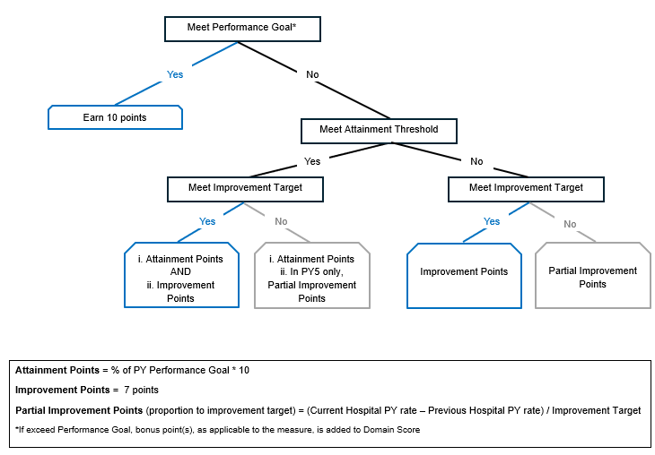

Appendix B: Scoring Examples

Example 1. PY3 – Disability Competent Care: Not Meet Attainment Threshold and Improvement Target
The CHA reported a 15% Training Rate in PY2 and a 20% Training Rate in PY3.
Disability Competent Care Measure Benchmarks:
Attainment Threshold | Performance Goal – PY2 | Performance Goal – PY3 | Improvement Target
25% | 25% | 45% | 12% pts

Steps for Calculating Improvement Points
- Partial improvement = (Current CHA PY rate – Previous CHA PY rate) / Improvement target = (20% - 15%) / 12% = 0.42
- Maximum eligible improvement points = 7.00 points
- Partial improvement points = Eligible improvement * Partial improvement = 7.00 * 0.42 = 2.94 points

Example 2. PY3 – Disability Competent Care: Not Meet Attainment Threshold and Improvement Target
CHA had a 60% Training Rate in PY4 and a 70% Training Rate in PY5.
Disability Competent Care Measure Benchmarks:
Attainment Threshold | Performance Goal – PY4 | Performance Goal – PY5 | Improvement Target
25% | 65% | 85% | 12%

In this example, in PY5, CHA’s Disability Component Care measure would be calculated as follows:
- Earned attainment points = % of Performance Goal * 10 = (70 / 85) * 10 = 8.24 points
- Maximum eligible improvement = Maximum measure points – Earned attainment points = 10.00 – 8.24 = 1.76 points
- Partial improvement (proportion to improvement target) = (Current CHA PY rate – Previous CHA PY rate) / Improvement Target = (70% - 60%) / 12% = 0.83
- Partial improvement points = Maximum eligible improvement * Partial improvement = 1.76 * 0.83 = 1.46 points

Total PY5 Performance Measure Score = Attainment points + Partial improvement points = 8.24 + 1.46 = 9.70 points

Example 3. PY3 – Achievement of External Standards for Health Equity (TJC’s Health Care Equity Certification (HCE)
CHA reported to MassHealth in PY3 that their status is Progress Towards HCE certification.
Steps for Health Equity Scoring
1. Measure Points | Measure points = 5  (Measure type: P4P)  Note: Referencing Table 6 above, Progress towards HCE certification (i.e., TJC review conducted) = 5 points.
2. Performance Measure Score | Performance Measure Score = $\frac{\text{5}}{\text{10}}$= 0.50
3. Domain Score  Domain 3 Measure Weights  - Achievement of Ext Stds. for HE (10%)  - Patient Experience (10%)  - Collaboration (5%) | - Achievement of Ext Stds. for HE = (0.5 * 0.1) * 100 = 5.00  - Patient Experience = (1 * 0.1) * 100 = 10.00  - Collaboration = (0.8 * 0.05) * 100 = 4.00  Domain 3 Score = 10 + 5 + 4 = 19.00
4. Health Equity Score | - Domain 1 Score = 20.00  - Domain 2 Score = 46.00  - Domain 3 Score = 19.00  Health Equity Score = 20 + 46 + 19 = 85.00

Example 4. PY4 – Health-Related Social Needs (HRSN) Screening
CHA reported to MassHealth in PY3 and PY4:
Setting | Component 1 - PY3 | Component 2 - PY3 | Component 1 - PY4 | Component 2 – PY4
Inpatient/Observation Stay – Medicaid | 41% | Data submitted | 50% | Data submitted
Inpatient/Observation Stay – Served Uninsured | 46% | Data submitted | 62% | Data submitted
ED – Medicaid | 19% | Data submitted | 24% | Data submitted
ED – Served Uninsured | 22% | Data submitted | 30% | Data submitted
Benchmarks & Setting Weights:
Component | Attainment Threshold | Performance Goal - PY4 |  | Improvement Target |  | Bonus Point |  |  | Setting Weight
Component 1± | Inpatient & Observation Stay: 10%  ED: 10% | Inpatient & Observation Stay: 45%  ED: 30% |  | Inpatient & Observation Stay: 10% pts  ED: 7% pts |  | +0.5 point if exceed PY performance goal (Inpatient/Observation Stay); +0.5 point if exceed PY performance goal (ED) |  |  | Inpatient & Observation Stay (50%)  ED (50%)
Component 2* |  |  |  |  | N/A — P4R
±Component 1: HRSN screening rate
*Component 2: HRSN screen positive rates

Steps for Health Equity Scoring
1. Measure Points | Inpatient/Observation Stay – Medicaid  Component 1  - Exceeded Performance Goal in PY4  - Submeasure Score = 10.00 points  - 10 points for reaching Performance Goal  - 0.5 bonus point for exceeding Performance Goal (bonus point added during domain scoring) [applied in Step #3]  Component 2  - Submeasure Score = 10.00 points  ED  Component 1  - Not reach Performance Goal in PY4  - Meet Attainment Threshold of 10% in PY4  - Attainment Points = (24 / 30) * 10 = 8.00 points  - Not reach Improvement Target [difference between PY4 & PY3 Rate 1]  - (24% - 19% = 5% points < 7% points)  - Submeasure Score = 8.00 points  Component 2  - Submeasure Score = 10.00 points  Component Weight  Inpatient/Observation Stay à (10.00*0.75) + (10.00*0.25) = 10.00 points  ED à (8.00*0.75) + (10.00*0.25) = 8.50 points  Setting Weight (50% each)  (10.00*0.5) + (8.50*0.5) = 5.00 + 4.25 = 9.25 points  Sub-measure points = 9.25 points | Inpatient/Observation Stay – Served Uninsured  Component 1  - Exceeded Performance Goal in PY4  - Submeasure Score = 10.00 points  - 10 points for reaching Performance Goal  - 0.5 bonus point for exceeding Performance Goal (bonus point added during domain scoring) [applied in Step #3]  Component 2  - Submeasure Score = 10.00 points  ED  Component 1  - Met Performance Goal in PY4  - Meet Attainment Threshold of 10% in PY4  - Submeasure Score = 10.00 points  - 10 points for reaching Performance Goal  Component 2  Submeasure Score = 10.00 points  Component Weight  Inpatient/Observation Stay à (10.00*0.75) + (10.00*0.25) = 10.00 points  ED à (10.00*0.75) + (10.00*0.25) = 10.00 points  Setting Weight (50% each)  (10.00*0.5) + (10.00*0.5) = 5.00 + 5.00 = 10.00 points  Sub-measure points = 10.00 points
Population Weight
(9.25*0.75) + (10.00*0.25) = 9.44 points

Measure points = 9.44 points
2. Performance Measure Score | Performance Measure Score = $\frac{\text{9.44}}{\text{10}}$= 0.94
3. Domain Score  Domain 1 Measure Weights  - RELD SOGI Data Completeness (15%)  - HRSN Screening (10%) | RELD SOGI Data Completeness = (0.87 * 0.15) * 100 = 13.05  [Performance Measure Score = 0.87]  HRSN Screening = (0.94 * 0.1) * 100 = 9.40  Domain 1 Score = 13.05 + 9.40 + 0.5 bonus point + 0.5 bonus point = 23.45
4. Health Equity Score | Domain 1 Score = 23.45  Domain 2 Score = 46.28  Domain 3 Score = 19.37  Health Equity Score = 23.45 + 46.28 + 19.37 = 89.10

Appendix C: Quality Performance Disparities Reduction Measure Logic Selection

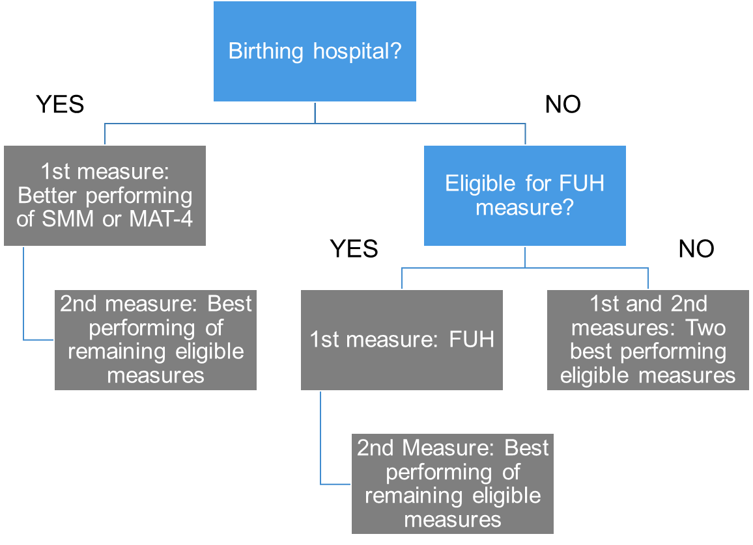

Appendix D: Quality Performance Disparities Reduction Measure Scoring Examples

Example 1. Statewide SUB-2 Measure Performance
In the baseline period (CY2024), a significant disparity was observed between the White patient population (reference group) and African American patient population (comparison group).
The statewide goal is 2% point absolute closure of the statewide baseline gap (full credit or 10 points earned) with a +1 bonus point opportunity if state exceeds performance goal.
 | SUB-2  CY2024  (Baseline Period) | SUB-2  CY2026  (Performance Period)
White (reference group) | 41% | 42%
African American (comparison group) | 22% | 28%
Gap | 19% points | 14% points

Statewide

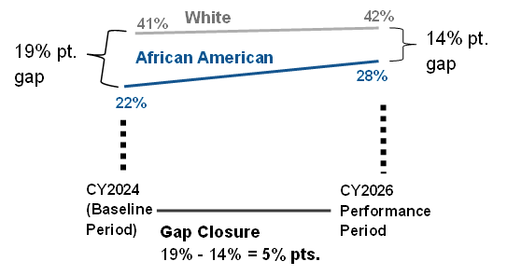
Determination of Measure Score
1. Met the statewide goal of 2% point gap closure? Yes à eligible for full points
2. Did the state exceed the performance goal? Yes, gap closed by 5% points à eligible for bonus point
Full Credit (achieving goal) + Bonus = 10 points + 1 point = 11 points

Example 2. Statewide & Hospital SUB-2 Measure Performance
In the baseline period (CY2024), a significant disparity was observed between the White patient population (reference group) and African American patient population (comparison group).
Partial credit of 7 points may be earned if there is a >=1% point but <2% point absolute closure of the statewide or hospital baseline gap if the Hospital.
Statewide Performance | SUB-2  CY2024  (Baseline Period) | SUB-2  CY2026  (Performance Period)
White (reference group) | 41% | 42%
African American (comparison group) | 22% | 24%
Gap | 19% points | 18% points

Hospital Performance | SUB-2  CY2024  (Baseline Period) | SUB-2  CY2026  (Performance Period)
White (reference group) | 22% | 23%
African American (comparison group) | 21.3% | 22.7%
Gap | N/A (no disparities gap to close) | N/A (no disparities gap to close)
White (reference group) | 22% | 23%
Asian (comparison group) | 9% | 13%
Gap | 13% points | 11% points

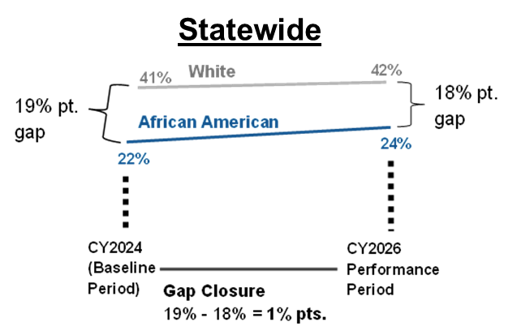
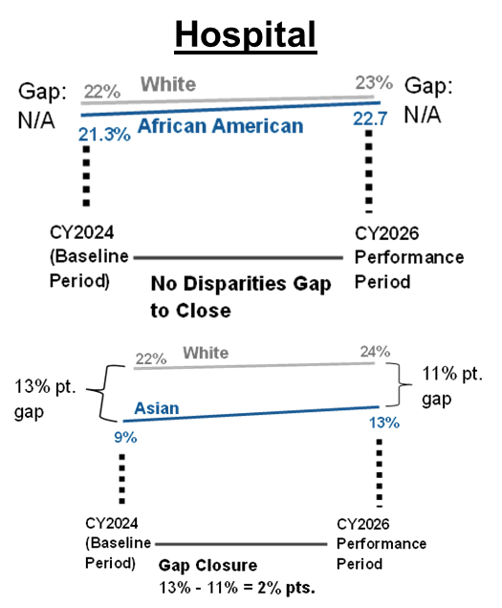

Measure Score
1. Met the statewide goal of 2% point gap closure? No
2. Did the state exceed the performance goal? No
3. Did the state partially close the gap between >=1% point to 2% point? Yes, gap closed by 1% points à eligible for partial credit
4. Did the hospital achieve the performance goal compared to own baseline for the same statewide disparity gap? No. While the Hospital closed the gap between White and Asian by 2% points, the Hospital did not close the gap for the same subgroup as the statewide disparity (i.e., White and African-American) à not eligible for full credit
Partial Credit = 7 points

Example 3. Statewide FUA Measure Performance
In the baseline period (CY2023), a significant disparity was observed between the White patient population (reference group) and Asian patient population (comparison group).
The statewide goal is 2% point absolute closure of the statewide baseline gap (full credit or 10 points earned) with a +1 bonus point opportunity if the state exceeds performance goal.
Partial credit of 7 points may be earned if there is a >=1% point but <2% point absolute closure of the statewide baseline gap.
Statewide Performance | FUA  CY2023  (Baseline Period) | FUA  CY2026  (Performance Period)
Non-Hispanic (reference group) 7-Day | 37% | 38%
Hispanic (comparison group) 7-Day | 29% | 31%
Gap 7-Day | 8% points | 7% points
Non-Hispanic (reference group) 30-Day | 50% | 52%
Hispanic (comparison group) 30-Day | 41% | 46%
Gap 30-Day | 9% points | 6% points

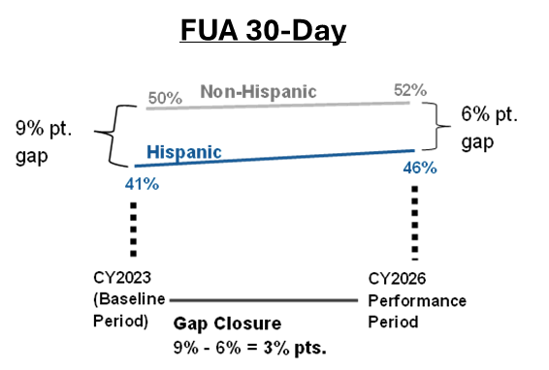
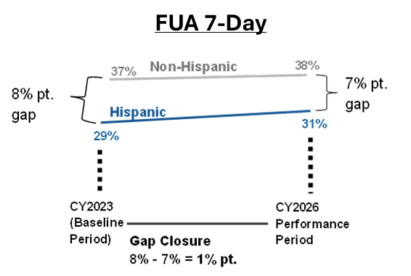

Determination of Measure Score: FUA 7- Day | Determination of Measure Score: FUA 30- Day
1. Met the statewide goal of 2% point gap closure? No  2. Did the state exceed the performance goal? N/A  3. Did the state partially close the gap between >=1% point to 2% point? Yes, gap closed by 1% points à eligible for partial credit | 1. Met the statewide goal of 2% point gap closure? Yes à eligible for full points  2. Did the state exceed the performance goal? Yes, gap closed by 5% points à eligible for bonus point
Partial Credit = 7 points | Full Credit (achieving goal) + Bonus =  10 points + 1 point = 11 points
To calculate the final measure for FUA, the two submeasures (i.e., 7-Day and 30-Day) will be equally weighed.
Final Measure Score for FUA = (7 * 0.5) + (11 * 0.5) = 9 points

