Water Damage Investigation

Joseph G. Pyne Arts Magnet School
145 Boylston St.
Lowell, MA 01852

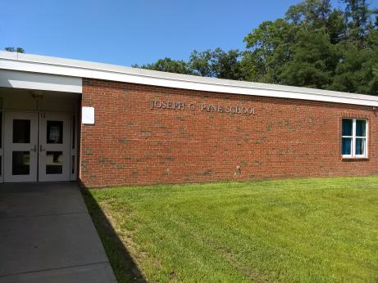

Prepared by:
Massachusetts Department of Public Health
Bureau of Environmental Health
Indoor Air Quality Program
August 2018

Background
Building: | Joseph G. Pyne Arts Magnet School (Pyne Arts)
Address: | 145 Boylston St.  Lowell, MA
Assessment Requested by: | Rick Underwood, Director of Operations,  Lowell Public Schools
Reason for Request: | Water damage/mold concerns on items in particular classrooms (015-018, 1164, 1161 and storeroom 004).
Date of Assessment: | August 23, 2018
Massachusetts Department of Public Health/Bureau of Environmental Health (MDPH/BEH) Staff Conducting Assessment: | Ruth Alfasso, Environmental Engineer/Inspector, IAQ Program
Date of Building Construction: | 1960s with significant renovations and an addition in the early 2000s
Building Description: | Pyne Arts is a two-story brick structure with basement section. It has a multi-level flat roof.
Windows: | Openable

Methods
BEH/IAQ staff conducted a visual assessment of suspect classroom items for water damage and possible mold colonization. Please refer to the IAQ Manual and appendices for methods, sampling procedures, and interpretation of results (MDPH, 2015).

Results and Discussion
A heating, ventilating, and air conditioning (HVAC) system has several functions. First it provides heating and, if equipped, cooling. Second, it is a source of fresh air. Finally, an HVAC system will dilute and remove normally occurring indoor environmental pollutants by not only introducing fresh air, but also filtering the airstream and ejecting stale air to the outdoors via exhaust ventilation. The act of cooling/providing air conditioning is two-fold; the system chills the air via cooling coils while also typically removing moisture from the air.
Moisture removal is important since the sensation of heat conditions increases as relative humidity (RH) increases (the relationship between temperature and RH is called the heat index). As indoor temperatures rise, the addition of more RH will make occupants feel hotter. If moisture is removed, the comfort of the individuals is improved. Note that although this school is equipped with air conditioning, school staff indicated that air conditioning had been in disrepair during the summer and was not functioning well if at all on the day of the assessment. Without the dehumidification from air conditioning, conditions of elevated relative humidity were more likely to occur and persist indoors. While temperature is mainly a comfort issue, RH in excess of 70 percent for extended periods of time can provide an environment for mold and fungal growth (ASHRAE, 1989).
School staff indicated that mold growth was observed in several classrooms during the process of setting up for the new school year. Cleaning and treatment with an antimicrobial solution had reportedly already been conducted in areas with visible mold growth. Other conditions relating to water damage, including water-damaged ceiling tiles and gaps in sink backsplashes were also observed:

- Storage room 004: This room reportedly had mold growth on the back wall which had since been cleaned. Some non-mold-associated staining was visible (Picture 1). Note that this room was used to store a variety of materials, including boxes on the floor (Picture 2). It is recommended that items in below-grade spaces be placed on shelving rather than in direct contact with the floor which may be subject to condensation. Additionally an air gap should be allowed between the rear of shelves and walls to prevent stored materials from being exposed to condensation.
- Classrooms 015- 018: Microbial growth had reportedly been cleaned from walls in these classrooms. In some areas, affected walls were partially covered by cabinets, bulletin boards and white boards which could not be moved to check for microbial growth (Pictures 3 and 4). Two upholstered chairs were observed in room 017. They had reportedly been cleaned of mold, however it is difficult to remove all mold from fabric and foam materials and they should be discarded. The surfaces of univents had also reportedly been cleaned of mold. Univents have non-porous surfaces that can be cleaned of mold, however debris was noted inside the grill of univents (Picture 5) which may also have been colonized with mold. Univent cabinets should be opened, inspected and cleaned. A water-damaged ceiling tile was observed in room 017 (Picture 6). The dark staining may indicate it is colonized with mold. Area rugs in these classrooms were examined and one appeared to be water-damaged/ mold-colonized (Picture 7). This carpet should be discarded.
- Classrooms 1164 and 1161: Water-damaged ceiling tiles were observed in both of these classrooms, which reportedly was from leaks from the HVAC system with some tiles having a dark color which may indicate mold colonization. Exterior and adjoining walls in these classrooms were reportedly cleaned of mold. No microbial growth on these walls was observed at the time of the visit. One area rug had been dripped on by the antimicrobial cleaning solution and was stained with white spots and damp to the touch (Picture 8). This carpet should be cleaned and ensured to be thoroughly dry before use.
- Third Grade Hallway: Multiple water-damaged ceiling tiles, reportedly from roof leaks, were observed in this hallway (Picture 8). These tiles should be replaced when the roof is repaired.

The exterior of the building was examined for sources of moisture infiltration. Plants and trees were observed overhanging the roof, close to the foundation and on walls (Pictures 9 and 10). These can hold moisture against the bricks and prevent drying and drainage. In addition, some plants were directly in front of univent intakes which can become a source of moisture, pollen, mold and debris into the univent.
Symptoms commonly associated with molds include allergic reactions and respiratory irritation. Some people with chronic respiratory conditions, such as asthma, are more likely to experience health symptoms. Controlling moisture is the key to preventing mold growth and potential health symptoms.

Other Conditions
Other conditions that can affect IAQ were observed during the assessment. An exhaust vent in a classroom restroom was examined and found not to be drawing air. Exhaust vents are necessary to remove odors and moisture from areas like restrooms.
In the classrooms examined, tennis balls had been sliced open and placed on table/chair footings to reduce noise (Picture 11). Tennis balls are made of a number of materials that are a source of respiratory irritants. Constant wearing of tennis balls can produce fibers and lead to off-gassing of VOCs. Tennis balls are made with a natural rubber latex bladder, which becomes abraded when used as a chair leg pad. Use of tennis balls in this manner may introduce latex dust into the school environment. Some individuals are highly allergic to latex (e.g., spina bifida patients) (SBAA, 2001). It is recommended that the use of materials containing latex be limited in buildings to reduce the likelihood of symptoms in sensitive individuals (NIOSH, 1997; NIOSH, 1998). Tennis balls also provide a porous surface in contact with the floor that may be moistened and lead to microbial growth.
The Institute of Inspection, Cleaning, and Restoration Certification (IICRC) recommends that carpeting be cleaned annually (or semi-annually in soiled high traffic areas) (IICRC, 2012). Regular cleaning with a high efficiency particulate air (HEPA) filtered vacuum in combination with an annual cleaning will help to reduce accumulation and potential aerosolization of materials from carpeting.
Supply and exhaust vents were notes to be dusty in some areas. These should be cleaned periodically to prevent the buildup of dust that can be reaerosolized or come mold-colonized when exposed to high humidity or condensation.

Conclusions and Recommendations
In view of the findings at the time of the visit, the following recommendations are made:
- Change all water-damaged ceiling tiles. Check area above ceiling tile system for additional water damage and repair as needed.
- Discard any additional porous items found to be colonized with mold (e.g., chairs, cardboard, area rugs).
- Clean the inside of univent cabinets in areas that had been subject to mold growth including removing debris from vents. Univent cabinets should be cleaned of debris during each filter change.
- Consider using dehumidifiers in areas prone to excessive moisture/condensation. Maintain these in accordance with manufacturer’s instructions, including drainage and cleaning.
- Ensure that procedures are in place and encourage occupants to report HVAC/maintenance issues so that they can be logged and repaired promptly.
- Monitor areas where mold growth had been noted for any reoccurrence, particularly in areas where furniture and bulletin boards/white boards made portions of the walls inaccessible for cleaning. If odors or other signs of ongoing mold colonization exist, items against the walls need to be removed for additional cleaning and repair.
- For more information about mold/remediation consult Mold Remediation in Schools and Commercial Buildings” published by the US Environmental Protection Agency (US EPA, 2008).
- Clean supply/return and exhaust vents periodically of accumulated dust/debris.
- Clean carpeting and area rugs annually or semi-annually in soiled high traffic areas as per the recommendations of the Institute of Inspection, Cleaning and Restoration Certification (IICRC, 2012). Ensure the carpeting shown in Picture 8 has been cleaned of any remaining anti-microbial solution and dried before use.
- Trim plants, shrubs and trees away from the foundation, particularly near univents. Avoid watering plants in this area to prevent water infiltration.
- Ensure all exhaust vents are operating during occupied hours.
- Consider replacing tennis balls on chair legs with latex-free glides.
- Refer to resource manual and other related indoor air quality documents located on the MDPH’s website for further building-wide evaluations and advice on maintaining public buildings. These documents are available at http://mass.gov/dph/iaq.

REFERENCES
ASHRAE. 1989. Ventilation for Acceptable Indoor Air Quality. American Society of Heating, Refrigeration and Air Conditioning Engineers. ANSI/ASHRAE 62-1989.
IICRC. 2012. Carpet Cleaning FAQ 4 Institute of Inspection, Cleaning and Restoration Certification. Institute of Inspection Cleaning and Restoration, Vancouver, WA.
MDPH. 2015. Massachusetts Department of Public Health. Indoor Air Quality Manual: Chapters I-III. Available at: http://www.mass.gov/eohhs/gov/departments/dph/programs/environmental-health/exposure-topics/iaq/iaq-manual/.
NIOSH. 1997. National Institute for Occupational Safety and Health. Alert Preventing Allergic Reactions to Natural Rubber latex in the Workplace. National Institute for Occupational Safety and Health, Atlanta, GA.
NIOSH. 1998. National Institute for Occupational Safety and Health. Latex Allergy A Prevention. National Institute for Occupational Safety and Health, Atlanta, GA.
SBAA. 2001. Latex In the Home And Community Updated Spring 2001. Spina Bifida Association of America, Washington, DC.
US EPA. 2008. Mold Remediation in Schools and Commercial Buildings. US Environmental Protection Agency, Office of Air and Radiation, Indoor Environments Division, Washington, D.C. EPA 402-K-01-001. http://www.epa.gov/mold/mold-remediation-schools-and-commercial-buildings-guide.

Picture 1
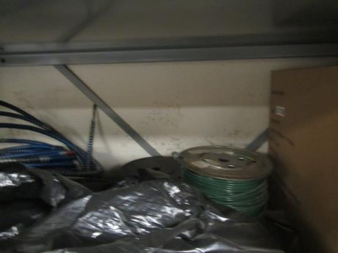
Stained wall in storeroom, note boxes up against wall
Picture 2
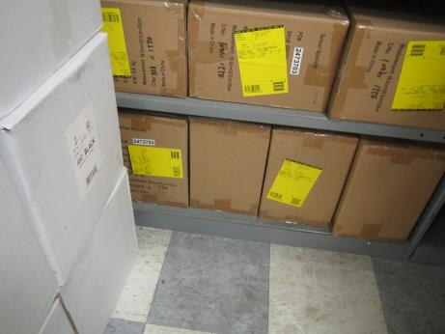
Boxes on floor in storeroom
Picture 3
Bulletin board/white board bolted to wall which had been cleaned of microbial growth
Picture 4
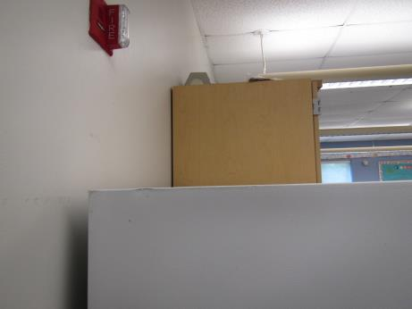
Cabinet attached to wall with reported microbial growth
Picture 5
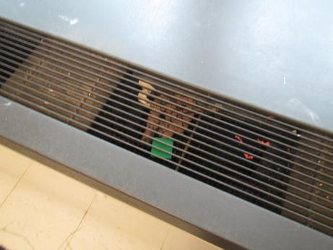
Univent grill with debris
Picture 6
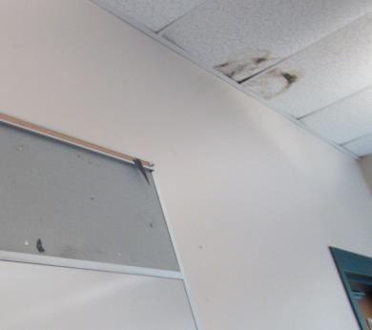
Water-damaged ceiling tile in room 017 which may be mold-colonized
Picture 7
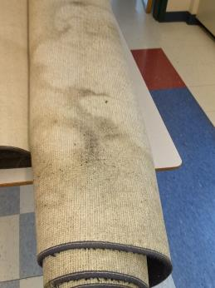
Potentially water-damaged/mold colonized or soiled carpet
Picture 8
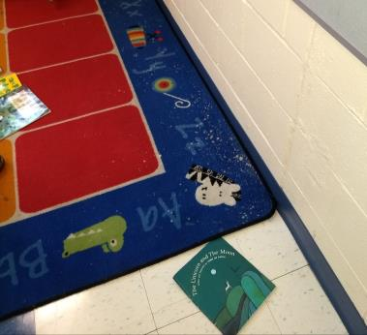
White spots on carpeting where antimicrobial cleaner dripped on it; carpet was damp
Picture 9
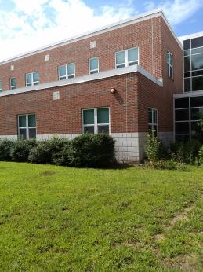
Plants and shrubs against the foundation
Picture 10
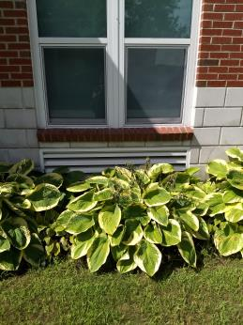
Plants in front of univent intake
Picture 11
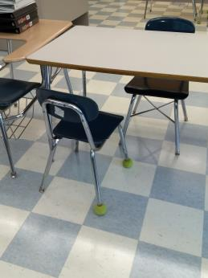
Tennis balls used as chair glides

