APPENDIX A
Medication Benchmarks
Please read this before reviewing medication error benchmark data

Use CAUTION when comparing data
The literature regarding medication errors in health care settings can be relatively confusing and the research findings are not always directly comparable to one another and especially to the DDS data obtained from its MOR system. For example, hospital and health care error reporting is often much more extensive and includes a large number of potential types of error, including:
- Prescription errors
- Dispensing errors
- Administration errors
- Monitoring errors
- Clerical errors
- Potential errors (detected and stopped)
- Compliance errors
This is in contrast to the MOR system which captures only “administration” errors. Therefore, it is important to carefully review the methods used to develop medication error data. Data that includes all of the different types of errors listed above, could be expected to show a much higher error rate than data that only included one of the categories above (such as the DDS MOR). A direct comparison could therefore be very misleading.
Another major concern with using medication error (or occurrence) rates for benchmarking purposes relates to the validity of the data. As noted by the Institute for Safe Medication Practices/Canada (ISMP, 2001), “The number of medication errors will vary, depending very much on the vigor with which errors are identified and reported.” For example, a “high” error rate in an organization could mean that they engage in unsafe medication practices – or, it could simply reflect a propensity within that organization for very prompt and accurate reporting. The same holds true for organizations with a “low” error rate: it either means they have very safe practices or they have an organizational culture that may be punitive and therefore discourages staff from reporting errors. Some research in fact does indicate that medication error rates captured by incident reports are the least effective and least reliable determinants of the true error rate. (Barker, 2000). For this reason use of MOR or other self report incident data to directly compare one organization to another must be executed with extreme caution and with an understanding that the organization’s reporting “culture,” practice and methods can have a very large impact on the number of reported incidents.
Safe Medication Use
Medication Benchmarks
continued
A third important consideration has to do with the methods used to collect data. Some of the medication error data is derived from direct observation. This type of study usually provides much more “valid” and “reliable” data. It may provide higher incident rates than self reporting. However, the findings from a relatively limited observational period of time must be extrapolated to a time standard such as month or year. If for some reason the sampled time period was not representative of the entire month or year, the data may not accurately reflect “usual” behavior.
There are “issues” and potential problems with all the different approaches to data collection for incidents such as medication errors or occurrences. It is important to keep this in mind when looking at benchmarks and comparing the findings of one study or report to those of another. Use caution when looking at benchmarks.
Some Medication Occurrence Benchmarks for Consideration
Hospital Nurses: 15% Error Rate
Using a direct observation method at two hospitals in the U.S., Greengold, et al (2003) found a combined medication error rate of 15.7% for dedicated “medication nurses” and 14.9% for general nurses. The researchers suggest that most medication errors are related to system design issues. This suggests that nursing staff in hospitals may commit an error in administering medications 15% of the time. This is substantially higher than the MOR rates reported by DDS supported programs.

3% of Hospital Medication Errors cause Patient Harm
Research by the U.S. Pharmacopeia (1999) suggests that approximately 3% of all hospital medication errors result in patient harm. In DDS, data for FY2008 suggest that about 1.2% of all medication occurrences resulted in “harm” - if all MOR “hotlines” are similarly categorized. If, however, only those “hotlines” that resulted in a hospital visit are categorized as “causing harm,” only about 0.09% of all MORs resulted in harm.

Safe Medication Use
Medication Benchmarks continued
5% of Hospital Patients experience a Medication Error
Bond, et al. (2001) studied reported medication errors in over 1,000 U.S. hospitals and over 900 facilities that reported errors that had an adverse outcome for the patient. They found that medication errors occurred in 5.07% of the patients admitted to these hospitals each year, equivalent to one error every 22.7 hours (total of over 430,500 errors in a year). These researchers also found that medication errors that adversely affected patient care outcomes took place in 0.25% of all patients admitted to the hospital. Each hospital experienced a medication error that adversely affected patient care outcomes every 19.23 days.

16% to 22% of Medication Doses have an Error
Research using direct observation of nursing staff in 36 hospitals/SNFs suggests a rather high rate of error when administering medications (Barker, et al., 2002) compared to the self reported occurrence rate within DDS programs. The table below illustrates this comparison. However, please note the different data collection methods that are used. Direct observation may yield much higher error rates than self report.
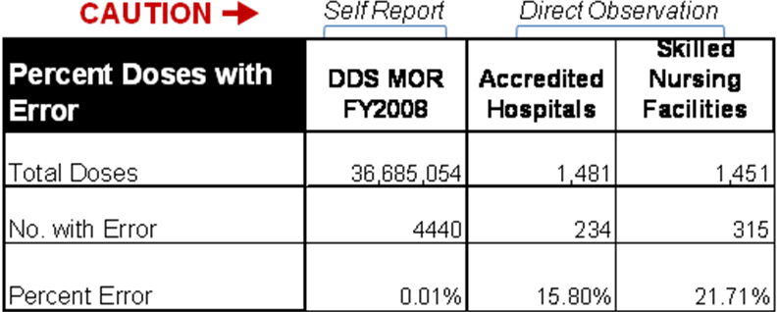

DDS and Health Care: Similar Patterns by Type of Error
Barker, et al. (2002) report on one of the few studies that looked at medication errors by doses of medication, similar to the DDS MOR process. As can be seen in the Table below, DDS programs appear to have a much higher percentage of errors due to omission (not administering the drug at all) compared to hospitals and SNFs, which in turn, have a much higher rate of administering the medications at the wrong time (usually later than ordered).
Safe Medication Use
Medication Benchmarks
continued
DDS and Health Care: Similar Patterns by Type of Error (continued)
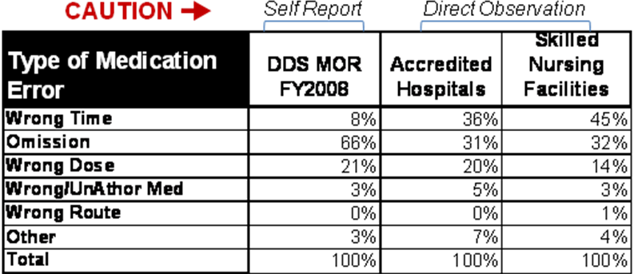
It must noted, however, that the Barker study used direct observation of medications being administered in health care facilities as opposed to the self reporting methodology used by DDS. [Caution: this difference in how the data was collected could significantly compromise the comparisons.] Nonetheless, a review of medication errors by cause or type reveals substantial similarity between DDS and both accredited hospitals and skilled nursing facilities with the exception of the “omission to wrong time” reversal.

REFERENCES
Barker, K. (2000) "Comparison of Methods for Detecting Medication Errors in 36 Hospitals and Skilled-nursing Facilities". Presented at ASHP Midyear Clinical Meeting, Las Vegas, December 2000.
Baker, KN, Flynn, EA, Pepper, GA, Bates, DW and Mikeal, RL. (2002) Medication errors observed in 36 health care facilities. Arch Intern Med; 162:1897-1903.
Bond CA, Raehl CL, Franke T. (2001) Medication errors in United States Hospitals. Pharmacotherapy 9:1023-1036.
Greengold, NL, Shane, R, Schneider, P, Flynn, E, Elashoff, J, Hoying, CL, Barker, K and Bolton, LB. (2003) The impact of dedicated medication nurses on the medication administration error rate: a randomized controlled trial. Arch Intern Med 163(19), 2359-2367.
ISMP (2001) Benchmarking medication error rates. Safe Medication Practices - March 2001. Institute for Safe Medication Practices-Canada. Accessed at: http://www.ismp-canada.org/smp0103.htm, April 2009.
U.S. Pharmacopeia (1999) Summary of the 1999 information submitted to MedMAR, a national database for hospital medication error reporting. Available from www.usp.org/medmarx.

