Background

INDOOR AIR QUALITY
WATER DAMAGE REASSESSMENT

Quaboag Regional Middle/High School
284 Old West Brookfield Road
Warren, Massachusetts

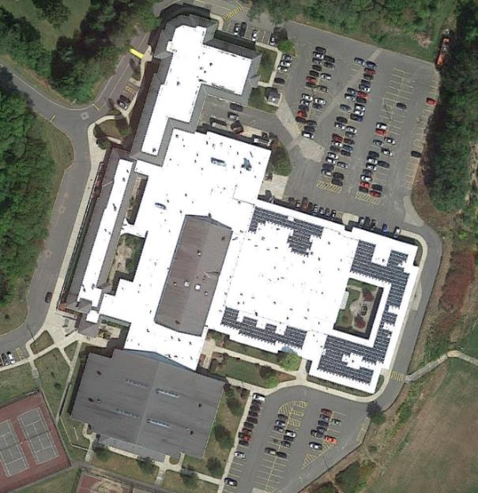

Prepared by:
Massachusetts Department of Public Health
Bureau of Environmental Health
Indoor Air Quality Program
February 2019
Building: | Quaboag Regional Middle/ High School (QRMHS)
Address: | 284 Old West Brookfield Road, Warren, Massachusetts
Requestor: | Brett Kustigian, Superintendent, Quaboag Regional Schools
Date of Pre-Occupancy Assessment: | February 8, 2019
Massachusetts Department of Public Health/Bureau of Environmental Health (MDPH/BEH) Staff Conducting Assessment: | Mike Feeney, Director, Indoor Air Quality (IAQ) Program
Date of Building Construction: | 1969 with an addition in 2001

INTRODUCTION
The IAQ program has previously visited the QRHS in 2018 to conduct a full IAQ assessment of the building. A report on that visit can be found at: https://www.mass.gov/info-details/indoor-air-quality-reports-cities-and-towns-w
The IAQ Program returned to spot check areas where water damage was likely the result of hot, humid weather during the summer of 2018.

METHODS
Please refer to the IAQ Manual for methods, sampling procedures, and interpretation of results (MDPH, 2015).

RESULTS and DISCUSSION
The following is a summary of indoor air testing results (Table 1).
- Carbon dioxide levels were above the MDPH guideline of 800 parts per million (ppm) in high volume locations (e.g., the cafeterias and kitchen). It is important to note that carbon dioxide levels would be expected to rise with increased occupancy.
- Temperature was mostly within or close to the recommended range of 70°F to 78°F.
- Relative humidity was mostly within the recommended range of 40 to 60%.
- Carbon monoxide levels were measured in a range of 3 to 7 ppm indoors. Outdoor measurements upwind from the QRHS were 9 ppm. It is likely the products of combustion held in place low to the ground by temperature inversion were moving towards the school along the Quaboag River valley and then were entrained by the building HVAC system. This unusual condition would only be present during a temperature inversion event and certain wind conditions.
- Fine particulate matter (PM2.5) concentrations measured were below the National Ambient Air Quality Standard (NAAQS) level of 35 μg/m³ in all areas assessed.

Ventilation
At the time of assessment, it was noted that mechanical systems were operating. To maximize air exchange, the BEH recommends that mechanical ventilation systems operate continuously during periods of occupancy. Without the system operating as designed, normally occurring pollutants cannot be diluted or removed, allowing them to build up and lead to IAQ/comfort complaints.

Observations
The Home Economics room and other locations had no visible mold. It was noted that the exhaust vent was not drawing air. No other exhaust vent exists in the home economics room, which means that cooking pollutants are not vented, including products of combustion from the gas stoves. Direct exhaust ventilation is recommended for large scale cooking operations to remove cooking residue, water vapor and products of combustion. Without overhead exhaust ventilation, cooking debris can coat surfaces with carbon-based residues which can serve as a substrate for mold growth.
Room 402 had an odor which was traced to a pair of upholstered chairs (Picture 1) that were identified as not being school property. It is likely odors and other pollutants are captured and aerosolized by the fan/waste heat generated by the refrigerator next to this furniture. Upholstered furniture is covered with fabric that comes in contact with human skin, which leaves oils, perspiration, hair and skin cells. This type of furniture can be prone to accumulating dust mites. Dust mites feed on human skin cells and excrete waste products that contain allergens. In addition, if relative humidity levels increase above 60 percent, dust mites tend to proliferate (US EPA, 1992). In order to remove dust mites and other pollutants, frequent vacuuming of upholstered furniture is recommended (Berry, 1994). It is also recommended that upholstered furniture (if present in schools), be professionally cleaned on an annual basis. If an excessively dusty environment exists due to outdoor conditions or indoor activities (e.g. renovations), cleaning frequency should be increased (every six months) (IICR, 2000). Elevated outdoor levels of airborne particulates can result in increased levels of indoor particulates entering into the building through open windows, doors and filter bypass.

Recommendations
Based on observations and information provided by various QRMHS staff, the building appears to have been cleaned of mold contamination in the areas most likely prone to water damage. In order to completely examine the building complex, the IAQ Program has offered to return to the QRMHS conduct a full IAQ assessment within several weeks.
Based on observations and measurements at the time of the visit, the following recommendations are made:
- Remove the upholstered chairs from Room 402.
- Clean other upholstered furniture regularly and discard when too worn to clean.
- Use windows as needed to supplement fresh air supply. Ensure windows are closed tightly at the end of the day.
- Continue to operate mechanical ventilation systems continuously during periods of occupancy to provide air exchange/filtration.
- Activate exhaust vent in Home Economics area, make repairs if possible.
- Refer to resource manual and other related IAQ documents located on the MDPH’s website for further building-wide evaluations and advice on maintaining public buildings. These documents are available at: http://mass.gov/dph/iaq.

References
Berry, M.A. 1994. Protecting the Built Environment: Cleaning for Health, Michael A. Berry, Chapel Hill, NC.
IICR. 2000. IICR S001 Reference Guideline for Professional On-Location Cleaning of Textile Floor Covering Materials Institute of Inspection, Cleaning and Restoration Certification. Institute of Inspection Cleaning and Restoration, Vancouver, WA.
MDPH. 2015. Massachusetts Department of Public Health. Indoor Air Quality Manual: Chapters I-III. Available at: http://www.mass.gov/eohhs/gov/departments/dph/programs/environmental-health/exposure-topics/iaq/iaq-manual/.
US EPA. 1992. Indoor Biological Pollutants. US Environmental Protection Agency, Environmental Criteria and Assessment Office, Office of Health and Environmental Assessment, research Triangle Park, NC. EPA 600/8-91/202. January 1992.
Picture 1
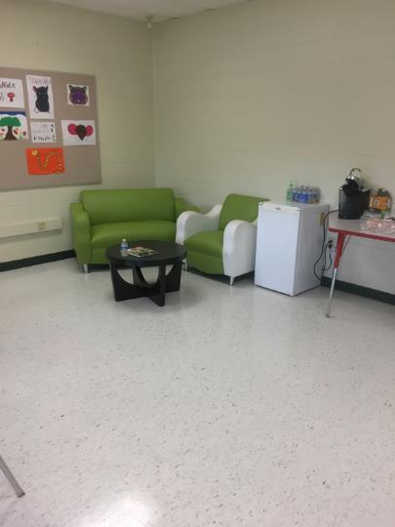
Upholstered furniture and refrigerator in Room 402

Location | Carbon  Dioxide  (ppm) | Carbon Monoxide  (ppm) | Temp  (°F) | Relative  Humidity  (%) | PM2.5  (µg/m³) | Occupants  in Room | Windows  Openable | Ventilation |  | Remarks
 |  |  |  |  |  |  |  | Supply | Exhaust
Background (outside) | 328 | 9 | 53 | 70 | 2 | - | - | - | -
Principal’s Office | 523 | ND | 69 | 33 | 2 | 6 | N | Y | Y
Main office | 556 | ND | 71 | 39 | 1 | 6 | Y | Y | Y
Nurse’s office | 472 | 3 | 69 | 38 | 3 | 2 | Y | Y | Y
Cafeteria A | 1939 | 3 | 71 | 43 | 7 | 100+ | N | Y | Y
Home economics | 531 | 5 | 72 | 39 | 5 | 4 | N | Y | Y | Exhaust fan off
Cafeteria | 873 | 7 | 76 | 41 | 5 | 0 | N | Y | Y
Kitchen | 887 | 7 | 80 | 55 | 4 | 3 | N | Y | Y
Library | 677 | 7 | 76 | 45 | 3 | 4 | N | Y | Y
402 | 605 | 7 | 69 | 44 | 2 | 0 | Y | Y | Y | Exhaust fan off  Upholstered furniture

