INDOOR AIR QUALITY ASSESSMENT

Quaboag Regional Middle/High School
284 Old West Brookfield Road,
Warren, MA

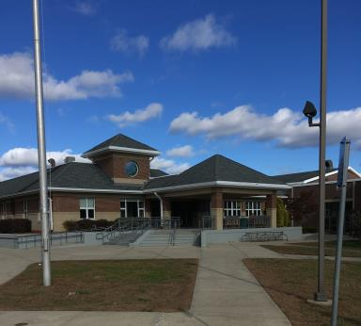

Prepared by:
Massachusetts Department of Public Health
Bureau of Environmental Health
Indoor Air Quality Program
November 2018

Background

Building: | Quaboag Regional Middle/High School (QRS)
Address: | 284 Old West Brookfield Road, Warren, MA
Assessment Requested by: | Brett Kustigian, Superintendent QRS District
Reason for Request: | General indoor air quality (IAQ)
Date of Assessment: | October 25, 2018
Massachusetts Department of Public Health/Bureau of Environmental Health (MDPH/BEH) Staff Conducting Assessment: | Mike Feeney, Director, IAQ Program  Jason Dustin, Environmental Analyst, IAQ Program
Building Description: | The QRS is a two-story brick building opened in 1968 and last renovated in 2001
Building Population: | Approximately 600 total students and staff
Windows: | Some windows are openable

IAQ Testing Results
Please refer to the IAQ Manual for methods, sampling procedures, and interpretation of results (MDPH, 2015). The following is a summary of indoor air testing results (Table 1).
- Carbon dioxide levels were above 800 parts per million (ppm) in many occupied classrooms tested, indicating a lack of air exchange in these areas. Some areas were empty, which can reduce carbon dioxide levels.
- Temperature was within or close to the recommended range of 70°F to 78°F the day of the assessment.
- Relative humidity was below the recommended range of 40 to 60% in all areas the day of assessment as is typical during the heating season.
- Carbon monoxide levels were non-detectable (ND) in all areas tested.
- Fine particulate matter (PM2.5) concentrations measured were below the National Ambient Air Quality (NAAQS) limit of 35 μg/m³ in all areas tested.

Ventilation
A heating, ventilating and air conditioning (HVAC) system has several functions. First it provides heating and, if equipped, cooling. Second, it is a source of fresh air. Finally, an HVAC system will dilute and remove normally occurring indoor environmental pollutants by not only introducing fresh air, but by filtering the airstream and ejecting stale air to the outdoors via exhaust ventilation. Even if an HVAC system is operating as designed, point sources of respiratory irritation may exist and cause symptoms in sensitive individuals.
Fresh air is provided by a combination of unit ventilators (univents) located in most individual classrooms (Picture 1) and roof top air handling units (AHUs) for common areas (e.g., library, gymnasium, etc.). The univents draw fresh air through a vent on the exterior wall (Picture 2). Air is mixed with return air from the room, filtered, heated (if needed) and delivered to the room (Figure 1). Some univents were obstructed by items placed on top or in front (Picture 3). Both the top and the vent at the bottom need to be kept clear of obstructions for the units to operate as designed. Air from the AHUs is filtered, heated or cooled as needed, and delivered to rooms via ducted supply vents (Picture 4).
QRS facilities personnel reported that the univents in classrooms are computer controlled. BEH staff noted that some univent fans were not operating during the assessment. Typically, the controls impact the fan operation as well as the fresh air intake louvre control. As shown in Table 1, most of the carbon dioxide readings were elevated in classes having full attendance. Another factor which may affect univent operation is the ability of occupants to shut off the units. This would prevent fresh air from being supplied to classrooms. To maximize air exchange, the MDPH recommends that both supply and exhaust ventilation operate continuously during periods of occupancy. In addition, the fresh air louvre setting must allow adequate fresh air into the classrooms to avoid the buildup of commonly found indoor air pollutants.
In order to have proper ventilation with a mechanical supply and exhaust system, these systems must be balanced to provide an adequate amount of fresh air while removing stale air from a room. It is recommended that existing ventilation systems be re-balanced every five years to ensure adequate air systems function (SMACNA, 1994). It is unknown the last time these systems were balanced.

Microbial/Moisture Concerns
Water-damaged ceiling tiles were observed in a few areas (Picture 5, Table 1), which indicate leaks from the building envelope or plumbing system. Ceiling tiles are considered porous and if exposed to chronic moisture may become a source for microbial colonization. These tiles should be replaced after the source of the leaks are found and repaired.
BEH staff observed a water pipe with water-damaged insulation and apparent mold on the surface of the insulation (Picture 6). This pipe was located in the culinary classroom (#108). The water damage is likely the result of chronic condensation or a small leak in the pipe joints/valve. This pipe should be inspected and the water-damaged insulation should be removed and replaced new.
The library conference room had some water-damaged ceiling tiles and blocked supply air vents (Picture 7). This room was also noted to have a slight musty odor. Blocked supply or exhaust vents reduce ventilation and will allow the buildup of common indoor air pollutants and odors.
It appeared most building materials were non-porous (e.g., concrete, tile). However, porous items (e.g., carpeting, books, boxes, etc.) stored on the floors or against exterior walls may be a source for microbial colonization if exposed to chronic moisture/condensation. Carpeting is generally not recommended in areas prone to chronic moisture and/or condensation since it may allow microbial colonization of the carpeting or in the dust/debris within the carpeting itself. Non porous, nontoxic closed cell foam mats may be used in place of carpeting if floor activities are required in these areas.
Indoor plants were observed in a few areas. Some of these plants were placed on porous materials. Plants can be a source of pollen and mold, which can be respiratory irritants to some individuals. Plants should be properly maintained, equipped with non-porous drip pans, and should be located away from air diffusers to prevent the aerosolization of dirt, pollen and mold.
BEH staff noted that some rooms had large numbers of bowed ceiling tiles (Picture 8). This is most likely due to high humidity weather events experienced during the summer of 2018. No visible mold or musty odors were detected at the time of this assessment. These areas should be monitored and replacement of any ceiling tiles should be conducted if musty odors or visual microbial growth is detected.
An inspection was conducted of the building exterior to identify other issues which could lead to water penetration. Vegetation was growing on or against the building, some of which was growing in front of fresh air intakes for univents (Picture 9). Also, some missing mortar in the brickwork and other gaps around utilities may provide pathways for moisture to enter occupied spaces (Pictures 10 and 11).

Other IAQ Evaluations
Exposure to low levels of total volatile organic compounds (TVOCs) may produce eye, nose, throat, and/or respiratory irritation in some sensitive individuals. To determine if VOCs were present, BEH/IAQ staff examined rooms for products containing VOCs. BEH/IAQ staff noted hand sanitizers, cleaners/spray bottles, plug-in air fresheners, and dry erase materials in use within the building. All of these products have the potential to be irritants to the eyes, nose, throat, and respiratory system of sensitive individuals. Due to the pervasive use of these products in schools throughout Massachusetts, the MDPH has produced a guideline called “Clean Air Is Odor-Free” which is included as Appendix A.
Some univents were noted to have inefficient filters (Picture 12). The MDPH recommends using pleated filters of Minimum Efficiency Reporting Value (MERV) of 8, which are adequate in filtering out pollen and mold spores (ASHRAE, 2012), if these can be used with current equipment.
BEH staff noted that the switch for the exhaust hood in room #108 (culinary class) could not be located. Exhaust ventilation should be operated to remove products of combustion and odors during cooking operations.
Some classrooms had personal fans. Some of these had dusty blades/housings (Table 1). Some supply diffusers and exhaust/return vents were also observed to be dusty. This dust can be reaerosolized when the equipment is activated.
In many areas, accumulated items including books, papers, toys and decorative items were observed on floors, windowsills, tabletops, counters, bookcases, and desks. Excess items on surfaces can make it more difficult for custodial staff to clean.
Many classrooms/areas had carpeting. Carpeting should be HEPA vacuumed daily and cleaned annually or semi-annually in soiled high traffic areas. Many classrooms had area rugs, which should also be cleaned regularly and discarded when too worn out or soiled to be cleaned.
Most of the above noted conditions are commonly found in schools throughout Massachusetts. The MDPH guideline “Indoor Air Quality in Schools” is included as Appendix B to explain in further detail how to remedy most commonly-found issues.
Note that the Environmental Protection Agency (EPA) conducted a National School Radon Survey in which it discovered nearly one in five schools had “…at least one frequently occupied ground contact room with short-term radon levels above 4 [picocuries per liter] pCi/L” (US EPA 1993). The BEH/IAQ Program therefore recommends that every school be tested for radon, and that this testing be conducted during the heating season while school is in session in a manner consistent with USEPA radon testing guidelines. Radon measurement specialists and other information can be found at www.nrsb.org and http://aarst-nrpp.com/wp, with additional information at: http://www.mass.gov/eohhs/gov/departments/dph/programs/environmental-health/exposure-topics/iaq/radon.

Conclusions/Recommendations
The following recommendations are made to assist in improving IAQ:
- Make necessary adjustments to univent controls to allow for proper function of fans and fresh air intake louvers.
- Operate all supply and exhaust ventilation equipment continuously during occupied hours. Fresh air should be supplied even when the thermostat set points are met to avoid intermittent ventilation that may allow indoor pollutants to build up.
- Remove items and furniture blocking univents both on top and along the front.
- Educate occupants that the univents provide not only heat but fresh air and should never be shut off. Temperature/comfort complaints should be made through proper channels and followed up by facilities staff.
- Consider installing anti-tamper plates on top of univents to prevent the units from being shut off by occupants.
- Use openable windows to supplement fresh air during temperate weather. Ensure all windows are tightly closed at the end of the day or during the use of air conditioning.
- Remove any items (e.g., cardboard) blocking supply and exhaust vents in the library conference room.
- Check exhaust vents (in classrooms and restrooms) for draw periodically and repair any non-operating motors/vents.
- Remove any carpeting exposed to chronic moisture/condensation (e.g., rooms on slab). Non porous, nontoxic closed cell foam mats may be used in place of carpeting if floor activities are required in these areas.
- Consider adopting a balancing schedule of every 5 years for all mechanical ventilation systems, as recommended by ventilation industrial standards (SMACNA, 1994).
- Ensure roof and plumbing leaks are repaired and replace any remaining water-damaged ceiling tiles and building materials.
- Inspect any stored supplies or porous items (e.g., books, papers, boxes, etc.) in areas prone to chronic moisture (e.g. slab floors). Discard any porous items noted to be water-damaged or have a musty odor. Store porous items on shelving and away from walls.
- Monitor areas which have bowed ceiling tiles. These ceiling tiles should be replaced if musty odors or visual microbial growth is detected.
- Remove any vegetation growing on or within 5 feet of the building.
- Repoint any areas of missing mortar in the brickwork and also seal any gaps around utilities that may allow moisture to penetrate the building envelope.
- Properly maintain plants, including drip pans, to prevent water damage to porous materials. Plants should also be located away from air diffusers to prevent the aerosolization of dirt, pollen, and mold.
- Eliminate the use of products and equipment that contain VOCs (e.g., air fresheners, scented cleaning wipes, scented hand sanitizer, etc.).
- Investigate the location of the exhaust hood switch in room #108 (culinary) and post instructions so that this hood is used during cooking operations.
- Continue to change filters for HVAC equipment 2-4 times a year. The MDPH recommends using pleated filters of Minimum Efficiency Reporting Value (MERV) of 8, which are adequate in filtering out pollen and mold spores (ASHRAE, 2012), if these can be used with current equipment.
- Regularly clean/vacuum univent cabinets, supply/return/exhaust vents and fans to avoid aerosolizing accumulated particulate matter. To clean ceiling grills, remove and wash.
- Consider reducing the amount of items stored in classrooms to make cleaning easier. Periodically move items to clean flat surfaces.
- Univent fresh air intakes on the exterior of the building should be monitored for debris and cleaned periodically. Ensure any vegetation is removed that is growing in front of these air intakes. Due to the low height of the intake vents, ensure that they are free from snow accumulation in the winter which would block the fresh air to the vents.
- HEPA vacuum carpeting daily and clean carpeting annually (or semi-annually in soiled high traffic areas). Clean area rugs similarly.
- For buildings in New England, periods of low relative humidity during the winter are often unavoidable. Therefore, scrupulous cleaning practices should be adopted to minimize common indoor air contaminants whose irritant effects can be enhanced when the relative humidity is low. To control dusts, a high efficiency particulate arrestance (HEPA) filter equipped vacuum cleaner in conjunction with wet wiping of all surfaces is recommended. Avoid the use of feather dusters. Drinking water during the day can help ease some symptoms associated with a dry environment (throat and sinus irritations).
- The school should be tested for radon by a certified radon measurement specialist during the heating season when school is in session. Radon measurement specialists and other information can be found at: www.nrsb.org, and http://aarst-nrpp.com/wp.
- Consider adopting the US EPA (2000) document, “Tools for Schools”, as an instrument for maintaining a good IAQ environment in the building available at: http://www.epa.gov/iaq/schools/index.html
- Refer to resource manual and other related IAQ documents located on the MDPH’s website for further building-wide evaluations and advice on maintaining public buildings. These documents are available at: http://mass.gov/dph/iaq.

References
ASHRAE. 2012. American Society of Heating, Refrigeration and Air Conditioning Engineers (ASHRAE) Standard 52.2-2012 -- Method of Testing General Ventilation Air-Cleaning Devices for Removal Efficiency by Particle Size (ANSI Approved).
MDPH. 2015. Massachusetts Department of Public Health. “Indoor Air Quality Manual: Chapters I-III”. Available at: http://www.mass.gov/eohhs/gov/departments/dph/programs/environmental-health/exposure-topics/iaq/iaq-manual/.
SMACNA. 1994. HVAC Systems Commissioning Manual. 1st ed. Sheet Metal and Air Conditioning Contractors’ National Association, Inc., Chantilly, VA.
US EPA. 1993. Radon Measurement in Schools, Revised Edition. Office of Air and Radiation, Office of Radiation and Indoor Air, Indoor Environments Division (6609J). EPA 402-R-92-014. https://www.epa.gov/sites/production/files/2014-08/documents/radon_measurement_in_schools.pdf
US EPA. 2000. Tools for Schools. Office of Air and Radiation, Office of Radiation and Indoor Air, Indoor Environments Division (6609J). EPA 402-K-95-001, Second Edition. http://www.epa.gov/iaq/schools/index.html.
Picture 1
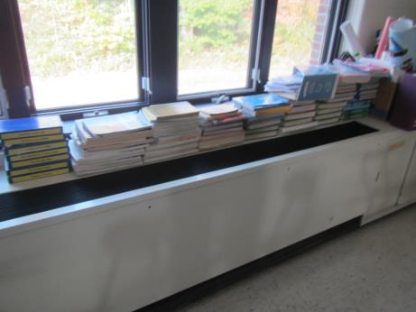
Univent in classroom
Picture 2
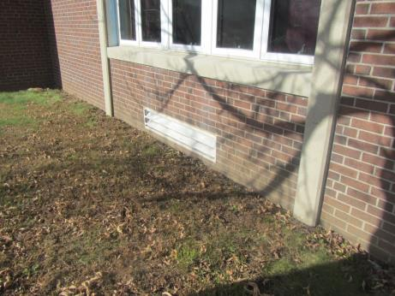
Exterior fresh air intake vent for classroom univent
Picture 3
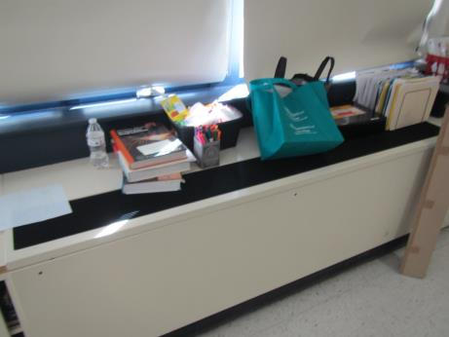
Univent with items obstructing supply air flow
Picture 4
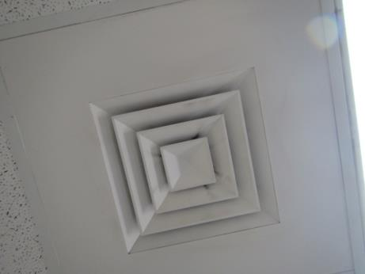
Ceiling-mounted supply air diffuser ducted from AHU (note dust on vent)
Picture 5
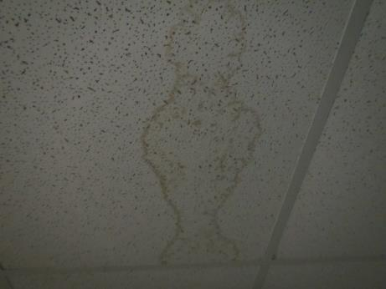
Water-damaged ceiling tile
Picture 6
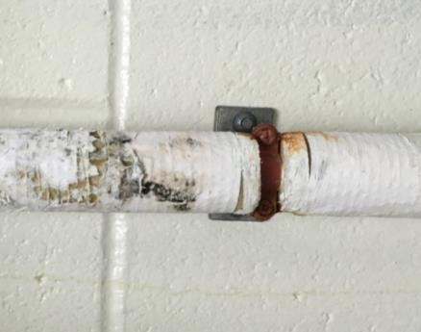
Water-damaged pipe insulation with apparent surface mold
Picture 7
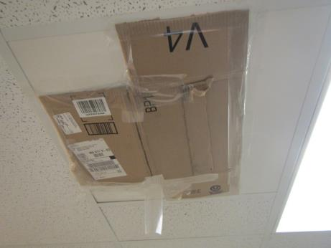
Blocked supply air vents in Library Conference room
Picture 8
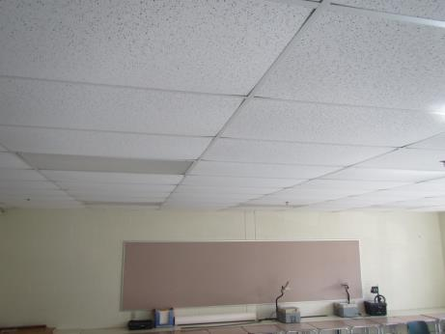
Classroom having bowed ceiling tiles
Picture 9
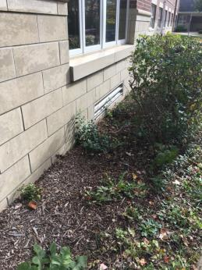
Vegetation against building and in front of univent
Picture 10
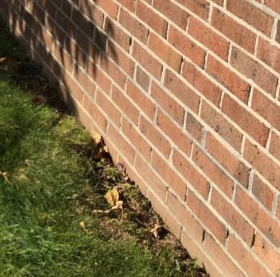
Missing mortar in brickwork
Picture 11
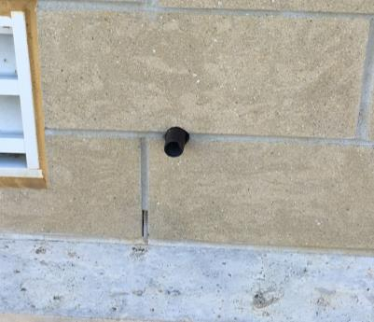
Gaps around utility pipe
Picture 12
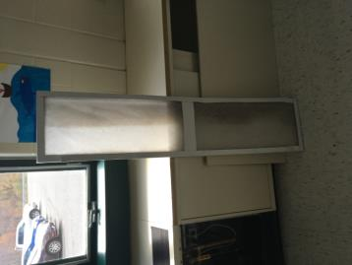
Inefficient filter used in univent
Location | Carbon  Dioxide  (ppm) | Carbon Monoxide  (ppm) | Temp  (°F) | Relative  Humidity  (%) | PM2.5  (µg/m³) | Occupants  in Room | Windows  Openable | Ventilation |  | Remarks
 |  |  |  |  |  |  |  | Supply | Exhaust
Background (outside) | 460 | ND | 51 | 34 | 8 | - | - | - | -
Principal | 710 | ND | 68 | 34 | 1 | 3 | Y | Y | Y | WD CT, carpet
Home Economics | 1297 | ND | 72 | 43 | 17 | 20 + | N | Y | Y | HS, cooking activities
801 | 1654 | ND | 73 | 41 | 5 | 18 | N | Y | Y
803 | 854 | ND | 71 | 33 | 2 | 0 | Y | Y | Y
805 | 1655 | ND | 72 | 41 | 3 | 12 | Y | Y | Y | AI, plants
808 | 697 | ND | 73 | 30 | 1 | 0 | Y | Y | Y | HS
807 | 712 | ND | 72 | 27 | 2 | 1 | Y | Y on | Y | DEM, PF
807 workroom | 810 | ND | 74 | 30 | 7 | 0 | Y | Y | N
809 | 964 | ND | 76 | 30 | 6 | 1 | Y | Y | Y | Plants
810 | 650 | ND | 74 | 22 | 1 | 0 | Y | Y on | Y
811 | 733 | ND | 74 | 27 | 3 | 22 | Y | Y | Y
811 | 733 | ND | 74 | 27 | 3 | 22 | Y | Y | Y
714 | 527 | ND | 73 | 21 | 3 | 0 | Y | Y on | Y | Bowed CTs, DEM
712 | 555 | ND | 73 | 25 | 2 | 2 | Y | Y | Y | DEM, AT
704 | 798 | ND | 71 | 31 | 4 | 0 | Y | Y on | Y | Items on Univent, DEM
702 | 641 | ND | 71 | 26 | 3 | 0 | Y | Y on | Y | DEM
Faculty Dining | 551 | ND | 71 | 28 | 1 | 0 | N | Y | Y | Small WD CT
Middle School Cafeteria | 847 | ND | 72 | 31 | 7 | 50 + | N | Y | Y
701 | 627 | ND | 71 | 26 | 3 | 2 | N | Y on | Y | WD CT near window
703 | 812 | ND | 71 | 29 | 2 | 17 | N | Y | Y | DEM
High School Cafeteria | 1015 | ND | 72 | 40 | 28 | 5 | N | Y | Y
Main Office | 534 | ND | 71 | 25 | 2 | 3 | N | Y | Y | Plants
Grants | 610 | ND | 72 | 27 | 2 | 1 | N | Y | Y | DEM
Office 2 | 578 | ND | 72 | 26 | 2 | 0 | N | Y | Y | Carpet
104 | 612 | ND | 71 | 29 | 3 | 5 | N | Y | Y | DEM, Blocked Univent, plant debris on Univent
103 Art | 872 | ND | 70 | 33 | 4 | 2 | Y | Y on | Y | Art supplies
102 Art | 633 | ND | 70 | 29 | 1 | 0 | N | Y | Y | HS, DEM, paint
101 | 1020 | ND | 70 | 33 | 3 | - | Y | Y on | Y | DEM, AI, WD CT
210 | 740 | ND | 72 | 29 | 5 | 7 | N | Y | Y | Carpeting
209 | 676 | ND | 72 | 32 | 1 | 0 | N | Y | Y | Plants
211 | 720 | ND | 72 | 32 | 1 | 1 | N | Y | Y
214 | 838 | ND | 72 | 33 | 1 | 1 | N | Y | Y
213 | 695 | ND | 72 | 32 | 1 | 1 | N | N | Y | Ductless AC
Library | 847 | ND | 72 | 29 | 5 | 7 | N | Y | Y | Carpeting
Library Conference | 775 | ND | 73 | 29 | 6 | 1 | N | Y blocked | Y | Blocked supply, WD CTs, musty odors
Video Services | 777 | ND | 73 | 29 | 5 | 0 | N | Y | Y | DEM
Periodical Storage | 750 | ND | 73 | 29 | 5 | 0 | N | Y | Y | WD CTs x 3
502 | 1018 | ND | 73 | 27 | 3 | 14 | N | Y | Y
504 | 787 | ND | 72 | 24 | 3 | 0 | N | Y | Y
506 | 918 | ND | 73 | 28 | 2 | 14 | N | Y | Y | DEM
508 | 709 | ND | 72 | 26 | 2 | 16 | N | Y | Y
507 | 778 | ND | 73 | 28 | 2 | 11 | N | Y | Y | DEM
415 | 1124 | ND | 71 | 33 | 4 | 0 | Y | Y on | Y | DEM, HS, Plant
413 | 1644 | ND | 72 | 38 | 5 | 21 | Y | Y | Y | DEM
405 | 1487 | ND | 70 | 38 | 3 | 18 | Y | Y | Y | DEM
406 | 1200 | ND | 72 | 34 | 4 | 12 | Y | Y | Y | DEM
407 | 1627 | ND | 71 | 41 | 4 | 15 | Y | Y | Y | DEM
403 | 912 | ND | 70 | 28 | 3 | 17 | Y | Y | Y | DEM
401 | 1090 | ND | 72 | 32 | 1 | 5 | Y | Y | Y | DEM
314 | 545 | ND | 70 | 23 | 1 | 0 | N | Y | Y | Ceiling Univent
Faculty copy | 934 | ND | 71 | 30 | 2 | 0 | N | Y | Y | Photocopier, AT
305A | 616 | ND | 70 | 28 | 2 | 0 | N | Y | Y | CPs, AT
Building & grounds | 618 | ND | 70 | 30 | 5 | 0 | N | Y | Y | WD CT, CPs, dehumidifier
302 | 596 | ND | 70 | 25 | 6 | 0 | N | Y | Y | Missing ceiling tiles
312 | 1038 | ND | 71 | 32 | 4 | 7 | N | Y | Y | DEM
310 | 997 | ND | 72 | 30 | 4 | 17 | Y | Y | Y | DEM
308 | 1235 | ND | 72 | 35 | 6 | 20 | Y | Y | Y | DEM
306 | 1005 | ND | 71 | 31 | 3 | 11 | Y | Y | Y | DEM
304 | 971 | ND | 71 | 30 | 1 | 0 | Y | Y | Y | DEM
301 | 589 | ND | 70 | 22 | 3 | 0 | N | Y | Y on | DEM, CPs, Bowed CTs
303 | 628 | ND | 69 | 23 | 3 | 0 | N | Y | Y | Computers
Gym-aerobics | 518 | ND | 69 | 27 | 3 | 1 | N | Y | Y
Gym- open | 546 | ND | 69 | 27 | 4 | 18 | N | Y | Y

