Background

INDOOR AIR QUALITY
WATER DAMAGE ASSESSMENT

Quaboag Regional Middle/High School
284 Old West Brookfield Road
Warren, Massachusetts

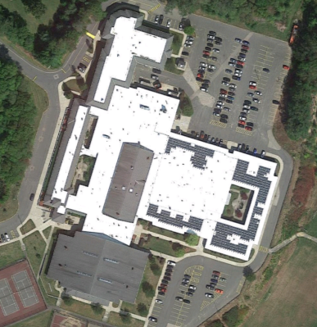

Prepared by:
Massachusetts Department of Public Health
Bureau of Environmental Health
Indoor Air Quality Program
October 2018
Building: | Quaboag Regional Middle/ High School (QRMHS)
Address: | 284 Old West Brookfield Road, Warren, Massachusetts
Requestor: | Brett Kustigian, Superintendent, Quaboag Regional Schools
Date of Pre-Occupancy Assessment: | October 5, 2018
Massachusetts Department of Public Health/Bureau of Environmental Health (MDPH/BEH) Staff Conducting Assessment: | Mike Feeney, Director, Indoor Air Quality (IAQ) Program
Date of Building Construction: | 1969 with an addition in 2001

Methods
BEH/IAQ staff performed a visual inspection of building materials for water damage and/or microbial growth in locations susceptible to mold growth in a selection of classrooms, including the library, gymnasium, shops and home economics room. Each space was examined for the presence of odors or other environmental concerns.

Background
The New England area experienced an unprecedented period of extended hot, humid weather. According to the Washington Post, “[d]ata…show[s]…cities in the Northeast have witnessed such humidity levels for record-challenging duration...[i]ncluding Albany, Boston, Burlington, Portland and Providence” during the summer of 2018 (WP, 2018). “Boston and nearby locations… [saw]…historic numbers of those warm nights with low temperatures at or above 70 degrees…Providence and Blue Hill Observatory have already broken their annual records” (WP, 2018). If a building does not have either adequate exhaust ventilation and/or air chilling capacity to remove/reduce relative humidity from outside air, then hot, moist air can be introduced into a building and linger to lead to possible moistening of building floor and other components and/or contents that may lead to mold growth. This type of weather condition has led to mold growth incidents in public buildings throughout Massachusetts in the summer of 2018.

Observations
The building has unit ventilators for ventilation as well as openable windows. No evidence of active water leaks or other moisture concerns were observed in walls or floors throughout the complex, with the exception of a single water-damaged ceiling tile in a foyer area. No increase in respiratory symptoms in building occupants was reported by the school’s medical staff.

Recommendations
Based on observations and information provided by various QRMHS staff, the building appears to have been cleaned of mold contamination in the areas most likely prone to water damage. In order to completely examine the building complex, the IAQ Program has offered to return to the QRMHS conduct a full IAQ assessment within several weeks.
Based on observations and measurements at the time of the visit, the following recommendations are made:
- Ensure that new filters are installed in unit ventilators if not already done.
- Use windows as needed to supplement fresh air supply as needed.
- Replace water-damaged ceiling tiles, as needed.
- Refer to resource manual and other related IAQ documents located on the MDPH’s website for further building-wide evaluations and advice on maintaining public buildings. These documents are available at: http://mass.gov/dph/iaq.

References
WP. 2018. ‘It’s been relentless’: Smothering summer humidity in the Northeast has crushed records. Washington Post, Washington, DC. https://www.washingtonpost.com/news/capital-weather-gang/wp/2018/08/30/its-been-relentless-smothering-summer-humidity-in-the-northeast-has-crushed-records/

