MASSACHUSETTS DIVISION OF MARINE FISHERIES

State Waters Dredge Quahog Fishery Catch Report Form

Boat Name: Boat #: Length: Gear: Size:
Permit Holder: Permit #: Month Fished:

Day: 1 2 3 4 5 6
Size: Nck Cher Chow Nck Cher Chow Nck Cher Chow Nck Cher Chow Nck Cher Chow Nck Cher Chow
Bushels:
Area:
Port Landed:
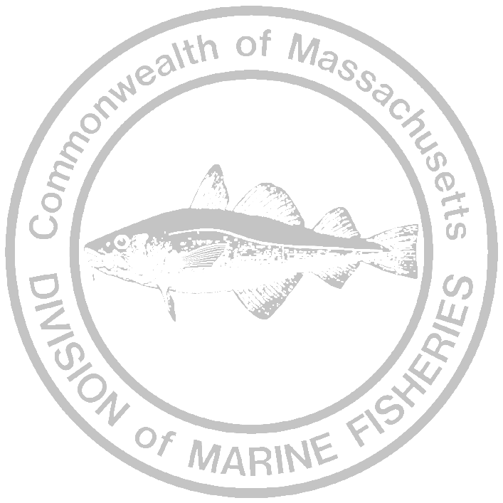
Processor:
Day: 7 8 9 10 11 12
Size: Nck Cher Chow Nck Cher Chow Nck Cher Chow Nck Cher Chow Nck Cher Chow Nck Cher Chow
Bushels:
Area:
Port Landed:
Processor:
Day: 13 14 15 16 17 18
Size: Nck Cher Chow Nck Cher Chow Nck Cher Chow Nck Cher Chow Nck Cher Chow Nck Cher Chow
Bushels:
Area:
Port Landed:
Processor:

Day: 19 20 21 22 23 24
Size: Nck Cher Chow Nck Cher Chow Nck Cher Chow Nck Cher Chow Nck Cher Chow Nck Cher Chow
Bushels:
Area:
Port Landed:
Processor:

Day: 25 26 27 28 29 30
Size: Nck Cher Chow Nck Cher Chow Nck Cher Chow Nck Cher Chow Nck Cher Chow Nck Cher Chow
Bushels:
Area:
Port Landed:
Processor:

Day: 31 Day: Day of the month that you fished.
Size: Nck Cher Chow Bushels: Number of bushels harvested by size. Area: Shellfish area code fished.
Bushels: Port Landed: Name of port where shellfish landed. Processor: To whom you sold catch.
Area: All neck sizes (bushels) should be added together and put in “Nck” column; for example,
Port Landed: top neck, count neck, etc.
Processor:

You must submit the catch report every month. It must be received by the Division by the 5th day of the following month.
If you did not fish, the form must be completed and submitted anyway; state on it that you did not fish.
Failure to submit catch reports on time may result in the revocation of your permit.

Return Completed Forms To: If you need assistance or information call:
Massachusetts Division of Marine Fisheries Dave Whittaker @ (508) 563-1779 ext. 126
50A Portside Drive
Pocasset, MA 02559
Attn: Dave Whittaker
Permit Holder’s Signature: ____________________________Telephone #:______________________ Q Form 2001

