Commonwealth of Massachusetts
Executive Office of Health and Human Services

EOHHS QUALITY MEASUREMENT ALIGNMENT
TASKFORCE

Meeting #25
February 27, 2019

Welcome
■ Recap of 1-23-19 Meeting Decisions & Discussion of Follow-up Items
CONFIDENTIAL WORKING DRAFT – POLICY IN DEVELOPMENT

- Developmental Measure Activity
- Innovation Measure Definition Question – Partners’ eCare Measures
- Promoting Adoption of the Aligned Measure Set
- Next Steps

1-23-19 Taskforce Meeting Decisions

- The Taskforce finalized its mission statement and 2019 goals.
CONFIDENTIAL WORKING DRAFT – POLICY IN DEVELOPMENT
- The Taskforce completed its abbreviated annual review:
  - The Taskforce did not recommend any changes to the Core, Menu, or Monitoring sets for 2020 implementation.
  - The Taskforce did not recommend removing “Comprehensive Diabetes Care: Eye Exam” or “Use of Imaging Studies for Low Back Pain” despite their 2019 removal from the MSSP measure set.
  - We will raise one additional item for discussion today.

- As part of its abbreviated annual review, the Taskforce recommended:
CONFIDENTIAL WORKING DRAFT – POLICY IN DEVELOPMENT
  - a MassHealth exception for “ED Visits for Adults with Mental Illness and/or Substance Addiction”
  - MassHealth’s “Health-Related Social Needs Screening” be categorized as an Innovation measure
- Based on post-1-23-19 feedback from Taskforce members, Taskforce staff wish to clearly articulate what was the staff goal in presenting the above two measures for consideration.
  - While MassHealth had previously committed to CMS to pilot and use the measures on its ACO contracts, it is committed to advancing alignment and therefore wanted to present them for discussion.
  - It was staff intent that the Taskforce have a robust discussion about the measures’ merits, and whether they should be adopted.
  - While the measures did not meet some Taskforce core principles for measure selection, they did address identified gap areas.

- The Taskforce will review progress towards its 2019 goals every few months.
CONFIDENTIAL WORKING DRAFT – POLICY IN DEVELOPMENT
- Taskforce staff will consider standard definitions of adequate denominator size at the ACO level.
  - Taskforce staff will consider the Taskforce’s role and capacity to consider adequate denominator size this summer.
- Taskforce staff will share the link to the Taskforce web page when available.
- Taskforce staff were to consider if there are resources to take a more active role in processing Oregon’s recommended Kindergarten Readiness measures.
  - To be discussed today!

Abbreviated Annual Review Follow-up – Inclusion of a Pediatric Core Measure

- Since our last meeting, a plan representative emailed the Taskforce staff expressing concern about provider pushback to use of the measures Childhood Immunization Status and Immunizations for Adolescents because of their exclusion from the Core set.
CONFIDENTIAL WORKING DRAFT – POLICY IN DEVELOPMENT

Would the Taskforce like to revisit inclusion of a pediatric or adolescent measure in the Core set?
Menu Measures Specific to Children/Adolescents
Childhood Immunization Status (Combo 10)
Immunizations for Adolescents (Combo 2)
Chlamydia Screening - Ages 16-24
Asthma Medication Ratio
Metabolic Monitoring for Children and Adolescents on Antipsychotics
Child and Adolescent Major Depressive Disorder: Suicide Risk Assessment

Monitoring Measures Specific to Children/Adolescents
Well-Child Visits in the First 15 Months of Life
Well-Child Visits in the 3rd, 4th, 5th, and 6th Years of Life
Adolescent Well-Care Visit

  - Welcome
CONFIDENTIAL WORKING DRAFT – POLICY IN DEVELOPMENT
  - Recap of 1-23-19 Meeting Decisions & Discussion of Follow-up Items
■ Developmental Measure Activity

  - Innovation Measure Definition Question – Partners’ eCare Measures
  - Promoting Adoption of the Aligned Measure Set
  - Next Steps

  - As part of the Taskforce’s 2019 work re: developmental measures we will periodically review the status of development activity.
CONFIDENTIAL WORKING DRAFT – POLICY IN DEVELOPMENT
  - Today, we will discuss each of the four developmental priorities:

- Kindergarten Readiness: Taskforce staff will discuss next steps.

Stratification of Measures to Understand Equities and Disparities:
DPH will discuss its plan for developing measures in this area.
- Depression Remission or Response for Adolescents and Adults: BCBSMA and MassHealth will provide a status update on their work.
- Joint Replacement Patient-Reported Outcome Measure: The State will provide a status update on the convening of external measure developers.

  - The Taskforce reviewed Oregon’s new Kindergarten Readiness measure during the 1/23 Taskforce meeting.
CONFIDENTIAL WORKING DRAFT – POLICY IN DEVELOPMENT
  - Oregon will vote on formal adoption of its Kindergarten Readiness measure for its MCO incentive program in August.
  - If the measure is adopted, the Taskforce will consider convening a work group to evaluate the measure for consideration for a future year.

  - During the 9/25 Taskforce meeting, the Taskforce prioritized the stratification of measures to understand equities and disparities.
CONFIDENTIAL WORKING DRAFT – POLICY IN DEVELOPMENT
  - The Taskforce will take an active role in the development of this measure through a collaboration among interested organizations.
  - Project leadership and support will be provided from DPH, CHIA, and HPC.
  - The next few slides will discuss the context for development and outline our plan for development.

  - Insurance Enrollment Form – Race or Ethnicity Example
O

EVEL D
N I
Y
C I
L
PO
–
T F

DRA
NG I

RK O W
L

A I

NT
DE I
NF CO
PMENT
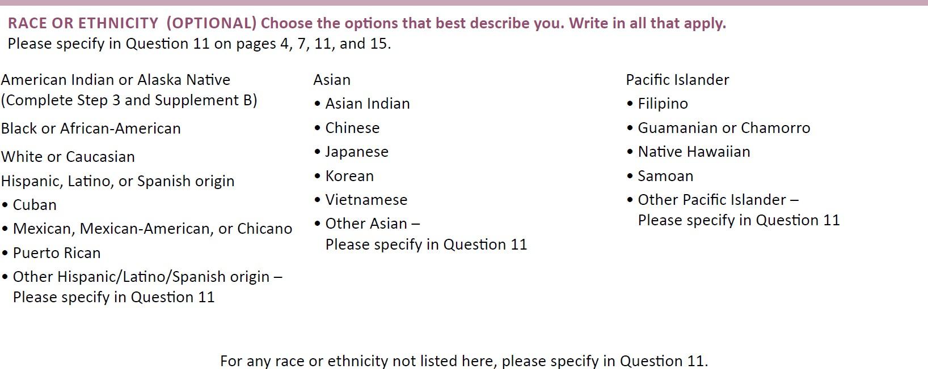

CONFIDENTIAL WORKING DRAFT – POLICY IN DEVELOPMENT
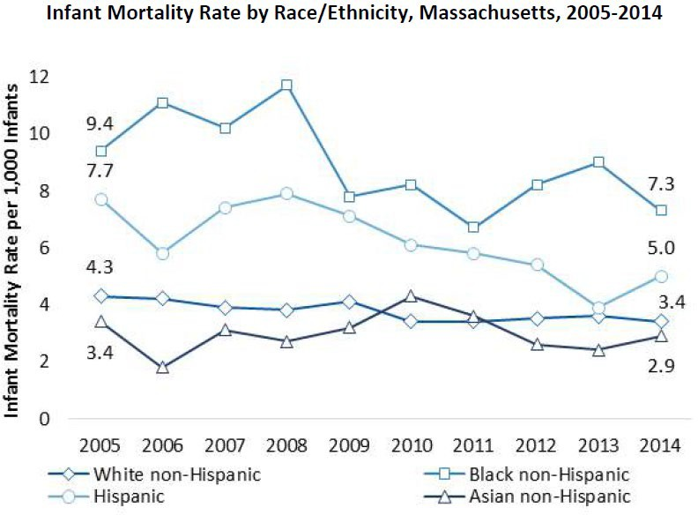

Rate of Non-Fatal Motor Vehicle Injuries among Persons 15-24 Years of Age, by Race/Ethnicity, Massachusetts, Federal Fiscal Year 2015
CONFIDENTIAL WORKING DRAFT – POLICY IN DEVELOPMENT

4,000

3,000
Black non-Hispanic
Hispanic
White non-Hispanic Asian and Pacific
Islander non- Hispanic
643.2

1,442.8

2,254.1

3,509.7
Rate per 100,000 Population

2,000

1,000

0

Age-Adjusted Diabetes Emergency Department Visit Rate, by Race/Ethnicity, Massachusetts, 2014
CONFIDENTIAL WORKING DRAFT – POLICY IN DEVELOPMENT

500

400

99.3
376.5
419.1
Age-Adjusted Rate per 100,000
Population

300

200

100

0
No Asians
White non-Hispanic Hispanic Black non-Hispanic

Why is establishing data standards and specifications important?
CONFIDENTIAL WORKING DRAFT – POLICY IN DEVELOPMENT

    - Helps set expectations around priority populations

    - Provides guidance for modification of current data or implementation of new datasets in order to facilitate streamlined data exchange, comparisons and dissemination

    - Allows for consistent reporting and identification of disparities and inequities

Work Plan for Stratification of Measures to Understand Inequities and Disparities
CONFIDENTIAL WORKING DRAFT – POLICY IN DEVELOPMENT

  - Vision: To stratify quality measures for the purpose of measuring inequities and disparities.

  - 2019 Objective: The Health Equity Workgroup will identify measures for a pilot of demographic stratification from the full list of the Massachusetts Aligned Measure Set with health equity implications. For this subset of measures, the Health Equity Work Group shall create a list of necessary data elements for stratification, and identify where strengths exist and where improved collection of data elements is necessary to advance equity/disparity measurement.

Phase I: Time Frame (January-March)
CONFIDENTIAL WORKING DRAFT – POLICY IN DEVELOPMENT
Environmental Scan by Health Equity Work Group Stakeholders

  - Phase 1a: Identification of key personnel to act as contacts for an environmental scan of demographic data.

  - Phase 1b: Each organization provides information in a standardized template on demographic variables currently used, including specifications for collection and attribution, and designating what could be made available for stratification of measures to the Health Equity Work Group.

Phase II: Time Frame (April-July)
CONFIDENTIAL WORKING DRAFT – POLICY IN DEVELOPMENT
The Health Equity Workgroup will identify measures from the Massachusetts Aligned Measure Set with health equity implications

  - Phase 2a: Use literature review or available data to identify Massachusetts Aligned Measure Set measures where there are known or documented disparities and for which demographic groups

Create a list of necessary data elements for each demographic variable suggested for stratification

  - Phase 2b: Identify current data standards for identification, classification and collection of data on demographic groups (e.g., REAL data, SOGI, Age, Income, Disability Status, Veteran Status, Homelessness/Housing Instability)

Phase II: Time Frame (April-July), cont.
Identify where improved collection of data elements is necessary to allow for stratification
CONFIDENTIAL WORKING DRAFT – POLICY IN DEVELOPMENT
  - Phase 2c: Cross-walk currently available demographics (Phase 1b) against possible data elements (Phase 2b) to demonstrate what is being collected and compare this with priorities suggested by disparities literature review (Phase 2a)
  - Phase 2d: Identify gaps where data elements are not currently available, but disparities literature review suggests they are necessary, and areas of opportunity where data elements for stratification are available
  - Phase 2e: Recommend a final set of quality measures and initial stakeholder organizations for piloting in Phase III where data elements are being collected or can be collected
Share findings/recommendations from Phase 2c through 2e with Taskforce.

Phase III: Time Frame (August-December)
CONFIDENTIAL WORKING DRAFT – POLICY IN DEVELOPMENT
Health Equity Work Group members will pilot test the feasibility of stratification for measures by demographics where data elements available

  - Phase 3a: Work with key stakeholders to pilot a subset of measures using common data elements for stratification and reporting of measures; this activity may extend beyond CY19

  - Phase 3b: Update the Taskforce with a set of recommendations for revisions to workplan and timeline based on pilot testing, and options for spread plans (including drafting technical specifications), if and when applicable

Process for Development:
CONFIDENTIAL WORKING DRAFT – POLICY IN DEVELOPMENT
- Meeting: DPH will convene the “Health Equity Workgroup” to discuss potential ways to stratify measures and review existing work being done by organizations. The Health Equity Workgroup will determine which measures to stratify and which data points to use for stratification.
- Pilot Testing: Informed by discussions and existing research, the Health Equity Workgroup will test the feasibility of stratification for a sample of quality measures using a variety of data sources.
- Updates: Periodically, the Health Equity Workgroup shall provide the Taskforce with an update on the status of their Developmental measure design and testing.

Process for Development (Cont’d):
CONFIDENTIAL WORKING DRAFT – POLICY IN DEVELOPMENT
- Technical Specifications: The Health Equity Workgroup shall draft a technical specifications manual describing how to stratify certain quality measures.
- Measure Specifications: The Health Equity Workgroup shall draft specifications for one or more equity measures, or an equity composite measure, to propose for Massachusetts Aligned Measure Set endorsement.
- Recommendation: The Health Equity Workgroup will present their proposed stratification methodology and measure specifications for endorsement by the Taskforce.

NOTE: Development Tasks 4-6 would be developed in 2020 dependent on outcomes of the initial pilot.

- BCBSMA and MassHealth are collaborating with PBGH/ICHOM, to understand and explore opportunities for measure alignment with regards to measure design/modifications to technical specifications or approaches toward data collection.
CONFIDENTIAL WORKING DRAFT – POLICY IN DEVELOPMENT

- Update on status: Early planning stages (PBGH – Lead)
- PBGH: Drafted data collection template/spreadsheet to understand the current depression measurement landscape and activities in both states.
- PBGH: Conducted online survey of 20 California ACOs (with 10 follow-up interviews)

- Proposed objectives/activities under consideration:
CONFIDENTIAL WORKING DRAFT – POLICY IN DEVELOPMENT
- Understand operational issues (data collection, integration with EHRs, clinician feedback, etc.)
- Develop a playbook of best practices to use to accelerate implementation in the collection of PHQ-9
- Convene a workshop in Spring/Summer: Compare notes and help solve some of the more challenging functions – (e.g., long-term patient follow-up)

Joint Replacement Patient-Reported Outcome Measure

  - Because of the number of PROM implementation activities underway, and the federally-sponsored effort to develop a PRO- PM for orthopedics, the Taskforce will begin its monitoring by convening organizations currently working on joint replacement PROMs to better understand how to monitor existing work.
CONFIDENTIAL WORKING DRAFT – POLICY IN DEVELOPMENT

  - Lisa is coordinating with organizations working on joint replacement PROMs to arrange a meeting for March or April to share the status of work being done in the field.
  - Taskforce staff will share a summary of the meeting with the Taskforce after it occurs.

Agenda

Welcome
CONFIDENTIAL WORKING DRAFT – POLICY IN DEVELOPMENT
  - Recap of 1-23-19 Meeting Decisions & Discussion of Follow-up Items
  - Developmental Measure Activity
■ Innovation Measures – Partners’ eCare Case Study

  - Promoting Adoption of the Aligned Measure Set
  - Next Steps

  - On 11/12, a few Taskforce staff met with Partners to better understand the Partners eCare measures in order to answer Partners’ question about whether the measures would qualify as meeting the Taskforce’s Innovation measures definition.
CONFIDENTIAL WORKING DRAFT – POLICY IN DEVELOPMENT
  - Partners eCare measures were created to better define the quality of care in the Partners clinically managed population with the ultimate goal of more effectively engaging providers in care improvement.

  - A number of the Partners eCare measures represent deviations from measures in the Massachusetts Aligned Measure Set:
CONFIDENTIAL WORKING DRAFT – POLICY IN DEVELOPMENT

Core
  - Diabetes HbA1c Control
  - Hypertension Blood Pressure Control

Menu
- Breast Cancer Screening
- Cervical Cancer Screening
- Colorectal Cancer Screening
- Diabetes Blood Pressure Control

  - The primary differences between the Partners eCare measures and the HEDIS measures in the Aligned Set are:
CONFIDENTIAL WORKING DRAFT – POLICY IN DEVELOPMENT
    - Health Maintenance Modifiers (HMM): eCare measures allow Partners clinicians flexibility to use their judgement in treatment plans by: 1) designating an alternative screening timeframe for screening measures, and 2) designation of a clinical “pass”* for a period of time for selected screening and outcomes measures if certain patient factors exist.
    - Denominator Differences: Partners also allows for additional denominator adjustments if 1) the patient is deceased, 2) the patient does not have the condition, 3) the patient is not the clinician’s patient, or 4) the patient should be monitored but is not captured by default measure logic (i.e. female <50 with family history of breast cancer)
*Designation of a “pass” gives a clinician credit for appropriately managing a patient if the clinician decides that a screening is not needed. Acceptable reasons are defined and not open-ended.

  - Other differences between the Partners eCare measures and HEDIS measures include:
CONFIDENTIAL WORKING DRAFT – POLICY IN DEVELOPMENT
    - Non-Claims-Based Sources: eCare measures use medical records from Epic.
    - Open-Ended Age Ranges: Diabetes and hypertension eCare measures include denominators with open-ended age ranges.
    - Numerator Differences: eCare measures have broader numerator definitions for their “Diabetes BP Control” and “Hypertension BP Control” measures: 1) a patient is considered as “passing” if on three blood pressure medications, 2) home blood pressure readings are included in numerator compliance, and 3) either the latest or the average of the last three blood pressure readings (taken in the last 18 months) is used for numerator compliance.

  - The Partners eCare measures contain more exclusions than traditional HEDIS measures, some of which are discretionary. The differences in cancer screening measures are denominator source expansions, with broader differences in standards of care for diabetes and hypertension measures.
CONFIDENTIAL WORKING DRAFT – POLICY IN DEVELOPMENT

  - Unlike with HEDIS measures where a rate of 100% is seldom considered attainable due to idiosyncratic patient characteristics that cause a clinical standards to be non-applicable for a small subset of patients, Partners believes that rates of 100% are attainable with its eCare measures.

  - The question the Taskforce needs to consider is whether the modifications made by Partners are “innovative.” The Taskforce defined Innovation measures as follows:
CONFIDENTIAL WORKING DRAFT – POLICY IN DEVELOPMENT
“... measures which address a) clinical topics or clinical outcomes in the Core or Menu Sets utilizing a novel approach or b) clinical topics that are not addressed in the Core or Menu Sets. Innovation measures are intended to advance measure development and therefore cannot include measures that have been previously considered and rejected by the Taskforce as Core or Menu measures...”

- Does the Taskforce find Partners’ eCare measures should be considered Innovation measures?
- If the measures are determined to qualify as Innovation measures, Partners and willing payers could use them in contracts instead of the standard versions contained in the Aligned Measure Set and still be considered to be “in alignment.”

Agenda

Welcome
CONFIDENTIAL WORKING DRAFT – POLICY IN DEVELOPMENT
  - Recap of 1-23-19 Meeting Decisions & Discussion of Follow-up Items
  - Developmental Measure Activity
  - Innovation Measures – Partners’ eCare Case Study
■ Promoting Adoption of the Aligned Measure Set

  - Next Steps

Promoting Adoption of the Aligned Measure Set

  - During the summer of 2018, Taskforce staff reached out to payers and asked how many months in advance of a contract renewal dates did payers start negotiating the quality measures in their contracts.
CONFIDENTIAL WORKING DRAFT – POLICY IN DEVELOPMENT
    - Payers start negotiating quality measures three to 18 months prior to a contract’s renewal date.
  - Since contract negotiations for 2020 have already begun in some cases, and one of the Taskforce’s 2019 goals is to advise EOHHS on the Adoption of the Aligned Measure Set, we would like to consider strategies for encouraging adoption of the Aligned Measure Set.
  - Actions may be taken by the State and/or the Taskforce to promote adoption of the Aligned Measure Set.
- How does the Taskforce recommend that the State and Taskforce promote adoption of the Aligned Measure Set?

Agenda

Welcome
CONFIDENTIAL WORKING DRAFT – POLICY IN DEVELOPMENT
  - Recap of 1-23-19 Meeting Decisions & Discussion of Follow-up Items
  - Developmental Measure Activity
  - Innovation Measures – Partners’ eCare Case Study
  - Promoting Adoption of the Aligned Measure Set
■ Next Steps

CONFIDENTIAL WORKING DRAFT – POLICY IN DEVELOPMENT
Upcoming Meetings
•
Meeting #26 – March 20
36

