Commonwealth of Massachusetts
Executive Office of Health and Human Services

EOHHS QUALITY MEASURE ALIGNMENT TASKFORCE

Meeting #26
March 20, 2019

Agenda

1. Welcome
2. Recap of 2-27-19 Meeting Decisions & Discussion of Follow-up Items
CONFIDENTIAL WORKING DRAFT – POLICY IN DEVELOPMENT

- The Impact of Performance Measures on Clinician Burnout
- Continued Discussion of Partners’ eCare Measures
- Quality Measure Catalogue Findings
- Update on Clinical Data Repository Development Efforts
- Impact of NCQA Proposed HEDIS Updates on the Aligned Measure Set
- Next Steps
Note: Topics 5 through 7 were not discussed during this meeting due to lack of time.
2

2-27-19 Taskforce Meeting Decisions

- After considering feedback from a health plan regarding a provider’s reluctance to adopt any non-Core measures into a contract, the Taskforce decided not recommend moving Childhood Immunization Status or Immunizations for Adolescents into the Core Set.
CONFIDENTIAL WORKING DRAFT – POLICY IN DEVELOPMENT
- The Taskforce agreed that Taskforce staff should track what happens during contracting for 2020 and then re- assess Aligned Measure Set composition.
- Following the meeting Lauren decided to request recommendations on insurer and ACO communication about the intended use of the Core and Menu sets.
  - Please email any recommendations to Justine (jzayhowski@bailit- health.com).

3

2-27-19 Taskforce Meeting Follow-up Items

- MassHealth will share results of the PBGH landscape review for Depression Remission or Response with the Taskforce once completed.
CONFIDENTIAL WORKING DRAFT – POLICY IN DEVELOPMENT
- Taskforce members were to consider Partners eCare measures in advance of the March Taskforce meeting using information disseminated during and following the meeting.
  - We’ll revisit this topic during today’s meeting.

4

Agenda

Welcome
CONFIDENTIAL WORKING DRAFT – POLICY IN DEVELOPMENT
- Recap of 2-27-19 Meeting Decisions & Discussion of Follow-up Items
3. The Impact of Performance Measures on Clinician Burnout

- Continued Discussion of Partners’ eCare Measures
- Quality Measure Catalogue Findings
- Update on Clinical Data Repository Development Efforts
- Impact of NCQA Proposed HEDIS Updates on the Aligned Measure Set
- Next Steps
Note: Topics 5 through 7 were not discussed during this meeting due to lack of time.
5

MMS-MHA Joint Task Force on Physician Burnout Presentation to
Massachusetts Executive Office of Health And Human Services

Quality Alignment Taskforce
Wednesday, March 20, 2019, 2:30 pm
50 Milk Street

Alain A. Chaoui, MD, FAAFP MMS Steve Defossez, MD EMHL MHA Jatin Dave, MD NEQCA

In order to improve Quality…

MMS – MHA Joint Task Force on Physician Burnout recommendations:

  - Decrease the number of Quality Measures

  - Best way to achieve this is to ALIGN Quality Measures Across ALL PLANS and PAYMENT MODELS

7

Clinician Burnout

  - Emotional exhaustion
    - Inefficient systems & useless tasks
    - (loss of enthusiasm)
  - Depersonalization
    - Loss of empathy, inability to express grief
    - Interpersonal disengagement
    - Cynicism
  - Feelings of low achievement and decreased effectiveness
    - As physicians begin to view their work as meaningless, the quality of their work suffers.

8

Common Drivers of Physician Burnout/Moral
Injury

    - Quality Measurement
    - Prior Authorization
    - E H R

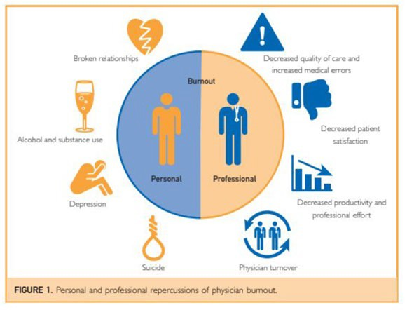

Burnout effects…
  - Physician
    - Satisfaction
    - SUD, alcoholism, divorce, depression, anxiety
    - Suicide
  - Patient
    - Satisfaction
    - Engagement
    - Quality
    - Safety
  - Practice
    - Income
    - Teamwork and team moral
    - Healthcare costs

10

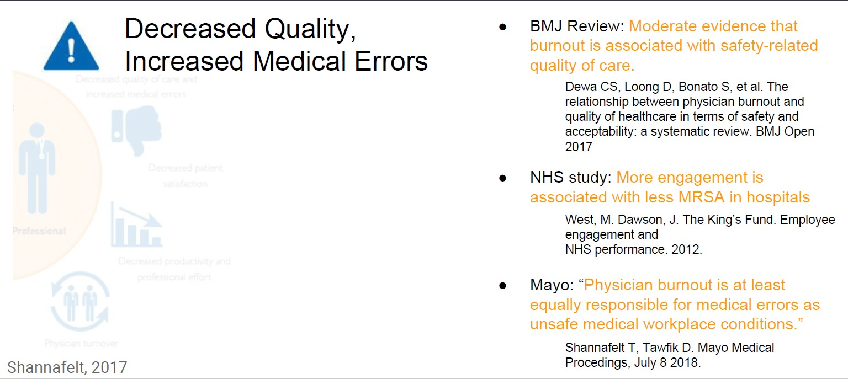

Consequences of Burnout

11

Too Many Quality Metrics: Tragedy of the Commons

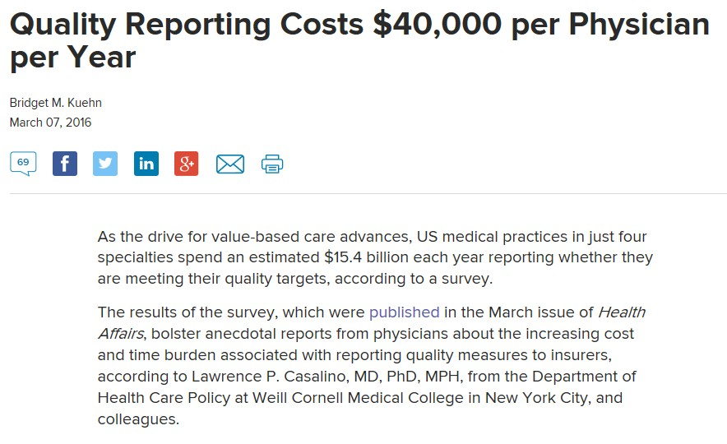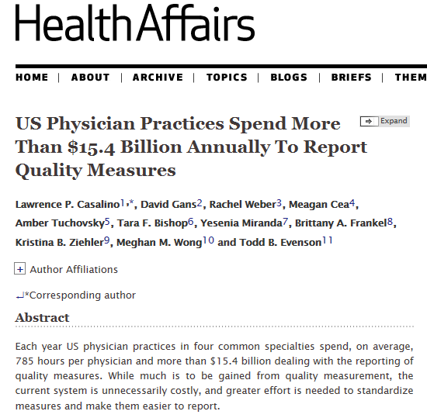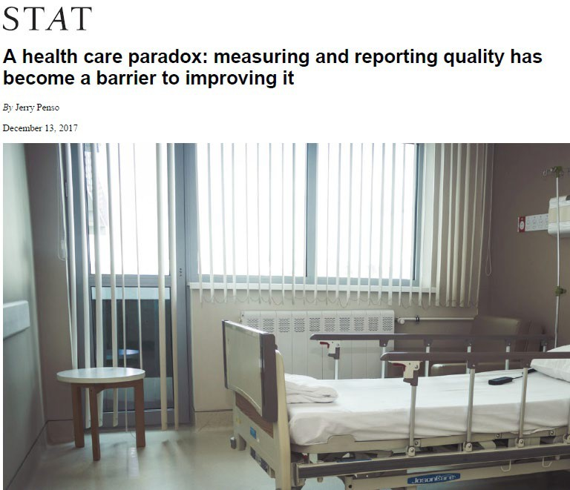

Importance: Measuring and reporting quality has become a barrier to improving it
-63% of physicians reports that current measures do not capture the quality of the care that physicians provide
-Significant burden: Physicians are spending $15.4 billion each year-$40,000 per physician -close to 80 days of work time/year on reporting quality measures

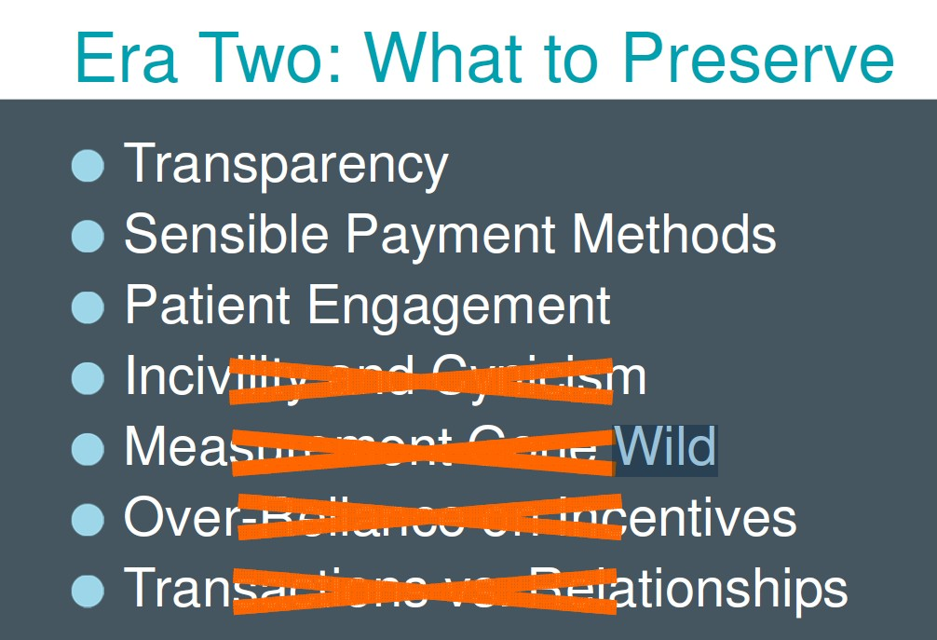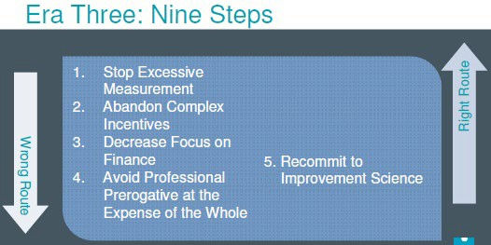

Importance of reducing measurement burden
Even strongest advocates of Quality Measurement like Dr. Berwick and IHI are recognizing the needs to balance and reduce measurement burden

Source: Recent Presentation at IHI

Etiology:
Due to Improvement and Innovation Lagging Significantly Behind Measurement/Control

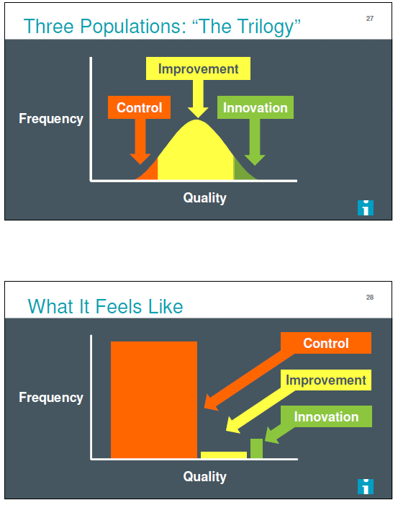Conclusion:
Quality metrics for cardiovascular disease are here to stay, though their utility in improving patient outcomes remains unclear. Measuring quality does seem to improve quality for processes of care, but unless these process measures are closely linked to patient-relevant outcomes, such as mortality,
hospital readmission, or patient experience, they may not have maximal impact.

Source: Recent Presentation at IHI

Proposed Solutions: Recent efforts to improve the quality of quality measurement

 | Launch year | Key Convener | Minimizing admin burden one of the core principles | Link | Burnout Taskforce Comments
Core Quality Measures Collaborative (CQMC) | 2015 | AHIP, NQF, CMS and  total 55 stakeholder organizations | Yes | http://www.qualityforum.o rg/cqmc/ | Agree and appreciate their aims and principles
CMS’s Meaningful Measures Framework | 2017 | CMS | Yes | https://www.cms.gov/Medi | Appreciate patients over
 |  |  |  | care/Quality-Initiatives-  Patient-Assessment- | paperwork initiative
 |  |  |  | Instruments/QualityInitiativ
 |  |  |  | esGenInfo/CMS-Quality-
 |  |  |  | Strategy.html
Statewide Quality Advisory Committee (SQAC) | 2010-  reestablishe d in 2012 | State-CHIA | ? | http://www.chiamass.go v/sqac/ | SQMS included 130  measures vs 800
The Massachusetts EOHHS Quality Alignment Taskforce | 2018 | State- EOHHS | ? | https://www.mass.gov  /info-details/eohhs-  quality-measure- | Seeking uniformity across plans/payment models, under 15 total,
 |  |  |  | alignment-taskforce | (inc. monitor burnout)

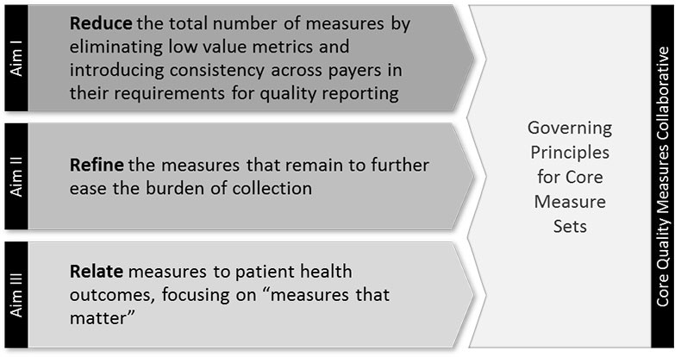Example of Aims/Principles for Balancing Quality Measurement

CQMC
EOHHS Quality Alignment Taskforce
- Evidence-based, scientifically acceptable, nationally-endorsed and valid at the level at which it is being used (ACO-level in particular).
- Required data should be either readily available, not overly burdensome to collect, or, if burdensome, of demonstrable value for improving patient care.
- Represents an opportunity for improvement.
- Is important to consumers and supports the triple aim of better care, better health and lower cost.
- Prioritize health outcomes, including measures sourced from clinical and patient-reported data.
- Provide a largely complete and holistic view of the entity being evaluated (e.g., ACO, primary care practice, hospital).
- The measure set should strive for parsimony.
- Taken as a whole, high performance on the proposed measure set should significantly advance the delivery system toward the goals of safe, timely, effective, efficient, equitable, patient-centered (STEEEP) care.
- Promotes value for consumers, purchasers, and providers.

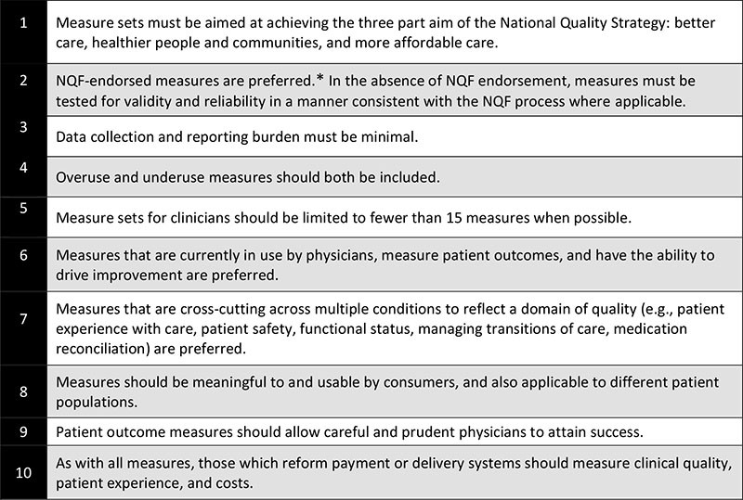

Criteria for measure selection

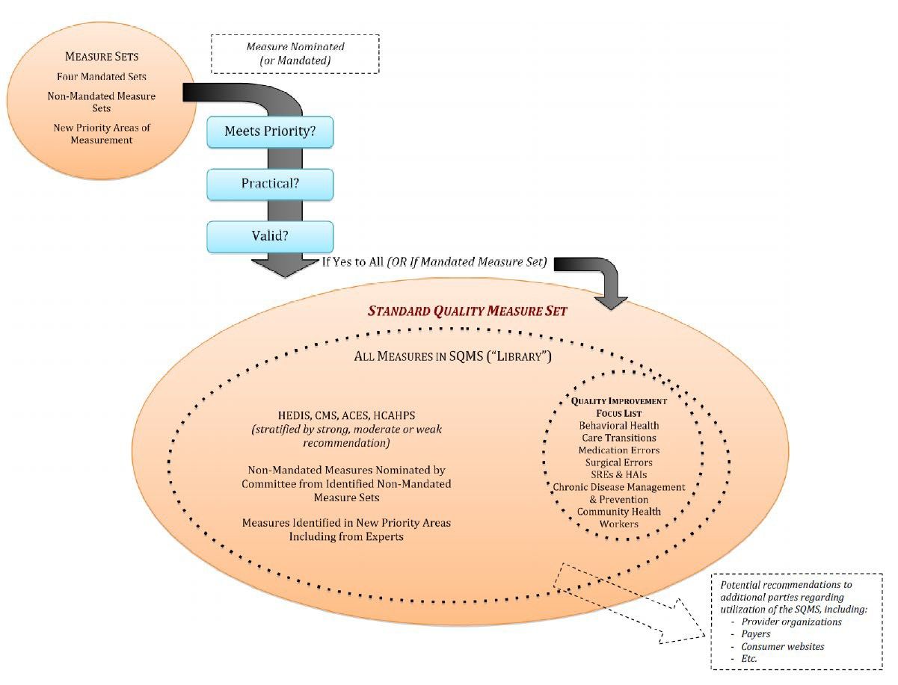

March 30, 2012 SQAC Internal Framework for Standard Quality Measure Set Striving for Practical, Valid measures aligned to overarching priorities of improving patient care

19

Proposed Solution

Help reduce administrative burden and improve patient care by having
  - Aligned (across all plan and payment models) measures
- Alignment among local and national payers and government agencies is critical

  - Limited Numbers of Meaningful Measures (Under 15)
- Those that matter to Patients and Physicians and can be measured without inordinate administrative work

20

How do you Improve Care?

Stanford: “Professional fulfillment of clinicians is inextricably linked to
quality, safety and patient-centeredness.”

21

Primary ask:

  - Help Reduce Administrative Burden and Improve Patient Care by…

Aligned, Uniform Quality Measures across Plans and Payment Models
  - Thus Improve Quality of Care for Patients

22

Thank You!

Agenda

Welcome
CONFIDENTIAL WORKING DRAFT – POLICY IN DEVELOPMENT
- Recap of 2-27-19 Meeting Decisions & Discussion of Follow-up Items
- The Impact of Performance Measures on Clinician Burnout
4. Continued Discussion of Partners’ eCare Measures

- Quality Measure Catalogue Findings
- Update on Clinical Data Repository Development Efforts
- Impact of NCQA Proposed HEDIS Updates on the Aligned Measure Set
- Next Steps
Note: Topics 5 through 7 were not discussed during this meeting due to lack of time.
24

Partners’ eCare Measures

- On 2/27, Christian Dankers, Amy Feeney, and Nicole Larue shared information about the Partners eCare measures with the Taskforce.
CONFIDENTIAL WORKING DRAFT – POLICY IN DEVELOPMENT
- After the meeting, Taskforce staff sent out a document on 3/8 framing the discussion about potential inclusion of eCare measures in the Innovation measures category. Taskforce staff requested feedback by 3/14.
- Five Taskforce members responded to the request. The following slides present their input.

25

Criteria for Assessing Innovation Measures

- Taskforce staff recommended the Taskforce consider the following when assessing the eCare measures:
CONFIDENTIAL WORKING DRAFT – POLICY IN DEVELOPMENT
- Do the eCare measures address clinical topics or clinical outcomes in the Core or Menu Sets utilizing a novel approach?
- Do the eCare measures pass a face validity test based on the information shared with you during the 2-26-19 Steering Committee meeting and specifications found on the Partners website: https://qualityandsafety.partners.org/Prevention-And- Chronic-Care/Default.aspx?
- Are eCare measures replicable (i.e., could other ACOs and payers adopt the measures for their own use such that the eCare measures could potentially become part of the Aligned Measure Set in the future)?

26

Feedback from Taskforce Members

- One respondent supported categorizing the eCare measures as Innovative, providing the following rationale:
CONFIDENTIAL WORKING DRAFT – POLICY IN DEVELOPMENT
  - “It will enable the collaboration between plans and provider groups to further explore the opportunities in EHR data exchange and quality measurement. As we all agree, there are many challenges in EHR data sharing and integration, but incorporating EHR data into measurement is the direction for the future. With NCQA aggressively shifting to e-measure specification, it is becoming more urgent to have such innovation in the field, even if just for the future viability of the existing core measures sourced from HEDIS. Any lesson learned from the innovation will help inform state, plans and providers on the path forward.”

27

Feedback from Taskforce Members

- Three respondents did not support categorizing the eCare measures as Innovative.
CONFIDENTIAL WORKING DRAFT – POLICY IN DEVELOPMENT
  - “They are too similar to publicly endorsed measures in the measure set we have - the engagement of these provider group measures should lead to higher rates in the already used publicly endorsed measures set.”
  - “These [are] HEDIS measures with the denominator changed to accommodate 100%. HEDIS is not about meeting 100% for the denominator.”
  - The measures do not meet the criteria we have set and their adoption could put us on a slippery slope. (paraphrased)

- One respondent asked how Partners had validated its measures, and also recommended the application of clear criteria to the decision process.
28

State’s Feedback

Assessment of Innovation Measures
Do the measures address:
CONFIDENTIAL WORKING DRAFT – POLICY IN DEVELOPMENT
- clinical topics or clinical outcomes in the Core or Menu Sets utilizing a novel approach?
  - NO (HEDIS adapted measures with exclusions to standard specifications, some differences in collection approach)
- clinical topics that are not addressed in the Core or Menu Sets?
  - NO (clinical topics are already addressed)
- Intent to advance measure development, not previously considered and rejected?
  - Yes (but advancements or changes in existing standard specifications should be addressed with the measure steward to advance their measure)
Consideration:
Innovative measures specifically adapted from standard measures should be used (if used at all) in addition to, not in lieu of using the standard measure in the Aligned Measure Set.
- Enables appropriate comparability and reporting of standard aligned measures
- Adaptations (i.e., exclusions, clinical changes etc…) to specifications of standard measures should be addressed through the measure stewards
- Innovative measures could be candidates in the future, for Aligned Measure Set adoption
Questions:
- Will measure stewards consider adaptations to their measures innovative or appropriate?
- Innovation measures: Fit for purpose? QI? Reporting? Performance? Comparability?

29

Agenda

Welcome
CONFIDENTIAL WORKING DRAFT – POLICY IN DEVELOPMENT
- Recap of 2-27-19 Meeting Decisions & Discussion of Follow-up Items
- The Impact of Performance Measures on Clinician Burnout
- Continued Discussion of Partners’ eCare Measures
- Quality Measure Catalogue Findings
- Update on Clinical Data Repository Development Efforts
- Impact of NCQA Proposed HEDIS Updates on the Aligned Measure Set

Note: Topics 5 through 7 were not discussed during this meeting due to lack of time.
8. Next Steps
30

Upcoming Meetings

  - April 29, 2:30-4:30pm
CONFIDENTIAL WORKING DRAFT – POLICY IN DEVELOPMENT
  - May 29, 2:30-4:30pm
  - June 24, 2:30-4:30pm

31

