Slide 1
Commonwealth of Massachusetts Executive Office of Health and Human Services
EOHHS Quality Measure alignment taskforce

Meeting #27
April 29, 2019
Confidential WORKING draft – policy IN DEVELOPMENT

Slide 2

Agenda

Welcome
- Recap of 3-20-19 Meeting Decisions & Discussion of Follow-up Items
- Impact of NCQA Proposed HEDIS Updates on the Aligned Measure Set
- Quality Measure Catalogue Findings
- Clinical Data Repository Development Efforts Update
- Concluding Discussion of eCare Measures
- Definitions of “Validated”, “Developmental Set” and “Innovation Measure”
- Reprocurement
- Next Steps

Slide 3

Agenda
- Welcome

Recap of 3-20-19 Meeting Decisions & Discussion of Follow-up Items
- Impact of NCQA Proposed HEDIS Updates on the Aligned Measure Set
- Quality Measure Catalogue Findings
- Clinical Data Repository Development Efforts Update
- Concluding Discussion of eCare Measures
- Definitions of “Validated”, “Developmental Set” and “Innovation Measure”
- Reprocurement
- Next Steps

Slide 4

3-20-19 Taskforce Meeting Follow-up Items
- Taskforce members were to email any recommendations on insurer and ACO communication about the intended use of the Core and Menu Sets to Justine.
- Taskforce staff were to further consider the eCare measures and bring final thoughts to the Taskforce during the April meeting.
  - To be discussed later today.
- Following the March Taskforce meeting, the MMS-MHA Joint Task Force on Physician Burnout agreed unanimously to support and advocate for the Core and Menu Measures as listed in the October 2018 report of the Massachusetts EOHHS Quality Alignment Task Force.

Slide 5

Other follow-up items – use of multi-payer data to generate adequate denominators
- In the 2020 Implementation Parameters, one of the proposed activities for 2019 is to revisit “the idea of using multi-payer case-mix data to generate adequate denominator sizes for at least select measures that would otherwise be problematic when generated on an individual payer basis.”
- The broader question here is if we could use CHIA’s APCD data to address challenges with measures with small denominator size at the individual payer/ACO dyad level.
- Taskforce staff looked into this possibility. These data likely cannot be used for contracting purposes due to the significant delay between the performance year and release of APCD data.
  - e.g., Release 7.0 on January 8, 2019, contained data for 2013-2017.
- Furthermore, provider-level analyses by ACO involve member attribution/enrollment, which adds additional complications.

Slide 6

Agenda
- Welcome
- Recap of 3-20-19 Meeting Decisions & Discussion of Follow-up Items

Impact of NCQA Proposed HEDIS Updates on the Aligned Measure Set
- Quality Measure Catalogue Findings
- Clinical Data Repository Development Efforts Update
- Concluding Discussion of eCare Measures
- Definitions of “Validated”, “Developmental Set” and “Innovation Measure”
- Reprocurement
- Next Steps

Slide 7

Impact of NCQA Proposed HEDIS Updates on the Aligned Measure Set
- NCQA has released for public comment proposed measure changes that apply across various measures for HEDIS 2020.
- Some of the proposed changes and cross-cutting topics impact measures in the Aligned Measure Set.
- Since we were unable to review NCQA’s proposed HEDIS 2020 changes during the March 20th meeting, we sent out a survey to Taskforce members following the meeting, requesting review by March 27th.
  - We received nine responses to the survey.
- We did so electronically because the terms of the Taskforce’s approved implementation parameters for the 2020 Aligned Measure Set had to be finalized by March 31st.

Slide 8

Impact of NCQA Proposed HEDIS Updates on the Aligned Measure Set
- All respondents supported adoption of these changes:
  - Cervical Cancer Screening adds primary screening with a high-risk human papillomavirus (hrHPV) test as a screening option. (Menu Measure)
  - Metabolic Monitoring for Children and Adolescents on Antipsychotics requires the reporting blood glucose and cholesterol testing separately and combining the 1–5 years and 6–11 years age strata. (Menu Measure)
  - Prenatal and Postpartum Care – Timeliness of Prenatal Care removes the requirement to only include visits that occurred while the member was enrolled. (Monitoring Measure)

Slide 9

Impact of NCQA Proposed HEDIS Updates on the Aligned Measure Set
- Taskforce staff also asked about updating the 2020 Implementation Parameters to reflect the following HEDIS changes:
- Add text to indicate that the Taskforce will revisit and confirm a final decision on use of the HEDIS 2020 specifications once NCQA finalizes the specifications in the fall.
- Add a footnote to indicate that the Taskforce intends to review and update that 2020 specifications to use HEDIS 2021 specification once they are released by NCQA in the winter of 2020.
- 8 of 9 respondents supported the changes above.

Slide 10

Impact of NCQA Proposed HEDIS Updates on the Aligned Measure Set Decisions
- Based on the feedback of the Taskforce, we have updated the Implementation Parameters.
- We will publish the final 2020 measure set and implementation parameters on the web site.
- We are planning to send an email message to ACOs and insurers informing them of their finalization.

Slide 11

Agenda
- Welcome
- Recap of 3-20-19 Meeting Decisions & Discussion of Follow-up Items
- Impact of NCQA Proposed HEDIS Updates on the Aligned Measure Set

Quality Measure Catalogue Findings
- Clinical Data Repository Development Efforts Update
- Concluding Discussion of eCare Measures
- Definitions of “Validated”, “Developmental Set” and “Innovation Measure”
- Reprocurement
- Next Steps

Slide 12

Quality Measure Catalogue: Background
- The purpose of the Quality Measure Catalogue is to capture the measures in use by payers in Massachusetts for the purposes of:
  - global budget-based risk contracts
  - tiering or limited network product methodology
  - consumer transparency
- CHIA and the HPC have been collecting these data since 2013.

Slide 13

Quality Measure Catalogue: Background
- In December 2018, the Taskforce issued a request for all Massachusetts commercial payers (N=12) to complete submissions to the Quality Measures Catalogue (QMC) by January 18, 2019.
  - Eight payers submitted responses to the QMC (Fallon was excluded from the analysis because the submission was incomplete).
    - Update (6/25/19): Fallon has submitted a complete catalogue, which is incorporated in the analysis now presented in slides 15-18.
  - Four payers did not complete the QMC request (Aetna, Cigna, CCA and United*).
*United responded to the request and indicated that it did not have any global budget-based risk contracts at present.

Slide 14

Quality Measure Catalogue: Questions
- Payers were asked to answer all of the following questions for each measure:
1. Is this measure used in global budget contracts? (Y/N)
1a. If yes, # of contracts (#)
1b. Is the measure Pay for Performance in Contracts? (Y/N)
1b. Is the measure Pay for Reporting in Contracts? (Y/N)
2. Is the measure used for tiering or limited network product methodology? (Y/N)
3. Is the measure used for consumer transparency information about provider performance (e.g., website)? (Y/N)
4. Is performance risk-adjusted for this measure? (Y/N)
5. Have you modified the measure specifications for this measure? (Y/N)
5a. If yes, please specify the changes to the measure specifications.
- Payers were asked to add any measures not included in the spreadsheet, and to respond to the questions as applicable.
  - Update (6/25/19): This analysis excludes measures added by payers and only considers measures the Taskforce reviewed for the Aligned Set, because the majority of measures added by payers are hospital measures, which the Taskforce intentionally did not review for the 2019 set.

Slide 15

Overview of quality measures in use in any contract by MA commercial payers
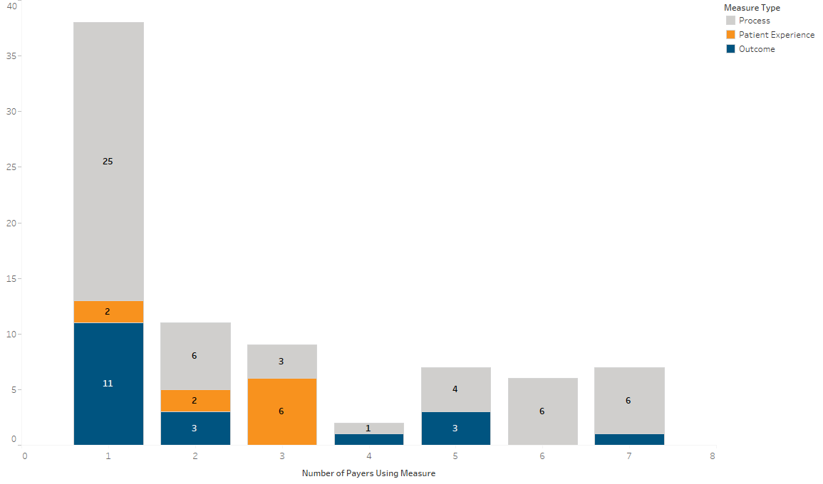
- A total of 185 measures were reviewed by the Taskforce and considered in this analysis
- For the eight reporting payers, a total of 80 unique measures are used in contracts
- Of these 80, 38 measures (47.5%) are used by a single payer
- No measure used by all eight reporting payers
- Only one outcome measure is used by seven payers:
  - Comprehensive Diabetes Care: Blood Pressure Control (<140/90 mm Hg)

Slide 16

Overview of quality measures in use in at least 10 contracts by MA commercial payers
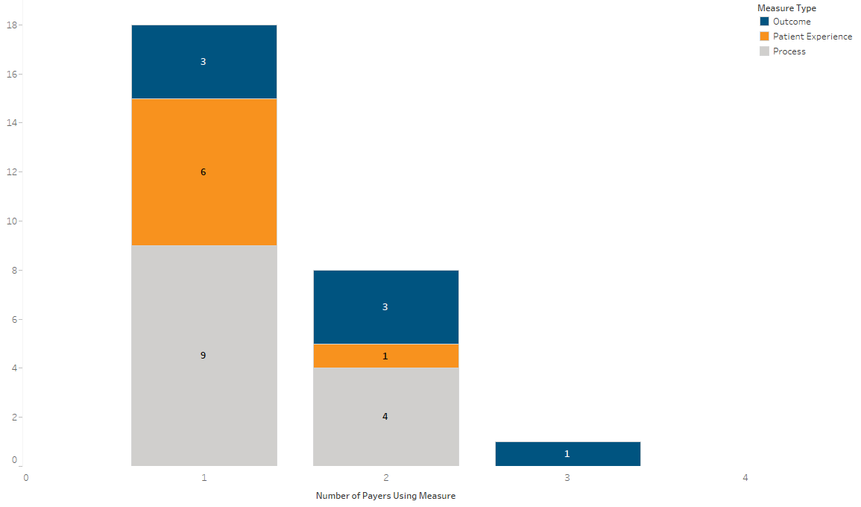
- Three of the eight reporting plans reported use of some measures in ≥ 10 contracts
- A total of 27 unique measures are used in ≥ 10 contracts
- Process measures are the most commonly used measures in ≥ 10 contracts, accounting for 13 of the 27 measures (48.1%)
- 18 of the 27 measures used in ≥ 10 contracts are not shared across more than one payer
- One measure included by all three plans in ≥ 10 contracts:
  - Comprehensive Diabetes Care: Blood Pressure Control (<140/90 mm Hg)

Slide 17

Plans Use of Core and Menu Measures in Any Contract
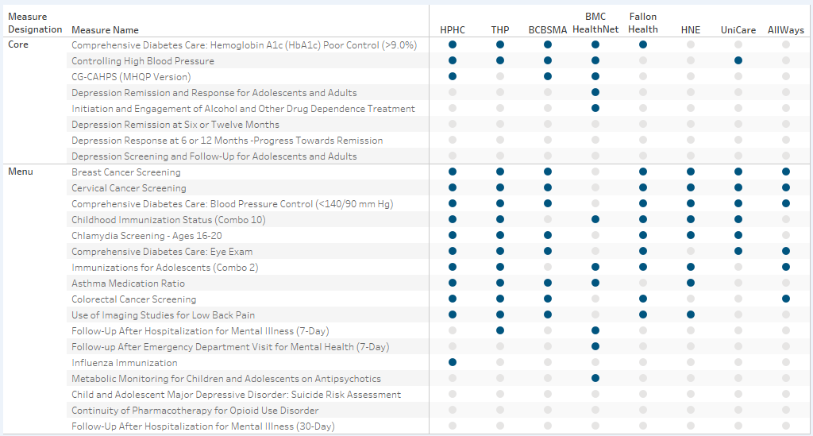
- Only two plans report using behavioral health measures from the core and menu sets
  - BMC HealthNet
    - Depression Remission and Response for Adolescents and Adults (Core)
    - Initiation and Engagement of Alcohol and Other Drug Dependence Treatment (Core)
    - Follow-Up After Hospitalization for Mental Illness (7-Day) (Menu)
    - Follow-Up After Emergency Department Visit for Mental Health (7-Day) (Menu)
    - Metabolic Monitoring for Children and Adolescents on Antipsychotics (Menu)
  - Tufts Health Plan
    - Follow-Up After Hospitalization for Mental Illness (7-Day) (Menu)

Slide 18

Plans report continued use of non-endorsed quality measures and developmental/monitoring measures in contracts
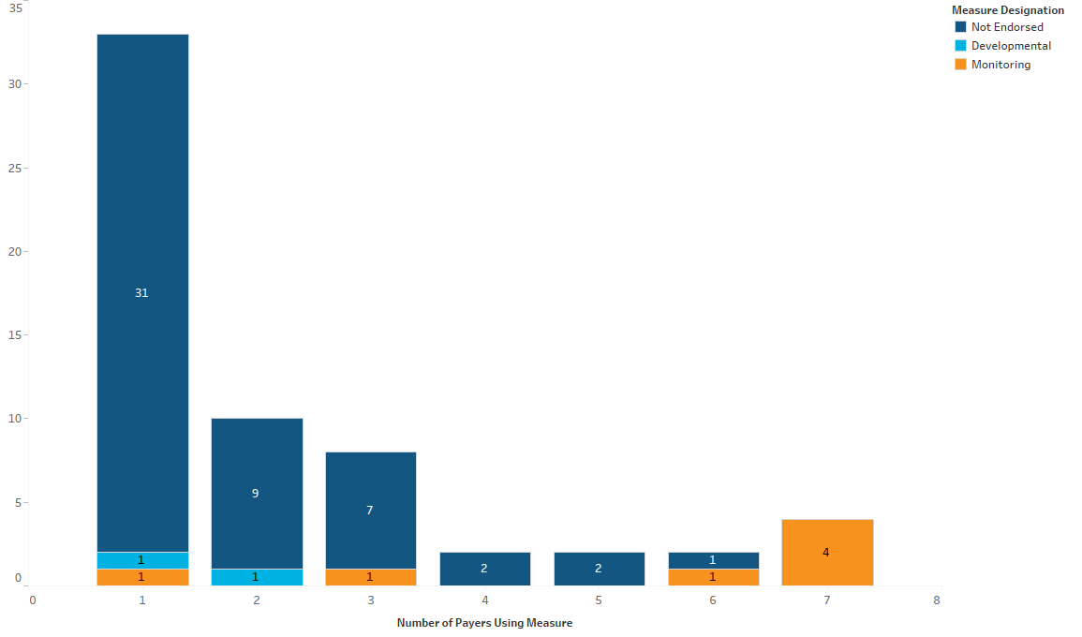
- Many non-aligned measures continue to be included in global budget based contracts
- 52 non-endorsed measures are in use in contracts, and 31 by only a single payer
- Developmental measures include: 35 – Community Tenure (used by 1 payer); 37 - Joint Replacement Patient Reported Outcome Measure (used by 2 payers)

Slide 19

Process for Registering and Tracking Innovation Measures
- In 2018, HPC and CHIA committed to overseeing implementation of the Massachusetts Aligned Measure Set into ACO contracts. As part of this work, they needed to create a process to “register” or track Innovation measures.
- Through its collection of Quality Catalogue survey responses, the HPC and CHIA identified a few measures in use that might qualify as Innovation measures.
- Taskforce staff followed up with the payers using these measures to request additional information to determine if their measures meet the Innovation criteria.

Slide 20

Process for Registering and Tracking Innovation Measures
- One payer indicated that it chose to be overly inclusive in its submission to aid in the discussion. For the measures identified by Taskforce staff, the payer is in the data collection process and does not consider these to be contractual performance measures.
- One payer clarified that they are no longer using the measures in question.
- Moving forward, HPC and CHIA will add additional questions to the Quality Catalogue to identify potential Innovation measures.

Slide 21

Promoting Adoption of the Aligned Measure Set
- Since contract negotiations for 2020 have already begun in some cases, and one of the Taskforce’s 2019 goals is to advise EOHHS on the Adoption of the Aligned Measure Set, we would like to consider strategies for encouraging adoption of the Aligned Measure Set.

How does the Taskforce recommend that the State and/or Taskforce members promote adoption of the Aligned Measure Set?

Slide 22

Agenda
- Welcome
- Recap of 3-20-19 Meeting Decisions & Discussion of Follow-up Items
- Impact of NCQA Proposed HEDIS Updates on the Aligned Measure Set
- Quality Measure Catalogue Findings

Clinical Data Repository Development Efforts Update
- Concluding Discussion of eCare Measures
- Definitions of “Validated”, “Developmental Set” and “Innovation Measure”
- Reprocurement
- Next Steps

Slide 23

Clinical Data Repository Development Efforts Update
- Understanding key stakeholder needs and current data capabilities and challenges
- Stakeholder engagement and feedback sessions
- Data sources, data flow, data capabilities
- MassHealth comprehensive quality measurement strategy
- Defining the business case(s) for the CDR
- Strategic options/approaches in developing the CDR
- Translation into the technical development of the CDR

Slide 24

MassHealth RFR – Comprehensive Quality Vendor
- EOHHS is seeking a qualified vendor to implement a comprehensive Quality Measure program involving data collection, calculation, analytics, and reporting tasks … for certain managed care programs
- A fundamental component of this strategy is a set of quality measures that assesses and monitors the quality of care and services provided to MassHealth members and that also informs continuous quality improvement efforts.
- MassHealth selects a slate of performance measures and a slate of monitoring measures for each program, which typically consists of standardized measures, including but not limited to HEDIS measures, and Non-HEDIS measures developed by MassHealth.

Slide 25

MassHealth RFR – Comprehensive Quality Vendor
- To the fullest extent possible, MassHealth aligns quality measures across the ACO, MCO, and CP programs, and the PCC Plan. Any variation in quality measures across these four programs may be because of differences in programmatic goals and the populations the programs serve.
- MassHealth will continue to strive toward quality alignment and opportunities to streamline measurement processes as appropriate across all its programs

Slide 26

MassHealth RFR Timeline

PROCUREMENT TIMETABLE
The following RFR Schedule of Events represents EOHHS’s best estimate of the schedule that shall be followed.
RFR Issued | February 14, 2019
Bidder’s Optional Letter of Intent due (See Section 5.6) | February 22, 2019, 12:00 PM EST
Bidders’ Written Questions due (See Section 5.7) | February 22, 2019, 12:00 PM EST
Electronic Responses (Quotes) Due on COMMBUYS (See Section 3.1.A)  (Note: COMMBUYS refers to this deadline as the “Bid Opening Date”) | March 14 18, 2019, 4:00 PM EST
Hard Copy and Flash Drive Responses Due to EOHHS (See Section 3.1.B) | March 14 18, 2019, 4:00 PM EST
Anticipated Contract Effective Date | May 1, 2019
EOHHS may adjust this schedule as it deems necessary.
Notification of any adjustment to the RFR Timetable shall be posted on COMMBUYS.

Slide 27

Agenda
- Welcome
- Recap of 3-20-19 Meeting Decisions & Discussion of Follow-up Items
- Impact of NCQA Proposed HEDIS Updates on the Aligned Measure Set
- Quality Measure Catalogue Findings
- Clinical Data Repository Development Efforts Update

Concluding Discussion of eCare Measures
- Definitions of “Validated”, “Developmental Set” and “Innovation Measure”
- Reprocurement
- Next Steps

Slide 28

Concluding Discussion of eCare Measures: Analysis
- Over the course of the last two Taskforce meetings we have devoted considerable time to discussion of Partners’ request that its “eCare” measures be considered “Innovation Measures” under the Taskforce’s measure categorization framework.
- Taskforce staff have concluded there are multiple unanswered questions regarding the Partners eCare measures and that they have not been fully validated. For this reason Taskforce staff believe these measures should be categorized as Developmental Measures, as defined by the Taskforce.

Slide 29

Concluding Discussion of eCare Measures: Analysis
- Until now, the Taskforce has conceived of Developmental Measures as not ready for use in contracts. In this case, however, there is an insurer and provider pair that is willing to adopt Developmental measures for contractual use (and adoption is not considered problematic by the ACO).
- With all of this as context, Taskforce staff recommend the following...

Slide 30

Concluding Discussion of eCare Measures: Recommendations
- Developmental and Innovation Measures may be used in contracts so long as they are in addition to, not in lieu of, the Core and Menu Measures.
- It is outside the scope of the Taskforce to provide specific guidance on monetary values that should be attached to measures; however, an insurer may not attach a de minimis amount to a Core Measure such that performance on the Core Measure lacks meaningful financial implication for the provider.

Slide 31

Concluding Discussion of eCare Measures: Recommendations (cont’d)
- The Taskforce supports Partners' work in validating the eCare measures and requests Partners report back on the status of these measures in early 2020; specifically, on validation efforts related to the three concerns identified by the Taskforce:
  - the impact on provider quality improvement motivation when providers have the ability to exclude certain patients from the measure denominator;
  - whether the ability to exclude patients from the measure denominator will result in gaming behavior, and
  - whether the measures will truly better provider buy-in and engagement, especially because the eCare measures require more documentation than is required for HEDIS measures.

Slide 32

Concluding Discussion of eCare Measures
- These decisions would allow Partners and BCBSMA to utilize the eCare measures in their ACO contract and still be considered to be adhering to the parameters of the Aligned Measure Set.
- They would not, however, compel other payers to utilize them in their contracts with Partners, and the measures would remain outside the Core and Menu sets for the time being.

Slide 33

Concluding Discussion of eCare Measures
- Based on these deliberations, Taskforce staff also recommend revisiting the definitions of “Developmental Measures” and “Innovation Measures”, as well as defining “validated” for its use in definitions.
- We will discuss these definitions next.

Slide 34

Agenda
- Welcome
- Recap of 3-20-19 Meeting Decisions & Discussion of Follow-up Items
- Impact of NCQA Proposed HEDIS Updates on the Aligned Measure Set
- Quality Measure Catalogue Findings
- Clinical Data Repository Development Efforts Update
- Concluding Discussion of eCare Measures

Definitions of “Validated”, “Developmental Set” and “Innovation Measure”
- Reprocurement
- Next Steps

Slide 35

Define “Validated” for Use in the Definition of Developmental Set and Innovation Measure
- The Developmental Set includes measures and measure concepts that address priority areas for the Taskforce, but the measure has not yet been defined, validated and/or tested for implementation.
- Utilize the National Quality Forum (NQF) definition: “Validity refers to the correctness of measurement. Validity of data elements refers to the correctness of the data elements as compared to an authoritative source. Validity of the measure score refers to the correctness of conclusions about quality that can be made based on the measure scores (i.e., a higher score on a quality measure reflects higher quality).”*
*www.qualityforum.org/Measuring_Performance/Scientific_Methods_Panel/Meetings/2018_Scientific_Methods_Panel_Meetings.aspx

Does the Taskforce recommend adoption of the NQF definition of validity?

Slide 36

Refine the Definition of Developmental Set
- Taskforce staff also recommend refining the Developmental Measure Set definition to make explicit that willing payers and ACOs may utilize them in their contracting.
- The Developmental Set includes measures and measure concepts that address priority areas for the Taskforce, but the measure has not yet been defined, validated and/or tested for implementation. Willing payers and providers may use these measures in their value-based contracts.
- The rationale is that the Taskforce should not impede a willing ACO from using Developmental Measures in its contract, since doing so does not create a measure non-alignment problem in the eyes of the ACO.

Does the Taskforce support the updated definition?

Slide 37

Refine the Definition of Innovation Measure
- Taskforce staff recommend modifying and clarifying the definition of Innovation measures so that it is clear that such measures must be thoroughly validated, thereby ensuring that a measure can no longer fit both Innovation and Developmental definitions.
- The Innovation measure category includes measures which address a) clinical topics or clinical outcomes in the Core or Menu Sets utilizing a novel approach or b) clinical topics that are not addressed in the Core or Menu Sets. Innovation measures are well-defined, and have been validated and tested for implementation. Innovation measures are intended to advance measure development and therefore cannot include measures that have been previously considered and rejected by the Taskforce as potential Core or Menu measures. Innovation measures can be used on a pay-for-performance or pay-for-reporting basis at the mutual agreement of the payer and providers. For payers choosing to voluntarily adopt the Massachusetts Aligned Measure Set and its associated parameters, use of Innovation measures, at the outset, will not be limited in number. The Taskforce will monitor and revisit use of Innovation measures. The Taskforce will evaluate Innovation measures, once developed and tested, for inclusion in the Menu, or On Deck, or Developmental Sets.

Does the Taskforce agree with the updated definition?

Slide 38

Agenda
- Welcome
- Recap of 3-20-19 Meeting Decisions & Discussion of Follow-up Items
- Impact of NCQA Proposed HEDIS Updates on the Aligned Measure Set
- Quality Measure Catalogue Findings
- Clinical Data Repository Development Efforts Update
- Concluding Discussion of eCare Measures
- Definitions of “Validated”, “Developmental Set” and “Innovation Measure”

Reprocurement
- Next Steps

Slide 39

Reprocurement
- The terms of Taskforce members are two years; the current term ends in May.
- EOHHS will reappoint current Taskforce members who would like to continue participating for another two-year term, and will reprocure for those positions that are vacant.
- EOHHS will also use this opportunity to restate the scope of the Taskforce.
- Taskforce staff will be in touch soon regarding next steps.

Slide 40

Agenda
- Welcome
- Recap of 3-20-19 Meeting Decisions & Discussion of Follow-up Items
- Impact of NCQA Proposed HEDIS Updates on the Aligned Measure Set
- Quality Measure Catalogue Findings
- Clinical Data Repository Development Efforts Update
- Concluding Discussion of eCare Measures
- Definitions of “Validated”, “Developmental Set” and “Innovation Measure”
- Reprocurement

Next Steps

Slide 41

Expression of Appreciation
- As we approach the end of two years, and 27 (!) Taskforce meetings, EOHHS, CHIA and the HPC convey appreciation to all of you for having given your time, attention, intellect and judgement to this process.
- Health care in the Commonwealth will be better off in the future for your efforts.

Slide 42

Upcoming Meetings
- May 29, 2:30-4:30pm
- June 24, 2:30-4:30pm

