Slide 1

Measure alignment in Rhode Island
Cory king
Director of policy
Rhode Island office of the health insurance commissioner
October 16, 2019

Slide 2

About Office of the Health Insurance Commissioner (OHIC)
The Office of the Health Insurance Commissioner (OHIC) was created by the Rhode Island General Assembly in 2004. The agency is charged with protecting consumers, ensuring fair treatment of health care providers, guarding the solvency of insurers, and improving the health care system as a whole.
RIGL 42-14.5-2 http://webserver.rilin.state.ri.us/Statutes/TITLE42/42-14.5/42-14.5-2.HTM

Slide 3

Agenda
- Rhode Island’s Rationale for Measure Alignment
- Foundational Efforts
- Structure of the Measure Sets
- Annual Review Process – Review Committee
- Annual Review Cycle
- Compliance Reviews
- Reflections

Slide 4

Rhode Island’s Rationale for Measure Alignment
- Proliferation of value-based contracts.
- Reduce administrative burden faced by providers.
- Channel clinical focus on core dimensions of care delivery.
- Fulfill the requirements of the SIM Model Test Grant.

Slide 5

Foundational Efforts
- August 2015 – October 2016: OHIC convened a Measure Alignment Work Group.
  - The Work Group developed measure sets for:
    - Accountable Care Organizations;
    - Hospitals;
    - Primary Care Providers
    - Maternity Care
    - Behavioral Health (MH/SUD)
- August 2016: OHIC conditioned the approval of individual and group market premiums on adherence to the aligned measure sets.
- January 2017: OHIC promulgated regulations mandating adherence to the measure sets and formally constituting an annual review process.

Slide 6

Work group members
- BCBSRI
- UnitedHealthcare
- Tufts Health Plan
- Neighborhood Health Plan of Rhode Island
- Lifespan
- Care New England
- RIPCPC
- Integrated Healthcare Partners
- CTC-RI
- HealthCentric Advisors
- RI Health Center Association
- Coastal Medical
- RIDOH
- EOHHS/Medicaid
- BHDDH
- Blackstone Valley CHC
- Hospital Association of RI
- Prospect/CharterCARE
- Providence Community Health Centers
- RI Medical Society
- RI Parent Information Network

Slide 7

Structure of the Measure Sets
- Core measures
- Menu measures
- Developmental Measures

Slide 8
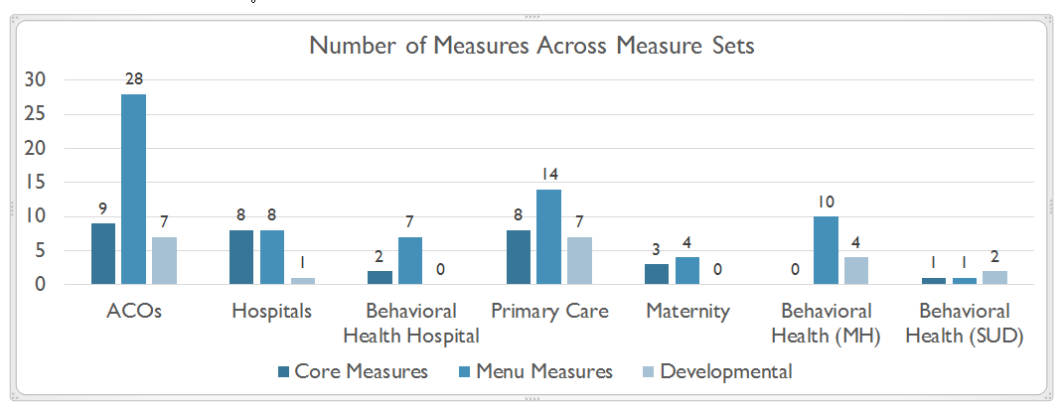

Slide 9

Annual review process - Review Committee
- In July OHIC convenes the Quality Measure Alignment and Review Committee.
- The Committee is charged with developing recommendations for the Commissioner that propose:
  - Modifications to the aligned measure sets.
  - Measures as core or menu measures.
  - The creation of other measure sets.
- The Review Committee completes its work by the end of August.
- The Commissioner reviews the recommendations of the Committee and issues final measure sets, measure specifications, and guidance by October 1.
- Measure sets become effective for contracts subject to amendment or renewal on or after January 1 of the following year.

Slide 10

Annual Review cycle
January–March
Developmental work and planning.
May–June
Survey payers and interested parties on measures.
July–September
Hold meetings of Review Committee
October
Commissioner issues measures sets and guidance.
Post-October
Health insurers implement the modified measure sets in their contracts which are
amended or renewed on or after January 1.

Slide 11

Compliance
- OHIC possesses statutory authority to examine health insurer contracts with providers.
- Compliance with the measure sets will be assessed in 2020.
- Noncompliant health insurers are subject to administrative penalties.

Slide 12

Reflections
- Measure alignment has been a very collaborative experience in Rhode Island.
- Medicaid has voluntarily adopted the measure sets and plays a role the annual review.
- Stakeholder feedback:
  - “Stakeholders offered mostly positive feedback about OHIC’s effort to create alignment across measure sets. Stakeholders believe that movement towards measure alignment will reduce some of the administrative burden on providers. They also support the use of a core measure set.” – from Evaluation Report.
  - “Having the quality measures gets people more focused on quality performance. Gets doctors to focus in and use the measures for improvement.” – from Evaluation Report.

Slide 13
Questions

