Slide 1

Commonwealth of Massachusetts
Executive Office of Health and Human Services (EOHHS)
EOHHS Quality Measure alignment taskforce
Meeting #29
October 16, 2019

Slide 2

Agenda
- Welcome
- Rhode Island’s Aligned Measure Sets
- Review Updated Taskforce Charter
- Developmental Measure Updates
- Next Steps

Slide 3

Agenda
- Welcome
- Rhode Island’s Aligned Measure Sets
- Review Updated Taskforce Charter
- Developmental Measure Updates
- Next Steps

Slide 4

Agenda
- Welcome
- Rhode Island’s Aligned Measure Sets
- Review Updated Taskforce Charter
- Developmental Measure Updates
- Next Steps

Slide 5

Review Updated Taskforce Charter
- Prior to today’s meeting, we shared with you a redlined version of the Taskforce Charter.
- The revised charter reflects input received from you:
- during the 9/23 Taskforce meeting and
- written feedback received following the meeting.
- Today, we will walk through the revised charter.

Slide 6

Agenda
- Welcome
- Rhode Island’s Aligned Measure Sets
- Review Updated Taskforce Charter
- Developmental Measure Updates
- Next Steps

Slide 7

Developmental Measure Activity
As a reminder, one of the Taskforce’s 2019 priorities is to track or sponsor four prioritized developmental measures.
Measure/Measure Concept | Mechanism for Development
Monitor external work
“Depression Remission or Response for Adolescents and Adults” | Monitor collaboration between BCBSMA and MassHealth and their partnership with PBGH/ICHOM
Joint replacement patient-reported outcome measure | Monitor CMS-funded work of David Bates and others working in this area
“Kindergarten Readiness” | Monitor development by the Oregon Health Authority
Active role in measure development
Stratification of measures to understand equity and disparities | Collaboration among interested organizations with project leadership and support from DPH, CHIA, and HPC

Slide 8

Depression Remission or Response for Adolescents and Adults
- Over the summer, BCBSMA and MassHealth participated in discussions about what depression measures in use, how data are collected, challenges in adoption and development best practice implementation guide.
- Activities included:
- Meeting with PBGH: Sharing MassHealth, BCBSMA and Integrated Healthcare Association (California) experience collecting data for PHQ-9)
- Participating in a day-long best practices symposium for PHQ-9 implementation leaders from: CA, MA (BCBSMA, Mt. Auburn, Partners), MN, NY,WA, CMMI (CMS)
- Key topic areas discussed included:
- What measures to use, when and how?
- Clinical workflow and data integration
- Patient engagement
- Building consensus, and moving the measurement and collection forward

Slide 9

Depression Remission or Response for Adolescents and Adults

Key Takeaways
- Clinical workflow and data integration
- Providers vary significantly in reporting major depressive disorder (measure requires dx and PHQ-9 screen)
  - e.g., MDD is a risk adjuster for Medicare
  - e.g., Many PCPs do not record a diagnosis of depression, rather: adjustment disorder with depressed mood – “don’t want to saddle the patient with a depression diagnosis in the chart”
- Allow flexibility for how and when PHQ-9 is collected/captured across sites and do not restrict modes of administration (in-person, telephone, tablet, paper, etc.)
- It is important to have some centralized tracking and outreach support
- Providers want funding to support infrastructure (e.g., EMR alerts, EPIC integration/customization, successful tools and formats to accelerate PHQ-9 user adoption)

Slide 10

Depression Remission or Response for Adolescents and Adults

Key Takeaways (continued)
- Patient engagement
- Education around addressing treatment: Not a matter of choosing the “right medication”, but a continuous effort to monitor/adjust based on data
- Set expectations for periodic assessments, show trends/trajectory
- Patient engagement in PROs is relationship with provider and warm hand-off to others on the care team
- Building consensus and moving the measurement/field forward
- Focus first on screening (use of PHQ-9) and follow-up measurement
- Consider varying levels of readiness; organizations will be discouraged if focus is immediately on the end result (remission)
- PROMs are important to incorporate in quality incentive programs
  - Incentive funding should be staged to support adoption process over time using a “measure cascade” moving from reporting to process improvement to outcomes.

Slide 11

Depression Measures in the 2020 Aligned Measure Set
As a reminder, the current Aligned Measure Set currently specifies the following in the Core:
- “At least one of the following behavioral health measures:
- Initiation and Engagement of Alcohol and Other Drug Abuse or Dependence Treatment (either the Initiation or Engagement Phase)
OR
- At least one of the following depression-related measures:
- Depression Screening and Follow-Up (CMS or NCQA)
- Depression Response – Progress Towards Remission (MNCM)
- Depression Remission (MNCM)
- Depression Remission or Response (NCQA)”

Slide 12

Depression Measure Recommendations for the 2021 Aligned Measure Set
- Retain Depression Screening and Follow-Up (CMS or NCQA) in the Core Set.
- This measure is currently implementable and focuses on making sure that follow-up is occurring, which is where the greatest opportunity for improvement exists. Also, allows flexibility for those able to use ECDS.
- This measure is currently implementable and focuses on making sure that follow-up is occurring, which is where the greatest opportunity for improvement exists. Also, allows flexibility for those able to use ECDS.
- Retain Depression Remission or Response (NCQA) as a Developmental Measure.
- Rate of follow-up is currently too low to make the measure viable.
- Remove the following three measures as Core Set options:
- Depression Response – Progress Towards Remission (MNCM)
- Depression Remission (MNCM)
- Depression Remission or Response (NCQA)

Slide 13

Depression Measure Recommendations for the 2021 Aligned Measure Set
- Consider during the upcoming 2019 annual review process whether Initiation and Engagement of Alcohol and Other Drug Abuse or Dependence Treatment (NCQA) should be in the Core or Menu Set.

- Does the Taskforce agree with these recommendations?

Slide 14

Kindergarten Readiness
- On 1/23/19, the Taskforce reviewed Oregon’s conceptual framework and proposed Kindergarten Readiness measures with the Taskforce.
- A final decision to include the measures in the 2020 Oregon incentive measure set was finalized over the summer.
- Oregon adopted two new measures for 2020 as part of its kindergarten readiness measure (which is really multiple measures to be phased in over time):
- Well-Child Visits in the 3rd, 4th, 5th, and 6th Years of Life (HEDIS)
- Members Receiving Preventive Dental Services, ages 1-5 (OHA)
- The next few slides will walk through additional information on Oregon’s process, measure, and next steps.
Source: https://www.oregon.gov/oha/HPA/ANALYTICS/CCOMetrics/2020-CCO-incentive-measures.pdf

Slide 15

Oregon’s Health Aspects of Kindergarten Readiness Technical Workgroup
Context: A time of opportunity to examine the health system’s role and responsibility in kindergarten readiness.
Charge: Recommend one or more health system measures that can be applied as incentive metrics to:
- drive health system behavior change, quality improvement, and investments in kindergarten readiness
- catalyze cross-sector collective action
- align with the goals of the CCO Incentive Program
Who: Children’s institute, Oregon Health, Oregon Pediatric Improvement Partnership (OPIP), and Artemis Consulting.

Slide 16

Oregon Kindergarten Readiness Measurement Strategy
2020 – Preventive dental visits for children 1-5 years old. Well-child visits for children 3-6 years old.
2022 – CCO attestation metric on social-emotional health.
2023 – Follow-up to developmental screening. (Future) Child-level metric on social-emotional health.
Health system behavior change, investments, and cross-sector efforts to improve kindergarten readiness

Slide 17

Oregon Kindergarten Readiness Measure Next Steps
- The measurement strategy proposal was fully endorsed; the first two metrics will be included in the CCO incentive metric set starting in 2020
- Work is underway to develop the two new measures addressing gaps in priority cross-sector topic areas (developmental screening and social-emotional health)
- The State needs to resolve the policy, capacity, funding, and practice barriers that exist in the larger early childhood system
  - e.g., build capacity in services that address children’s developmental and social-emotional needs
Does the Taskforce now want to convene a work group to consider a possible kindergarten readiness measure?

Slide 18

Joint replacement patient-reported outcome measure
On 6/14, Taskforce staff convened Massachusetts researchers, providers and payers previously identified by the Taskforce as being involved in joint replacement PROM development or implementation efforts, with the goal of understanding existing work in the state and sharing findings with the Taskforce.
Organization | Presenters
Blue Cross Blue Shield of Massachusetts | Wei Ying
Brigham and Women’s Hospital | David Bates  Ronen Rozenblum
Partners HealthCare System | Christian Dankers  Rachel Sisodia
UMass Memorial Medical Center and Medical School | David Ayers

Slide 19

Joint replacement patient-reported outcome measure
- Following the meeting, we distributed a memo to Taskforce members summarizing learnings, developmental activity, and next steps with the summary of June Taskforce activities update.
- It became clear that what the Taskforce has referred to as a patient-reported outcome measure (PROM) is actually a patient-reported outcome-based performance measure (PRO-PM).
  - PRO-PMs are performance measures, whereas PROMs are the tool with which patient data are collected.
  - We recommend that moving forward the Taskforce refer to this developmental measure topic as “joint replacement PRO-PM.”

Slide 20

PROMs Challenges
- Stakeholders identified a number of challenges facing the use of PROMs that need to be considered, as each of these issues impact the development and implementation of a standard PRO-PM.
- Standard Data Collection Method: There are many different joint replacement PROMs in use. While many in the community agree that joint-specific measures are appropriate, there is neither consensus on which version of the HOOS/KOOS should be used, nor whether the summary or a pain-specific score should be used. A PRO-PM would need to require use of a single tool or use of tools for which crosswalk comparisons have been developed, to ensure comparable results across providers.
- Risk Adjustment: There is no standard risk adjustment for the PROMs.
- Clinically Important Difference: There are no guidelines on what a clinically meaningful difference is in performance and how the performance score should be translated into clinical action.

Slide 21

PROMs Challenges
- Timing of Follow-up: Currently, some organizations are conducting the follow-up assessment at six months and others are conducting follow-up at one year. There does not appear to be a standard timing for follow-up survey administration.
- Loss to Follow-up: Participants noted that loss to follow-up is a significant challenge. One participant said that to be valid, one-year post-surgery assessments should be 80% complete (typical rates across the country are 40-49%).
- Racial and Ethnic Disparities: There is a lack of racial and ethnic diversity in available PROMs data. Therefore, clinical standards are being developed on a primarily white data set. Furthermore, most of the PROMs are only offered in English. One participant expressed concerns that the use of PROMs could actually propagate racial and ethnic disparities if special attention is not given to this issue.

Slide 22

PRO-PM Next Steps
- Taskforce staff will plan to connect with these same stakeholders to discuss the status of their work next June.
- Following the meeting, Taskforce staff learned that while there is no standard PRO-PM yet developed or in use in Massachusetts, there is in Minnesota.
- We recommend inviting Minnesota Community Measurement to present their measure to a subcommittee of the Taskforce interested in considering the measure for possible future Taskforce endorsement.
- Are there Taskforce members with interest in learning about Minnesota Community Measurement’s joint replacement PRO-PM?

Slide 23

Stratification of measures to understand equity and disparities
- Vision: To stratify quality measures for the purpose of measuring inequities and disparities.
- 2019 Objective: The Health Equity Workgroup will identify measures for a pilot of demographic stratification from the full list of the Massachusetts Aligned Measure Set with health equity implications. For this subset of measures, the Health Equity Work Group shall create a list of necessary data elements for stratification, and identify where improved collection of data elements is necessary to advance equity/disparity measurement.
- Workgroup, consisting primarily of Taskforce members, has convened three times in 2019.

Slide 24

Stratification of measures to understand equity and disparities
- Environmental Scan by Health Equity Work Group Stakeholders
- Payers and providers shared information in a standardized template on demographic variables currently used, including specifications for collection and attribution, and designating what could be made available for stratification of measures to the Health Equity Work Group.
- Work Group then prioritized variables based on findings reported.
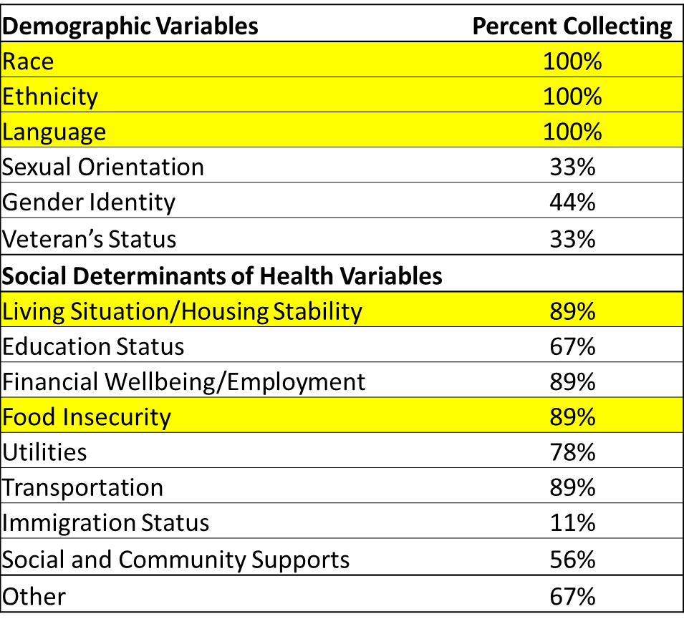

Slide 25

Stratification of measures to understand equity and disparities
Based on Work Group discussion and feedback, DPH is currently soliciting payers and providers re: feasibility of stratifying demographic and SDOH information for selected measures.
Abbreviated Measure Description
- Comprehensive Diabetes Care: Hemoglobin A1c (HbA1c) Poor Control (>9.0%)
- Controlling High Blood Pressure
- Depression Remission and Response for Adolescents and Adults
- Depression Remission at Six or Twelve Months
- Depression Response at 6 or 12 Months - Progress Towards Remission
- Depression Screening and Follow-Up for Adolescents and Adults
- Initiation and Engagement of Alcohol and Other Drug Dependence Treatment
- Asthma Medication Ratio
- Breast Cancer Screening
- Cervical Cancer Screening
- Child and Adolescent Major Depressive Disorder: Suicide Risk Assessment
- Childhood Immunization Status (Combo 10)
- Chlamydia Screening
- Colorectal Cancer Screening
- Comprehensive Diabetes Care: Blood Pressure Control (<140/90 mm Hg)
- Comprehensive Diabetes Care: Eye Exam
- Continuity of Pharmacotherapy for Opioid Use Disorder
- Follow-up After Emergency Department Visit for Mental Health (7-Day)
- Follow-Up After Hospitalization for Mental Illness (30-Day)
- Follow-Up After Hospitalization for Mental Illness (7-Day)
- Immunizations for Adolescents (Combo 2)
- Influenza Immunization
- Metabolic Monitoring for Children and Adolescents on Antipsychotics
- Use of Imaging Studies for Low Back Pain
- Adolescent Well-Care Visit
- Comprehensive Diabetes Care: Hemoglobin A1c Testing
- Comprehensive Diabetes Care: Medical Attention for Nephropathy
- Contraceptive Care - Postpartum
- Incidence of Episiotomy
- Prenatal & Postpartum Care - Timeliness of Prenatal Care
- Well-Child Visits in the 3rd, 4th, 5th, and 6th Years of Life
- Well-Child Visits in the First 15 Months of Life

Slide 26

Role of the Taskforce in Measure Development Work
- In 2019, the Taskforce prioritized tracking or sponsoring four prioritized developmental measures. Over the summer, Taskforce staff discussed the role of the Taskforce in measure development.
  - Taskforce staff expressed concern about the State resources required to take on active development and about the State leading development work.
- Taskforce staff therefore recommend adoption of a policy statement on the role of the Taskforce in measure development:
- Proposed Policy Statement: When the Taskforce identifies a priority measure gap, it will perform an environmental scan for measures and monitor ongoing measure development work. Should no suitable measure potentially be in development, the Taskforce will not undertake measure development. In some cases, however, the Taskforce may assume work to adapt existing measures to fill a priority measure gap.
- Does the Taskforce have any feedback on the proposed policy statement?

Slide 27

Agenda
- Welcome
- Rhode Island’s Aligned Measure Sets
- Review Updated Taskforce Charter
- Developmental Measure Updates
- Next Steps

Slide 28

Next Meeting
- Finalize Taskforce Charter
- Discuss the process for considering homegrown measures
- Begin annual review of the Aligned Measure Set
- Review Quality Catalogue survey results
- Consider whether to add hospital measures for the 2021 set

