Slide 1

Commonwealth of Massachusetts
Executive Office of Health and Human Services (EOHHS)
EOHHS Quality Measure alignment taskforce
Meeting #30
November 19, 2019

Slide 2

Agenda
- Legislative update
- Finalize the Taskforce charter
- Discuss the process for considering non-endorsed measures
- Begin the annual review of the Aligned Measure Set
- Next Steps

Slide 3

Legislative Update
- On 10/18, Governor Baker filed H4134, “An Act to Improve Health Care by Investing in VALUE,” which aims to promote investments in primary care and behavioral health; address costs; increase access to care; support community hospitals and health centers; and promote a stable and affordable merged market.
  - This is the first step of a long legislative process that may extend until July 2020.
- Section 1 of the bill codifies the Quality Alignment Taskforce and charges the Taskforce with making recommendations to the Secretary of EOHHS on an aligned measure set for use between payers and providers.
- The next several slides provide an overview of the proposed Taskforce.

Slide 4

Taskforce Membership
Next Steps Through May 2021, Taskforce membership shall remain the same. After May 2021, the Taskforce shall include the following prescribed mix of state staff and gubernatorial appointees:
- state staff or their designees:
  - Secretary of Health and Human Services (Chair)
  - Assistant Secretary for MassHealth
  - Commissioner of Public Health
  - Commissioner of Mental Health
  - Commissioner of the Division of Insurance
  - Executive Director of CHIA
  - Executive Director of HPC
  - Executive Director of GIC

Slide 5

Taskforce Membership (cont’d)
Prior to today’s meeting, we shared with you a redlined version of the Taskforce Charter.

- provider trade association
- medical society
- behavioral health provider
- long-term supports and services provider
- community health center serving the Medicaid population
- Medicaid MCO
- statewide ACO
- commercial MCO
- persons with complex health conditions
- consumers
- hospital
- academic with expertise in health care quality and measurement (at least one representative)
- employer with experience in health care quality measurement

Slide 6

Aligned Measure Set Purpose & Process
Taskforce charged with developing recommendations for submission to the Secretary of EOHHS on aligned measures for use in:
- Payer and provider value-based contracting
- Assigning tiers to providers in the design of any health plan
- Consumer transparency websites and other methods of consumer information
- Monitoring system-wide performance.
- In developing recommendations, Taskforce shall consider measures that are:
- Evidence-based, scientifically acceptable, nationally endorsed quality measures as well as other valid measures
- Applicable to primary care providers, specialists, hospitals, provider organizations, ACOs, oral health providers, and others
- Secretary of EOHHS, in consultation with DOI, may establish an aligned measure set, including core and non-core measures, based on the Taskforce’s recommendations; in establishing the aligned measure set, the Secretary may consider following factors:
- Quality improvement priorities for the Commonwealth
- Quality measurement innovation
- Data collection methodology
- Measure feasibility

Slide 7

Timing of Taskforce Activities
- January 15, 2021: The first of at least monthly meetings of the Taskforce will occur.
- January 31, 2021 and annually thereafter: The Taskforce shall submit an annual report with recommendations, including any modifications to the Aligned Measure Set, to the secretary of health and human services and the joint committee on health care financing.
- March 31, 2021 and annually thereafter: The secretary of health and human services in consultation with the commissioner of insurance may establish an aligned measure set to be used in value-based contracts and for tiering.
- May 31, 2021: Taskforce members shall be appointed, including state staff prescribed by the legislation and gubernatorial appointees.

Slide 8

Agenda
- Legislative update
- Finalize the Taskforce charter
- Discuss the process for considering non-endorsed measures
- Begin the annual review of the Aligned Measure Set
- Next Steps

Slide 9

Finalize Taskforce Charter
- Following the October Taskforce meeting, Taskforce staff distributed an updated version of the Taskforce Charter for your final review on 10/18.
  - As a reminder, EOHHS has decided not to revisit the problem statement it established in 2017.
  - Other changes recommended by the Taskforce on 10/16 were incorporated into the most recent draft, with changes tracked.
- Does the Taskforce recommend finalizing the revised Taskforce Charter?

Slide 10

Agenda
- Legislative update
- Finalize the Taskforce charter
- Discuss the process for considering non-endorsed measures
- Begin the annual review of the Aligned Measure Set
- Next Steps

Slide 11

Process for Considering Non-endorsed Measures: Context
- Since early in the Taskforce’s work, BCBSMA and Partners have expressed an interest in the Aligned Measure Set parameters permitting them to use measures outside of the Aligned Measure Set within their contracts.
  - For BCBSMA, this would allow for development and testing of new measures to fill current measurement gaps, e.g., patient-reported outcome measures.
  - For Partners, this would allow for use of Partners’ internally developed eCare measures instead of similar HEDIS measures.
- In response, the Taskforce recommended, and Secretary Sudders endorsed, the creation of a measure category titled “Innovation Measures.”

Slide 12

Process for Considering Non-endorsed Measures: Context
- Partners’ was concerned whether its homegrown “eCare” measures would qualify as meeting the Taskforce’s Innovation measures definition. In response, a few Taskforce staff met with Partners on 11/12/18 to better understand the Partners eCare measures in order to answer the question.
- Staff learned that Partners eCare measures were created to better define the quality of care in the Partners clinically managed population with the ultimate goal of more effectively engaging providers in care improvement, and decided to bring the topic to the Taskforce for discussion.
- The following slides were initially presented at the 2/29/19 Taskforce meeting to explain Partners’ eCare measures.

Slide 13

Process for Considering Non-endorsed Measures: Context
- The Partners eCare measures deviate from the following measures in the 2020 Massachusetts Aligned Measure Set:
  - Core
    - Diabetes HbA1c Control
    - Hypertension Blood Pressure Control
  - Menu
    - Breast Cancer Screening
    - Cervical Cancer Screening
    - Colorectal Cancer Screening
    - Diabetes Blood Pressure Control

Slide 14

Process for Considering Non-endorsed Measures: Context
- The primary differences between the Partners eCare measures and the HEDIS measures in the Aligned Set are:
  - Health Maintenance Modifiers (HMM): eCare measures allow Partners clinicians flexibility to use their judgement in treatment plans by: 1) designating an alternative screening timeframe for screening measures, and 2) designation of a clinical “pass”* for a period of time for selected screening and outcomes measures if certain patient factors exist.
  - Denominator Differences: Partners also allows for additional denominator adjustments if 1) the patient is deceased, 2) the patient does not have the condition, 3) the patient is not the clinician’s patient, or 4) the patient should be monitored but is not captured by default measure logic (e.g., female <50 with family history of breast cancer)
*Designation of a “pass” gives a clinician credit for appropriately managing a patient if the clinician decides that a screening is not needed. Acceptable reasons are defined and not open-ended.

Slide 15

Process for Considering Non-endorsed Measures: Context
- Other differences between the Partners eCare measures and HEDIS measures include:
  - Non-Claims-Based Sources: eCare measures use medical records from Epic.
  - Open-Ended Age Ranges: Diabetes and hypertension eCare measures include denominators with open-ended age ranges.
  - Numerator Differences: eCare measures have broader numerator definitions for their “Diabetes BP Control” and “Hypertension BP Control” measures: 1) a patient is considered as “passing” if on three blood pressure medications, 2) home blood pressure readings are included in numerator compliance, and 3) either the latest or the average of the last three blood pressure readings (taken in the last 18 months) is used for numerator compliance.

Slide 16

Process for Considering Non-endorsed Measures: Context
- The Partners eCare measures contain more exclusions than traditional HEDIS measures, some of which are discretionary. The differences in cancer screening measures are denominator source expansions, with broader differences in standards of care for diabetes and hypertension measures.
- Unlike with HEDIS measures where a rate of 100% is seldom considered attainable due to idiosyncratic patient characteristics that cause clinical standards to be non-applicable for a small subset of patients, Partners believes that rates of 100% are attainable with its eCare measures.

Slide 17

Process for Considering Non-endorsed Measures: Context
- The Taskforce discussed Partners’ eCare measures earlier this year during the 2/27, 3/20, and 4/29 meetings.
- During the 4/29 meeting EOHHS proposed, and the Taskforce endorsed, the following modified definitions of an Innovation measure and Developmental Set.

Slide 18

Process for Considering Non-endorsed Measures: Context
- The Innovation measure category includes measures which address:
  - clinical topics or clinical outcomes in the Core or Menu Sets utilizing a novel approach, or
  - clinical topics that are not addressed in the Core or Menu Sets.
Innovation measures are well-defined, and have been validated and tested for implementation. Innovation measures are intended to advance measure development and therefore cannot include measures that have been previously considered and rejected by the Taskforce as potential Core or Menu measures.
- Innovation measures can be used on a pay-for-performance or pay-for-reporting basis at the mutual agreement of the payer and providers.

Slide 19

Process for Considering Non-endorsed Measures: Context
- The Developmental Set includes measures and measure concepts that address priority areas for the Taskforce, but the measure has not yet been defined, validated and/or tested for implementation. Willing payers and providers may use these measures in their value-based contracts.
  - Definition of “Validated”: “Validity refers to the correctness of measurement. Validity of data elements refers to the correctness of the data elements as compared to an authoritative source. Validity of the measure score refers to the correctness of conclusions about quality that can be made based on the measure scores (i.e., a higher score on a quality measure reflects higher quality).” - National Quality Forum (source)
  - Current Development Measures:
  - Depression Remission or Response for Adolescents and Adults
  - Joint replacement patient-reported outcome performance measure
  - Kindergarten Readiness
  - Stratification of measures to understand equity and disparities

Slide 20

Process for Considering Non-endorsed Measures: Context
- In addition, Taskforce staff proposed, and the Taskforce supported, the following decisions during the 4/29 meeting.
  - Developmental and Innovation Measures may be used in contracts so long as they are in addition to, and not in lieu of, the Core and Menu Measures.
  - It is outside the scope of the Taskforce to provide specific guidance on monetary values that should be attached to measures; however, an insurer may not attach a de minimis amount to a Core Measure such that performance on the Core Measure lacks meaningful financial implication for the provider.

Slide 21

Process for Considering Non-endorsed Measures: Context
- EOHHS concluded in April that Partners eCare measures met the Developmental definition.
- EOHHS asked that Partners report back on the status of these measures in early 2020; specifically, on validation efforts related to the three concerns identified by the Taskforce:
- the impact on provider quality improvement motivation when providers have the ability to exclude certain patients from the measure denominator;
- whether the ability to exclude patients from the measure denominator will result in gaming behavior, and
- whether the measures will truly better provider buy-in and engagement, especially because the eCare measures require more documentation than is required for HEDIS measures.

Slide 22

Process for Considering Non-endorsed Measures: Context
- These decisions allow Partners and BCBSMA to utilize the eCare measures in their ACO contract and still be considered to be adhering to the parameters of the Aligned Measure Set.
- They would not, however, compel other payers to utilize them in their contracts with Partners, and the measures would remain outside the Core and Menu sets for at least the time being.

Slide 23

Process for Considering Non-endorsed Measures: Context
- At the conclusion of the 4/29 meeting Partners requested further definition of what it means for a measure to be validated.
- In response, Taskforce staff developed draft criteria for the review of homegrown measures like the eCare measures. Those draft criteria were distributed to the Taskforce for comment on 9/19, with feedback requested by 10/9.
- A few Taskforce members responded, providing valuable feedback. In advance of today’s meeting, Taskforce staff distributed revised criteria for your review.

Slide 24

Process for Considering Non-endorsed Measures: Context
- One substantive change in response to the feedback was to rename the criteria as “Criteria for Non-Endorsed Measure Adoption.”
- We defined “Non-Endorsed Measures” as those for which the measure steward has not obtained endorsement from a national recognition body, such as the National Quality Forum (NQF), National Committee for Quality Assurance (NCQA), or Centers for Medicare and Medicaid Services (CMS).
- Today, Taskforce staff ask that you provide feedback on the updated proposed criteria.

Slide 25

Proposed Criteria for Non-endorsed Measure Adoption
- Evidence-Based: The measure topic is evidence-based. There must be evidence demonstrating that the structure, process, or outcome being measured correlates with improved patient health.
- Room for Improvement: The measure shows room for improvement.
- Addresses a State Priority or Measure Gap in the Aligned Measure Set: The measure addresses a topic or population priority that is not currently accounted for in the Aligned Measure Set.
- No Nationally Endorsed Measures on the Topic: The measure specifications are novel, and there are no nationally endorsed (i.e., endorsed by NQF, NCQA, or CMS, or other national recognition bodies) measures available for use, or the Taskforce has evaluated the nationally endorsed measures as failing to meet other measure selection principles.

Slide 26

Proposed Criteria for Non-endorsed Measure Adoption (cont’d)
- Statistically Valid: The measure is valid and has undergone testing at both the data element and performance score level. Any exclusion criteria are also valid. For this purpose, the NQF definition of validity is used: “Validity refers to the correctness of measurement. Validity of data elements refers to the correctness of the data elements as compared to an authoritative source. Validity of the measure score refers to the correctness of conclusions about quality that can be made based on the measure scores (i.e., a higher score on a quality measure reflects higher quality).”
- Statistically Reliable: The measure can be applied consistently across providers, within and across organizations. For this purpose, the NQF definition of reliability is used: “Reliability refers to the repeatability or precision of measurement.” To achieve this criterion, the measure must be clearly specified and have undergone reliability testing at the data element level and performance score level.

Slide 27

NQF on Reliability and Validity
- NQF considers both measure reliability and validity as instrumental in determining the scientific acceptability of a measure’s properties.
- Before considering validity, one must confirm the measure’s reliability to ensure it is applied consistently across providers.
  - To be reliable, the measure must be clearly specified and reliability testing must be performed.
  - NQF recommended that measure stewards conduct interrater reliability testing at the data element level and performance score level.

Slide 28

NQF on Validity
- Validity is tested by NQF at both the data element and performance score level.
  - To examine validity, the NQF confirms that specifications are supported by evidence and tests the validity of the data elements and performance score.
  - Validity testing at the data element level confirms if information is being captured accurately and correctly.
  - At the performance score level, NQF recommended comparing the measure to a well-established measure (that is conceptually linked to the measure in question) at a provider level to see if results are correlated, the magnitude of correlation, and if it is in the direction anticipated.
  - Scores should allow for identification of statistically significant and practically/clinically meaningful differences in performance.

Slide 29

Proposed Criteria for Non-endorsed Measure Adoption (cont’d)
- Appropriate for Measurement at the ACO-Level: The measure is appropriate for use in an ACO contract. For this purpose, an ACO is defined as a provider organization that has entered into a global budget-based risk contract with a commercial or MassHealth payer.
- Suitable for Implementation by Providers and Payers Without Extensive Administrative Effort for Either: The measure can be generated without causing extensive burden, or the measure would reduce burden by supplanting a measure in the Aligned Measure Set with greater burden.

Slide 30

Proposed Criteria for Non-endorsed Measure Adoption vs. Measure Selection Criteria
Criteria for Adoption of Non-Endorsed Measures as Core, Menu or On Deck Measures in the Massachusetts Aligned Measure Set  (Proposed) | Measure Selection Criteria – Principles to be Applied to Individual Measures  (Current) | Evidence-based, scientifically acceptable, nationally-endorsed and valid at the level at which it is being used (ACO-level in particular) | Required data should be either readily available, not overly burdensome to collect, or, if burdensome, of demonstrable value for improving patient care | Represents an opportu-nity for improve-ment | Is important to consumers and supports the triple aim of better care, better health and lower cost
Evidence-based |  | X
Room for improvement |  |  |  | X
Address a state priority or measure gap in the Aligned Measure Set
No nationally endorsed measures on the topic
Statistically valid |  | X
Statistically reliable
Appropriate for measurement at the ACO-level |  | X
Implementation by providers and/or payers without extensive administrative effort for either |  |  | X

Slide 31

Proposed Criteria for Non-endorsed Measure Adoption
- Does the Taskforce support adoption of the proposed criteria?
  - Should any of these criteria be removed?
  - Are there any additional criteria that should be considered?

Slide 32

Agenda
- Legislative update
- Finalize the Taskforce charter
- Discuss the process for considering non-endorsed measures
- Begin the annual review of the Aligned Measure Set
- Next Steps

Slide 33

Quality Measure Catalogue: Background
- The purpose of the Quality Measure Catalogue is to capture the measures in use by payers in Massachusetts for the purposes of:
  - global budget-based risk contracts
  - tiering or limited network product methodology
  - consumer transparency
- CHIA and the HPC have been collecting these data since 2013.

Slide 34

Quality Measure Catalogue: Background
- In October 2019, CHIA and the HPC issued a request for all Massachusetts commercial payers (N=12) to complete submissions to the Quality Measures Catalogue (QMC) including measures in use for 2020 contracts, by October 25, 2019.
  - Nine payers submitted responses to the QMC (AllWays was excluded from the analysis and removed from 2019 analysis because they reported they do not use quality measures in their global budget contracts).
  - Three payers did not complete the QMC request (Aetna, Cigna, CCA).
  - Analysis excludes hospital measures and measures added by payers since these were not reviewed by the Taskforce for inclusion in the Aligned Measure Set.

Slide 35

Quality Measure Catalogue: Questions
- Appropriate Payers were asked to answer all of the following questions for each measure:
1. Is this measure used in global budget contracts? (Y/N)
1a. If yes, # of contracts (#)
1b. Is the measure Pay for Performance in Contracts? (Y/N)
1b. Is the measure Pay for Reporting in Contracts? (Y/N)
2. Is the measure used for tiering or limited network product methodology? (Y/N)
3. Is the measure used for consumer transparency information about provider performance (e.g., website)? (Y/N)
4. Is performance risk-adjusted for this measure? (Y/N)
5. Have you modified the externally developed specifications for this measure? (Y/N)
6. Is this measure homegrown (Y/N)?
- Payers were asked to add any measures not included in the spreadsheet, and to respond to the questions as applicable.

Slide 36

Quality Measure Catalogue: Questions
- If Payers answered “Y” to questions 5 and/or 6, they were asked to complete a supplemental form to provide the following information:
  - Please provide the original measure’s specifications (through PDF or hyperlink), and specify the changes to the measure specifications (modification); OR, Please provide numerator, denominator, exclusion and data source information for the measure specifications (homegrown).
  - What was the purpose of modifying the measure specifications? (modification only)
  - Have you tested the validity of these measure specifications? If yes, please describe the results.
  - Is the measure replicable by other payers and/or providers without extensive administrative effort? Why or why not?
- This process for collecting detailed information is new to the survey, and allows the HPC and CHIA to track potential Innovation measures for future Taskforce consideration.

Slide 38

Overview of Quality Measures in Use in Any Global Budget Contract by Commercial Payers
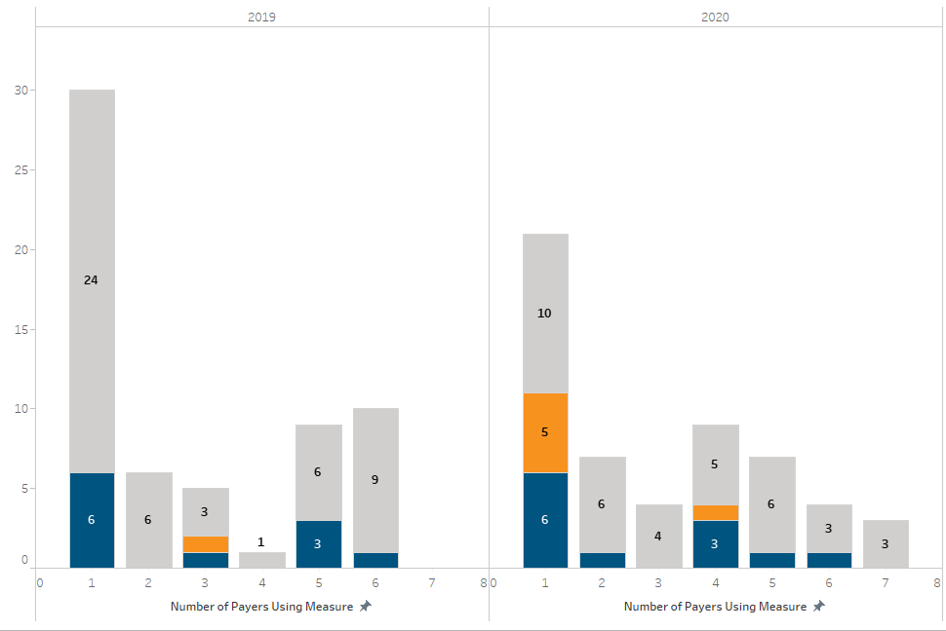
- Notable decrease in process measures used by one payer from 24 in 2019 to 10 in 2020, while patient experience measures in use by a single payer increased from 0 in 2019 to 5 in 2020.
- No measure used by all eight reporting payers in 2020, and by no more than six of seven payers in 2019.
  - The only outcome measure used by six payers both years is Comprehensive Diabetes Care: Blood Pressure Control (<140/90 mm Hg)

Slide 40

Overview of Quality Measures in Use in at Least 10 Contracts by Commercial Payers
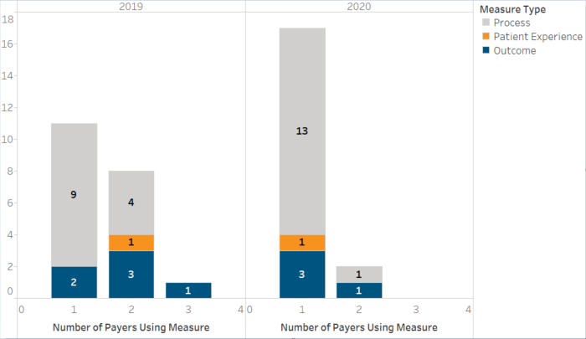
- In 2020, two of the eight reporting plans reported use of some measures in ≥ 10 contracts
- Process measures are the most commonly used measures in ≥ 10 contracts
- The majority of measures used in ≥ 10 contracts are not shared across more than one payer
- One measure included by both plans in ≥ 10 contracts:
- Comprehensive Diabetes Care: Blood Pressure Control (<140/90 mm Hg)

Slide 41

Plans Use of Core and Menu Measures in Any Global Budget Contract
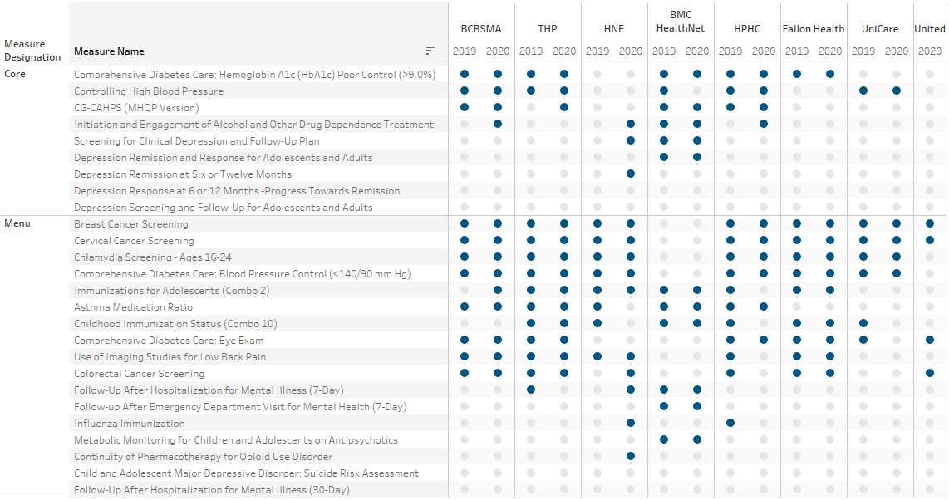
- In 2019, only two plans reported using behavioral health measures from the core and menu sets. In 2020, this increased to four plans.

Slide 43

Plans Report Continued Use of Non-endorsed Quality Measures and Developmental/Monitoring Measures in Global Budget Contracts
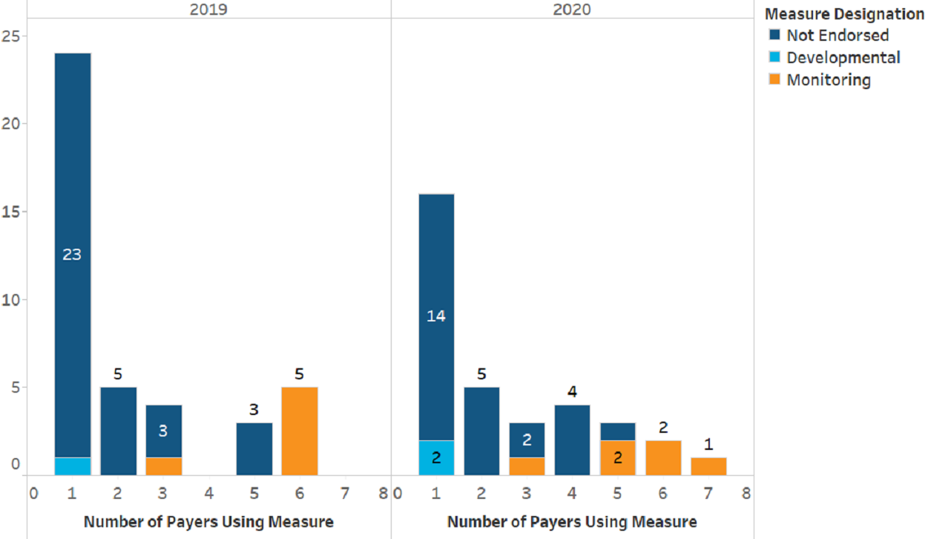
- Many non-aligned measures continue to be included in global budget-based contracts, though fewer in 2020 than in 2019.
- 26 non-endorsed measures are in use in contracts in 2020 (down from 34 in 2019), and 14 by only a)
- Developmental measures include: Community Tenure, Joint Replacement Patient Reported Outcome Measure, and Depression Remission or Response for Adolescents and Adults (2020 only)

Slide 44

Annual Review Timing
- During today’s meeting, the Taskforce will commence its first full annual review of the Aligned Measure Set.
- This review will determine the 2021 Massachusetts Aligned Measure Set.
- In 2019, the Taskforce conducted an abbreviated review because the 2020 set had been finalized only a short time previously.
- Following the Taskforce’s annual review, the Taskforce will submit its recommendations for annual changes to the Secretary of the Executive Office of Health and Human Services for re

Slide 45

Annual Review Process
- The proposed annual review process is as follows:
  - Background
    - Review guiding principles
    - Review State priorities
  - Solicit Taskforce member proposals for additions, subtractions and replacements for 2021

Slide 46

Annual Review Process
- Initial review of new measures/topics
  - Consider whether to add hospital measures for 2021
  - Review candidate pediatric measures for further consideration
    - During the 10/18 Taskforce meeting a few Taskforce members recommended adding additional pediatric measures to the Aligned Measure Set
  - Review new HEDIS measures
  - Review recommended additions to the:
    - Core Set of Children’s Health Care Quality Measures for Medicaid and CHIP (Child Core Set)
    - Core Set of Adult Health Care Quality Measures for Medicaid (Adult Core Set)

Slide 47

Annual Review Process
- Review the 2020 Aligned Measure Set
  - Review adoption in global budget-based risk contracts
  - Review substantive HEDIS changes
  - Review CMS-driven changes to existing measures in the MassHealth ACO, Medicaid Core, and Medicare ACO Sets
  - Review performance of Core, Menu, and Monitoring measures
- Revisit refined list of new measures/topics for inclusion
  - Hospital measures
  - Pediatric measures
  - New HEDIS measures
  - New Medicaid Core measures
  - Other measures

Slide 48

Annual Review Process (cont’d)
- Consider movement of measures within measure set categories
  - Finalize recommendation on Depression measure from 10/18
  - Consider transition of Developmental measures into the Core or Menu
- Finalize recommended changes to the Aligned Measure Set

Slide 49

Annual Review Process
- Background
  - Review guiding principles
  - Review State priorities

Slide 50

Background
- The first step of the annual review process is to re-orient ourselves to key considerations impacting our discussion of all measures.
- These key considerations include:
  - The Measure Set Guiding Principles
  - State health priorities
- Please keep these considerations in mind throughout the annual review process.

Slide 51

Guiding Principles

Principles applied to individual measures
- Evidence-based, scientifically acceptable, nationally-endorsed and valid at the level at which it is being used (ACO-level, in particular).
- Required data should be either readily available, not overly burdensome to collect, or, if burdensome, of demonstrable value for improving patient care.
- Represents an opportunity for improvement.
- Is important to consumers and supports the triple aim of better care, better health and lower cost.

Principles applied to the measure set
- Prioritize health outcomes, including measures sourced from clinical and patient-reported data.
- Provide a largely complete and holistic view of the entity being evaluated (i.e., ACO).
- Strive for parsimony.
- Taken as a whole, high performance on the proposed measure set should significantly advance the delivery system toward the goals of safe, timely, effective, efficient, equitable, patient-centered (STEEEP) care.
- Promote value for consumers, purchasers, and providers.

Slide 52

Guiding Principles (cont’d)
- The Taskforce adopted the following principles specific to Core Measure Set adoption:
  - No more than five in number
  - Outcomes-oriented
  - At least one measure is focused on behavioral health
  - Universally applicable to the greatest extent possible
  - Crucial from a public health perspective
  - Comprised of measures that are highly aligned across existing payer global budget-based risk contract measures
  - Enhances value

Slide 53

Guiding Principles (cont’d)
- Do you recommend any updates to the Guiding Principles?
  - If so, do you recommend changes to:
    - principles applied to individual measures,
    - principles applied to the measure set, and/or
    - principles specific to Core Measure Set adoption?

Slide 54

State Health Priorities
The Secretariat has identified the following as continuing state health priorities:
- Substance use disorders
- Mental health, including pediatric mental health
- Chronic disease, with a focus on cancer, heart disease, and diabetes
- Housing stability/homelessness
- Community tenure
- Health equity

Slide 55

Agenda
- Legislative update
- Finalize the Taskforce charter
- Discuss the process for considering non-endorsed measures
- Begin the annual review of the Aligned Measure Set
- Next Steps

Slide 56

Next Meeting
- December 9
  - Continue annual review of the Aligned Measure Set

